Tutorial – 2
1 : Predict and write output for the following code.

using System;
using System.Collections.Generic;
using System.Linq;
using System.Text;
using System.Threading.Tasks;

namespace _24SOECE11019_RAJVI_LUNAGARIYA_TUTORIAL_2
{
internal class EXAMPLE1
{

static void Main(string[] args)

{

/* local variable definition */

int a = 10;

/* check the boolean condition using if statement */

if (a < 20)

{

/* if condition is true then print the following */

Console.WriteLine("a is less than 20");

}

Console.WriteLine("value of a is : {0}", a);

Console.ReadLine();

}

}

}

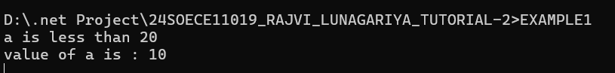

2 : Write missing statement to get the desired output.

using System;
using System.Collections.Generic;
using System.Linq;
using System.Text;
using System.Threading.Tasks;

namespace _24SOECE11019_RAJVI_LUNAGARIYA_TUTORIAL_2
{
internal class EXAMPLE2
{

static void Main(string[] args)
{
// local variable definition
int a = 100;

// check the boolean condition
if (a < 20)
{
// if condition is true then print the following
Console.WriteLine("a is less than 20");
}
else
{
// Missing statement-1
Console.WriteLine("a is not less than 20");
}

// Missing statement-2
Console.WriteLine("value of a is : " + a);

Console.ReadLine();
}

}
}

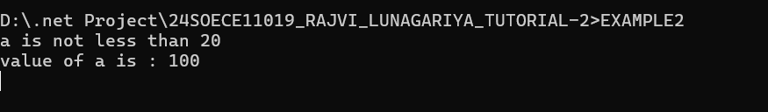

3 : Correct the following code and write output for the corrected code.
using System;

using System;
using System.Collections.Generic;
using System.Linq;
using System.Text;
using System.Threading.Tasks;

namespace _24SOECE11019_RAJVI_LUNAGARIYA_TUTORIAL_2
{
internal class EXAMPLE3
{

static void Main(string[] args)
{
string firstName = "John";
string lastName = "Doe";

Console.WriteLine("Name: " + firstName + " " + lastName);

Console.WriteLine("Please enter a new first name:");
firstName = Console.ReadLine();

Console.WriteLine("New name: " + firstName + " " + lastName);

Console.ReadLine();
}

}
}

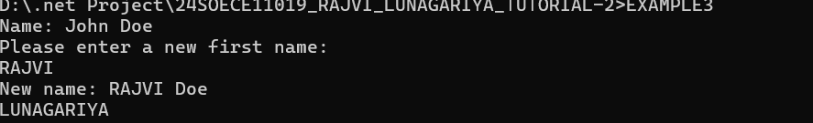

4 : Input two number A and B. perform different operations using different operators and different data types available in C#. (Note : Follow all the operators and data types to do above task. Use Online help whenever necessary.)

using System;
using System.Collections.Generic;
using System.Linq;
using System.Text;
using System.Threading.Tasks;

namespace _24SOECE11019_RAJVI_LUNAGARIYA_TUTORIAL_2
{
internal class EXAMPLE4
{
static void Main(string[] args)
{
// Integer data type
int A, B;

Console.Write("Enter first number (A): ");
A = Convert.ToInt32(Console.ReadLine());

Console.Write("Enter second number (B): ");
B = Convert.ToInt32(Console.ReadLine());

// Arithmetic Operators
Console.WriteLine("\n--- Arithmetic Operators ---");
Console.WriteLine("A + B = " + (A + B));
Console.WriteLine("A - B = " + (A - B));
Console.WriteLine("A * B = " + (A * B));
Console.WriteLine("A / B = " + (A / B));
Console.WriteLine("A % B = " + (A % B));

// Relational Operators
Console.WriteLine("\n--- Relational Operators ---");
Console.WriteLine("A == B : " + (A == B));
Console.WriteLine("A != B : " + (A != B));
Console.WriteLine("A > B : " + (A > B));
Console.WriteLine("A < B : " + (A < B));
Console.WriteLine("A >= B : " + (A >= B));
Console.WriteLine("A <= B : " + (A <= B));

// Logical Operators
Console.WriteLine("\n--- Logical Operators ---");
Console.WriteLine("(A > 0 && B > 0) : " + (A > 0 && B > 0));
Console.WriteLine("(A > 0 || B > 0) : " + (A > 0 || B > 0));
Console.WriteLine("!(A > B) : " + !(A > B));

// Assignment Operators
Console.WriteLine("\n--- Assignment Operators ---");
int C = A;
C += B;
Console.WriteLine("C += B : " + C);

C = A;
C -= B;
Console.WriteLine("C -= B : " + C);

// Increment / Decrement
Console.WriteLine("\n--- Increment / Decrement ---");
Console.WriteLine("++A = " + (++A));
Console.WriteLine("--B = " + (--B));

// Different Data Types
Console.WriteLine("\n--- Different Data Types ---");
double d = 15.75;
float f = 8.5f;
char ch = 'X';
bool flag = true;
string name = "C# Programming";

Console.WriteLine("Double : " + d);
Console.WriteLine("Float : " + f);
Console.WriteLine("Char : " + ch);
Console.WriteLine("Boolean : " + flag);
Console.WriteLine("String : " + name);

Console.ReadLine();
}
}

}

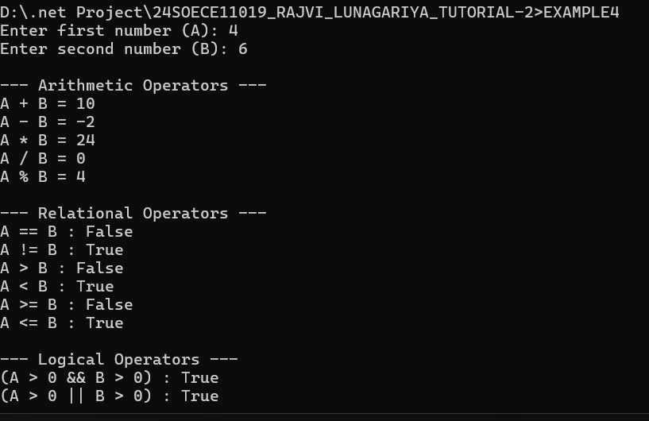

5 : Rearrange the given code to correct the program. The resultant program will be to enter 5 elements into an array and print sum of these elements.

using System;
using System.Collections.Generic;
using System.Linq;
using System.Text;
using System.Threading.Tasks;

namespace _24SOECE11019_RAJVI_LUNAGARIYA_TUTORIAL_2
{
internal class EXAMPLE5
{
static void Main(string[] args)
{
int[] arr = new int[5];
int sum = 0;

// Input 5 elements
for (int i = 0; i < 5; i++)
{
Console.Write("Enter Element {0}: ", i);
string str = Console.ReadLine();
arr[i] = Convert.ToInt32(str);
}

// Calculate sum
for (int i = 0; i < 5; i++)
{
sum = sum + arr[i];
}

Console.WriteLine("Sum of Elements : {0}", sum);
Console.Read();
}

}
}

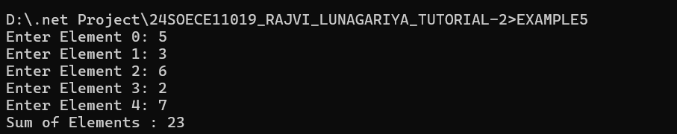

6: Write missing statement to get the desired output.

using System;
using System.Collections.Generic;
using System.Linq;
using System.Text;
using System.Threading.Tasks;

namespace _24SOECE11019_RAJVI_LUNAGARIYA_TUTORIAL_2
{
internal class EXAMPLE6
{
public static void Main(string[] args)
{
Console.WriteLine("Hello, World!");
Console.WriteLine("You entered the following 4 command line arguments:");

Console.WriteLine(Console.ReadLine());
Console.WriteLine(Console.ReadLine());
Console.WriteLine(Console.ReadLine());
Console.WriteLine(Console.ReadLine());

Console.ReadLine();
}

}
}

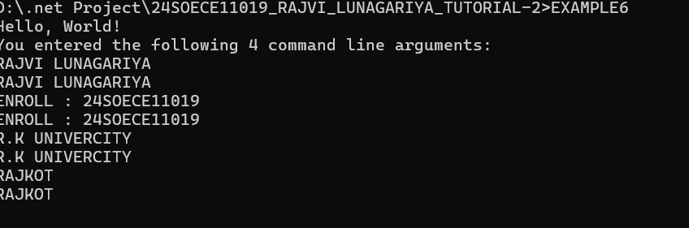

7 : Predict and write the output of the given code.

using System;
using System.Collections.Generic;
using System.Linq;
using System.Text;
using System.Threading.Tasks;

namespace _24SOECE11019_RAJVI_LUNAGARIYA_TUTORIAL_2
{
internal class EXAMPLE7
{

public void swap(ref int x, ref int y)
{
int temp;
temp = x;
x = y;
y = temp;
}
}

class TestRef
{
static void Main(string[] args)
{
EXAMPLE7 n = new EXAMPLE7();

int a, b;

Console.Write("Enter value of a: ");
a = Convert.ToInt32(Console.ReadLine());

Console.Write("Enter value of b: ");
b = Convert.ToInt32(Console.ReadLine());

Console.WriteLine("Before swap, value of a : {0}", a);
Console.WriteLine("Before swap, value of b : {0}", b);

n.swap(ref a, ref b);

Console.WriteLine("After swap, value of a : {0}", a);
Console.WriteLine("After swap, value of b : {0}", b);

Console.ReadLine();
}

}
}

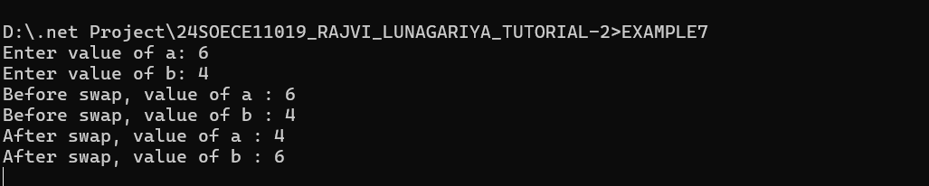

8 : Find out error code and correct it. Write the output of the corrected code.

using System;
using System.Collections.Generic;
using System.Linq;
using System.Text;
using System.Threading.Tasks;

namespace _24SOECE11019_RAJVI_LUNAGARIYA_TUTORIAL_2
{
internal class EXAMPLE8
{
public int getValues(out int x, out int y, out int z)
{
int sum;

Console.WriteLine("Enter the first value: ");
x = Convert.ToInt32(Console.ReadLine());

Console.WriteLine("Enter the second value: ");
y = Convert.ToInt32(Console.ReadLine());

Console.WriteLine("Enter the third value: ");
z = Convert.ToInt32(Console.ReadLine());

sum = x + y + z;

return sum;
}
}

class TestOut
{
static void Main(string[] args)
{
EXAMPLE8 n = new EXAMPLE8();

int a, b, c, sum;

sum = n.getValues(out a, out b, out c);

Console.WriteLine("After method call, value of a : {0}", a);
Console.WriteLine("After method call, value of b : {0}", b);
Console.WriteLine("After method call, value of c : {0}", c);
Console.WriteLine("Sum : {0}", sum);
}
}

}
}

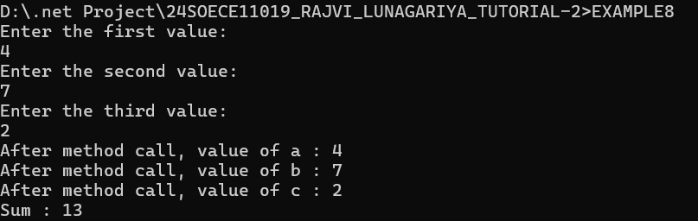

9 : Given an array A containing 2*N+2 positive numbers, out of which 2*N numbers exist in pairs whereas the other two number occur exactly once and are distinct. Find the other two numbers.
Example 1:Input:

using System;
using System.Collections.Generic;
using System.Linq;
using System.Text;
using System.Threading.Tasks;

namespace _24SOECE11019_RAJVI_LUNAGARIYA_TUTORIAL_2
{
internal class EXAMPLE9CS
{
static void Main()
{
Console.Write("Enter N: ");
int N = Convert.ToInt32(Console.ReadLine());

int size = 2 * N + 2;
int[] arr = new int[size];

Console.WriteLine("Enter array elements:");
for (int i = 0; i < size; i++)
{
arr[i] = Convert.ToInt32(Console.ReadLine());
}

int xor = 0;

for (int i = 0; i < size; i++)
{
xor ^= arr[i];
}

int setBit = xor & (-xor);

int num1 = 0, num2 = 0;

for (int i = 0; i < size; i++)
{
if ((arr[i] & setBit) != 0)
num1 ^= arr[i];
else
num2 ^= arr[i];
}

if (num1 < num2)
Console.WriteLine("Output: " + num1 + " " + num2);
else
Console.WriteLine("Output: " + num2 + " " + num1);
}

}
}

N = 2
arr[] = {1, 2, 3, 2, 1, 4}
Output:
3 4
Explanation:
3 and 4 occur exactly once.

Example 2:
Input:
N = 1
arr[] = {2, 1, 3, 2}
Output:
1 3
Explanation:
1 3 occur exactly once.

10: Given a matrix mat[][] of size N x M, where every row and column is sorted in increasing order, and a number X is given. The task is to find whether element X is present in the matrix or not.

using System;
using System.Collections.Generic;
using System.Linq;
using System.Text;
using System.Threading.Tasks;

namespace _24SOECE11019_RAJVI_LUNAGARIYA_TUTORIAL_2
{
internal class EXAMPLE10
{
static void Main()
{
Console.Write("Enter number of rows (N): ");
int N = Convert.ToInt32(Console.ReadLine());

Console.Write("Enter number of columns (M): ");
int M = Convert.ToInt32(Console.ReadLine());

int[,] mat = new int[N, M];

Console.WriteLine("Enter matrix elements:");

for (int i = 0; i < N; i++)
{
for (int j = 0; j < M; j++)
{
mat[i, j] = Convert.ToInt32(Console.ReadLine());
}
}

Console.Write("Enter element to search (X): ");
int X = Convert.ToInt32(Console.ReadLine());

int row = 0;
int col = M - 1;
int found = 0;

while (row < N && col >= 0)
{
if (mat[row, col] == X)
{
found = 1;
break;
}
else if (mat[row, col] > X)
{
col--;
}
else
{
row++;
}
}

Console.WriteLine("Output: " + found);
}

}
}

Example 1:
Input:
N = 3, M = 3
mat[][] = 3 30 38
44 52 54
57 60 69
X = 62
Output:
0
Explanation:
62 is not present in the
matrix, so output is 0

Example 2:
Input:
N = 1, M = 6
mat[][] = 18 21 27 38 55 67
X = 55
Output:
1

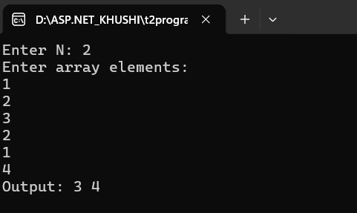

Example 2:Onput:
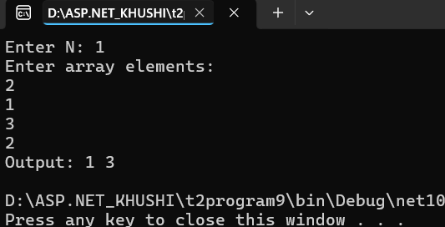

11: Write a program to find the sum of N elements of an Array.
using System;

using System;

class Program
{
static void Main()
{
Console.Write("Enter the number of elements: ");
int n = Convert.ToInt32(Console.ReadLine());

int[] arr = new int[n];
int sum = 0;

Console.WriteLine("Enter the array elements:");

for (int i = 0; i < n; i++)
{
arr[i] = Convert.ToInt32(Console.ReadLine());
sum += arr[i];
}

Console.WriteLine("Sum of array elements = " + sum);
}
}

Output:

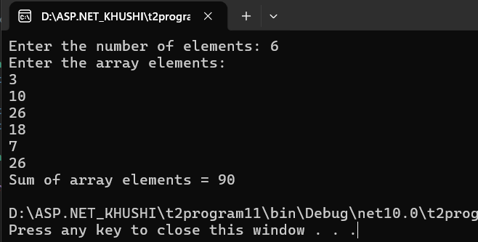

12: Write a program to find the element from an Array and print 1 if element is found else print 0.

using System;
using System.Collections.Generic;
using System.Linq;
using System.Text;
using System.Threading.Tasks;

namespace _24SOECE11019_RAJVI_LUNAGARIYA_TUTORIAL_2
{
internal class EXAMPLE12
{
static void Main()
{
Console.Write("Enter the number of elements: ");
int n = Convert.ToInt32(Console.ReadLine());

int[] arr = new int[n];

Console.WriteLine("Enter the array elements:");

for (int i = 0; i < n; i++)
{
arr[i] = Convert.ToInt32(Console.ReadLine());
}

Console.Write("Enter the element to search: ");
int key = Convert.ToInt32(Console.ReadLine());

int found = 0;

for (int i = 0; i < n; i++)
{
if (arr[i] == key)
{
found = 1;
break;
}
}

Console.WriteLine(found);
}

}
}

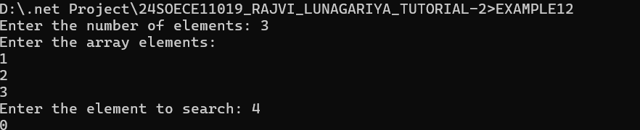

13. Write a Program that will accept the amount and find how many minimum
no of notes you required for that.
(Using the rupee notes of 1, 2, 5, 10, 20, 50, 100, 200, 500, 2000)
Input: 5748

Output:

Notes of Rs.2000 = 2 Notes of Rs.500 = 3 Notes of Rs.200 = 1
Notes of Rs.20 = 2 Notes of Rs.10 = 0 Notes of Rs.5 = 1
Notes of Rs.2 = 1 Notes of Rs.1 = 1

using System;
using System.Collections.Generic;
using System.Linq;
using System.Text;
using System.Threading.Tasks;

namespace _24SOECE11019_RAJVI_LUNAGARIYA_TUTORIAL_2
{
internal class EXE13
{
static void Main()
{
Console.Write("Enter the amount: ");
int amount = Convert.ToInt32(Console.ReadLine());

int[] notes = { 2000, 500, 200, 100, 50, 20, 10, 5, 2, 1 };

foreach (int note in notes)
{
int count = amount / note;
amount = amount % note;

Console.WriteLine("Notes of Rs." + note + " = " + count);
}
}

}
}

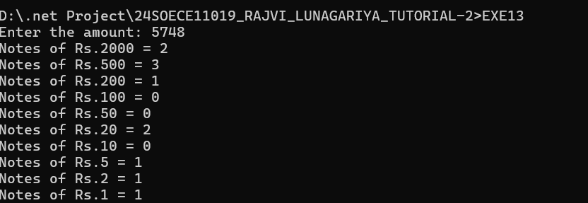
14. Write a Program to find the eligibility of admission for a professional course
based on the following criteria:

using System;
using System.Collections.Generic;
using System.Linq;
using System.Text;
using System.Threading.Tasks;

namespace _24SOECE11019_RAJVI_LUNAGARIYA_TUTORIAL_2
{
internal class EXAMPLE14
{

static void Main()
{
Console.Write("Input the marks obtained in Maths : ");
int maths = Convert.ToInt32(Console.ReadLine());

Console.Write("Input the marks obtained in Physics : ");
int physics = Convert.ToInt32(Console.ReadLine());

Console.Write("Input the marks obtained in Chemistry : ");
int chemistry = Convert.ToInt32(Console.ReadLine());

int total = maths + physics + chemistry;
int mathPhyTotal = maths + physics;

if (maths >= 65 &&
physics >= 55 &&
chemistry >= 50 &&
(total >= 180 || mathPhyTotal >= 140))
{
Console.WriteLine("The candidate is eligible for admission.");
}
else
{
Console.WriteLine("The candidate is not eligible for admission.");
}
}

}
}

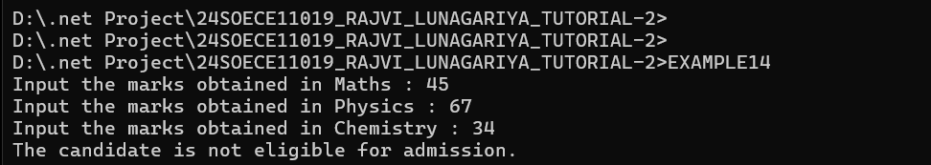
15.Write a Program which accepts name from the user and prints the same
INPUT : R K University
OUTPUT: R K University

