Tutorial -5

- Write a C# Sharp program that stores elements in an array and prints them.

using System;
using System.Collections.Generic;
using System.Linq;
using System.Text;
using System.Threading.Tasks;

namespace _24SOECE11019_RAJVI_LUNAGARIYA_TUTORIAL_5
{
internal class pROGRAM1
{
public static void Main(string[] args)
{
int[] arr = new int[5];
for (int i = 0; i < arr.Length; i++)
{
Console.WriteLine("Enter number " + (i + 1) + ":");
arr[i] = Convert.ToInt32(Console.ReadLine());
}

for (int i = 0; i < arr.Length; i++)
{
Console.WriteLine(arr[i]);
}
Console.ReadLine();
}
}
}

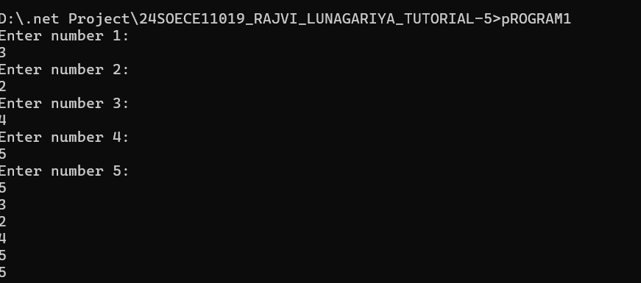

- Write a program of sorting an array. Declare single dimensional array and accept 5 integer values from the user. Then sort the input in ascending order and display output.
- using System;
- using System.Collections.Generic;
- using System.Linq;
- using System.Text;
- using System.Threading.Tasks;

- namespace _24SOECE11019_RAJVI_LUNAGARIYA_TUTORIAL_5
- {
- internal class Short_array
- {
- public static void Main(string[] args)
- {
- short[] arr = new short[5];
- for (int i = 0; i < arr.Length; i++)
- {
- Console.WriteLine("Enter number " + (i + 1) + ":");
- arr[i] = Convert.ToInt16(Console.ReadLine());
- }
- Array.Sort(arr);
- for (int i = 0; i < arr.Length; i++)
- {
- Console.WriteLine(arr[i]);
- }
- Console.ReadLine();

- }
- }
- }

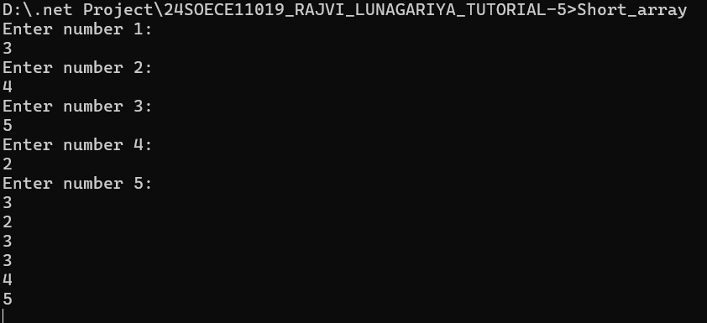
3. Write a C# Sharp program to read n values in an array and display them in reverse order.

using System;
using System.Collections.Generic;
using System.Linq;
using System.Text;
using System.Threading.Tasks;

namespace _24SOECE11019_RAJVI_LUNAGARIYA_TUTORIAL_5
{
internal class reverse
{
public static void Main(string[] args)
{
int[] arr = new int[5];
for (int i = 0; i < arr.Length; i++)
{
Console.WriteLine("Enter number " + (i + 1) + ":");
arr[i] = Convert.ToInt32(Console.ReadLine());
}
Array.Reverse(arr);
for (int i = 0; i < arr.Length; i++)
{
Console.WriteLine(arr[i]);
}
Console.ReadLine();
}
}
}

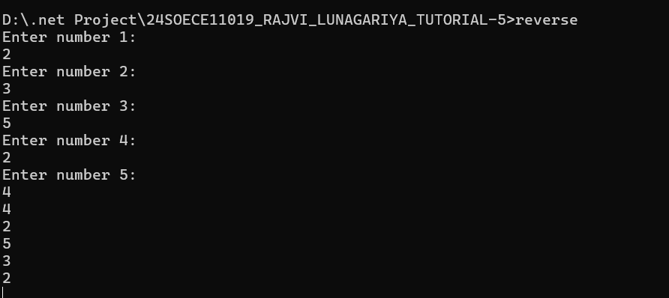

4. Write a C# Sharp program to copy the elements of one array into another array.

using System;
using System.Collections.Generic;
using System.Linq;
using System.Text;
using System.Threading.Tasks;

namespace _24SOECE11019_RAJVI_LUNAGARIYA_TUTORIAL_5
{
internal class copy1
{
public static void Main(string[] args)
{
int[] arr1 = new int[5];
for (int i = 0; i < arr1.Length; i++)
{
Console.WriteLine("Enter number " + (i + 1) + ":");
arr1[i] = Convert.ToInt32(Console.ReadLine());
}
int[] arr2 = new int[arr1.Length];
Array.Copy(arr1, arr2, arr1.Length);
for (int i = 0; i < arr2.Length; i++)
{
Console.WriteLine(arr2[i]);
}
Console.ReadLine();
}
}
}

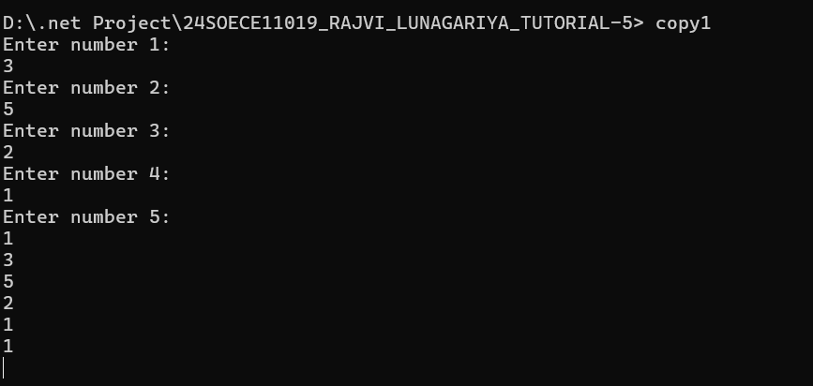

5. Write a C# Sharp program to count duplicate elements in an array.

using System;

namespace _24SOECE11019_RAJVI_LUNAGARIYA_TUTORIAL_5
{

interface Count_duplicate
{

public static void Main()
{
int[] arr = { 10, 20, 10, 30, 20, 40, 10 };
for (int i = 0; i < arr.Length; i++)
{
int count = 0;
for (int j = 0; j < arr.Length; j++)
{
if (arr[i] == arr[j])
count++;
}
if (count > 1)
Console.WriteLine(arr[i] + " occurs " + count + "times");
}
Console.Read();
}
}
}

6. Write a C# Sharp program to find the maximum and minimum elements in an array.
using System;
using System.Collections.Generic;
using System.Linq;
using System.Text;
using System.Threading.Tasks;

namespace _24SOECE11019_RAJVI_LUNAGARIYA_TUTORIAL_5
{
internal class min_max
{

static void Main()
{
int[] arr = { 10, 25, 5, 40, 15 };

int max = arr[0];
int min = arr[0];

for (int i = 1; i < arr.Length; i++)
{
if (arr[i] > max)
max = arr[i];

if (arr[i] < min)
min = arr[i];
}

Console.WriteLine("Maximum element = " + max);
Console.WriteLine("Minimum element = " + min);
}
}
}


7. Write a program in C# Sharp to separate odd and even integers into separate arrays.

using System;
using System.Collections.Generic;
using System.Linq;
using System.Text;
using System.Threading.Tasks;

namespace _24SOECE11019_RAJVI_LUNAGARIYA_TUTORIAL_5
{
internal class Odd_even_sepatrete
{
static void Main()
{
int[] arr = { 10, 25, 5, 40, 15 };
int[] odd = new int[arr.Length];
int[] even = new int[arr.Length];
int o = 0, e = 0;
Console.WriteLine("Odd numbers in the array:");
foreach (int num in arr)
{
if (num % 2 != 0)
{
even[o] = num;
o++;
Console.WriteLine(num);
}
}
Console.WriteLine("Even numbers in the array:");
foreach (int num in arr)
{
if (num % 2 == 0)
{
even[e] = num;
e++;
Console.WriteLine(num);
}
}
}
}
}

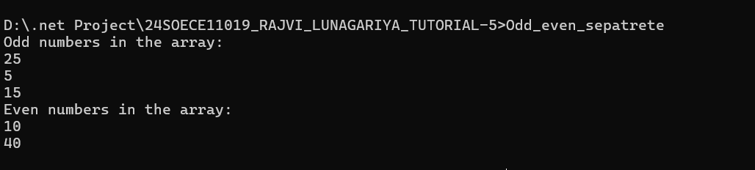
8. Write a C# Sharp program to sort array elements in descending order.

using System;
using System.Collections.Generic;
using System.Linq;
using System.Text;
using System.Threading.Tasks;

namespace _24SOECE11019_RAJVI_LUNAGARIYA_TUTORIAL_5
{
internal class Desending_order
{
static void Main()
{
int[] arr = { 10, 25, 5, 40, 15 };
Array.Sort(arr);
Array.Reverse(arr);
Console.WriteLine("Array in descending order:");
foreach (int num in arr)
{
Console.Write(num + " ");
}
}
}
}


9. Write a C# Sharp program to delete an element at the desired position from an array.

using System;
using System.Collections.Generic;
using System.Linq;
using System.Text;
using System.Threading.Tasks;

namespace _24SOECE11019_RAJVI_LUNAGARIYA_TUTORIAL_5
{
internal class del_position
{
static void Main()
{
int[] arr = { 10, 25, 5, 40, 15 };
int position = 2; // Position to delete (0-based index)
if (position < 0 || position >= arr.Length)
{
Console.WriteLine("Invalid position.");
return;
}
for (int i = position; i < arr.Length - 1; i++)
{
arr[i] = arr[i + 1];
}
Array.Resize(ref arr, arr.Length - 1); // Resize the array to remove the last element
Console.WriteLine("Array after deleting element at position " + position + ":");
foreach (int num in arr)
{
Console.Write(num + " ");
}
}

}
}


10. Write a C# Sharp program for adding two matrices of the same size.

using System;
using System.Collections.Generic;
using System.Linq;
using System.Text;
using System.Threading.Tasks;

namespace _24SOECE11019_RAJVI_LUNAGARIYA_TUTORIAL_5
{
internal class add_matrix
{
static void Main()
{
int[,] matrix1 = { { 1, 2, 3 }, { 4, 5, 6 }, { 7, 8, 9 } };
int[,] matrix2 = { { 9, 8, 7 }, { 6, 5, 4 }, { 3, 2, 1 } };
int rows = matrix1.GetLength(0);
int cols = matrix1.GetLength(1);
int[,] result = new int[rows, cols];
for (int i = 0; i < rows; i++)
{
for (int j = 0; j < cols; j++)
{
result[i, j] = matrix1[i, j] + matrix2[i, j];
}
}
Console.WriteLine("Resultant Matrix after Addition:");
for (int i = 0; i < rows; i++)
{
for (int j = 0; j < cols; j++)
{
Console.Write(result[i, j] + " ");
}
Console.WriteLine();
}
}
}
}

