Tutorial – 6

- Write a program to define an interface IEmployee with methods to accept and display employee details. Implement the interface using an Employee class. (Interface)

- using System;

- namespace _24SOECE11019_RAJVI_LUNAGARIYA_TUTORIAL_6
- {
- interface IEmployee
- {
- void AcceptDetails();
- void DisplayDetails();
- }

- class Employee : IEmployee
- {
- int id;
- string name;
- double salary;

- public void AcceptDetails()
- {
- Console.Write("Enter Employee ID: ");
- id = Convert.ToInt32(Console.ReadLine());

- Console.Write("Enter Employee Name: ");
- name = Console.ReadLine();

- Console.Write("Enter Employee Salary: ");
- salary = Convert.ToDouble(Console.ReadLine());
- }

- public void DisplayDetails()
- {
- Console.WriteLine("\n--- Employee Details ---");
- Console.WriteLine("Employee ID: " + id);
- Console.WriteLine("Employee Name: " + name);
- Console.WriteLine("Employee Salary: " + salary);
- }
- }

- class Program1
- {
- static void Main(string[] args)
- {
- Employee emp = new Employee();

- emp.AcceptDetails();
- emp.DisplayDetails();

- Console.ReadLine();
- }
- }
- }

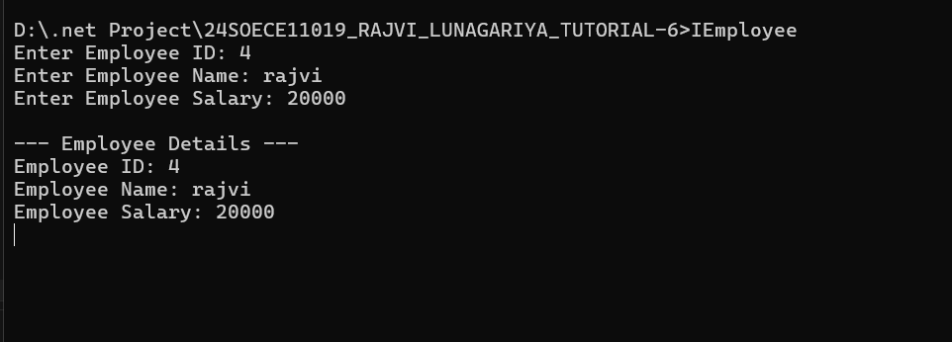
2. Write a program to define two interfaces, IPersonalDetails and IProfessionalDetails, and implement both interfaces in an Employee class to display complete employee information.(Multiple interfaces)
using System;

namespace _24SOECE11019_RAJVI_LUNAGARIYA_TUTORIAL_6
{
interface IPersonalDetails
{
void AcceptPersonalDetails();
void DisplayPersonalDetails();
}

interface IProfessionalDetails
{
void AcceptProfessionalDetails();
void DisplayProfessionalDetails();
}

class Employee2 : IPersonalDetails, IProfessionalDetails
{
int id;
string name = "";
string address = "";
string designation = "";
double salary;

public void AcceptPersonalDetails()
{
Console.Write("Enter Employee ID: ");
id = Convert.ToInt32(Console.ReadLine());

Console.Write("Enter Employee Name: ");
name = Console.ReadLine();

Console.Write("Enter Employee Address: ");
address = Console.ReadLine();
}

public void AcceptProfessionalDetails()
{
Console.Write("Enter Employee Designation: ");
designation = Console.ReadLine();

Console.Write("Enter Employee Salary: ");
salary = Convert.ToDouble(Console.ReadLine());
}

public void DisplayPersonalDetails()
{
Console.WriteLine("\n--- Personal Details ---");
Console.WriteLine("Employee ID: " + id);
Console.WriteLine("Employee Name: " + name);
Console.WriteLine("Employee Address: " + address);
}

public void DisplayProfessionalDetails()
{
Console.WriteLine("\n--- Professional Details ---");
Console.WriteLine("Designation: " + designation);
Console.WriteLine("Salary: " + salary);
}
}

class Program2
{
static void Main(string[] args)
{
Employee2 emp = new Employee2();

emp.AcceptPersonalDetails();
emp.AcceptProfessionalDetails();

emp.DisplayPersonalDetails();
emp.DisplayProfessionalDetails();

Console.ReadLine();
}
}
}

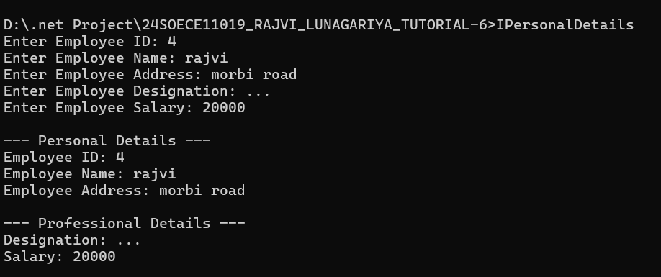

3. Write a program to create a delegate Calculate which accepts two numbers and performs addition, subtraction, multiplication and division using different methods.(Delegate)

using System;

namespace _24SOECE11019_RAJVI_LUNAGARIYA_TUTORIAL_6
{
delegate double Calculate(double a, double b);

class Program3
{
static double Addition(double a, double b)
{
return a + b;
}

static double Subtraction(double a, double b)
{
return a - b;
}

static double Multiplication(double a, double b)
{
return a * b;
}

static double Division(double a, double b)
{
return a / b;
}

static void Main(string[] args)
{
Console.Write("Enter first number: ");
double num1 = Convert.ToDouble(Console.ReadLine());

Console.Write("Enter second number: ");
double num2 = Convert.ToDouble(Console.ReadLine());

Calculate calc;

calc = Addition;
Console.WriteLine("Addition: " + calc(num1, num2));

calc = Subtraction;
Console.WriteLine("Subtraction: " + calc(num1, num2));

calc = Multiplication;
Console.WriteLine("Multiplication: " + calc(num1, num2));

if (num2 != 0)
{
calc = Division;
Console.WriteLine("Division: " + calc(num1, num2));
}
else
{
Console.WriteLine("Division by zero is not possible.");
}

Console.ReadLine();
}
}
}

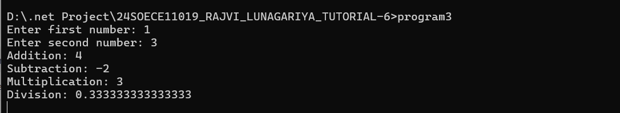

4. Write a program to demonstrate a multicast delegate by creating a delegate that calls multiple methods to display student information such as name, course and semester. (Multicast Delegate)

using System;

namespace _24SOECE11019_RAJVI_LUNAGARIYA_TUTORIAL_6
{
delegate void StudentInfo();

class Program4
{
static void DisplayName()
{
Console.WriteLine("Student Name: Rajvi Lunagariya");
}

static void DisplayCourse()
{
Console.WriteLine("Course: B.Tech");
}

static void DisplaySemester()
{
Console.WriteLine("Semester: 4th Semester");
}

static void Main(string[] args)
{
StudentInfo student;

student = DisplayName;
student += DisplayCourse;
student += DisplaySemester;

Console.WriteLine("--- Student Information ---");
student();

Console.ReadLine();
}
}
}

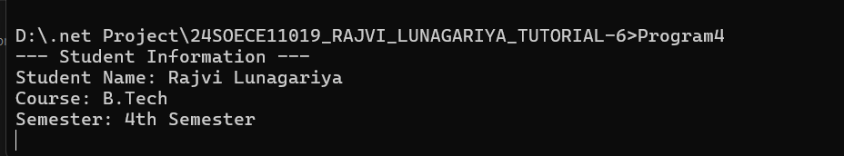
5. Write a program to demonstrate event handling by creating a BankAccount class. Raise an event whenever money is deposited into the account and display an appropriate message.(Events)

using System;

namespace _24SOECE11019_RAJVI_LUNAGARIYA_TUTORIAL_6
{
class BankAccount
{
public event EventHandler MoneyDeposited;

public double Balance { get; private set; }

public void Deposit(double amount)
{
if (amount <= 0)
{
Console.WriteLine("Please enter a valid deposit amount.");
return;
}

Balance += amount;

MoneyDeposited?.Invoke(this, EventArgs.Empty);
}

public void DisplayMessage(object sender, EventArgs e)
{
Console.WriteLine("Money deposited successfully!");
Console.WriteLine("Current Balance: " + Balance);
}
}

class Program5
{
static void Main(string[] args)
{
BankAccount account = new BankAccount();

account.MoneyDeposited += account.DisplayMessage;

Console.Write("Enter deposit amount: ");
double amount = Convert.ToDouble(Console.ReadLine());

account.Deposit(amount);

Console.ReadLine();
}
}
}

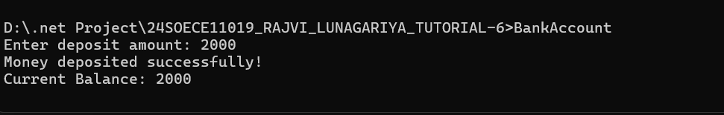
6. Write a program which accepts two numbers from the user and performs division. Handle the DivideByZeroException using a try-catch block.(Exception)

using System;

namespace _24SOECE11019_RAJVI_LUNAGARIYA_TUTORIAL_6
{
class Program6
{
static void Main(string[] args)
{
try
{
Console.Write("Enter first number: ");
int num1 = Convert.ToInt32(Console.ReadLine());

Console.Write("Enter second number: ");
int num2 = Convert.ToInt32(Console.ReadLine());

int result = num1 / num2;

Console.WriteLine("Division Result: " + result);
}
catch (DivideByZeroException)
{
Console.WriteLine("Error: Cannot divide by zero.");
}

Console.ReadLine();
}
}
}

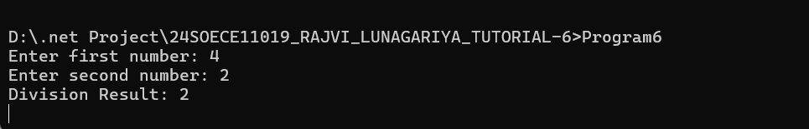

7. Write a program which accepts an integer from the user and handles the exception when the user enters an invalid value instead of a number. Use appropriate try-catch-finally blocks.(Try-Catch-Finally)

using System;

namespace _24SOECE11019_RAJVI_LUNAGARIYA_TUTORIAL_6
{
class Program7
{
static void Main(string[] args)
{
try
{
Console.Write("Enter an integer: ");
int num = Convert.ToInt32(Console.ReadLine());

Console.WriteLine("You entered: " + num);
}
catch (FormatException)
{
Console.WriteLine("Error: Please enter a valid integer.");
}
finally
{
Console.WriteLine("Finally block executed.");
}

Console.ReadLine();
}
}
}

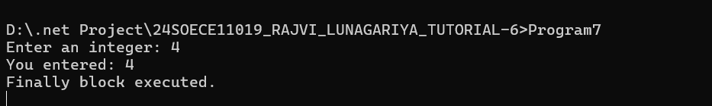
8. Write a program to create a custom exception InsufficientBalanceException for a bank account. If the withdrawal amount is greater than the available balance, generate the custom exception.(Custom Exception)

using System;

namespace _24SOECE11019_RAJVI_LUNAGARIYA_TUTORIAL_6
{
// Custom Exception
class InsufficientBalanceException : Exception
{
public InsufficientBalanceException(string message) : base(message)
{
}
}

// Bank Account Class
class BankAccount1
{
double balance = 50000;

public void Withdraw(double amount)
{
if (amount > balance)
{
throw new InsufficientBalanceException(
"Error: Insufficient balance for withdrawal.");
}

balance -= amount;

Console.WriteLine("Withdrawal successful.");
Console.WriteLine("Remaining Balance: " + balance);
}
}

class Program8
{
static void Main(string[] args)
{
BankAccount1 account = new BankAccount1();

try
{
Console.Write("Enter amount to withdraw: ");
double amount = Convert.ToDouble(Console.ReadLine());

account.Withdraw(amount);
}
catch (InsufficientBalanceException ex)
{
Console.WriteLine(ex.Message);
}

Console.ReadLine();
}
}
}

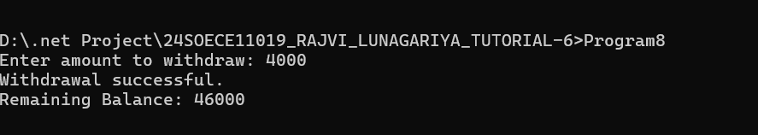
9. Write a program which accepts two numbers from the user and uses a lambda expression to calculate their addition, multiplication and maximum value.
(Lambda)

using System;

namespace _24SOECE11019_RAJVI_LUNAGARIYA_TUTORIAL_6
{
class Program9
{
static void Main(string[] args)
{
Console.Write("Enter first number: ");
int a = Convert.ToInt32(Console.ReadLine());

Console.Write("Enter second number: ");
int b = Convert.ToInt32(Console.ReadLine());

// Lambda expressions
Func<int, int, int> addition = (x, y) => x + y;
Func<int, int, int> multiplication = (x, y) => x * y;
Func<int, int, int> maximum = (x, y) => x > y ? x : y;

Console.WriteLine("Addition: " + addition(a, b));
Console.WriteLine("Multiplication: " + multiplication(a, b));
Console.WriteLine("Maximum: " + maximum(a, b));

Console.ReadLine();
}
}
}

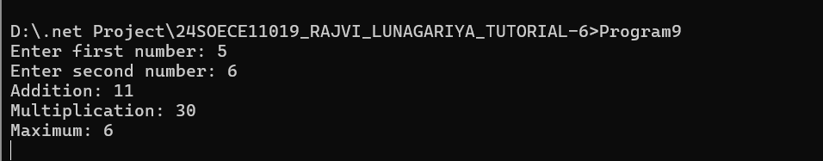

10. Write a program to create a list of student marks and use a lambda expression to display students who have obtained marks greater than 50.(Lambda + Collection)

using System;
using System.Collections.Generic;

namespace _24SOECE11019_RAJVI_LUNAGARIYA_TUTORIAL_6
{
class Program10
{
static void Main(string[] args)
{
List<int> marks = new List<int> { 45, 75, 60, 35, 90, 50, 85 };

Console.WriteLine("Student Marks Greater Than 50:");

marks.FindAll(m => m > 50)
.ForEach(m => Console.WriteLine(m));

Console.ReadLine();
}
}
}

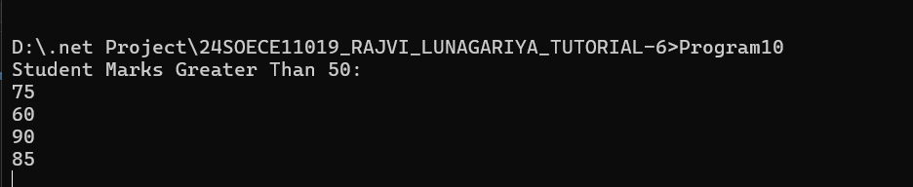

11. Write a program to create a collection of integers and use LINQ to display all even numbers from the collection in ascending order.(LINQ)

using System;
using System.Collections.Generic;
using System.Linq;

namespace _24SOECE11019_RAJVI_LUNAGARIYA_TUTORIAL_6
{
class Program11
{
static void Main(string[] args)
{
List<int> numbers = new List<int>
{
15, 8, 3, 12, 6, 21, 10, 4, 18
};

var evenNumbers = from n in numbers
where n % 2 == 0
orderby n ascending
select n;

Console.WriteLine("Even numbers in ascending order:");

foreach (int n in evenNumbers)
{
Console.WriteLine(n);
}

Console.ReadLine();
}
}
}

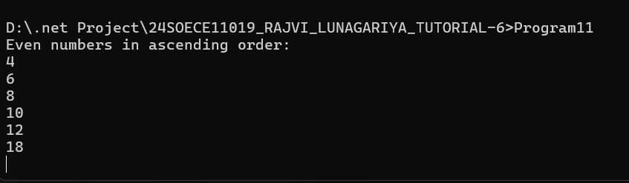
12. Write a program to create a list of Student objects containing Student ID, Name, Course and Marks. Use LINQ to display students whose marks are greater than 70 and sort them by marks.(LINQ + Objects)

using System;
using System.Collections.Generic;
using System.Linq;

namespace _24SOECE11019_RAJVI_LUNAGARIYA_TUTORIAL_6
{
class Student
{
public int StudentID { get; set; }
public string Name { get; set; }
public string Course { get; set; }
public double Marks { get; set; }
}

class Program12
{
static void Main(string[] args)
{
List<Student> students = new List<Student>
{
new Student { StudentID = 1, Name = "Rajvi", Course = "B.Tech", Marks = 85 },
new Student { StudentID = 2, Name = "Amit", Course = "BCA", Marks = 65 },
new Student { StudentID = 3, Name = "Priya", Course = "B.Tech", Marks = 92 },
new Student { StudentID = 4, Name = "Rahul", Course = "BCA", Marks = 75 },
new Student { StudentID = 5, Name = "Neha", Course = "B.Tech", Marks = 60 }
};

var result = from s in students
where s.Marks > 70
orderby s.Marks ascending
select s;

Console.WriteLine("Students with Marks Greater Than 70:");
Console.WriteLine("------------------------------------");

foreach (Student s in result)
{
Console.WriteLine("Student ID: " + s.StudentID);
Console.WriteLine("Name: " + s.Name);
Console.WriteLine("Course: " + s.Course);
Console.WriteLine("Marks: " + s.Marks);
Console.WriteLine();
}

Console.ReadLine();
}
}
}
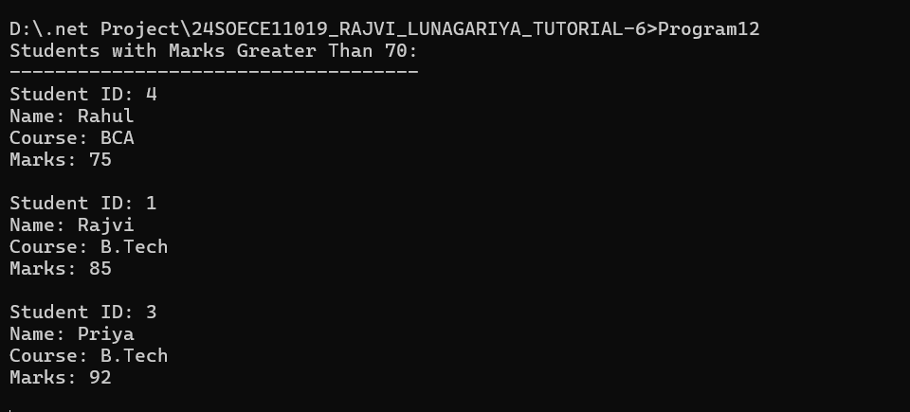
13. Write a program to create and start multiple threads to perform different tasks such as displaying numbers from 1 to 10, displaying alphabets from A to J, and displaying a message.(Multithreading)

using System;
using System.Threading;

namespace _24SOECE11019_RAJVI_LUNAGARIYA_TUTORIAL_6
{
class Program13
{
static void DisplayNumbers()
{
for (int i = 1; i <= 10; i++)
{
Console.WriteLine("Number: " + i);
Thread.Sleep(100);
}
}

static void DisplayAlphabets()
{
for (char ch = 'A'; ch <= 'J'; ch++)
{
Console.WriteLine("Alphabet: " + ch);
Thread.Sleep(100);
}
}

static void DisplayMessage()
{
for (int i = 1; i <= 5; i++)
{
Console.WriteLine("Hello! This is a separate thread.");
Thread.Sleep(100);
}
}

static void Main(string[] args)
{
Thread t1 = new Thread(DisplayNumbers);
Thread t2 = new Thread(DisplayAlphabets);
Thread t3 = new Thread(DisplayMessage);

t1.Start();
t2.Start();
t3.Start();

t1.Join();
t2.Join();
t3.Join();

Console.WriteLine("All threads completed.");

Console.ReadLine();
}
}
}
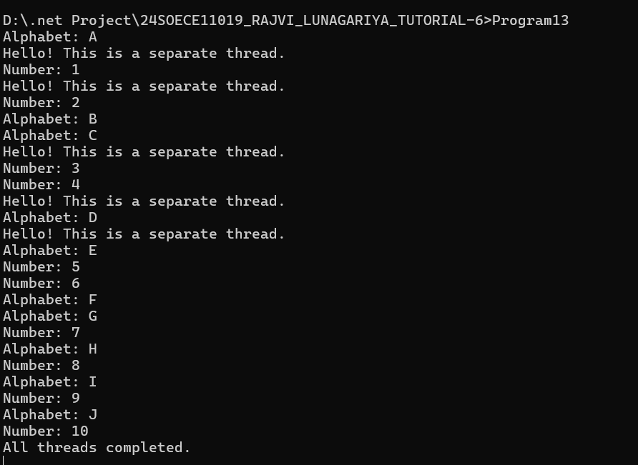
14. Write a program to demonstrate the thread lifecycle by creating a thread, starting it, checking its state, waiting for its completion using Join(), and displaying the thread status at different stages.(Thread Lifecycle)

using System;
using System.Threading;

namespace _24SOECE11019_RAJVI_LUNAGARIYA_TUTORIAL_6
{
class Program14
{
static void DisplayMessage()
{
Console.WriteLine("Thread is running...");

Thread.Sleep(2000);

Console.WriteLine("Thread task completed.");
}

static void Main(string[] args)
{
Thread t = new Thread(DisplayMessage);

Console.WriteLine("Thread Created.");
Console.WriteLine("Thread State: " + t.ThreadState);

t.Start();

Console.WriteLine("Thread Started.");
Console.WriteLine("Thread State: " + t.ThreadState);

Console.WriteLine("Waiting for thread to complete...");

t.Join();

Console.WriteLine("Thread Execution Finished.");
Console.WriteLine("Thread State: " + t.ThreadState);

Console.ReadLine();
}
}
}

