Lab Assignment – 2

1. Create an ASP.Net page to enter the details for student with the help of different views using MultiView Control. View 1: Student Personal Info(Name,Gender,Address,Degree,etc..) View 2: Student Contact Info(Email,Contact No,etc..) View 3: Show summery(View1+View2).

Demo.aspx Code

<%@ Page Language="C#" AutoEventWireup="true" CodeBehind="Student.aspx.cs" Inherits="WebApplication1.StudentRegistration" %>

<!DOCTYPE html>

<html xmlns="http://www.w3.org/1999/xhtml">
<head runat="server">
<title>Student Registration - MultiView Control</title>
<style type="text/css"> body { font-family: 'Segoe UI', Tahoma, Geneva, Verdana, sans-serif; background-color: #f4f6f9; margin: 40px;
}
.container { width: 550px; margin: 0 auto; background: #ffffff; padding: 30px 40px; border-radius: 8px; box-shadow: 0 4px 15px rgba(0,0,0,0.1);
} h2 { color: #2c3e50; text-align: center; margin-bottom: 20px;
}
.step-indicator { text-align: center; font-weight: bold; color: #007bff; margin-bottom: 20px; font-size: 16px;
padding: 8px; background-color: #e9f5ff; border-radius: 4px;
}
.form-group { margin-bottom: 15px;
}
.form-group label { display: block; margin-bottom: 5px; font-weight: bold; color: #555;
}
.form-control { width: 100%; padding: 8px 10px; box-sizing: border-box; border: 1px solid #ccc; border-radius: 4px; font-size: 14px;
}
.btn {
padding: 9px 20px; background-color: #007bff; color: white; border: none; border-radius: 4px; cursor: pointer; font-size: 14px; font-weight: bold;
}
.btn-secondary { background-color: #6c757d;
height: 40px;
}
.btn:hover { opacity: 0.9;
}
.btn-group { margin-top: 25px; display: flex; justify-content: space-between;
}
.summary-table { width: 100%; border-collapse: collapse; margin-top: 15px;
}
.summary-table td { padding: 10px; border-bottom: 1px solid #eee;
}
.summary-table td.label-col { font-weight: bold; width: 35%; color: #333;
}
</style>
</head>
<body>
<form id="form1" runat="server">
<div class="container">
<h2>Student Details Form</h2>

<asp:MultiView ID="MultiView1" runat="server" ActiveViewIndex="0">
<%-- View 1: Student Personal Info --%>
<asp:View ID="View1" runat="server">
<div class="step-indicator">View 1: Student Personal Info</div> <div class="form-group">
<asp:Label ID="lbl1" runat="server" Text="Student Name:"></asp:Label>
<asp:TextBox ID="txtName" runat="server" CssClass="form-control"></asp:TextBox>
<asp:RequiredFieldValidator ID="rfvName" runat="server"
ControlToValidate="txtName" ErrorMessage="Name is required" ForeColor="Red"
ValidationGroup="Group1"></asp:RequiredFieldValidator>
</div>

<div class="form-group">
<asp:Label ID="lbl2" runat="server" Text="Gender:"></asp:Label>
<asp:RadioButtonList ID="rblGender" runat="server"
RepeatDirection="Horizontal">
<asp:ListItem Selected="True">Male</asp:ListItem>
<asp:ListItem>Female</asp:ListItem>
<asp:ListItem>Other</asp:ListItem>
</asp:RadioButtonList>
</div>

<div class="form-group">
<asp:Label ID="lbl3" runat="server" Text="Address:"></asp:Label>
<asp:TextBox ID="txtAddress" runat="server" TextMode="MultiLine" Rows="3"
CssClass="form-control"></asp:TextBox>
<asp:RequiredFieldValidator ID="rfvAddress" runat="server"
ControlToValidate="txtAddress" ErrorMessage="Address is required" ForeColor="Red"
ValidationGroup="Group1"></asp:RequiredFieldValidator>
</div>

<div class="form-group">
<asp:Label ID="lbl4" runat="server" Text="Degree / Course:"></asp:Label>
<asp:DropDownList ID="ddlDegree" runat="server" CssClass="form-control">
<asp:ListItem>B.Tech</asp:ListItem>
<asp:ListItem>B.Sc</asp:ListItem>
<asp:ListItem>BCA</asp:ListItem>
<asp:ListItem>M.Tech</asp:ListItem>
<asp:ListItem>MCA</asp:ListItem>
<asp:ListItem>M.Sc</asp:ListItem>
</asp:DropDownList>
</div>
<div class="btn-group">
<div>
</div>
<asp:Button ID="btnNext1" runat="server" CssClass="btn" OnClick="btnNext1_Click" Text="Next (Contact Info) &gt;&gt;" ValidationGroup="Group1" />
</div>
</asp:View>

<%-- View 2: Student Contact Info --%>
<asp:View ID="View2" runat="server">
<div class="step-indicator">View 2: Student Contact Info</div>

<div class="form-group">
<asp:Label ID="lbl5" runat="server" Text="Email Address:"></asp:Label>
<asp:TextBox ID="txtEmail" runat="server" CssClass="form-control"></asp:TextBox>
<asp:RequiredFieldValidator ID="rfvEmail" runat="server"
ControlToValidate="txtEmail" ErrorMessage="Email is required" ForeColor="Red"
ValidationGroup="Group2"></asp:RequiredFieldValidator>
<asp:RegularExpressionValidator ID="revEmail" runat="server"
ControlToValidate="txtEmail" ErrorMessage="Invalid Email Format" ForeColor="Red"
ValidationExpression="\w+([-+.']\w+)*@\w+([-.]\w+)*\.\w+([-.]\w+)*" ValidationGroup="Group2"></asp:RegularExpressionValidator>
</div>

<div class="form-group">
<asp:Label ID="lbl6" runat="server" Text="Contact No:"></asp:Label>
<asp:TextBox ID="txtContact" runat="server" CssClass="form-control"></asp:TextBox>
<asp:RequiredFieldValidator ID="rfvContact" runat="server"
ControlToValidate="txtContact" ErrorMessage="Contact number is required" ForeColor="Red"
ValidationGroup="Group2"></asp:RequiredFieldValidator>
<asp:RegularExpressionValidator ID="revContact" runat="server"
ControlToValidate="txtContact" ErrorMessage="Must be 10 digits" ForeColor="Red"
ValidationExpression="\d{10}" ValidationGroup="Group2"></asp:RegularExpressionValidator>
</div>

<div class="form-group">
<asp:Label ID="lbl7" runat="server" Text="City:"></asp:Label>
<asp:TextBox ID="txtCity" runat="server" CssClass="form-control"></asp:TextBox>
<asp:RequiredFieldValidator ID="rfvCity" runat="server"
ControlToValidate="txtCity" ErrorMessage="City is required" ForeColor="Red"
ValidationGroup="Group2"></asp:RequiredFieldValidator>
</div>

<div class="btn-group">
<asp:Button ID="btnPrev2" runat="server" Text="<< Previous (Personal Info)" CssClass="btn btn-secondary" OnClick="btnPrev2_Click" CausesValidation="false" />
<asp:Button ID="btnNext2" runat="server" Text="Next (Show Summary) >>" CssClass="btn" ValidationGroup="Group2" OnClick="btnNext2_Click" />
</div>
</asp:View>

<%-- View 3: Show Summary (View 1 + View 2) --%>
<asp:View ID="View3" runat="server">
<div class="step-indicator">View 3: Student Summary</div>

<table class="summary-table">
<tr>
<td class="label-col">Name:</td>
<td><asp:Label ID="lblSummaryName" runat="server"></asp:Label></td>
</tr>
<tr>
<td class="label-col">Gender:</td>
<td><asp:Label ID="lblSummaryGender" runat="server"></asp:Label></td>
</tr>
<tr>
<td class="label-col">Address:</td>
<td><asp:Label ID="lblSummaryAddress" runat="server"></asp:Label></td>
</tr>
<tr>
<td class="label-col">Degree:</td>
<td><asp:Label ID="lblSummaryDegree" runat="server"></asp:Label></td>
</tr>
<tr>
<td class="label-col">Email:</td>
<td><asp:Label ID="lblSummaryEmail" runat="server"></asp:Label></td>
</tr>
<tr>
<td class="label-col">Contact No:</td>
<td><asp:Label ID="lblSummaryContact" runat="server"></asp:Label></td>
</tr>
<tr>
<td class="label-col">City:</td>
<td><asp:Label ID="lblSummaryCity" runat="server"></asp:Label></td>
</tr>
</table>

<asp:Label ID="lblStatusMessage" runat="server" ForeColor="Green"
Font-Bold="true" style="display:block; margin-top:15px; text-align:center;"></asp:Label>

<div class="btn-group">
<asp:Button ID="btnPrev3" runat="server" Text="<< Edit Contact Info"
CssClass="btn btn-secondary" OnClick="btnPrev3_Click" CausesValidation="false" />
<asp:Button ID="btnSubmit" runat="server" Text="Final Submit" CssClass="btn" OnClick="btnSubmit_Click" CausesValidation="false" />
</div>
</asp:View>
</asp:MultiView>
</div>
</form>
</body>
</html>

Demo.aspx.cs Code

//------------------------------------------------------------------------------
// <auto-generated>
// This code was generated by a tool.
//
// Changes to this file may cause incorrect behavior and will be lost if
// the code is regenerated.
// </auto-generated>
//------------------------------------------------------------------------------

namespace WebApplication1
{

public partial class StudentRegistration
{

/// <summary>
/// form1 control.
/// </summary>
/// <remarks>
/// Auto-generated field.
/// To modify move field declaration from designer file to code-behind file.
/// </remarks>
protected global::System.Web.UI.HtmlControls.HtmlForm form1;

/// <summary>
/// MultiView1 control.
/// </summary>
/// <remarks>
/// Auto-generated field.
/// To modify move field declaration from designer file to code-behind file.
/// </remarks>
protected global::System.Web.UI.WebControls.MultiView MultiView1;

/// <summary>
/// View1 control.
/// </summary>
/// <remarks>
/// Auto-generated field.
/// To modify move field declaration from designer file to code-behind file.
/// </remarks>
protected global::System.Web.UI.WebControls.View View1;

/// <summary>
/// lbl1 control.
/// </summary>
/// <remarks>
/// Auto-generated field.
/// To modify move field declaration from designer file to code-behind file.
/// </remarks>
protected global::System.Web.UI.WebControls.Label lbl1;

/// <summary>
/// txtName control.
/// </summary>
/// <remarks>
/// Auto-generated field.
/// To modify move field declaration from designer file to code-behind file.
/// </remarks>
protected global::System.Web.UI.WebControls.TextBox txtName;

/// <summary>
/// rfvName control.
/// </summary>
/// <remarks>
/// Auto-generated field.
/// To modify move field declaration from designer file to code-behind file.
/// </remarks>
protected global::System.Web.UI.WebControls.RequiredFieldValidator rfvName;

/// <summary>
/// lbl2 control.
/// </summary>
/// <remarks>
/// Auto-generated field.
/// To modify move field declaration from designer file to code-behind file.
/// </remarks>
protected global::System.Web.UI.WebControls.Label lbl2;

/// <summary>
/// rblGender control.
/// </summary>
/// <remarks>
/// Auto-generated field.
/// To modify move field declaration from designer file to code-behind file.
/// </remarks>
protected global::System.Web.UI.WebControls.RadioButtonList rblGender;

/// <summary>
/// lbl3 control.
/// </summary>
/// <remarks>
/// Auto-generated field.
/// To modify move field declaration from designer file to code-behind file.
/// </remarks>
protected global::System.Web.UI.WebControls.Label lbl3;

/// <summary>
/// txtAddress control.
/// </summary>
/// <remarks>
/// Auto-generated field.
/// To modify move field declaration from designer file to code-behind file.
/// </remarks>
protected global::System.Web.UI.WebControls.TextBox txtAddress;

/// <summary>
/// rfvAddress control.
/// </summary>
/// <remarks>
/// Auto-generated field.
/// To modify move field declaration from designer file to code-behind file.
/// </remarks>
protected global::System.Web.UI.WebControls.RequiredFieldValidator rfvAddress;

/// <summary>
/// lbl4 control.
/// </summary>
/// <remarks>
/// Auto-generated field.
/// To modify move field declaration from designer file to code-behind file.
/// </remarks>
protected global::System.Web.UI.WebControls.Label lbl4;

/// <summary>
/// ddlDegree control.
/// </summary>
/// <remarks>
/// Auto-generated field.
/// To modify move field declaration from designer file to code-behind file.
/// </remarks>
protected global::System.Web.UI.WebControls.DropDownList ddlDegree;

/// <summary>
/// btnNext1 control.
/// </summary>
/// <remarks>
/// Auto-generated field.
/// To modify move field declaration from designer file to code-behind file.
/// </remarks>
protected global::System.Web.UI.WebControls.Button btnNext1;

/// <summary>
/// View2 control.
/// </summary>
/// <remarks>
/// Auto-generated field.
/// To modify move field declaration from designer file to code-behind file.
/// </remarks>
protected global::System.Web.UI.WebControls.View View2;

/// <summary>
/// lbl5 control.
/// </summary>
/// <remarks>
/// Auto-generated field.
/// To modify move field declaration from designer file to code-behind file.
/// </remarks>
protected global::System.Web.UI.WebControls.Label lbl5;

/// <summary>
/// txtEmail control.
/// </summary>
/// <remarks>
/// Auto-generated field.
/// To modify move field declaration from designer file to code-behind file.
/// </remarks>
protected global::System.Web.UI.WebControls.TextBox txtEmail;

/// <summary>
/// rfvEmail control.
/// </summary>
/// <remarks>
/// Auto-generated field.
/// To modify move field declaration from designer file to code-behind file.
/// </remarks>
protected global::System.Web.UI.WebControls.RequiredFieldValidator rfvEmail;

/// <summary>
/// revEmail control.
/// </summary>
/// <remarks>
/// Auto-generated field.
/// To modify move field declaration from designer file to code-behind file.
/// </remarks>
protected global::System.Web.UI.WebControls.RegularExpressionValidator revEmail;

/// <summary>
/// lbl6 control.
/// </summary>
/// <remarks>
/// Auto-generated field.
/// To modify move field declaration from designer file to code-behind file.
/// </remarks>
protected global::System.Web.UI.WebControls.Label lbl6;

/// <summary>
/// txtContact control.
/// </summary>
/// <remarks>
/// Auto-generated field.
/// To modify move field declaration from designer file to code-behind file.
/// </remarks>
protected global::System.Web.UI.WebControls.TextBox txtContact;

/// <summary>
/// rfvContact control.
/// </summary>
/// <remarks>
/// Auto-generated field.
/// To modify move field declaration from designer file to code-behind file.
/// </remarks>
protected global::System.Web.UI.WebControls.RequiredFieldValidator rfvContact;

/// <summary>
/// revContact control.
/// </summary>
/// <remarks>
/// Auto-generated field.
/// To modify move field declaration from designer file to code-behind file.
/// </remarks>
protected global::System.Web.UI.WebControls.RegularExpressionValidator revContact;

/// <summary>
/// lbl7 control.
/// </summary>
/// <remarks>
/// Auto-generated field.
/// To modify move field declaration from designer file to code-behind file.
/// </remarks>
protected global::System.Web.UI.WebControls.Label lbl7;

/// <summary>
/// txtCity control.
/// </summary>
/// <remarks>
/// Auto-generated field.
/// To modify move field declaration from designer file to code-behind file.
/// </remarks>
protected global::System.Web.UI.WebControls.TextBox txtCity;

/// <summary>
/// rfvCity control.
/// </summary>
/// <remarks>
/// Auto-generated field.
/// To modify move field declaration from designer file to code-behind file.
/// </remarks>
protected global::System.Web.UI.WebControls.RequiredFieldValidator rfvCity;

/// <summary>
/// btnPrev2 control.
/// </summary>
/// <remarks>
/// Auto-generated field.
/// To modify move field declaration from designer file to code-behind file.
/// </remarks>
protected global::System.Web.UI.WebControls.Button btnPrev2;

/// <summary>
/// btnNext2 control.
/// </summary>
/// <remarks>
/// Auto-generated field.
/// To modify move field declaration from designer file to code-behind file.
/// </remarks>
protected global::System.Web.UI.WebControls.Button btnNext2;

/// <summary>
/// View3 control.
/// </summary>
/// <remarks>
/// Auto-generated field.
/// To modify move field declaration from designer file to code-behind file.
/// </remarks>
protected global::System.Web.UI.WebControls.View View3;

/// <summary>
/// lblSummaryName control.
/// </summary>
/// <remarks>
/// Auto-generated field.
/// To modify move field declaration from designer file to code-behind file.
/// </remarks>
protected global::System.Web.UI.WebControls.Label lblSummaryName;

/// <summary>
/// lblSummaryGender control.
/// </summary>
/// <remarks>
/// Auto-generated field.
/// To modify move field declaration from designer file to code-behind file.
/// </remarks>
protected global::System.Web.UI.WebControls.Label lblSummaryGender;

/// <summary>
/// lblSummaryAddress control.
/// </summary>
/// <remarks>
/// Auto-generated field.
/// To modify move field declaration from designer file to code-behind file.
/// </remarks>
protected global::System.Web.UI.WebControls.Label lblSummaryAddress;

/// <summary>
/// lblSummaryDegree control.
/// </summary>
/// <remarks>
/// Auto-generated field.
/// To modify move field declaration from designer file to code-behind file.
/// </remarks>
protected global::System.Web.UI.WebControls.Label lblSummaryDegree;

/// <summary>
/// lblSummaryEmail control.
/// </summary>
/// <remarks>
/// Auto-generated field.
/// To modify move field declaration from designer file to code-behind file.
/// </remarks>
protected global::System.Web.UI.WebControls.Label lblSummaryEmail;

/// <summary>
/// lblSummaryContact control.
/// </summary>
/// <remarks>
/// Auto-generated field.
/// To modify move field declaration from designer file to code-behind file.
/// </remarks>
protected global::System.Web.UI.WebControls.Label lblSummaryContact;

/// <summary>
/// lblSummaryCity control.
/// </summary>
/// <remarks>
/// Auto-generated field.
/// To modify move field declaration from designer file to code-behind file.
/// </remarks>
protected global::System.Web.UI.WebControls.Label lblSummaryCity;

/// <summary>
/// lblStatusMessage control.
/// </summary>
/// <remarks>
/// Auto-generated field.
/// To modify move field declaration from designer file to code-behind file.
/// </remarks>
protected global::System.Web.UI.WebControls.Label lblStatusMessage;

/// <summary>
/// btnPrev3 control.
/// </summary>
/// <remarks>
/// Auto-generated field.
/// To modify move field declaration from designer file to code-behind file.
/// </remarks>
protected global::System.Web.UI.WebControls.Button btnPrev3;

/// <summary>
/// btnSubmit control.
/// </summary>
/// <remarks>
/// Auto-generated field.
/// To modify move field declaration from designer file to code-behind file.
/// </remarks>
protected global::System.Web.UI.WebControls.Button btnSubmit;
}
}

Output Screenshot:
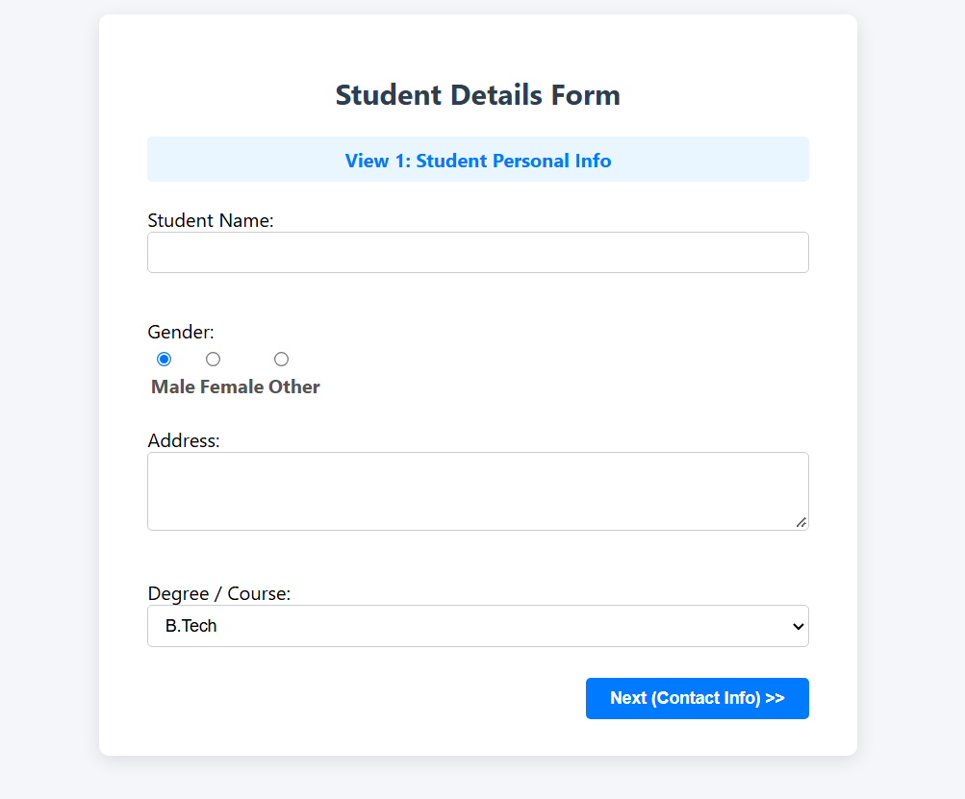

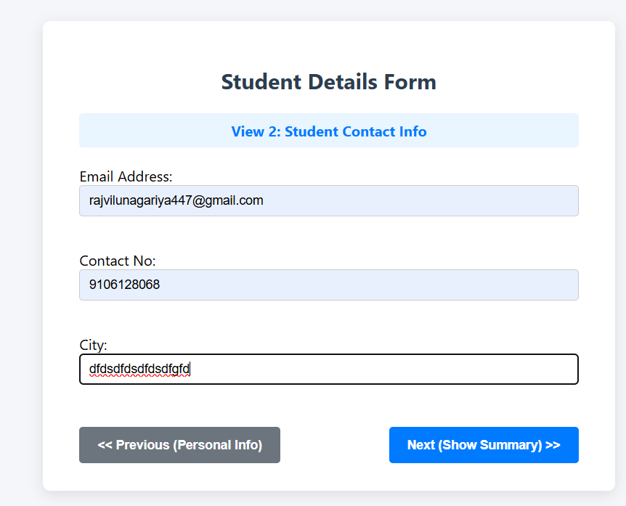
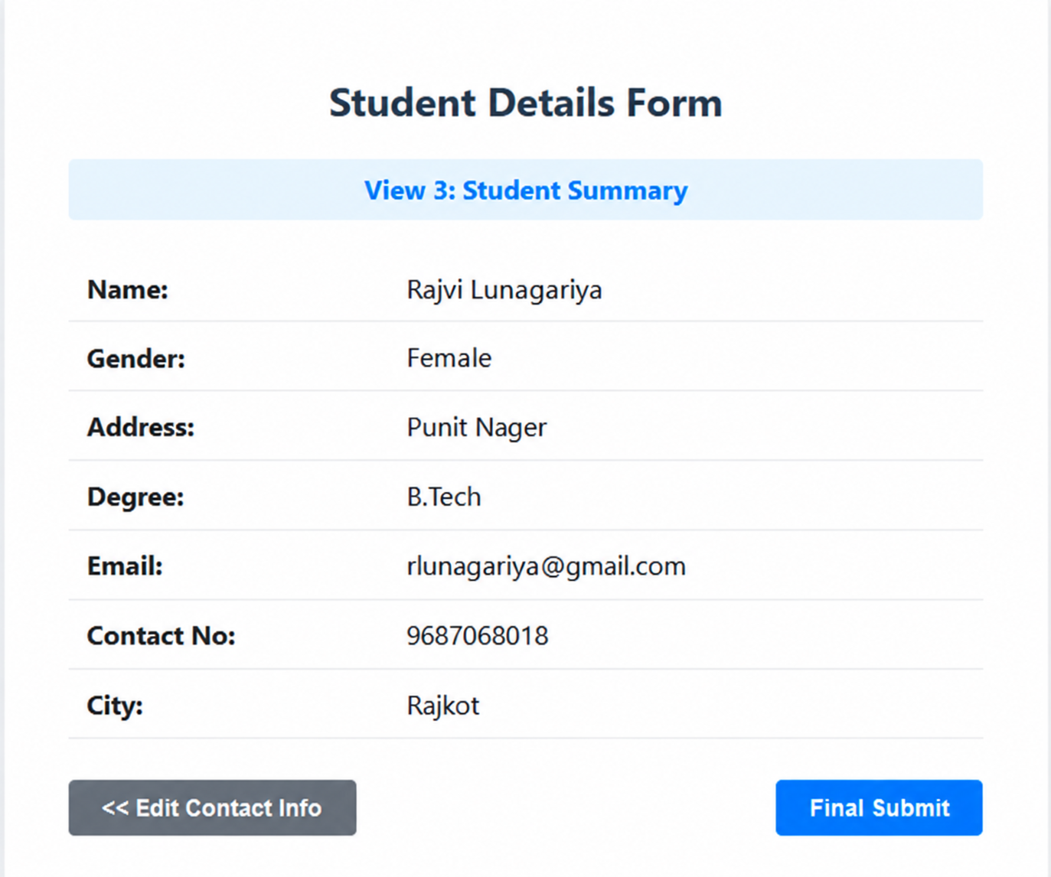

2. Design a registration form using different validation controls.

Demo.aspx Code

<%@ Page Language="C#" AutoEventWireup="true"
CodeBehind="WebForm1.aspx.cs"
Inherits="class_projecct_2.WebForm1" %>

<!DOCTYPE html>

<html xmlns="http://www.w3.org/1999/xhtml">

<head runat="server">
<title>Registration Form</title>

<style>
body {
font-family: Arial;
font-size: large;
margin: 40px;
}

.form-box {
width: 700px;
}

.row {
margin-bottom: 18px;
}

.label {
display: inline-block;
width: 180px;
}

.textbox {
width: 250px;
height: 25px;
}

.button {
padding: 8px 25px;
font-size: large;
}
</style>
</head>

<body>

<form id="form1" runat="server">

<div class="form-box">

<h2>Registration Form</h2>

<!-- NAME -->

<div class="row">

<asp:Label
ID="Label1"
runat="server"
Text="Name:"
CssClass="label">
</asp:Label>

<asp:TextBox
ID="name"
runat="server"
CssClass="textbox">
</asp:TextBox>

<asp:RequiredFieldValidator
ID="RequiredFieldValidator1"
runat="server"
ControlToValidate="name"
ErrorMessage=" Enter name"
ForeColor="Red">
</asp:RequiredFieldValidator>

</div>

<!-- PASSWORD -->

<div class="row">

<asp:Label
ID="Label2"
runat="server"
Text="Password:"
CssClass="label">
</asp:Label>

<asp:TextBox
ID="pass"
runat="server"
TextMode="Password"
CssClass="textbox">
</asp:TextBox>

<asp:RequiredFieldValidator
ID="RequiredFieldValidator2"
runat="server"
ControlToValidate="pass"
ErrorMessage=" Enter password"
ForeColor="Red">
</asp:RequiredFieldValidator>

</div>

<!-- CONFIRM PASSWORD -->

<div class="row">

<asp:Label
ID="Label6"
runat="server"
Text="Confirm Password:"
CssClass="label">
</asp:Label>

<asp:TextBox
ID="confrim"
runat="server"
TextMode="Password"
CssClass="textbox">
</asp:TextBox>

<asp:CompareValidator
ID="CompareValidator1"
runat="server"
ControlToCompare="pass"
ControlToValidate="confrim"
ErrorMessage=" Password does not match"
ForeColor="Red">
</asp:CompareValidator>

</div>

<!-- AGE -->

<div class="row">

<asp:Label
ID="Label3"
runat="server"
Text="Age:"
CssClass="label">
</asp:Label>

<asp:TextBox
ID="age"
runat="server"
CssClass="textbox">
</asp:TextBox>

<asp:RangeValidator
ID="RangeValidator1"
runat="server"
ControlToValidate="age"
MinimumValue="18"
MaximumValue="100"
Type="Integer"
ErrorMessage=" Enter age between 18 and 100"
ForeColor="Red">
</asp:RangeValidator>

</div>

<!-- EMAIL -->

<div class="row">

<asp:Label
ID="Label4"
runat="server"
Text="Email:"
CssClass="label">
</asp:Label>

<asp:TextBox
ID="email"
runat="server"
CssClass="textbox">
</asp:TextBox>

<asp:RequiredFieldValidator
ID="RequiredEmailValidator"
runat="server"
ControlToValidate="email"
ErrorMessage=" Enter email"
ForeColor="Red">
</asp:RequiredFieldValidator>

<asp:RegularExpressionValidator
ID="RegularExpressionValidator2"
runat="server"
ControlToValidate="email"
ErrorMessage=" Enter valid email"
ForeColor="Red"
ValidationExpression="\w+([-+.']\w+)*@\w+([-.]\w+)*\.\w+([-.]\w+)*">
</asp:RegularExpressionValidator>

</div>

<!-- CONTACT -->

<div class="row">

<asp:Label
ID="Label5"
runat="server"
Text="Contact No:"
CssClass="label">
</asp:Label>

<asp:TextBox
ID="contact"
runat="server"
CssClass="textbox">
</asp:TextBox>

<asp:RequiredFieldValidator
ID="RequiredContactValidator"
runat="server"
ControlToValidate="contact"
ErrorMessage=" Enter contact number"
ForeColor="Red">
</asp:RequiredFieldValidator>

<asp:RegularExpressionValidator
ID="RegularExpressionValidator1"
runat="server"
ControlToValidate="contact"
ErrorMessage=" Enter 10 digit number"
ForeColor="Red"
ValidationExpression="^[0-9]{10}$">
</asp:RegularExpressionValidator>

</div>

<!-- REGISTER BUTTON -->

<div class="row">

<asp:Button
ID="btn_reg"
runat="server"

</html>
Text="Register"
CssClass="button"
OnClick="btn_reg_Click" />

</div>

</div>

</form>

</body>

Demo.aspx.cs Code

using System;
using System.Data.SqlClient;
using System.Web.UI;
using System.Web.UI.WebControls;

namespace class_projecct_2
{
public partial class WebForm1 : System.Web.UI.Page
{
protected void Page_Load(object sender, EventArgs e)
{
}

protected void name_TextChanged(object sender, EventArgs e)
{
}

protected void btn_reg_Click(object sender, EventArgs e)
{
if (Page.IsValid)
{
string ConnectionString =
@"Data Source=(LocalDB)\MSSQLLocalDB;AttachDbFilename=D:\.net Project\class_projecct-2\App_Data\Database1.mdf;Integrated Security=True";

SqlConnection con = new SqlConnection(ConnectionString);

try
{
// Save password values BEFORE database operation
string password = pass.Text;
string confirmPassword = confrim.Text;

string Query = @"
INSERT INTO Register
(Name, Email, Password, [Confirm Password], Age, [Contact No])
VALUES
(@Name, @Email, @Pass, @confirm, @age, @contact)";

SqlCommand cmd = new SqlCommand(Query, con);

cmd.Parameters.AddWithValue("@Name", name.Text);
cmd.Parameters.AddWithValue("@Email", email.Text);
cmd.Parameters.AddWithValue("@Pass", password);
cmd.Parameters.AddWithValue("@Confirm Password", confirmPassword);
cmd.Parameters.AddWithValue("@age", age.Text);
cmd.Parameters.AddWithValue("@contact", contact.Text);

con.Open();

int result = cmd.ExecuteNonQuery();

if (result > 0)
{
pass.Attributes["value"] = password;
confrim.Attributes["value"] = confirmPassword;

Response.Write(
"<script>alert('Registered Successfully');</script>"
);
}
}
catch (Exception ex)
{
Response.Write(
"<script>alert('" +
ex.Message.Replace("'", "\\'") +
"');</script>"
);
}
finally
{
if (con.State == System.Data.ConnectionState.Open)
{
con.Close();
}
}
}
}
}
}

Output Screenshot:

