30018755 Scripting Final Project

Robert Jacobs

Robert.inc

30018755 Scripting Final Project

Scripting Final Project AT 2.1

# Table of Contents

Table of Contents

Project Requirements 1

Library Code Requirements 2

Testing Requirements 4

Bibliography 5

Bibliography 5

## Project Requirements

This documentation is to outline the Development Process of an application that monitors the condition of an environment (temp and humidity), displays the results provided by the sensors, give user feedback depending on the measurements of the data and display a mood light.

The Prototype will use a Leonardo Arduino hardware facilitated by the Arduino Language and IDE along side the .NET Framework using Forms facilitated by the C# computer Language.

#### What is the .NET framework?

The .NET framework is a collection of different tools, programming languages and libraries that allows developers to produce high quality applications, websites and services. It is created and supported by Microsoft and includes Visual Studios which is the IDE I will be using for this project. (Glenn, 2017)

#### What is the Arduino IDE?

The Arduino IDE is a Integrated Development Environment that allows developers to write, validate and upload simple code to Arduino modules (the hardware) in order to perform tasks using the different sections of the Arduino hardware. (Aqeel, 2018)

Arduinos have many inputs (temp sensors, light sensors, humidity sensors, buttons) and outputs (lights, buzzer) that can be defined and coded using the Arduino IDE. Arduino also supports C# and can interact directly with Visual Studios (it is more accurate to say that Visual Studios contains a library that allows C# to interact with Arduino). (Aqeel, 2018)

Below is an initial prototype for the visual layout of the application.

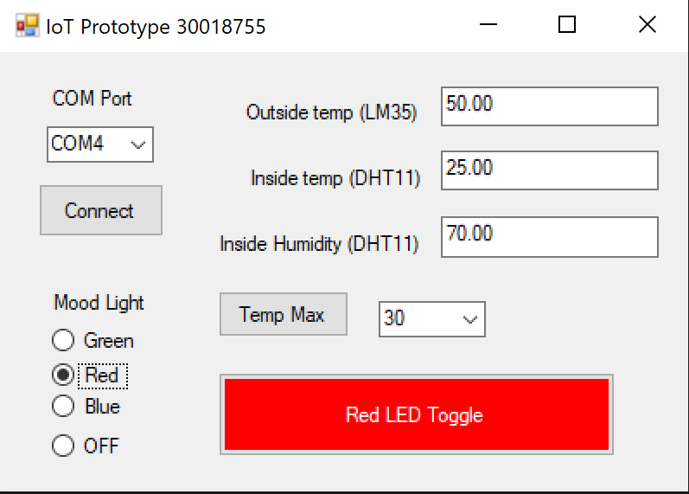

## Library Code Requirements

#### Introduction

This section will outline the different libraries, function, licensing issues as well as details on how the libraries and languages interact with each other.

#### C# - Visual Studios



The System Library is the fundamental parts of the C# language such as the most basic methods including arrays, strings ect.

The IO.Ports Library allows your code to interact with the Arduino via a port (e.g. COM5) to send and receive data to display in the forms.

The Windows.Forms allows for the end user GUI experience. This includes all the buttons, text boxes and backend functionality in regards to everything the user sees when the program is running.

All the libraries are implemented by ticking the relevant referances, downloading the correct external libraries and using the “using” syntax to import the library into your code.

Although Microsoft created, supports and owns the Visual Studios IDE that license and copyright only applies to the visual studios application itself. If you develop, test and publish your own code using this IDE then the developers get to choose to make it open source or charge different licenses.

#### Arduino – Arduino IDE

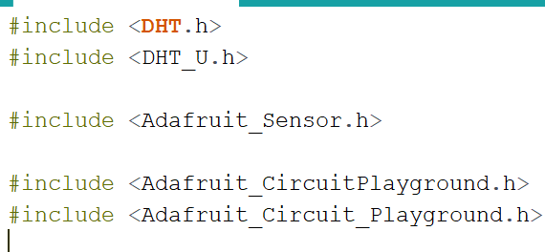

The DHT Library allows the Arduino to use the DHT11 sensor to measure the temperature and Humidity of the environment that the hardware is placed in. It also allows for that data to be presented in the Serial Monitor of the Arduino IDE.

The Adafruit Sensor Library allows the Arduino to use the LM35 Temperature sensor to measure the current temp of the surrounding area the hardware is placed in. It also allows the data to be printed inside the Serial Monitor of the Arduino IDE.

The Adafruit Circuit Playgrounds add extra methods and functionality to allow the developer to use more pieces of the hardware on the Arduino board.

The libraries are obtained by downloading them from trusted sites and adding the .zip file into the IDE itself while clicking the applicable menus to add the library to the code itself.

There are no licensing issues in regards to publishing Arduino code since your code will be open source. The Arduino IDE is also free to download.

The communication between the two IDE’s are as a result of the port used in the Arduino. Inside the C# code there must be a port number defined which represents the hardware you wish to connect to. This port is also used for the Serial Monitor so as a result only 1 can be used at a time (Visual Studio / Serial Monitor). Once the connection is established any data that would be printed on the Serial Monitor will be instead sent over to Visual Studios to be manipulated and printed into the various Forms Functionality.

These Arduino codes were chosen because they coincide with what is available on the Arduino Hardware that is being used for the prototype. The alternatives of the libraries are directly dependant on the alternatives of the hardware. The DHT library only works for DHT sensors. The SHT1X Sensor Requires the SHT Library as a perfect example.

The major characteristics of the Arduino Language is the fact that it is based on C and therefore shares a lot of syntax with C#. It does not have as much functionality as C# or C and therefore can only perform simple methods and loops.

## Testing Requirements

#### The Iterative SDLC

. The Iterative SDLC is a methodology that allows for changes to be made mid development and is considered a lot less risky than other methodologies such as waterfall. While the Waterfall method only allows for a single pass of each step of development the Iterative Model allows for multiple passes at designing, coding, testing and implementation while having a single pass at the initial process and the end deployment. This is the better SDLC for larger projects since the client may have new ideas for functionality or errors can be more easily handled. (Altervater, 2020)

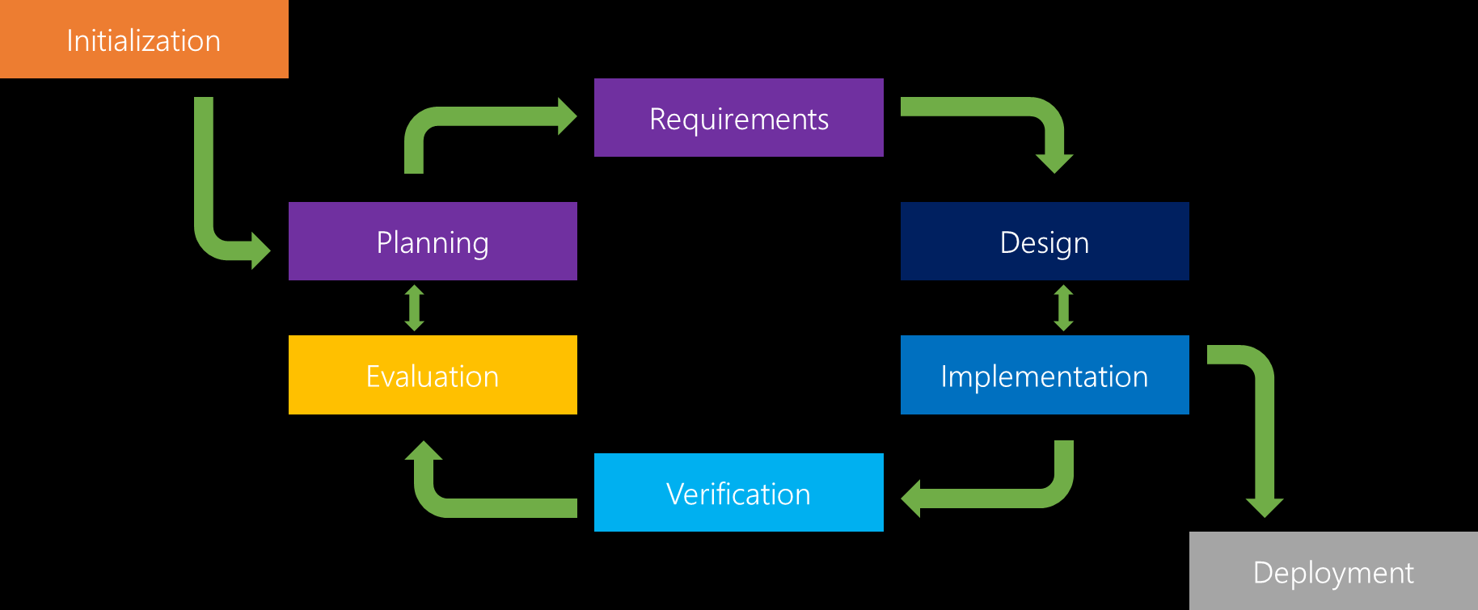

(Iterative Model: What Is It And When Should You Use It?, 2016)

#### Testing Methodology

I believe that White Box Testing would be the most appropriate for this project since the GUI side of things are quite simple and an issues would be easy to notice while testing the back end code. The logic behind the Forms are the most important in this project especially since two languages are being used.

WhiteBox Testing covers 3 main parts of the testing. Statement Coverage (Examines the programming statements), Branch Coverage( Series of tests ensuring that all branches are tested) and Path Coverage (Tests all possible paths to cover the previous two). (Software Development And Testing Methodologies (With Pros And Cons), 2020)

The Testing will be conducted for half a day after each version of the prototype is completed and ready for testing. The testing does not need to be very time consuming and extensive until the last pass since different functionality will be added to it over time.

## Bibliography

# Bibliography

Altervater, A. (2020, Apr 8). *What Is SDLC? Understand the Software Development Life Cycle*. Retrieved from stackify.com: https://stackify.com/what-is-sdlc/

Aqeel, A. (2018, Oct 3). *Introduction to Arduino IDE*. Retrieved from theengineeringprojects.com: https://www.theengineeringprojects.com/2018/10/introduction-to-arduino-ide.html

Glenn, W. (2017, Jul 10). *What Is the Microsoft .NET Framework, and Why Is It Installed on My PC?* Retrieved from howtogeek.com: https://www.howtogeek.com/253588/what-is-the-microsoft-net-framework-and-why-is-it-installed-on-my-pc/

Half, R. (2019, May 24). *6 Basic SDLC Methodologies: Which One is Best?* Retrieved from roberthalf.com: https://www.roberthalf.com/blog/salaries-and-skills/6-basic-sdlc-methodologies-which-one-is-best

*Iterative Model: What Is It And When Should You Use It?* (2016, Dec 15). Retrieved from airbrake.io: https://airbrake.io/blog/sdlc/iterative-model

Parsons, J. (2016, August 08). *Is It Possible to Switch Back to The Old Facebook Page Layout?* Retrieved from boostlikes.com: https://boostlikes.com/blog/2016/08/switch-old-facebook-layout

*Software Development And Testing Methodologies (With Pros And Cons)*. (2020, Nov 13). Retrieved from softwaretestinghelp: https://www.softwaretestinghelp.com/software-development-testing-methodologies/

Software Test Help. (2020, August 02). *Spiral Model – What Is SDLC Spiral Model?* Retrieved from softwaretestinghelp.com: https://www.softwaretestinghelp.com/spiral-model-what-is-sdlc-spiral-model/

Software Testing Help. (2020, August 2). *SDLC (Software Development Life Cycle) Phases, Methodologies, Process, And Models*. Retrieved from softwaretestinghelp.com: https://www.softwaretestinghelp.com/software-development-life-cycle-sdlc/

Software Testing Help. (2020, August 02). *What Is SDLC Waterfall Model?* Retrieved from softwaretestinghelp: https://www.softwaretestinghelp.com/what-is-sdlc-waterfall-model/