Assignment 3 – Marketing Analytics

# Introduction

Tesco’s is one of the largest supermarkets in the UK who sell a wide variety of goods, from Groceries to home goods and even apparel. Tesco’s also has a wide variety in its customers from Budget customers who value the reasonable prices to high end customers who value the premium products and convenience of Tesco’s many stores.

When designing a marketing campaign, it is importance to consider that different customers will have different priorities for the goods that they choose to purchase, and so different campaigns should be sent out to different customer segments; for example, Customers who purchase premium goods will likely be uninterested in discounts on budget foods. Sending the wrong promotions to the wrong customer base can irritate customers significantly and in the worst case can encourage customers to shop at competitors. Keating highlights the benefits of targeted advertising to companies, listing: “More efficient Campaign development, More effective use of advertising resources, Better use of you advertising dollar, and Increased return on Investment.” (Ereach, 2017) As the supermarket business is highly competitive, Tesco should be very careful to make sure that its promotions are going to the right customer base.

# Methodology

For the task that has been given, there are two main tasks involved. Full explanations of how the analysis was performed is below.

* Task 1: Involving assigning customers to 1 of 4 clusters that will group customer with similar preferences based on their answers to the survey; this will be performed using IBM SPSS Modeler 17.
* Task 2: Involving splitting customers into the 4 clusters generated in Task 1 and discovering the CLV (Customer Lifetime Value) and Total Segment Value for each cluster; this will be performed using Microsoft Excel.

## Task 1

In order to create customer clusters for Tesco, SPSS modeller was used to analyse the sample data that was provided.

Firstly, the data was imported into SPSS using the file import node. Then the data was ran through a “Type” node, in order to filter out all the spending data and classify the survey data as continuous data.

The filtered data was then analysed with a K Means module that created a Model “K Means 1” that clustered the data. These clusters are shown in *Graph 1 – “Cluster Sizes”* and the performance of the model is shown in *Figure 1 – “K-Means Clustering Model Performance”*.

The clusters were then run through another “Type” Node in order to classify the newly generated cluster variable. After briefly checking that the distribution of the clusters was fairly equal; the data was exported into excel format in order to calculate CLV and Total Segment Value.

## Task 2

To calculate the CLV of each segment, we first had to determine a couple of statistics. Firstly we had to find the retention rate of each segment by counting how many customers in each cluster bought from 1 section and then bought from the same section again the next year. I then took an average of these retention rates and used these as the retention rate for the cluster.

To calculate the margin for each cluster I first averaged every customers spending over the two observation periods. I then took an average of every customer’s spending in each cluster, before then multiplying this with the margin percentages supplied in the case study to find the average margin per cluster.

Finally I used these (cluster) statistics in the following formula to calculate CLV for each cluster:

$$CLV=Average Margin* \frac{Retention rate}{1∓Discount rate-Retention Rate}$$

Obtaining the CLV for each cluster enabled me to then find the Total Segment Value for each cluster using the following formula:

$$TSV= CLV * Average Number of Retaining Customers$$

# Analysis Findings

## Task 3

Analyse and interpret your findings from Tasks 1 and 2

Hint: Start by identifying appropriate labels for the four customer segments created in Task 1. Use “Cells show relative distribution” tab under “View: Clusters” option of your K-Means model nugget to interpret your customer segments.

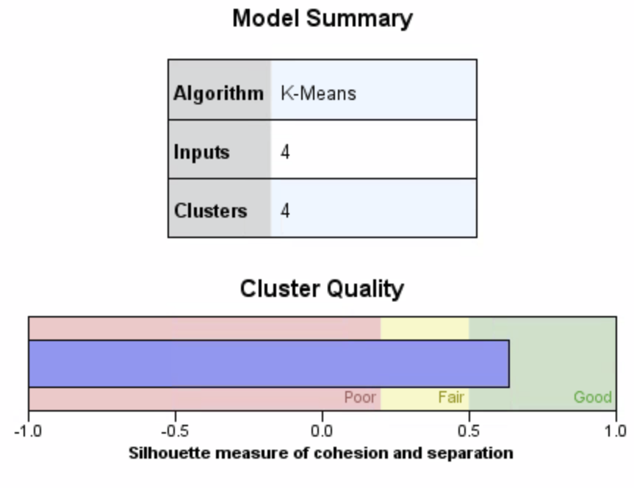

Figure – “K-Means Clustering Model Performance”

*Figure 1 – “K-Means Clustering Model Performance”* shows the performance of the clustering model and how well the clusters fit the data. The clusters have an average silhouette of 0.6 which is a good fit for the data.

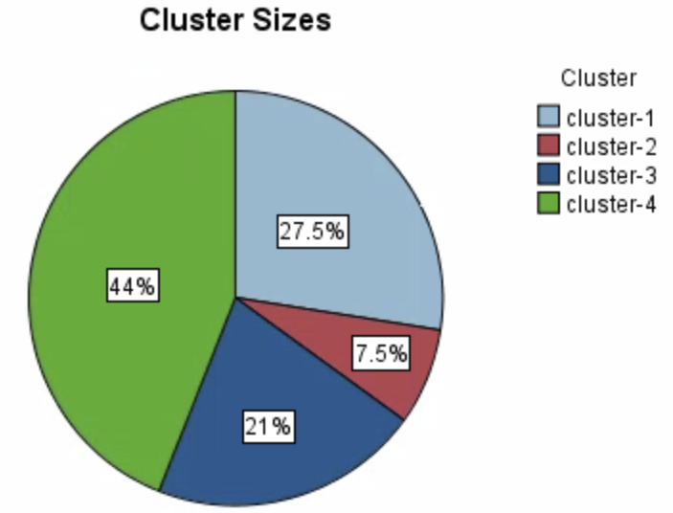

Graph – “Cluster Sizes”

Graph 1 – “Cluster Sizes” shows the size of each of the clusters. Cluster 4 is clearly the largest cluster at 44%, with the rest of the customers being split mainly into clusters 1 + 3 and a minority in Cluster 2.

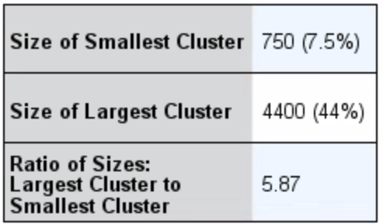

Table – “Clusters Statistics”

|  |  |  |  |
| --- | --- | --- | --- |
| Cluster | Size of  Population | CLV | Total Segment Value |
| 1 | 27.5% | $ 258.03 | $ 327,186.39 |
| 2 | 7.5% | $ 296.75 | $ 99,104.54 |
| 3 | 21% | $ 254.99 | $ 245,296.46 |
| 4 | 44% | $ 270.75 | $ 568,029.54 |

Table 2 – “Cluster Table”

*Table 2 – “Cluster Table”* shows the CLV and Total Segment Value for each cluster. Each cluster has pretty similar Customer Lifetime Values and the Total Segment Value appears to be largely based on the size of each cluster as opposed to any clusters contributing more per customer. Interestingly Cluster 2 has the highest CLV, whereas Cluster 3 has the lowest.

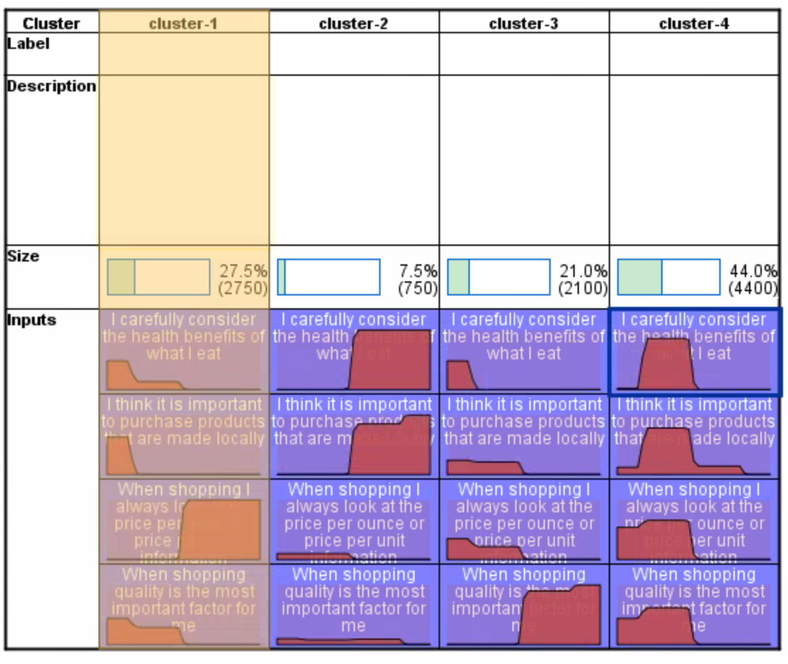

Table – “Relative Distributions of Customer Preferences”

|  |  |  |
| --- | --- | --- |
| Cluster | Priorities | Suggested Marketing Plan |
| Cluster 1 | Does not care about health benefits or local products, only really fussed about the price of products | Advertise cheap products and discounts on midrange products |
| Cluster 2 | Prefers "high quality" products and willing to pay more for them | Don’t offer any discounts instead focus advertising on quality, local premium goods |
| Cluster 3 | Does not care about health benefits or local products, only really fussed about the shopping experience | Offer discounts to improve the shopping experience, e.g. free shipping for online shopping or personal shopping plans |
| Cluster 4 | No real priorities | Use generic marketing plan. |

Table 4 – “Cluster Attributes”

Table 3 shows the relative distributions of survey respondent’s preferences in each cluster. This information has then been analysed to create the general insights shown in *Table 4 – “Cluster Attributes”*. Further analysis of each cluster follows below.

Overall the clustering was largely successful, as the silhouette measure indicates strong model performance and Clusters 1, 2 and 3 are clearly different customer segments that can easily be targeted individually. The only failing of the clustering was in identifying what the priorities are for Cluster 4; as this is the largest Cluster, (and thus the cluster with the greatest Total Segment Value).

# Recommendations

The design of the survey questions enables customers to convey their preferences for how they like to shop as shown in *Table 3 – “Relative Distributions of Customer Preferences”* and this information has been used to cluster the customers together. *Table 4 – “Cluster Attributes”* shows each of the clusters and the general customer profile that fits. Deeper explanations of the characteristics of each of the segments follow, along with recommendations for Tesco to use this information to maximise revenue / profit from each cluster, primarily through its marketing efforts.

Cluster 1 has highest scores / most customers prioritise price and appear to not care about health benefits or whether products are locally sourced. This group is likely composed of low income customers who aim to shop on a budget; therefore these customers will likely react and buy cheap products or those that have decent discounts. As the (assumed) general cost of the goods bought is quite low, Tesco can afford to offer fairly significant discounts to its budget goods without worrying about losing a significant source of revenue. Doing so would likely have a good effect on this segment due to their focus on prices. However this customer segment only makes up 7.5% of the customer base and so has the lowest Total Segment Value.

For Cluster 2, most customers place a high priority on Healthy and Local food, with very low priorities for price per unit and an average priority for experience. It could be assumed that the normal customer for this segment has a high income and is willing to pay more for better “quality” goods. Therefore when marketing to this sector, Tesco should focus on highlighting the health benefits and local sources of its most expensive / profitable premium products. Tesco should also likely hold off on offering any discounts as this cluster are not that influenced by price. As Cluster 2 has the highest CLV, Tesco should aim to grow the Cluster size and encourage more premium customers to shop at Tescos as they offer the most value to the company. Tescos could do this by expanding its selection of premium items or by targeting its marketing to potential customers who have high incomes or care about premium product details such as gluten-free, vegan-friendly, locally sourced etc.

Cluster 3 is fairly similar to Cluster 1 but with some slight differences. Again the cluster does not carer about healthy products from local sources and has little concern for prices; however shopping experience is of high importance. Tesco should aim to improve the shopping experience for these customers as this would encourage them to shop at Tesco’s. One of the determinants of shopping experience for supermarkets is convenience; in order to improve this Tesco should look to potentially expand the number of open checkouts / self service checkouts, look to reduce the cost of shipping online shopping orders, or even offering free shipping to those in Cluster 3. Tesco’s could also partner with a third party to offer discounts on personal shoppers to help make shopping even easier.

Cluster 4 has no real priorities, expressing equal preference to each variable. Tesco should likely use its generic marketing plan with this customer group as customers have no clear priority and it would be difficult to pick a strategy that would benefit the entire sector. The best likely plan would be to offer medium sized discounts on most products and correlate purchases of these goods with the Customer ID’s of customers in this group (which would be identified with the club-card). If there are any significant correlations in the future it may be possible to perform more analysis and gain a better understanding of this customer segment. As this segment is the largest cluster, it would be worthwhile trying to understand the segment’s priorities more.

Overall the most important recommendation is for Tesco’s to split up its marketing efforts into 4 different campaigns which uniquely target each of the 4 clusters identified above. Targeted marketing tends to have a greater response / success rate that blanket / one-size-fits-all marketing and tuning the promotions offer to each customer base can help customer discover products and deals which interest them the most, ultimately resulting in more purchase and therefore greater revenues / profits for Tescos.