**JOB APPLICATION TRACKING SYSTEM**

**INTRODUCTION**

An applicant tracking system (ATS) is software for recruiters and employers to track candidates throughout the recruiting and hiring process.

**PURPOSE AND BENEFITS**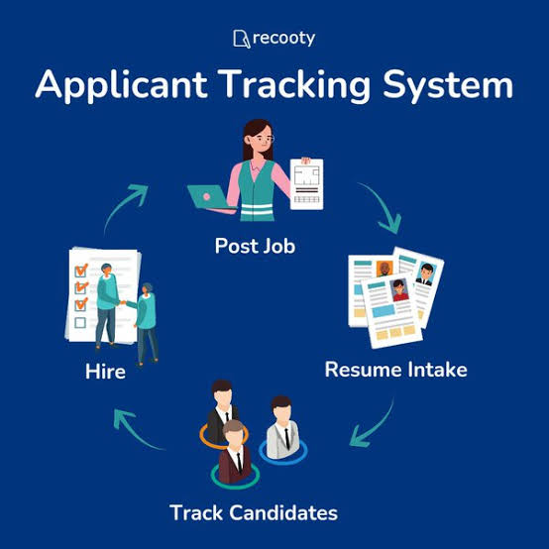

Purpose :

* Automatically shortlist suitable candidates.
* Gathers all applicant’s data & info in one place.
* Assist with scheduling interviews.
* Integrates career sites, job boards, and social media so that you post jobs with a few clicks.

Benefits :

* Saves time.
* Boost communication with all candidates.
* Stores all information related to hiring in one place.
* AI-enabled resume screening assists with hectic tasks.
* Provides data and insights into hiring metrics, such as time-to-hire, cost-per-hire, and candidate sources.

**PROBLEM DEFINITION & DESIGN THINKING**

1. **Empathy map**



1. 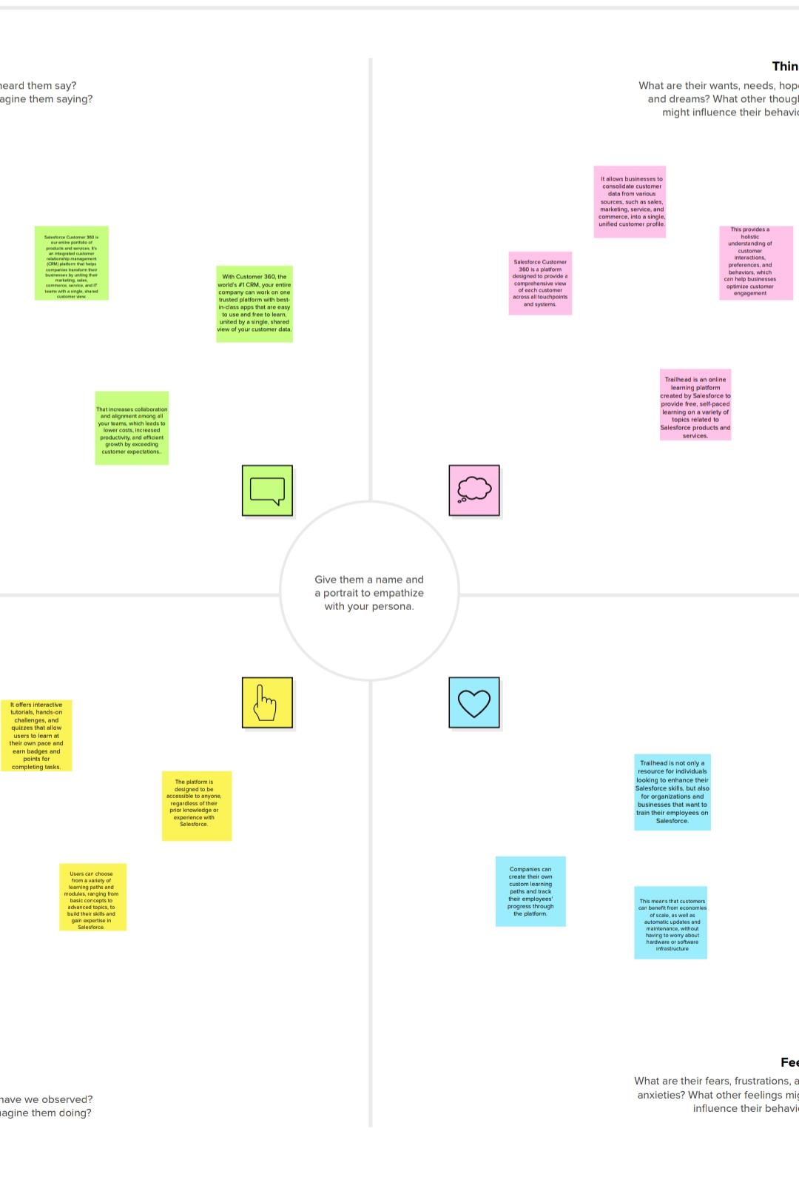**Ideation & brainstorming**

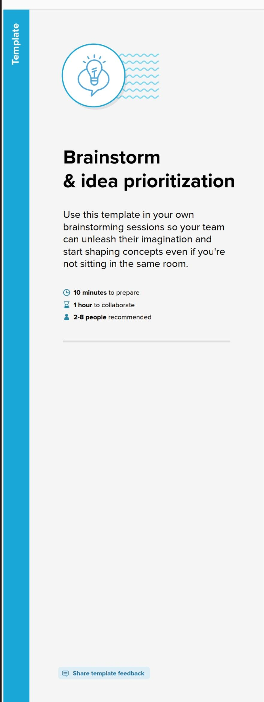

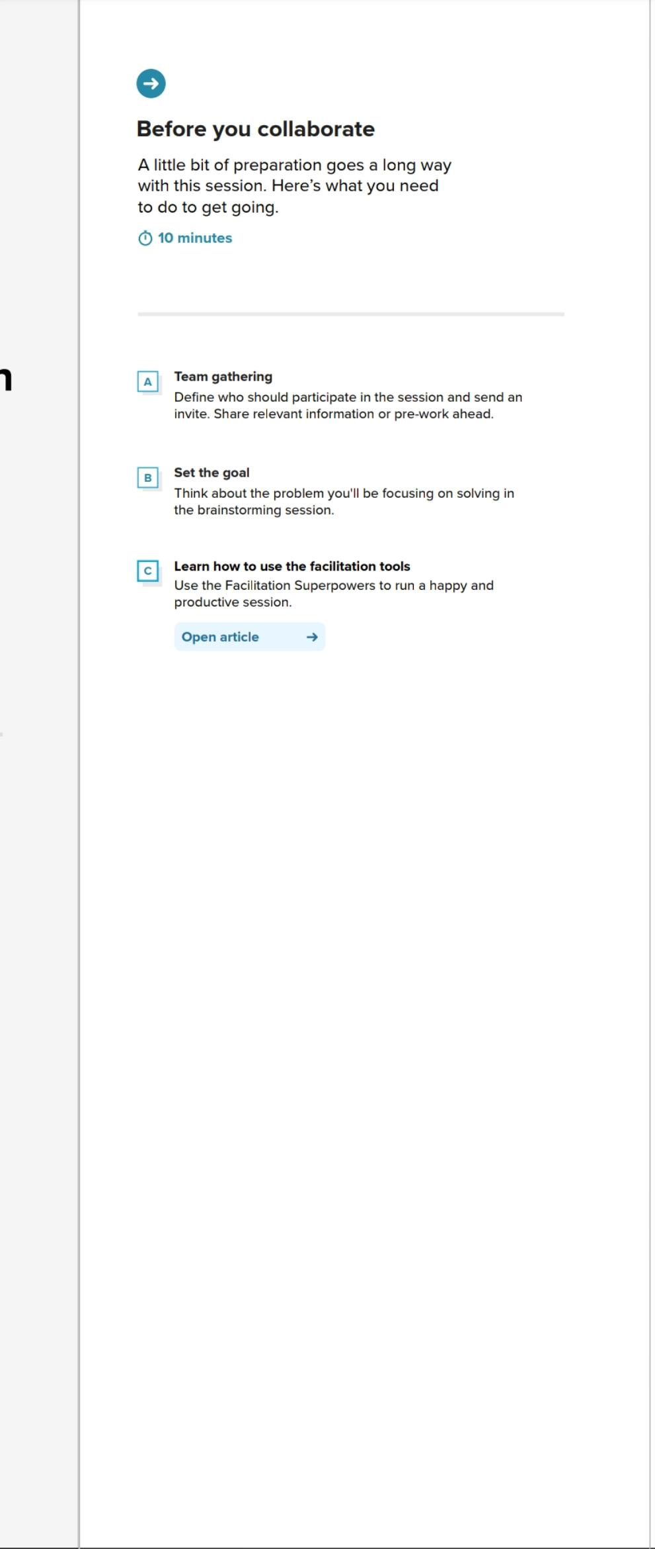



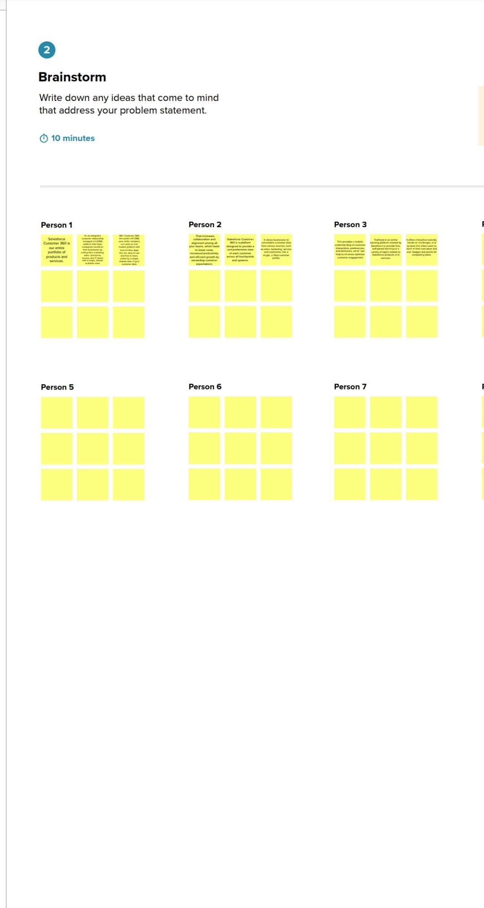



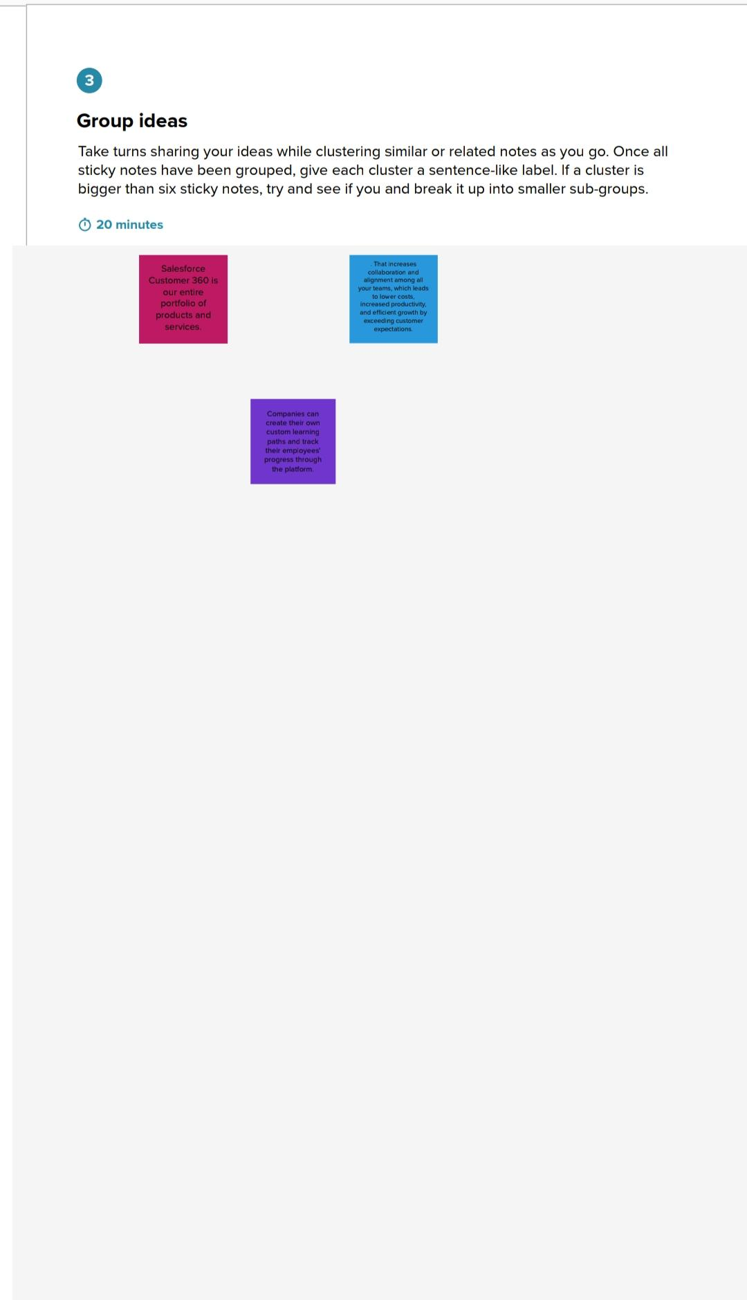

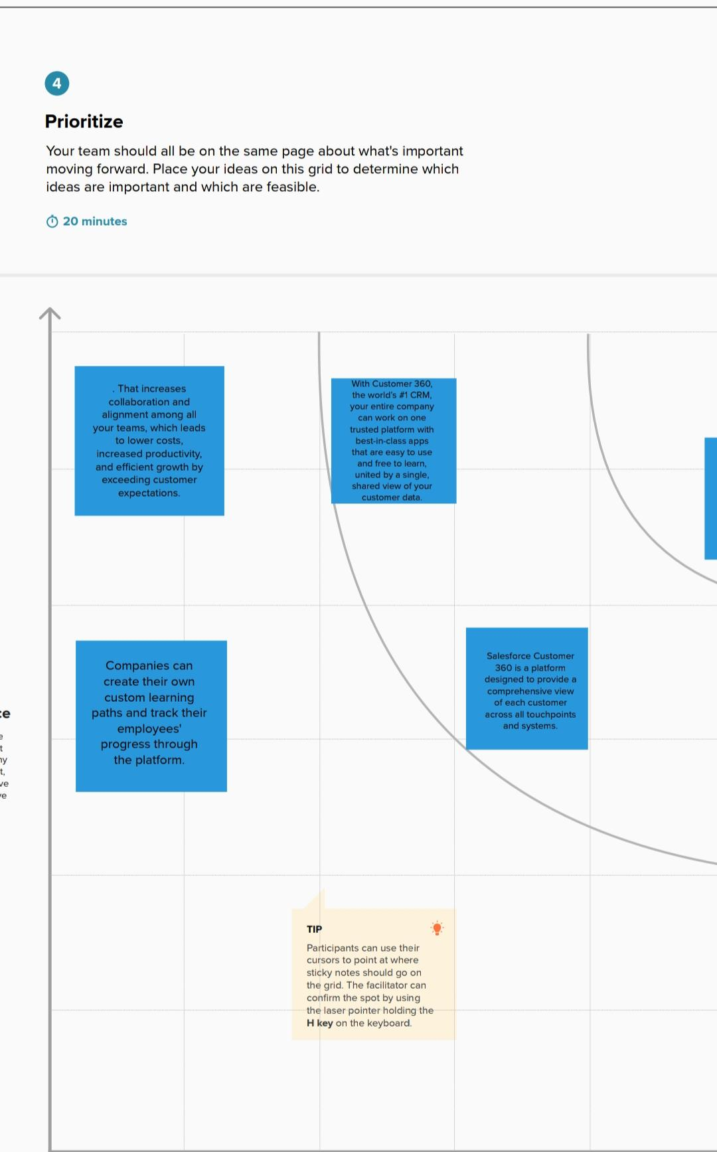

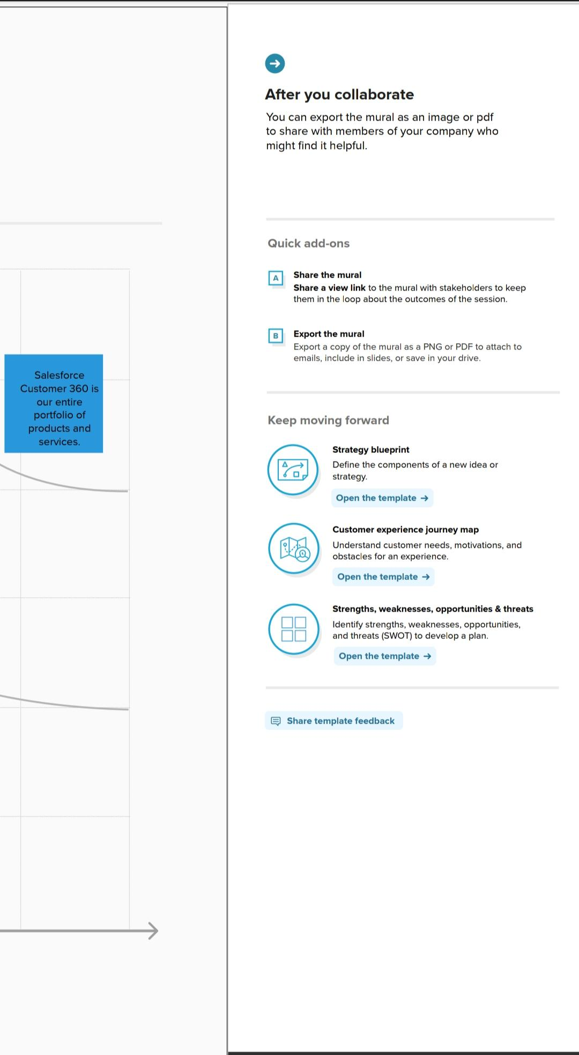

**ADVANTAGES AND DISADVANTAGES**

**Pros :**

* Reduces time spent on admin tasks. ATS software allows you to automate various tasks of the hiring process that can save you a lot of time and free up your recruiting personnel for other high-value tasks. Posting to multiple job boards, tracking candidate applications, notifying candidates individually, and scheduling interview feedback can all be automated. Not only will it speed up the time it takes to do all of those tasks, it will increase the overall quality through standardization.
* Resume and CV screening. With recruiters receiving 100s of resumes per role, even scanning can take a lot of time. ATS software can be utilized to review applications and filter out candidates that don’t meet the minimum requirements of the role. So, the number of resumes a recruiter needs to review can be reduced drastically using pre-screening questions or word searches within resumes. Once again, a recruiter’s time can be redirected to higher value items of the business.

Cons :

* Could filter out good candidates. When “programming” your recruiting software to recognize common keywords around roles and responsibilities, you could end up filtering out good candidates that have atypical experience or lack keywords that are aligned with what you are looking for. Careful consideration of your filters and a quality assurance process will help to fine tune the filter and reduce filtering out good candidates. This can happen with manual reviews as well, so automation, in most situations, has a net benefit.
* Communications can be less personalized. When automating responses to candidates, your messaging will be less personalized and can come off as robotic. Taking additional time to construct good communication can help make it feel more personalized. It’s much better to send a less personalized communication than no communication at all.

TRAILHEAD PROFILE PUBLIC URL

Team leader :

https://trailblazer.me/id/mugesh02

Team member 1 :

https://trailblazer.me/id/abi07

Team member 2 :

https://trailblazer.me/id/visa22

Team member 3 :

https://trailblazer.me/id/muthu02

CONCLUSION

An applicant tracking system is a valuable tool for any business looking to streamline its hiring process. It can help businesses save time and money by allowing them to quickly review resumes, source candidates, and manage job postings with minimal effort.