- Title of your project.
Adam Gorman’s Video Game Database
- Outline of what your project does.
I wanted to create a database that would keep several games high scores and their respective names. I would have some queries that could generate a hall of fame for all games and players in different methods.
Would probably have quite a few games, some high scores, date of submissions, names, teams, and various queries for winners and whatever else I need to throw together to keep it a solid 4 tables. There should be 4 tables as follows: players, games, gamehighscores, and teams

- ER Diagram.
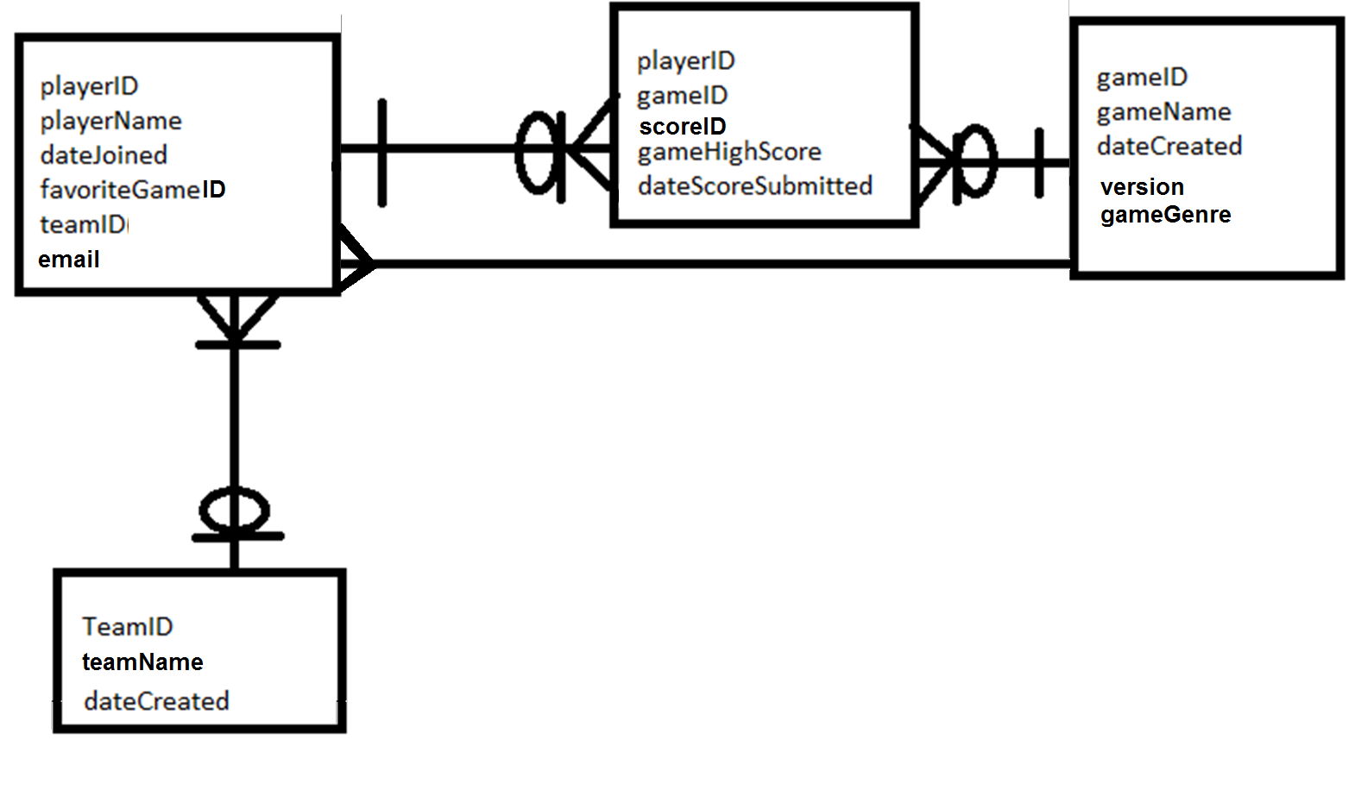
- Table schemas.
Game (gameID, gameName, version, gameGenre, dateCreated)
GameScore (playerID, gameID, scoreID, highScore, dateScoreSubmitted)
Player (playerID, playerName, dateJoined, favoriteGameID, teamID, email)
Team (teamID, teamName, dateCreated)
- An explanation demonstrating that the tables are normalized.

1NF: All attributes are atomic and have no repeated attributes.
2NF: Game, Player, GameScore I know are whole key dependent
3NF: There are no real transitive dependencies
4NF: The only multivalued dependencies I have are located in my GameScore intersection table, so my tables are compliant with 4N. GameScore intersection table are compliant with 4NF. (All intersection/association tables have a multivalued dependency).
BCNF: I feel decently confident that it meets BCNF as well,

Each table only has a single theme or a single type of object, there also appears to not contain any non key dependencies.

- DDL to create the tables.

CREATE TABLE Game (
gameID INT NOT NULL AUTO_INCREMENT,
gameName CHAR(20) NOT NULL,
dateCreated DATETIME,
version INT,
gameGenre INT,
PRIMARY KEY( gameID)
);
CREATE TABLE GameScore (
playerID INT,
gameID INT,
gameScoreID INT NOT NULL AUTO_INCREMENT,
highScore INT,
dateScoreSubmitted DATETIME,
PRIMARY KEY( playerID, gameID, gameScoreID),
FOREIGN KEY(playerID, gameID) REFERENCES Player(playerID), Game(gameID)
);
CREATE TABLE Player (
playerID INT NOT NULL AUTO_INCREMENT,
playerName CHAR(20) NOT NULL,
dateJoined DATETIME,
favoriteGame INT,
teamID INT,
email CHAR(30),
PRIMARY KEY(playerID),
FOREIGN KEY(teamID) REFERENCES Team(teamID)
);
CREATE TABLE Team (
teamID INT NOT NULL AUTO_INCREMENT,
teamName CHAR(20) NOT NULL,
dateCreated DATETIME,
PRIMARY KEY( teamID)
);
I added the foreign keys and references statements after the fact and have not been tested, no longer have access to the database/ssh for the day, I think I put them in there correctly but I wasn’t sure? They weren’t part of my original query design :/

- List the queries for interacting with the database.
- Instructions for using the system. For the Manual Query Method, this will make up your user interface.
- Screen shots (printouts) of the user interface.
- Samples of reports.
(For the Manual Query Method, items 7 through 10 can be combined).
I have combined the above 4 items. Each block has an example query for interacting with the database, often showing

Included examples of queries you can do with the database, just follow the examples:

Add new
Team, Game, Player, HighScore
Update
playerName
Remove
highScore
Count
Number of players
Top ##
Top 10 players, top 10 scores.
Most
Most favorited game, Most played game
View
Player count per team
An individual players games played and their respective scores
Teams
View the teams and their playercount
View cumulative team score sorted and not sorted
View the individual highest score of each time, sorted and not.

There are many additional derivatives of these functions not shown, such as count number of teams or games, but I only included a ‘sampling’ of functions

On some of the example inputs, I highlighted the variable data in red.
The font in red in the example inputs are simply example data filled in.

Add New Game
Description: | Example Input: | Output:
Add a new game to the Game table | INSERT INTO Game( gameName, dateCreated, version, gameGenre) values( 'Profane Tank Tales', '2005-11-4', 4, 4); | Query OK, 1 row affected (0.00 sec)
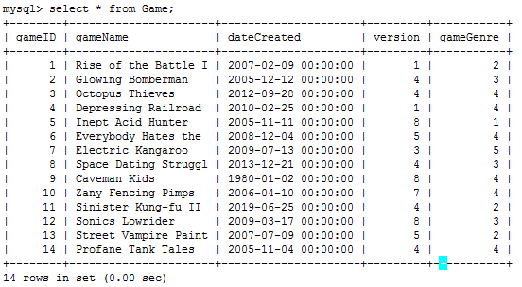
The results after inserting various games

Add New Team
Description: | Example Input: |  | Output:
Add a new team to the Team table | INSERT INTO Team(teamName, dateCreated) VALUES ('Compter Architects', '2001-2-3'); |  | Query OK, 1 row affected (0.00 sec)
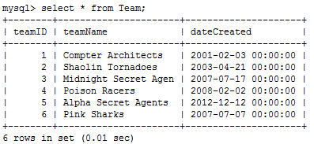 |  | The results after inserting various Teams

Add New Player
Description: | Example Input: | Output:
Add a new player to the Player table | INSERT INTO Player( playerName, dateJoined, favoriteGame, teamID, email) VALUES ('Adam', '2012-8-10', 1, 1, "namrog84@gmail.com"); | Query OK, 1 row affected (0.02 sec)
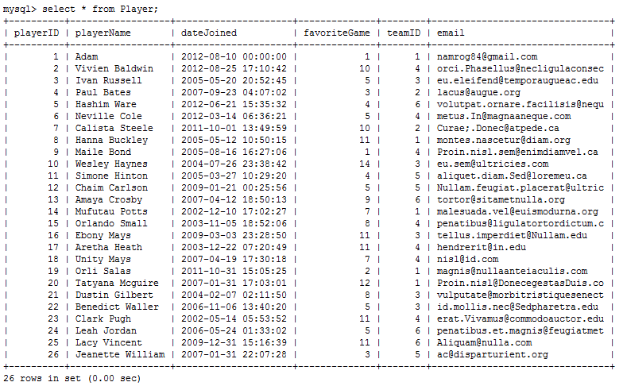

The results after inserting various Players.
Note: I have added an additional 75 players not shown here

Add New HighScore
Description: | Example Input: | Output:
Add a new game score to the GameScore table | INSERT INTO GameScore(playerID, gameID, highScore, dateScoreSubmitted) values( 1, 1, 10000, '2012-8-10'); | Query OK, 1 row affected (0.02 sec)
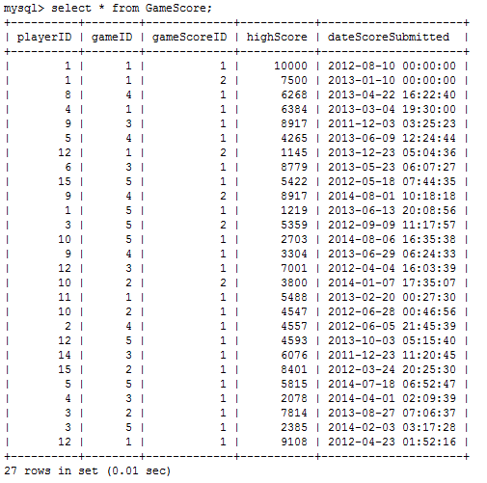
The results after inserting various highScores.
Note: When the same player submits a score to the same game, the gameScoreID will increment. This is easily identified in the first 2 rows of playerID and gameID of 1

Update Player Name
Description: | Example Input: | Output:
Update a player in the Player Table | UPDATE Player SET playerName = ‘Adam Gorman’ WHERE playerID = 1; | Query OK, 1 row affected (0.02 sec)
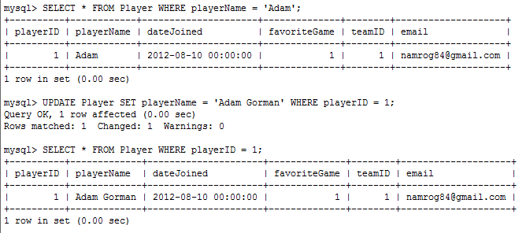
The results after updating a player.

Note: I first found my player I wanted to update, then I changed it, then I viewed my results

Remove Invalid HighScore
Description: | Example Input: | Output:
Remove a highscore from GameScore | DELETE FROM GameScore WHERE playerID=3 AND gameID=6 AND gameScoreID=1; | Query OK, 1 row affected (0.02 sec)
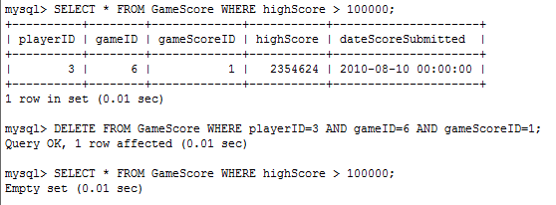
The results after removing a unusually highscore

Note: Although there is only 1 highscore right now, its important to use the full Primary Composite key for GameScore, which is playerID, gameID, and gameScoreID. Because there could be another game that has a legit score of that value. You don’t want to accidentally erase multiple highscores

Count number of players or ‘other’
Description: | Example Input: |  | Output:
Count the number of players | SELECT COUNT(*) FROM Player; |  | See Below
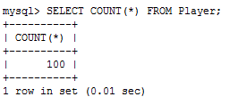  The results of counting players |  | 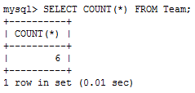  The results of counting Teams
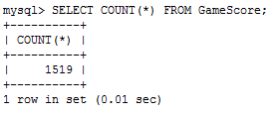  The results of counting the number of gamescores |  | 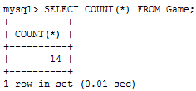  The results of counting the games

Get the 10 highest scoring players
Description: | Example Input: |  | Output:
Display the highest scoring players | SELECT playerName, MAX(highScore) FROM GameScore JOIN Player ON GameScore.playerID = Player.playerID GROUP BY GameScore.PlayerID ORDER BY MAX(highScore) DESC LIMIT 10; |  | See Below
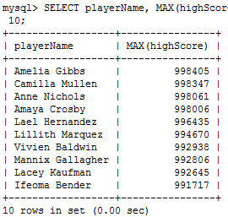 |  | We join the Player and GameScore together using playerID, so that we can display the score and the names. Then we group the players, to remove duplicates or else 1 player might appear multiple times. Then we sort descending for highest scores and limit it to 10.

Get the 10 Scores
Description: | Example Input: |  | Output:
Display the highest scores | SELECT Player.playerName, highScore FROM Player JOIN GameScore on Player.playerID= GameScore.playerID ORDER BY highScore DESC LIMIT 10; |  | See Below
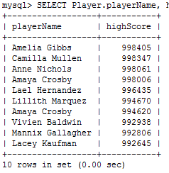 |  | In contrast, to the top 10 player queries, this is the top 10 highscores. As we can see Amaya Crosby appears twice here

Get the Favorite Games
Description: | Example Input: |  | Output:
Display the favorite games | SELECT gameName, count(favoriteGame) FROM Game JOIN Player ON favoriteGame = gameID GROUP BY gameID ORDER BY COUNT(favoriteGame) DESC; |  | See Below
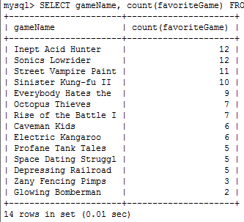 |  | Here you can see a list of all the games and how many times they are favorited and which one is the favorite game.

Get the Most Played Games
Description: | Example Input: |  | Output:
Display the most played games | SELECT gameName, count(favoriteGame) FROM Game JOIN Player ON favoriteGame = gameID GROUP BY gameID ORDER BY COUNT(favoriteGame) DESC; |  | See Below
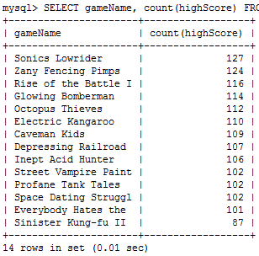 |  | An interesting comparasion to the most favorited games, The top 2 favorite game is IneptAcid Hunter and Sonic Lowrider but the in playCount, Inept Acid Hunter is 9th place.  Most likely Inept Acid Hunter simply takes much longer to play and thus has fewer scores to submit.

View the Teams and their player count
Description: | Example Input: |  | Output:
Display Team names and their team member count | SELECT Team.teamID, teamName, COUNT(*) AS TeamMembers FROM Player JOIN Team ON Team.teamID=Player.teamID GROUP BY Team.teamID; |  | See Below
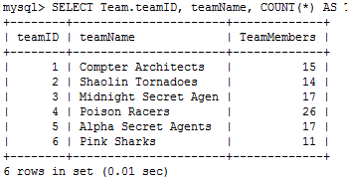 |  | This time I utilized a renaming of count as team members per team, You can see the team names, ids and playercount.

View the Team’s cumulative scores
Description: | Example Input: |  | Output:
Display each Team’s Cumulative score of points | SELECT Team.teamID, Team.teamName, SUM(highScore) AS CUMULATIVE_HIGHSCORE FROM Team JOIN Player ON Team.teamID = Player.teamID JOIN GameScore ON Player.playerID = GameScore.playerID GROUP BY teamID; |  | See Below
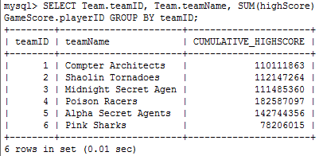 |  | This is displaying the cumulative scores of each teams

View the Team’s cumulative scores, ordered by highest score
Description: | Example Input: |  | Output:
Display each Team’s Cumulative score of points, ordered by highest score | SELECT Team.teamID, Team.teamName, SUM(highScore) AS CUMULATIVE_HIGHSCORE FROM Team JOIN Player ON Team.teamID = Player.teamID JOIN GameScore ON Player.playerID = GameScore.playerID GROUP BY teamID ORDER BY CUMULATIVE_HIGHSCORE DESC; |  | See Below
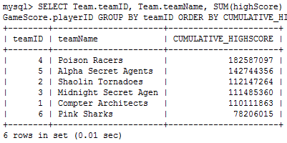 |  | This is displaying the cumulative scores of each teams, ordered by cumulative_highscore

View the Team’s highest score, ordered by highest
Description: | Example Input: |  | Output:
Display each Team’s individual highest earned score, ordered by highest score | SELECT Team.teamID, teamName, MAX(highScore) AS HIGH_SCORE FROM GameScore JOIN Player ON GameScore.playerID=Player.playerID JOIN Team ON Player.teamID=Team.teamID GROUP BY Team.teamID OR  DER BY HIGH_SCORE DESC; |  | See Below
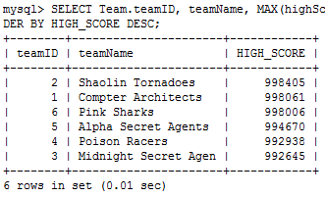 |  | This is displaying the individual highest score of each team, ordered by high score.

View an individual’s game plays and scores
Description: | Example Input: | Output:
Display an individuals game played and their respective scores | SELECT Player.playerName, Game.gameName, highScore, GameScore.dateScoreSubmitted AS Date FROM Player JOIN GameScore ON Player.playerID = GameScore.playerID JOIN Game ON GameScore.gameID = Game.gameID WHERE Player.playerName = 'Adam Gorman'; | See Below
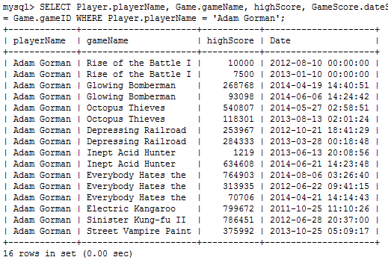
This is displaying the all the games played by ‘Adam Gorman’, and their respectives scores along with the dates they were submitted.

I have tried to incorporate a sampling of a variety of types of queries and display them the best way I can think of, from specific searches to advanced 3 table joins, groups, and sorts. I can expand further on any area if I have failed to meet the requirements of a particular area of the project assignments. I am stopping here, not because I can’t do more, but because I hope this is adaquete to earn full points on section 7-10 of the Project.

Additionally, I have dumped the database and zipped it up for you if you wanted to see it
It is located at http://www.newrog.com/cop4710/database_project1_mysql.zip and contains my 4 tables

Thanks for a great semester of Databases! I have learned a lot!
Adam
13 of 13 pages

