COP4710 – Theory and Structure of Databases
Summer 2012

Homework 5
Due Saturday Night, June 16, 2012
Adam Gorman

MySQL at FSU:
It’s time to use your account at the CS Department’s MySQL server. For the first six questions, you’ll upload the cia.sql file (attached to the assignment) to your CS account. Refer to the Read-Me’s in the Hands On section to see how to do this.

The cia.sql file will create the cia table, which has this schema:

cia(name, region, area, population, gdp)

Aggregate Functions (These do not require GROUP BY clauses).

1. Give the total gdp of North America. (The query result is 10844874000000)

SELECT SUM(gdp) FROM cia WHERE region = 'North America';

2. How many countries have an area of at least two million? (The query result is 14)

SELECT COUNT(name) FROM cia WHERE AREA >= 2000000;

3. What is the total population of (‘Belgium’,’Netherlands’,’Luxembourg’)? (The query result is 26571132)

SELECT SUM(population) FROM cia WHERE name IN ('Belgium','Netherlands','Luxembourg');

GROUP BY Clause

4. For each region, show the region and number of countries. (There are 15 regions; the first region is Africa, 59; the last region is World, 5)

SELECT region, COUNT(name)
FROM cia
GROUP BY region;

5. For each region show the region and number of countries with populations of at least 20 million. (There are 9 regions; the first region is Africa, 11; the last region is Southeast Asia, 7)

SELECT region, COUNT(name)
FROM cia
WHERE population >= 20000000
GROUP BY region;

6. List the regions with total populations of at least 200 million. (There are 6 regions; the first region is Africa, the last region is Southeast Asia)

SELECT region FROM cia GROUP BY region HAVING SUM(population)>=200000000;

===========================================================
SQLzoo:
Run these queries in the Query Entry Box in SQLzoo.net. See what they do. Paste your query (but not the results) below the questions below.

GROUP BY and Subqueries
Do the following problem at http://www.sqlzoo.net/3.htm. We will use the Movie database.

ER Diagram for the Movie Database. This database consists of a single M:M relationship:

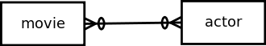

It’s easier to work with our queries if we explicitly show the intersection table.

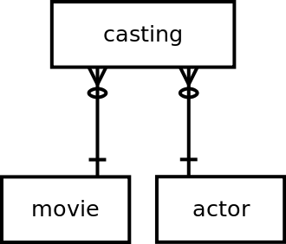

Table schemas (The table names and attributes):

movie(id, title, yr, score, votes, director)
actor(id, name)
casting(movieid, actorid, ord)

Seeing what the data in a table looks like will help you to build a query. To see what’s in a table, run SELECT * FROM movie; and so on for the tables you are working with.

Look in the top right corner of the web page below the advertisement, and you’ll see the currently selected database server:

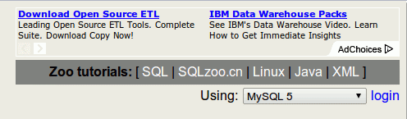

Default database server

7. Run this query using the MySQL server:
Heads up! Problem 7 right here!
SELECT title, yr
FROM movie
GROUP BY yr

Change the database server to Oracle:

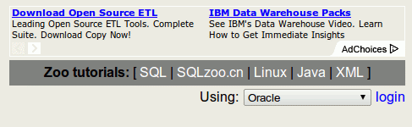

New database server

Rerun the above query using the Oracle server.

Question: One DBMS ran the query and produced a result, the other gave an error. Which one behaved according to the rules of the GROUP BY clause and why? Why do you think the MySQL DBMS behaved like it did? (We mentioned this in the discussion board last week).

The oracle server threw an error. I think I was the one that may have brought it up in the discussion board last week or at least something very similar. MYSQL actually does attempt to not throw errors, either by fixing small problems and/or simply returning something that may not be exactly what you wanted. Whereas Oracle will throw an error if it does not meet the proper rules exactly by mysql will let you ‘cheat’ a little on the rules of GROUP BY clause.

If you remove ‘title’ from the select, it appears to work. I believe this is caused by the fact that Which title would be displayed with each grouping? Mysql appears to do something so that it lists the first in the list in the group.

Note: In the following problems, if you compare the results of your queries in both the MySQL and Oracle servers, you’ll notice that they might not be quite the same. That’s because the tables in the two servers don’t contain identical data. If you run SELECT COUNT(*) FROM movie in each server, you’ll see that there are a different number of rows in each.

GROUP BY
8. Write a query to list the titles of the movies and the number of actors listed in each. This will require a JOIN between the three tables, along with a GROUP BY. (If you only joined the movie table and the casting table without joining the actor table, you would get the same result).

SELECT movie.title, count(casting.actorid)
FROM casting JOIN movie ON movie.id = casting.movieid JOIN actor ON casting.actorid = actor.id
GROUP BY movie.title

Correlated Subquery
9. Rewrite the above query using a subquery instead of a JOIN and GROUP BY. The subquery will go into the SELECT clause of the outer query.

SELECT movie.title, (select count(casting.actorid)
FROM casting where casting.movieid = movie.id)
from movie

GROUP BY
10. Write a query to show the movie titles that have 15 or more actors.

SELECT movie.title
FROM casting JOIN movie ON movie.id = casting.movieid GROUP BY movie.title
HAVING count(casting.actorid) >= 15

We saw in problem 7 that MySQL is lenient about the GROUP BY attributes matching the SELECT attributes but Oracle isn’t. Don’t depend on MySQL’s automatic cleanup, or your queries may work differently than you intend.

=================================================================
MySQL at FSU Again:

Now it's back to your FSU account. You’ll upload two files (Orders.sql, OrderDetails.sql) attached to the assignment) to your CS account that will build two new tables. (Refer to the Read-Me’s in the Hands On section).

The files you’ll be uploading are part of the BIRT sample database that were obtained at http://www.eclipse.org/birt/phoenix/db/ . BIRT stands for Business Intelligence and Reporting Tools. Quoting the web site: “BIRT is an open source Eclipse-based reporting system that integrates with your Java/J2EE application to produce compelling reports”. This system and the sample data are available under the Eclipse Public License.

We’ll be practicing with part of the Line Item Pattern, the classic structure described in the 0375 Data Modeling and Implementation Read-Me.

We’ll use only two tables:
- order headers
- order line items (also called details)

These two tables have a parent/child relationship with each other. Each row from the order header table contains the fields found at the top of an order form. Each row from the order line item table contains an individual line on the order form. We would expect to find several line item rows for each header row, because an order form lets you order several items on the same form.

Notice that the line items (OrderDetails table) are ID-dependent on the headers (Orders table). Notice that these tables use surrogate keys. In addition to the primary keys, you can see the foreign keys for the Customers table and the Products table (two tables that we won't be using for this exercise).
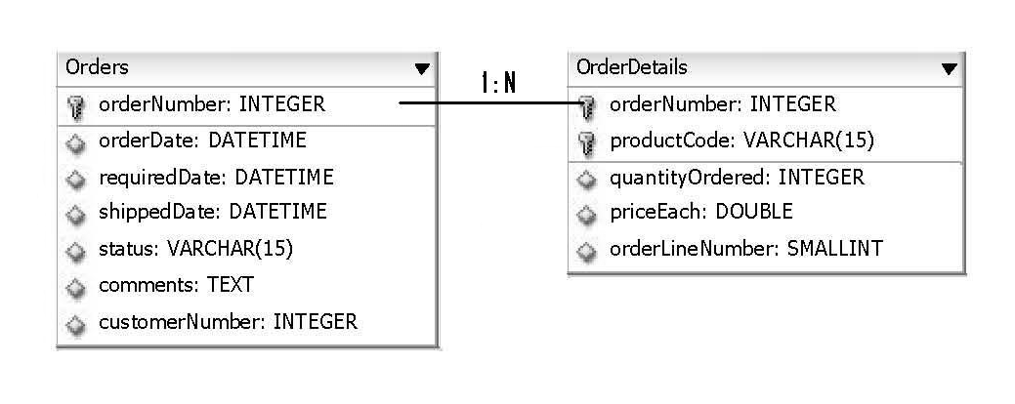

Upload and run both the Orders.sql and the OrderDetails.sql files attached to this assignment. They'll create and populate the Orders and the OrderDetails tables.

You can use the DATEDIFF(date1, date2) function to do date math. This function subtracts date2 from date1. It returns the number of days between the two dates. The DATE data type contains both date and time. DATEDIFF is handy because it ignores the time-of-day component and deals only with the date component.

The YEAR(date) function returns the year component of a date.

Remember that the form of a SELECT statement is:

SELECT
FROM
JOIN ON
WHERE
GROUP BY
HAVING
ORDER BY
LIMIT

SELECT-FROM-WHERE is the basic chunk you always use. GROUP BY and HAVING go together. ORDER BY appears last. LIMIT goes after ORDER BY, but is specific to MySQL.

Here’s a shortcut for joins: if the join columns in both tables of an equijoin have the same name, then instead of writing:

ON Orders.orderNumber = OrderDetails.orderNumber

you can simplify your statement by replacing that with:

USING(orderNumber)

GROUP BY Problems
These will help you get the hang of the GROUP BY.

11. We want to see how long of a delay there is between the time an order is placed and when it ships. Write a SELECT statement to return a result containing two columns: (1) the number of days from the orderDate to the shippedDate; and (2) the number of orders falling into this category.

select datediff(shippedDate, orderDate), count(orderNumber)
from Orders
WHERE shippedDate IS NOT NULL
group by datediff(shippedDate, orderDate);

12. Write a SELECT statement to return the orderNumber and total amount for each order placed in 2004 that took more than 7 days from the orderDate to the shippedDate. (Hint: This doesn’t use HAVING).

select orderNumber, SUM(OrderDetails.quantityOrdered*OrderDetails.priceEach) from Orders join OrderDetails using(orderNumber)
where datediff(shippedDate, orderDate)>7 AND year(orderDate) = 2004 AND shippedDate IS NOT NULL
group by orderNumber;

13. Write a SELECT statement to return the orderNumber and total amount for each order totaling over $60,000.

select orderNumber, sum(OrderDetails.quantityOrdered*OrderDetails.priceEach)
from Orders join OrderDetails using(orderNumber)
where shippedDate IS NOT NULL
group by orderNumber
having sum(OrderDetails.quantityOrdered*OrderDetails.priceEach) > 60000;

14. Find the orderNumber and amount for the top 5 largest orders placed. (Not just the largest line item value, but the largest dollar amount for the orders).

Tip for number 14 – Sort your output and use LIMIT. You have to use a trick to sort and it’ll drive you crazy if you don’t know the secret: In the SELECT clause use an alias for the sum:

SUM( … ) AS Amt

Then refer to the alias when you sort:

ORDER BY Amt

Remember that you can sort in both ascending (the default) and descending (DESC) order.

select orderNumber, sum(OrderDetails.quantityOrdered*OrderDetails.priceEach) AS Amt
from OrderDetails
Group By orderNumber
Order By Amt Desc
Limit 5;

=================================================================
More MySQL at FSU:

Here’s a problem from last week’s homework:
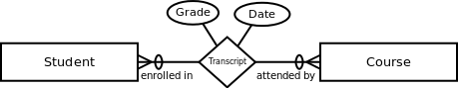

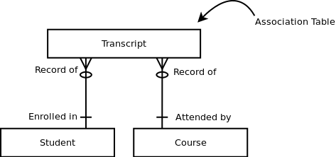

Table Schemas:

Student (id, lName, fName, yearStart, Major)
Course (id, name, creditHours)
Transcript (studentId, CourseId, date, grade)

15. Write the DDL statements for the tables above. They will look like this:

CREATE TABLE student (
id INT UNSIGNED NOT NULL AUTO_INCREMENT,
lName VARCHAR(20) NOT NULL,
fName VARCHAR(20) NOT NULL,
etc...
);

ALTER TABLE student
ADD PRIMARY KEY (id);

Note that you can use an AUTO_INCREMENT column to create the values for a surrogate key, or you can enter your own values. It’s very common to use AUTO_INCREMENT for assigning surrogate keys, although there are other ways to create them.

Run your DDL statements in MySQL to build the tables.

Remember, after creating your tables, you can use the statement SHOW COLUMNS IN student; to see the structure of your table.

After you build a table, you can use the statement SHOW CREATE TABLE student; to show the CREATE statement that will build the same table again.

For this step, write the DLL statements on your homework. (You can cut-and-paste from MySQL if you wish. You can use the output from SHOW CREATE TABLE if you would like.)

CREATE TABLE Student (
id INT UNSIGNED NOT NULL AUTO_INCREMENT PRIMARY KEY,
lName VARCHAR(20) NOT NULL,
fName VARCHAR(20) NOT NULL,
yearStart INT UNSIGNED,
major VARCHAR(50)
);

CREATE TABLE Course (
id INT UNSIGNED NOT NULL AUTO_INCREMENT PRIMARY KEY,
name VARCHAR(30) NOT NULL,
creditHours INT UNSIGNED
);

CREATE TABLE Transcript (
studentID INT UNSIGNED NOT NULL,
courseId INT UNSIGNED NOT NULL,
date DATETIME,
grade VARCHAR(2),
PRIMARY KEY(studentID, courseID)
);

16. Add some data to your tables, including the association table:

INSERT INTO student (lName, fName, … )
VALUES (‘Smith’, ‘John’, … )

Show a representative DML statement for each table.

INSERT INTO Student(lName, fName, yearStart, Major)
VALUES( “Jones” , “Bob”, 2009, “Database Engineering”);

INSERT INTO Course(name, creditHours)
VALUES( “Databases”, 3);

INSERT INTO Transcript(studentID, CourseID, Date, Grade)
VALUES( 1 , 1, ‘2012-10-11’, ‘A’);

17. Write a SQL statement to print the students' names, the courses they took, and the date they
completed them. Use all the tables. Use the explicit style of join syntax.

Run the statement to get some output. Cut-and-paste the query and the output here.

Select Student.lName, Student.fName, Course.name, Transcript.date From Student join Transcript ON Student.id = Transcript.studentID join Course on Course.id = Transcript.courseID;

Output

+---------+--------+----------------------+---------------------+
| lName | fName | name | date |
+---------+--------+----------------------+---------------------+
| Jones | Bob | Software Engineering | 2011-10-11 00:00:00 |
| Gorman | Adam | Software Engineering | 0207-02-02 00:00:00 |
| Gorman | Adam | Bowling | 2008-02-02 00:00:00 |
| Caetano | Kaylee | Software Engineering | 2009-01-01 00:00:00 |
| Caetano | Kaylee | Hacking 101 | 2010-05-01 00:00:00 |
+---------+--------+----------------------+---------------------+

Note: I didn’t show all my input into table in above
Note: I had accidentally had typo in year for software engineering, but I left it in. Cause I am several thousand years old, and this college has been around for a while!

