**ABSTRACT**

This project is on Hospital Management. In today’s world people do not have the need to make an register.

They can record all the data in computer using this software, will help them in different way (using MySQL).

Using MYSQL connector. Its almost made the creation of tables easy as ever. This reduces consumption of time and increases productivity.

This paves way for the Management systems to be more efficient than the alternate manual methods

Using modules such as tkinter in a python program with a MySQL database connector is used for this program

­­­

**Software and Hardware requirements**

**Hardware requirements**

* OPERATING SYSTEM: Windows 10/11
* PROCESSOR: Intel core i3/i5/i7/i9
* RAM: 4GB/8GB

**Software requirements**

* PYTHON: Version 3.7 or Above
* MySQL: Version 5.1 or Above
* MySQL Connector Installed

**APPLICATION**

This software is specially used to maintain any fitness centre where they can maintain records of any gym

Today one cannot afford to rely on the human beings of be really wants to stand against today’s merciless competition. To replace the unending heaps of flies with a much-sophisticated hard disk of the computer.

One has to use the data management software. Software has been an ascent in atomization various organisations. Many software products working are now in markets, which have helped in making the organizations work easier and efficiently. Data management initially had to maintain a lot of ledgers and a lot of paper work has to be done but now software product on this organization has made their work faster and easier. Now only this software has to be loaded on the computer and work can be done.

This prevents a lot of time and money. The work becomes fully automated and any information regarding the organization can be obtained by clicking the button. Moreover, now it is an age of computers of and automating such an organization gives the better look of the future

Improved Processes Automation is one of the main benefits here. It helps to optimize the user experience. Medical specialists, patients, and hospital authorities can interact online, make the appointments and exchange information. Digital medical records .The hospital database includes all the necessary patient data. The disease history, test results, prescribed treatment can be accessed by doctors without much delay in order to make an accurate diagnosis and monitor the patient’s health. It enables lower risks of mistakes. Staff interaction It is vital to engage all your employees for improved coordination and teamwork. They do not need to make special requests and wait for a long time for an answer. Each specialist will oversee certain process stage and can share outcomes with colleagues just in one click. Facility management Hospitals authorities can manage their available resources, analyse staff work, reduce the equipment downtime, optimize the supply chain, etc. Another fact to mention is that hospital staff deal with the digital data instead of endless paperwork.

**DESIGN**

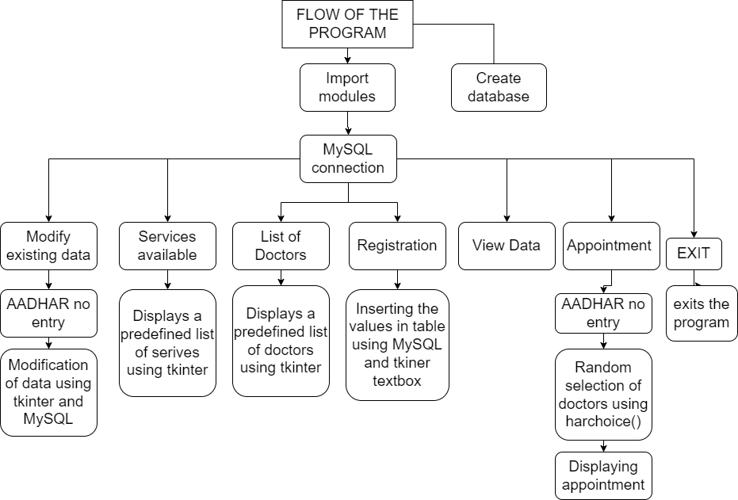

* Modules are imported.
* Database is created with a condition
* Modify the existing data option is used to update the records using MySQL and uses AADHAR no to do so. Tkinter message box is used for the GUI
* Service available option forecasts a predefined lists with a little touch of tkinter to give a view of the list in a neatly organized manner
* List of Doctors option give the predefined list of doctors with tkiner GUI playing its part
* Registration option is used to insert values using .format into MySQL and tkinter message box is used to receive input from the client(user)
* View data option is used to view the existing register tables in the database
* Appointment option is used to display the appointments from the doctors using hardchoice() in random() function and uses the aadhar as a means to do so
* Exit option is used to terminate the program

**FLOWCHART**

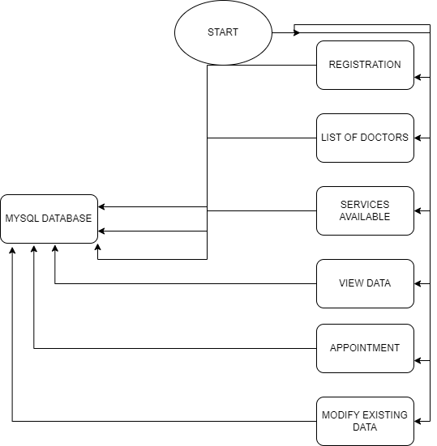

**ALGORITHM**

Firstly import the modules required. The modules consist of tkiner

And mysql.connector(alias name) and check the parameters and edit them according the device being used to make the connection of mysql successful and random module is used

Then connect MySQL to python using connector object and appoint a cursor object to carry the queries given

Creation of database is given inside the if condition. Creation of database first occurs and then followed by it the creation of the table followed by another table. Then def entry() is used to insert the values into the table which is collected by the user .

def register() acts as the GUI to collect these values from the user and thus acts the function which collects data from the user. This is a button

def apo_details() consists of harchoice() being used to randomly select and place certain doctors for the appointments followed by the execution of this data into mysql .This function contains if and elif to vary with the random selections being made.

def get_apoint() is used as a barrier to check whether the AADHAR no given is right or wrong. And if it is wrong it terminates the process with the error message. But if the given AADHAR no is in fact existing the table then a welcome is given followed by a choice to be made by the user as to the type of appointment to be given and the data and time in the 24 hour format is given for the user to choose This is executed by a button

def appoint() is used a exception handler where even if the user decides the give no input for the AADHAR no in the appointment section. The program still continues by connecting this with the get_apoint().

def lst_doc() uses the predefined list in python along with the tkinter display box and using for loop to construct a proper table and display it to the user. This is executed by a button.

def ser_avail() is used to display a predefined list of servies offered by the hospital management and similar to the appoint() function. This function also uses for loops and tkinter message box to display a proper table for the user to view .This is executed by a button

def modify() consists of the tkinter messages functions to collect the data which needs updating and uses for loop and continued by the for loop comes another fuction connected to this function called do_modify().This is executed by a button

def do_modify() consist of mysql queries to update the values present in the tables and is followed by a message using tkinter to display in GUI. This is executed by a button

def mod_sub consists of a label and a verification using AADHAR no and modify() is used for the modification. This is executed by a button

def search_data() consists of a entry of AADHAR no followed by the working of view_data().This is executed by a button

def view_data() consists of select query in mysql. Followed this query ,Data is collected using fetchall() and stored in a variable and for is used to append the data into another list in which a if else condition determining the length of the new variable is given. Then the data is shown using messagebox in tkinter.

The buttons are defined in order and attached with methods using commands as well as colours are being given according to the button

Tkinter is used for the design of the secondary windows