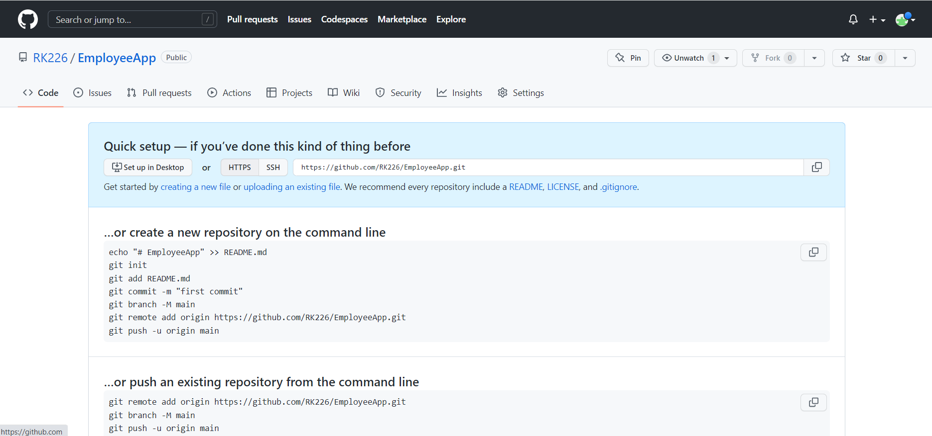

- using **git init** – initialize and existing directory as a git repo

- Created EmployeeApp Repository

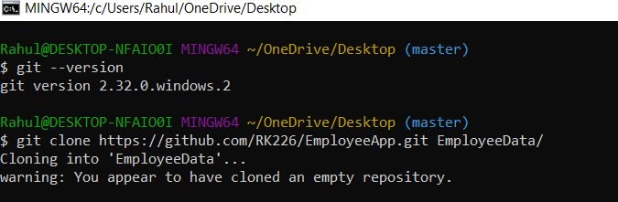

* Using **git –version** - check git version
* Using **git clone [url] -** clone repository in our local system
* Using **vi filename.txt** – create file

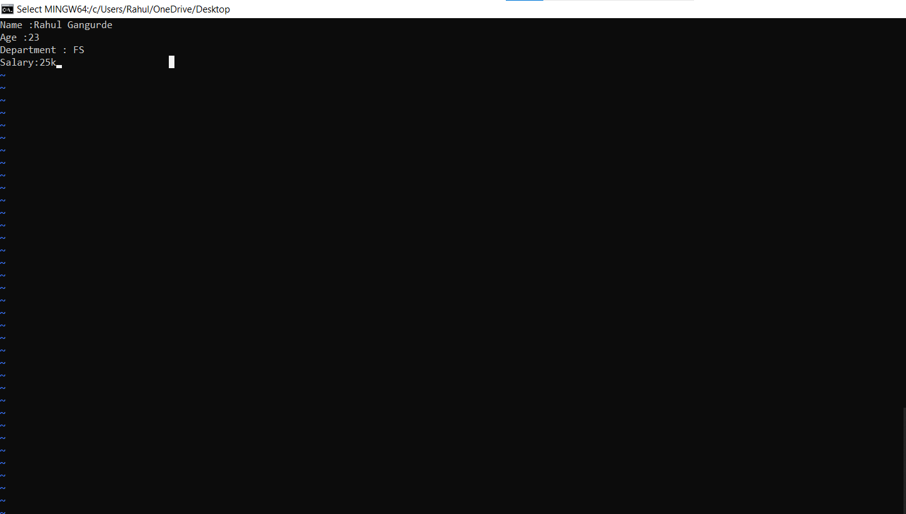

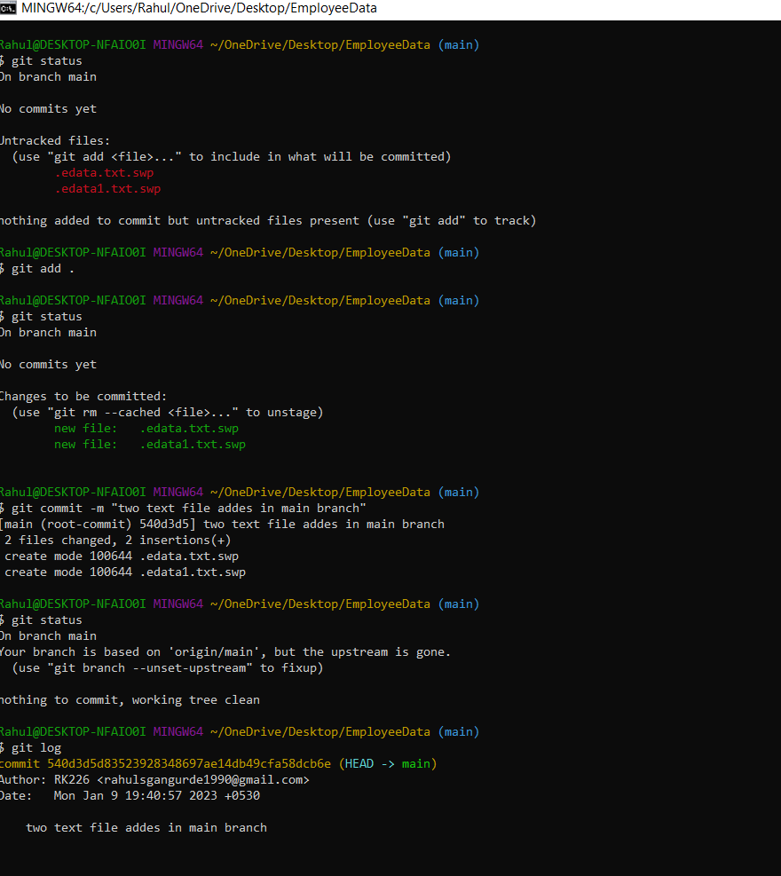

* using **git status** – check current git status
* using **git add .** - add all files as a next commit stage
* using **git add [file name]** – add particular file as a commit stage
* using **git commit** – commit your staged content as a new commit
* using **git commit -m “message”** - give descriptive message
* using **git log** – show all commits in the current branch history

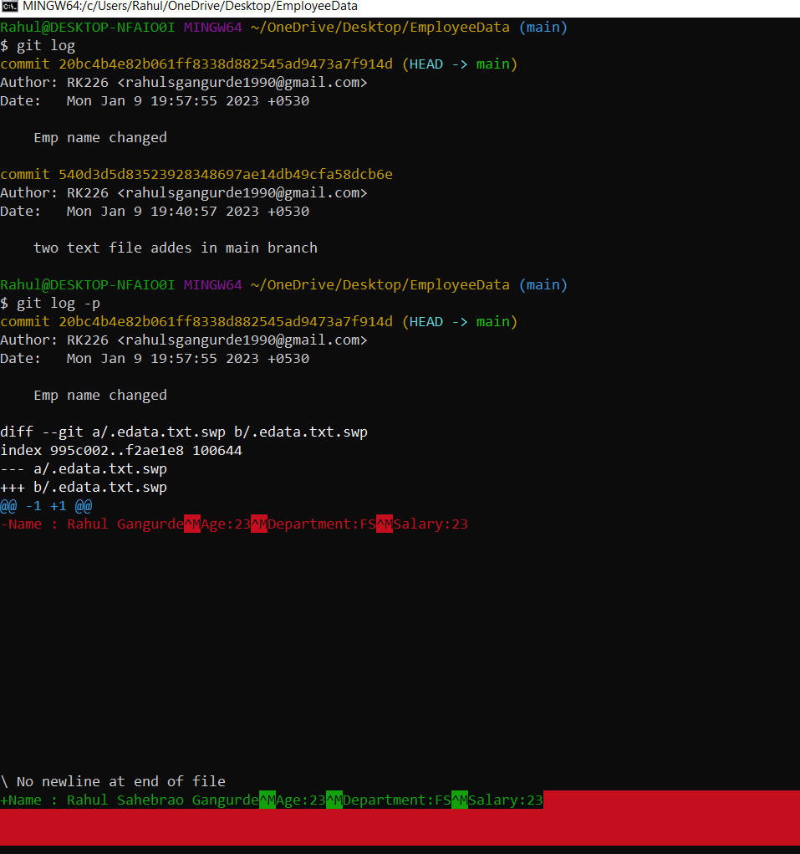

* Using **git log -p** - show the difference

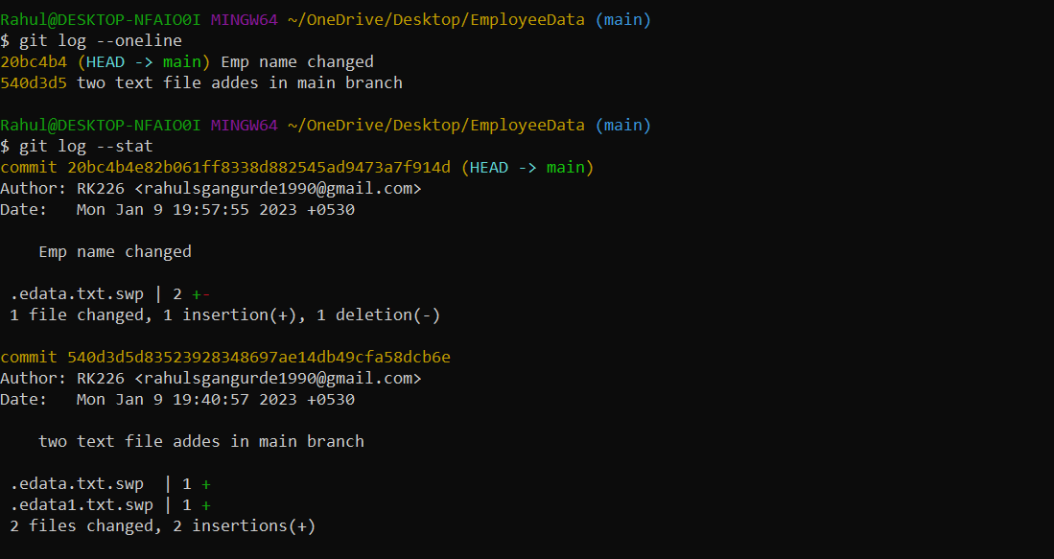

* Using **git log –oneline** – show all current branch history or SHA id in a short one line
* Using **git log –stat** -show all current branch history with details

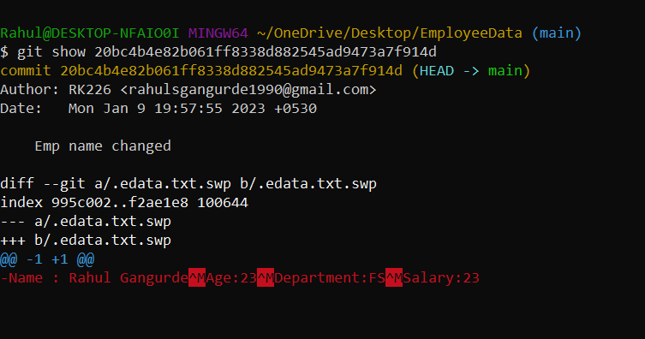

* Using **git show[SHA id]** – show particular commit details using SHA id

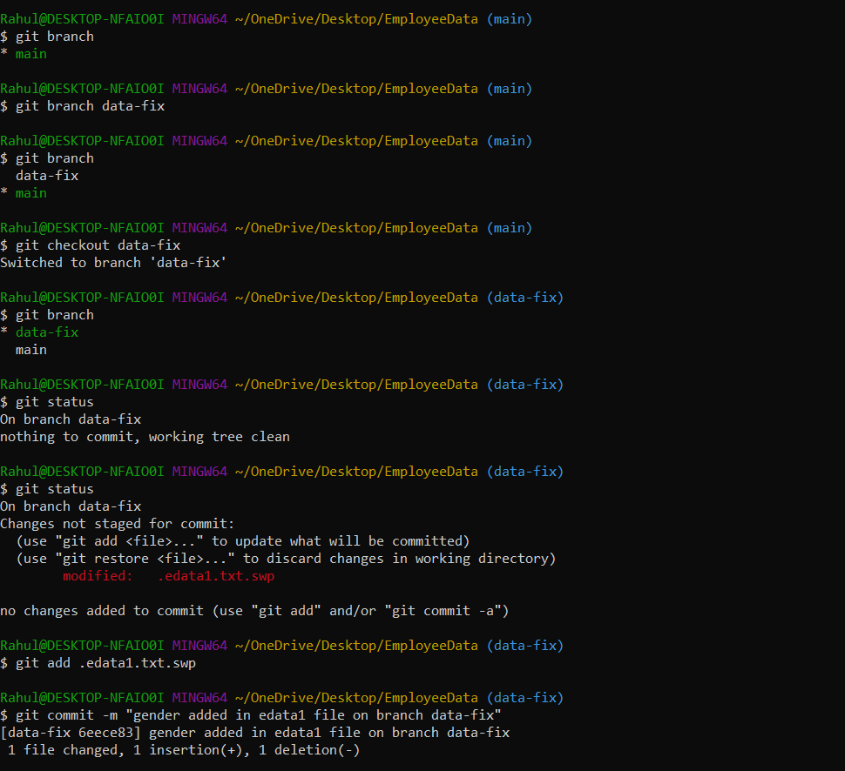

* Using **git branch** – list all branches
* Using **git branch [branchname]** – create new branch
* Using **git checkout[branchname]** – switch particular branch

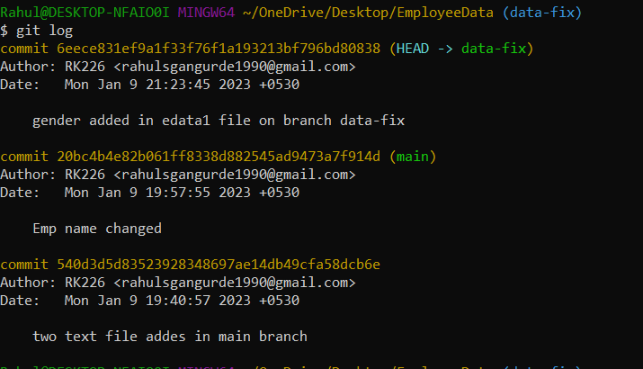

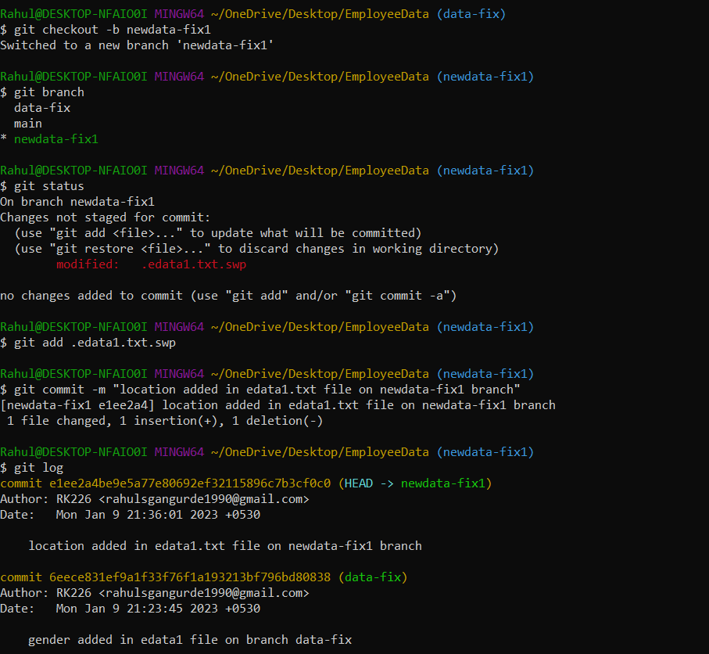

* Using **git checkout -b [branchname]** – create new branch and direct switch on this new created branch

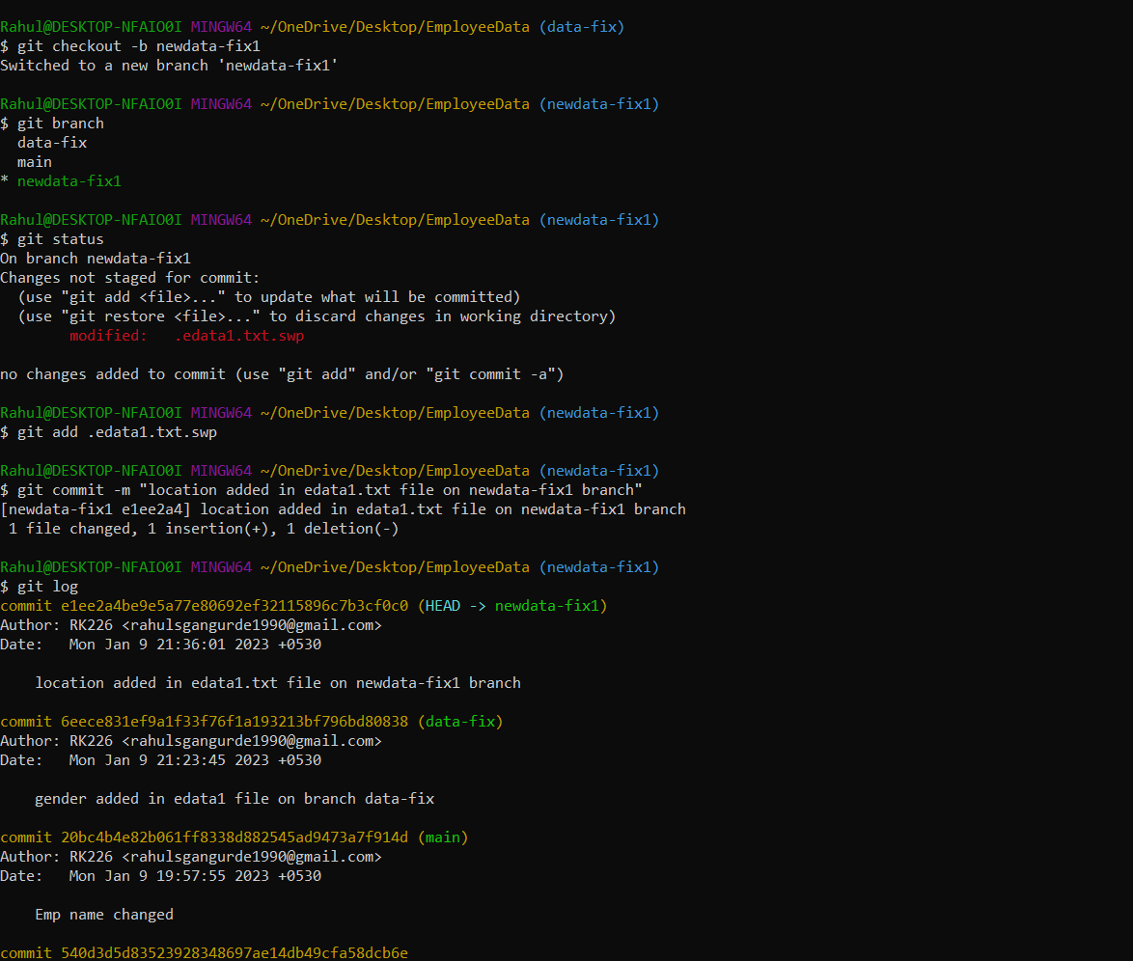

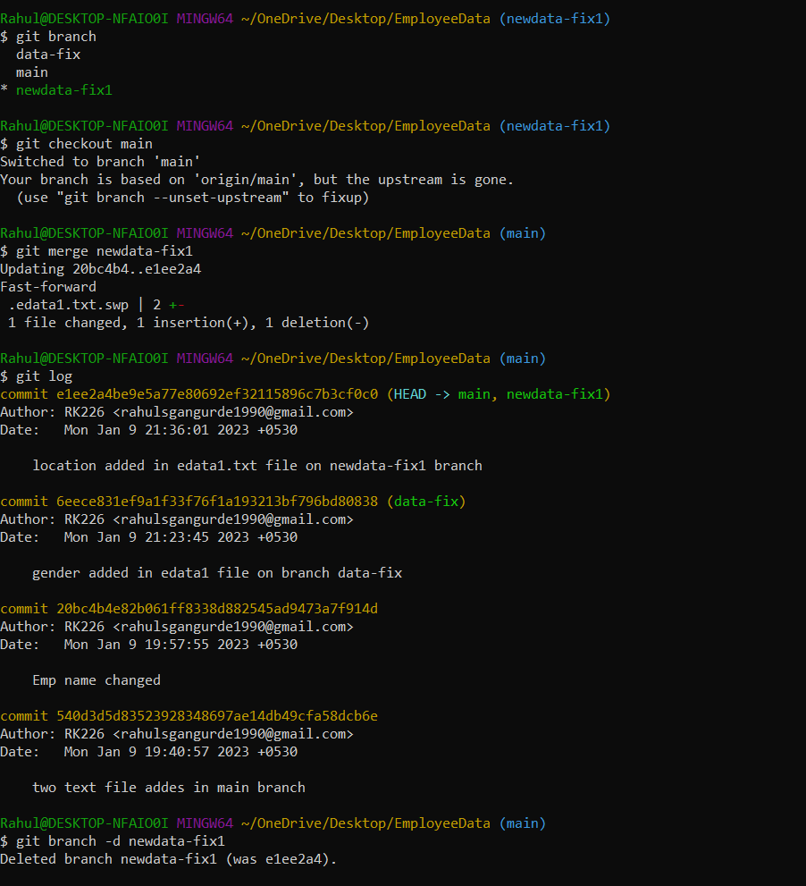

* Using **git merge [branchname]** – merge branch with current branch

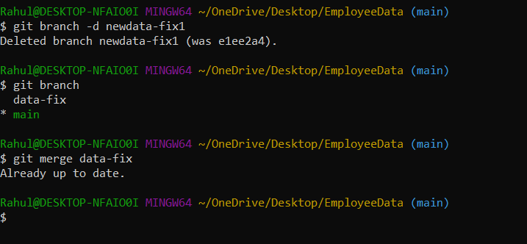

* Using **git branch -d [branchname]** – delete branch

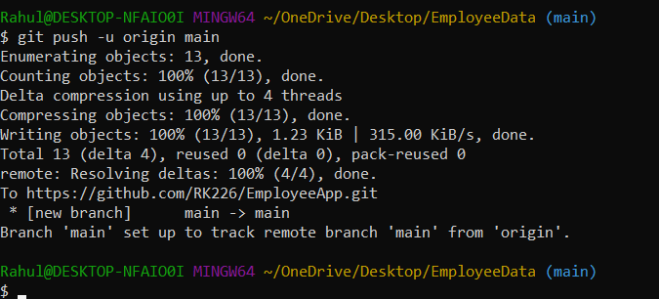

* Using **git push [branchname] –** Transmitall local commit to the remote repository branch