MADA Project: COVID-19 Vaccinations and recovery

Dawson Dobash

2021-11-29

# 1 Abstract

COVID-19 has been the talk of the world for the past two years, and it is still prevalent. The affects of COVID-19 not only affected individual people, but it also affected businesses, health protocols, and the economy of governments. It has affected all countries not only specific to a type of country which is the scary part. It is truly indeed a pandemic.

I am interested in looking at the difference between the proportion of those who recovered to those who have died for each country in the world. I am also looking at how the proportion of people vaccinated in each country is affected by multiple factors. The predictors I will be considering are: percent of cases within a population, continent the country is on, number of tests per person, gdp per capita, proportion of those who died, government type, and health care funds.

By looking at some simple linear regressions and other exploratory analysis, I determined due to how high the recovery rate is within each country overall and no association based on R-squared values, the difference in proportions did not change based on multiple factors.

While looking at vaccination proportions, I decided to do some analyses using training/test data sets and applying them to find the RMSE of the full model and a null model. When finding the RMSE, I found that the full model does a better job in fitting the data compared to the null model. This is a good sign to share that some combination of predictors have an association to the proportion of vaccinated people for each country.

The next analysis was creating a machine learning modeling technique called the LASSO model. This type of modeling will create multiple models from a five-fold cross-validation and a tuning grid which will try to find the best performing model. From the LASSO we find that model 27 give the best model, and the amount of cases, which continent the country resides in, and the type of government have impacts to the vaccination proportions. Compared to Africa, South America and Asia increases the proportion of vaccinations the most while an increase of cases means more vaccinations as well. A monarchy government compared to a republic government has more people vaccinated proportionally.

# 2 Introduction

## 2.1 General Background Information

COVID-19 hit the world by storm and is a possible ever-lasting change to the way society acts. It also had an impact on each countries funding towards health care. Actions within the past two years have been taken to help fight against this virus. Although COVID-19 has been here for over two year, there is still problems with under staffing in hospitals and not enough beds at some hospitals. Recovery rates are still high in the United States but what about the whole world. Other countries are still getting hit hard by this virus. In terms of vaccination output, there has been back and forth movements on people getting the vaccination. A poll was close to when vaccinations were starting to disperse where only 51% of adults in the United States said they would get a vaccine (Choi, 2021). Although in developed countries this happens but what about the less developed countries and regions such as Africa. While people in the United States are fighting about whether the vaccine should be given or not, the people in these other countries might have a limited supply. According to the United Nations in September, there is still an unequal amount of vaccinations going to developed and less developed countries. This could be due to the cost of each vaccination (“COVID vaccines,” 2021). In a paper by Choi, as of January 2021, cases were fairly even between developed and less developed countries (Choi, 2021). This just shows that although COVID-19 is affected everyone, the supply is not equal between all countries even though all countries need it.

Looking at the difference in recovered patients and those who have died will be beneficial in determining if more care is needed in certain countries. According to paper by Liang et al, the mortality rates were negatively impacted by the number of tests performed and also based on the countries economic status and government (Liang, Tseng, Ho, & Wu, 2020). I also think the percentage of people vaccinated is also affected and can lead to important results that might show we need more either distribution or requirements of the vaccines.

## 2.2 Description of data and data source

The data I am using is from a mixture of locations. Two sources are from kaggle.com, one from the world bank database, one created by myself based on information from wikipedia, and the other is from the Organisation for Economic Co-operation and Development (OECD) website. My data consists of ten data sets with information over each country in the world (for those that data was collected for). Six of these data sets provide the same information just for different countries where each data set is a different region. There is a data set that includes all of the countries but I want to include a region indicator variable for each country. These data sets includes total covid-19 cases, active cases, total deaths, total recovered, total tests, and population size. This data was updated on kaggle as of Sept 16th. Another data set I am using is a vaccination data set for each country. This is also data as of Sept. 16th. The other data sets are providing single stats for each country that was not included in the larger data sets but I still wanted to use. These data sets include the following statistics/demographics: healthcare funding for 2019-2020, vaccination numbers/percentages, gdp per capita, and government type.

I plan on combining the data sets into one with the variable combining them all is the country. If there are missing data within the variables used in analysis, I will exclude those countries. There will be a lot of cleaning for this data just to make it as I want it and work.

Links to the locations I received the data are below:

<https://data.oecd.org/healthres/health-spending.htm>

<https://www.kaggle.com/iamsouravbanerjee/covid19-dataset-world-and-continent-wise?select=Covid+Data+-+World.csv>

<https://www.kaggle.com/anandhuh/latest-worldwide-vaccine-data>

<https://data.worldbank.org/indicator/NY.GDP.PCAP.CD>

<https://en.wikipedia.org/wiki/List_of_countries_by_system_of_government>

## 2.3 Questions/Hypotheses to be addressed

1. Since this data is cumulative and does not break down the amount of cases per month per country, I want to compare the recovery proportion to the death proportion and if this difference is based on variables such as the number of vaccines pushed out to society, the amount of funding the health care system has, the amount of tests taken. This will hopefully show if the amount of health care support really helps patients recover.
2. I will also look at how the percent of people vaccinated for each country is affected by multiple predictors. I am planning on seeing that more developed countries based on GDP per capita will have a more vaccinated population.

Some confounders that I could run into are: 1) Developed countries might have more cases as more travelers visit these countries and it could have an effect on recovery numbers.

1. Unknown dates of when a country received vaccines and amount. This could skew the amount of vaccinations a country receives.

# 3 Methods and Results

## 3.1 Data import and cleaning

For data importing and cleaning, I first had to import ten different data sets into R from multiple sources specified in the Description of data and data source. After this importation, The first thing to do before combining the data set was to create indicator variables for each country. After this, I wanted to make sure that each variable was the right class as some of the numeric variables were character variables. This will help in making sure that each variable was able to be used in the right way. I then was able to combine each continent data set into one world data set to make the importing go easier. After combining the continent data sets, I need to only include the variables from the world data set needed for analysis and make sure that all missing values were removed as I only want full information observations. However this would delete some countries that were large in population such as China and the Philippines as they did not have vaccine information.

The next part was looking at all of the other datasets which include the government type, gdp per capita, health care funds, and vaccine datasets. To combine these with the world data set, there was a huge problem that goes with using data sets from different sources. This problem is how to combine the data sets with a specific variable. Fortunately, each data set had a country variable to combine them with. However, the country names for all datasets were different. One included a three letter code for countries, then another ones used different abbreviations/names for countries. I had to use the countrynames package to help change into names I wanted for the three-letter code. Since I could not change all of the countries names to the way I wanted it, I had to unfortunately go into the raw data csv files to change them manually for some of the continent specific data sets. I also used ifelse statements to change the names for the gdp per capita and health care funds data sets. I was able to do these in r because there were not as many country names to change compared to the other data sets I had to manually change. A comment within the proccessingscript.R tell of the countries that needed manual changes. After all of this was good to go, I used the merge function to combine all of the data sets the way I wanted to.

I created some variables from the pre-existing ones that I will use within my analysis. Some of these changes were, for example, creating proportions from percentages and combining two variables.

One disclosure I have for this is that one data set, health care funds, only had 48 countries when I cleaned the data. Therefore, there are a lot of missing values for only the specific variables that came from the health care funds data set in the merged one.

To look at a more descriptive explanation of all of the steps I took in data cleaning and importing, go to the processing script where it has comments for every line of code.

## 3.2 Question 1: Difference in proportions of recovery and deaths

Table 1.1 displays the top five and bottom five death rates. Also within this, it shows their corresponding recovery rates as well. We can see that the bottom five death rates are from Asia but also the highest, Yemen, is also within the Asia continent as well.

Table 1.1: Top 5 and bottom 5 death rates by country

|  |  |  |  |  |  |
| --- | --- | --- | --- | --- | --- |
|  | Country | location | recov_rate | death_rate | Total Cases |
| 1 | Yemen | Asia | 0.6222975 | 0.1892018 | 8557 |
| 2 | Mexico | N. America | 0.8164215 | 0.0761703 | 3549229 |
| 3 | Sudan | Africa | 0.8398947 | 0.0756579 | 38000 |
| 4 | Syria | Asia | 0.7602892 | 0.0697775 | 30153 |
| 5 | Ecuador | S. America | 0.8774760 | 0.0643637 | 505860 |
| 159 | Maldives | Asia | 0.9758072 | 0.0027268 | 83248 |
| 160 | Qatar | Asia | 0.9899229 | 0.0025682 | 235187 |
| 161 | Bhutan | Asia | 0.9984592 | 0.0011556 | 2596 |
| 162 | Laos | Asia | 0.3083227 | 0.0008860 | 18059 |
| 163 | Singapore | Asia | 0.9252218 | 0.0007883 | 74848 |

Figure 1.1 shows a histogram figure that describes the difference in proportions between those who recovered versus the proportion of those who died. From the histogram we can see that this difference is left skewed as most countries have a much higher recovery rate with only a some having more of a lower difference meaning lower recovery rates. This is very worrisome for the analysis as most of the countries are over 0.80 in the difference.

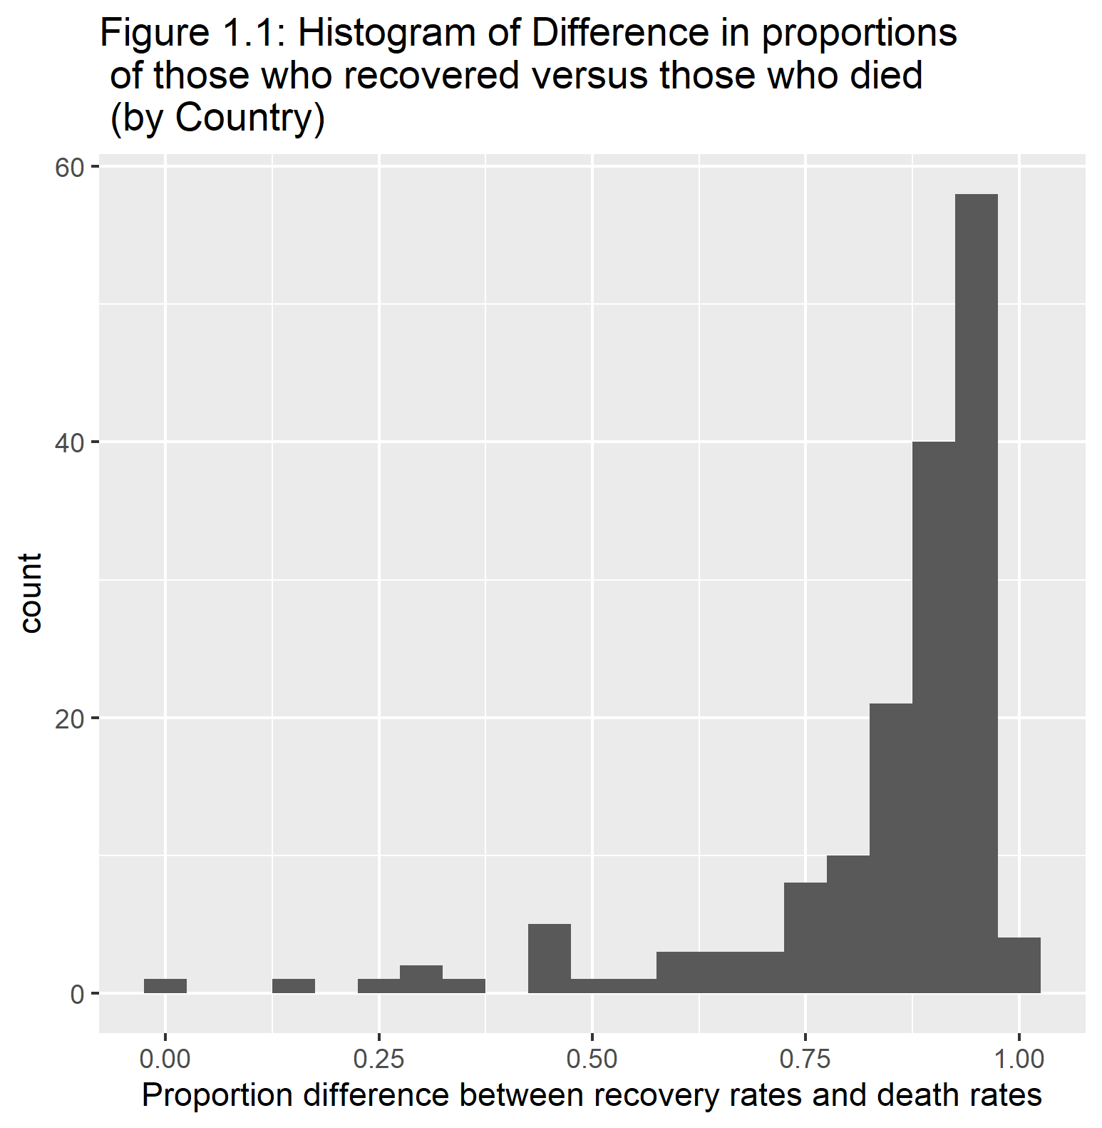

We can see in figure 1.1 that this data is fairly skewed. Therefore, I will do a logit transformation of the outcome to make it more normal as shown in figure 1.2.

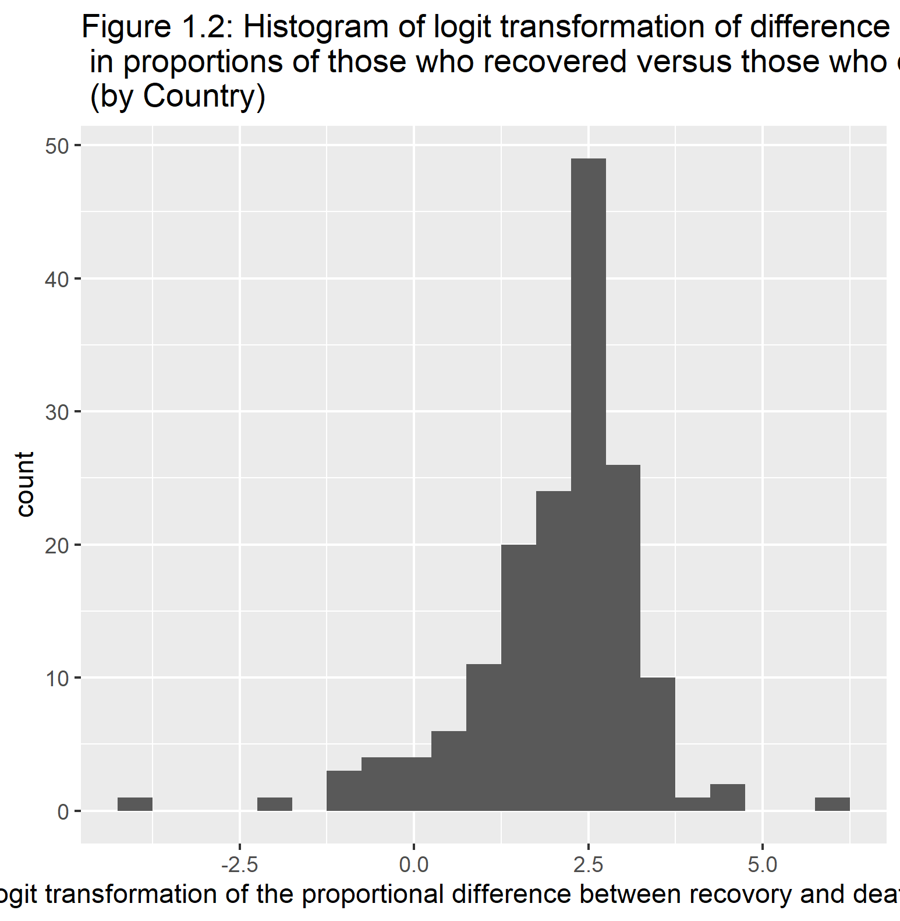

Before I decided on the logit transformation, I first decided to try this difference in proportions outcome I made within a binomial model and then a quasibinomial using the values of total cases as my weight to see how the deviance and dispersion values are. After running two simple models, the results were showing very high values for these statistics. Therefore this is how I decided on using the logit transformation.

Using the logit transformation, I ran 4 simple linear regression models. Below I provide the statistics of one of the models within Tables 1.2.

Table 1.2 is showing statistics for the predictor vaccine percentage.

Table 1.2: Summary statistics for linear regression (logit transformation of prop diff of recovery and deaths vs. vaccine)

|  |  |  |  |  |  |  |  |  |  |  |  |
| --- | --- | --- | --- | --- | --- | --- | --- | --- | --- | --- | --- |
| r.squared | adj.r.squared | sigma | statistic | p.value | df | logLik | AIC | BIC | deviance | df.residual | nobs |
| 0.0403567 | 0.0343962 | 1.184012 | 6.770678 | 0.0101312 | 1 | -257.8129 | 521.6257 | 530.907 | 225.7033 | 161 | 163 |

Looking at Table 1.2, we can see that the R^2 values are very low. This is similar to all of the other simple linear regression models. The statistics for the other three models are within the supplemental material. Therefore none of these predictors shows any association with the logit transformation outcome. Since not even one predictor is good for this outcome, I am going to stop my analysis with this outcome and go to my second question which uses the percent of cases within each country.

## 3.3 Question 2: Percent of people vaccinated for each country

### 3.3.1 Methods

For my main analysis, I will be using the logit transformation of the proportion of people vaccinated within each country as my main outcome. Since I am using the logit transformation, I am creating another data set that is a subset of the overall data set that only includes the variables I will be using for my analysis. The predictor variables I will be testing out on the main outcome are: percent of cases within a population, continent the country is on, number of tests per person, gdp per capita, proportion of those who died, government type, and health care funds. These will create my full model.

The first part of my main analysis will be using test/training data and finding the RMSE for both the full model and the null model which only include a intercept. This is just to see if using a full model is better than the null model.

After comparing the two RMSE, I will be going into more detail on model fitting and tuning. I will be applying my full model a machine learning model, the LASSO model. This will help find the best model I can use for the predictors in predicting the logit transformation of the proportion of people vaccinated. I will be applying this lasso model to both my test and training data created before to make sure the model fits both data sets similarly so show improvement on over-fitting.

### 3.3.2 Exploratory Analysis

Table 2.1 displays percentage of people vaccinated within the top five and bottom five countries. Just by the look of the countries displayed, the less developed countries tend to not have a lot of people vaccinated. It is honestly kind of scary to see some countries are not vaccinated at all or very low.

Table 2.1: Top 5 and bottom 5 vaccination percentages by country

|  |  |  |  |
| --- | --- | --- | --- |
|  | Country | location | % of population vaccinated |
| 1 | UAE | Asia | 92.0 |
| 2 | Portugal | Europe | 86.0 |
| 3 | Malta | Europe | 83.0 |
| 4 | Qatar | Asia | 83.0 |
| 5 | Singapore | Asia | 81.0 |
| 159 | Madagascar | Africa | 0.8 |
| 160 | Chad | Africa | 0.5 |
| 161 | South Sudan | Africa | 0.5 |
| 162 | Haiti | N. America | 0.3 |
| 163 | Congo | Africa | 0.1 |

Figure 2.1 shows a histogram figure of the percent of vaccinated people. We can see that the histogram is right skewed with the spike around the percentages of 0%.

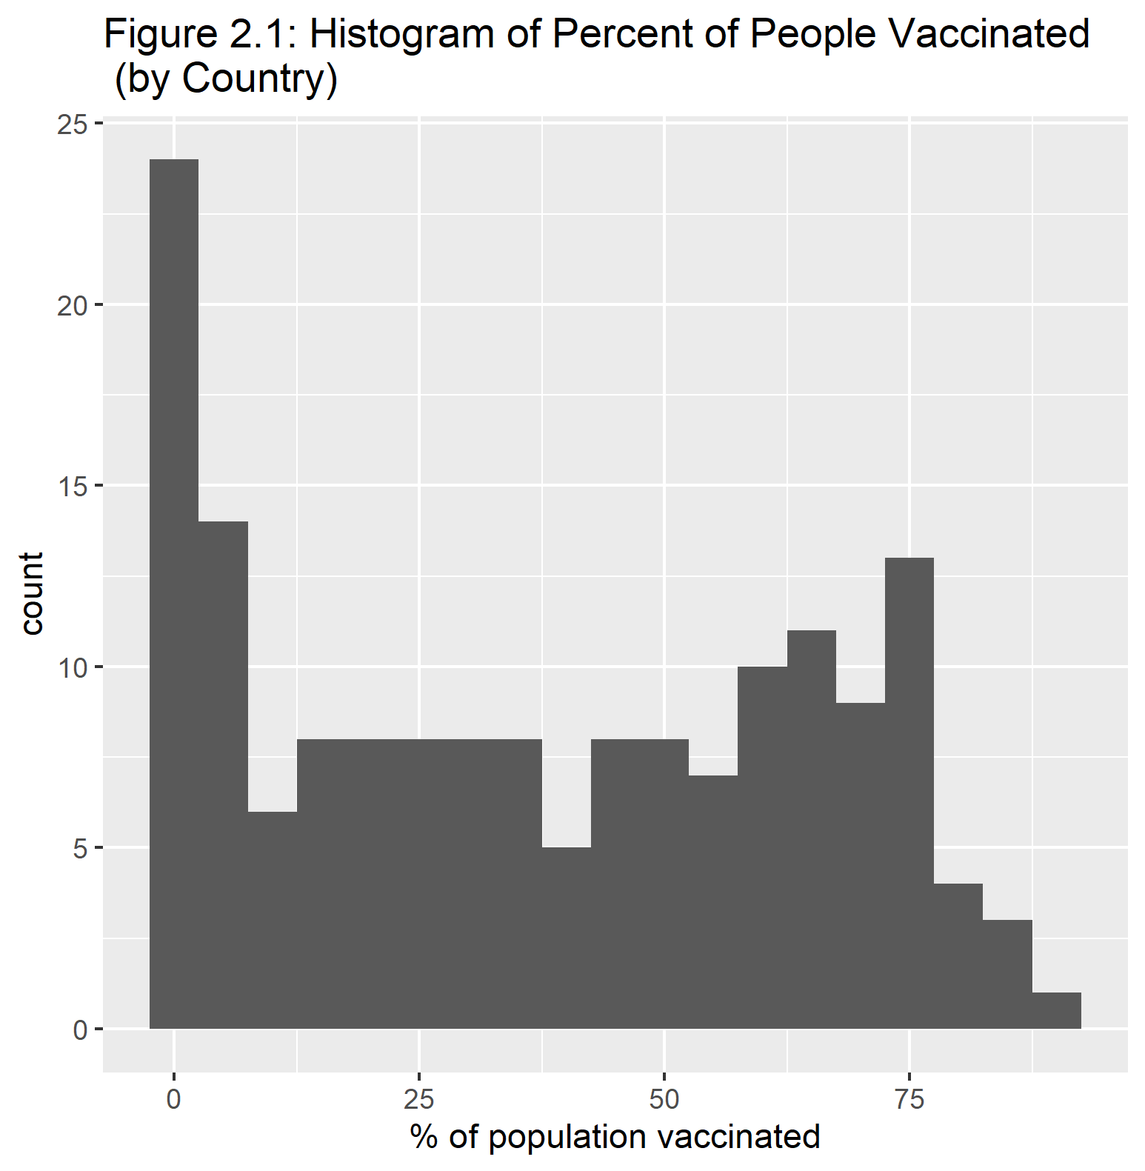

When looking at Figure 2.2, we can see that those countries who have large values of GDP per capita, their population is more vaccinated. The vaccination number varies when the GDP per capita is relatively low.

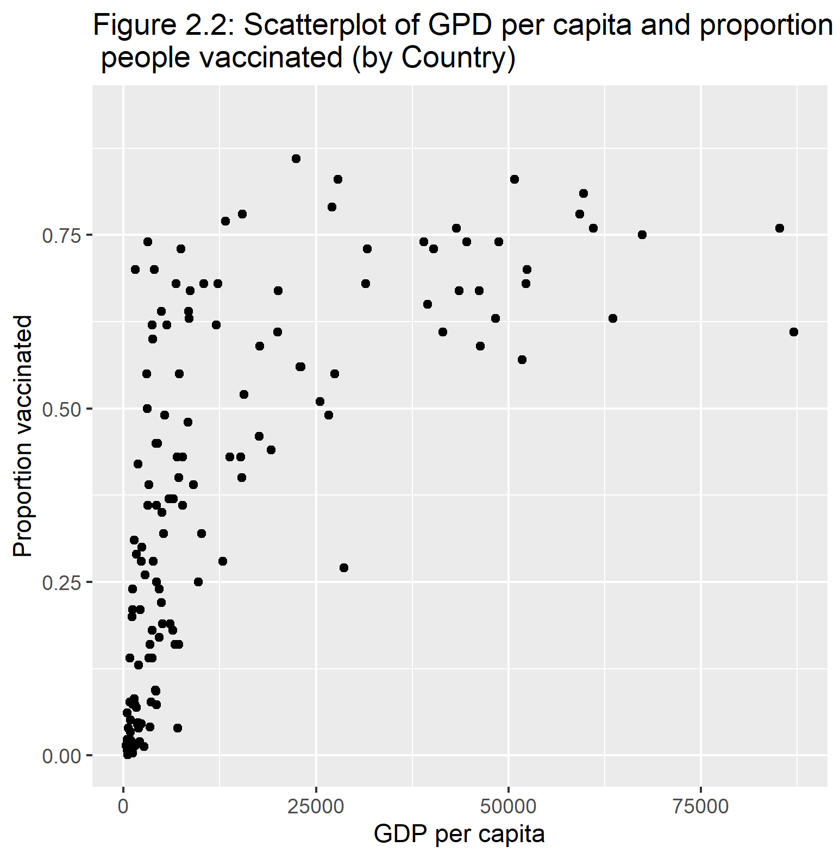

Looking at Figure 2.3, this side-by-side boxplot shows that Africa is significantly different to all of the other continents. Africa is historically known is a less developed continent. This could be result in lower supplies to Africa compared to other places in the world. Within the other continents, Europe seems to have th highest median vaccinated proportions.

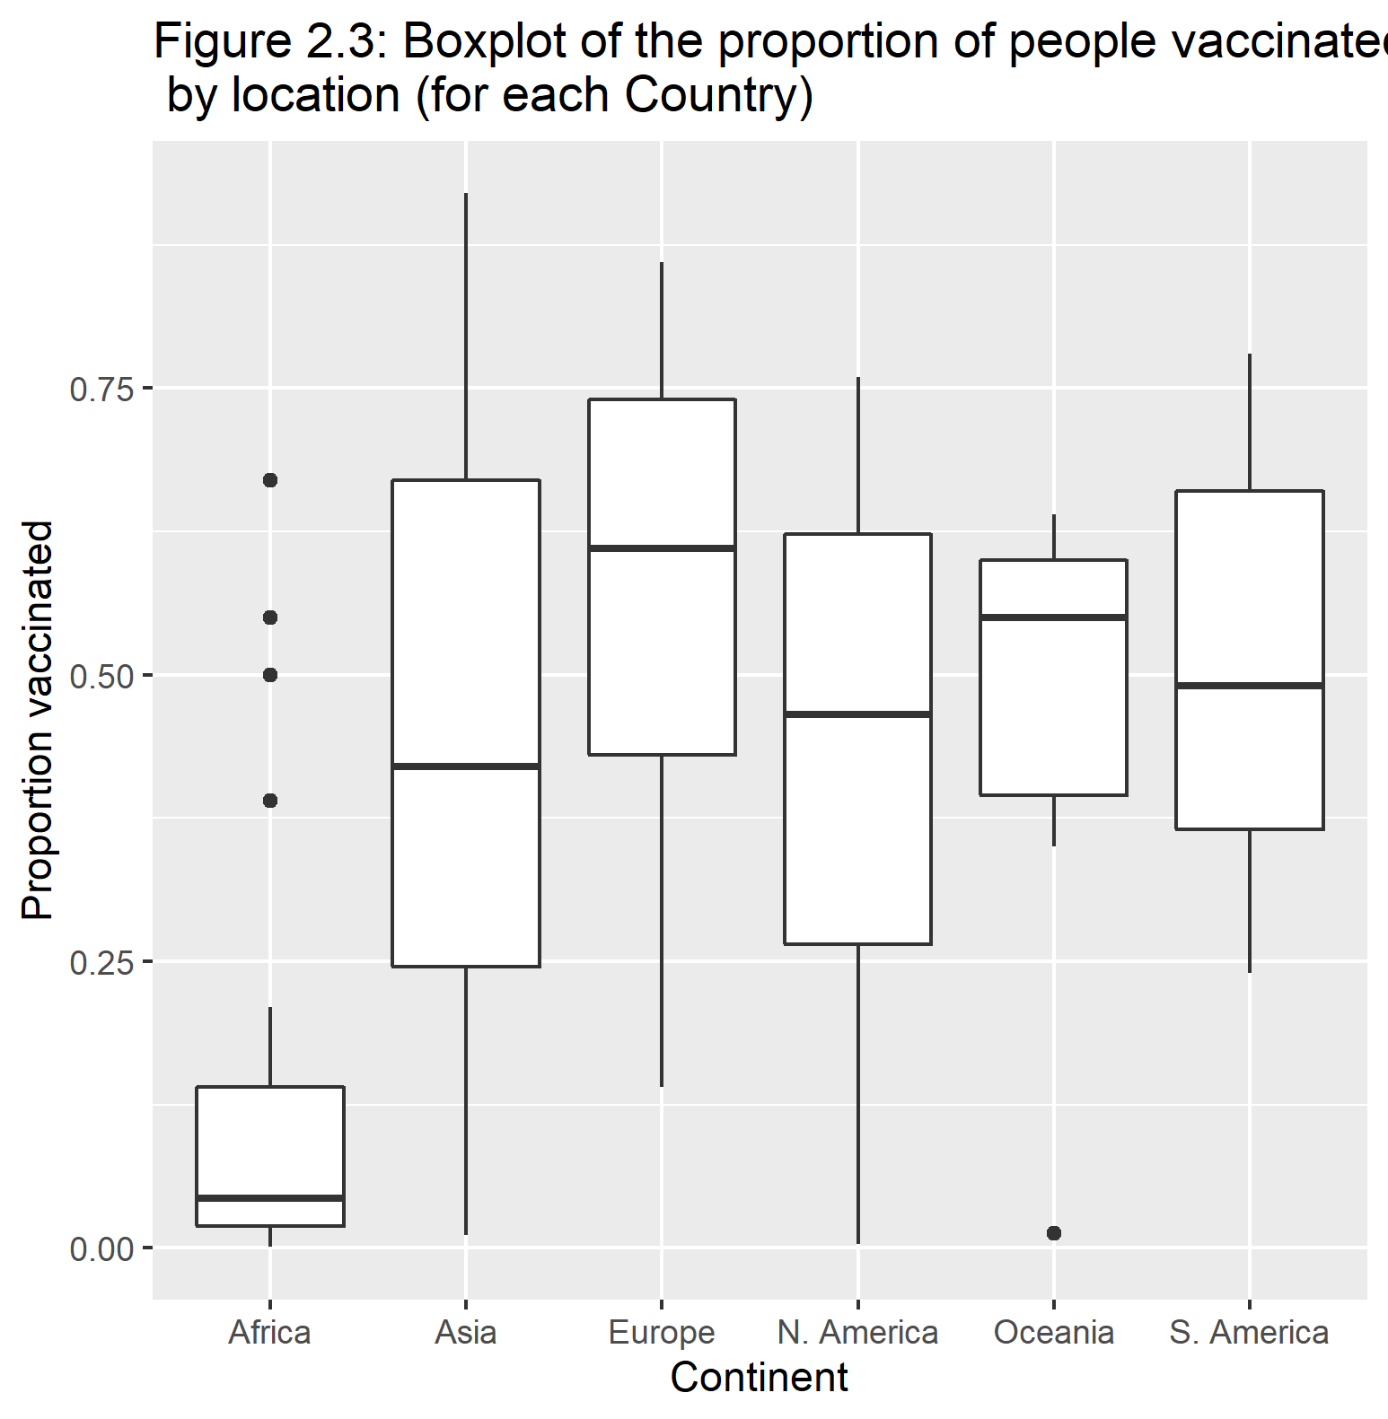

Figure 2.4 is showing the logit transformation of the proportion of the population vaccinated. This is due to the skewness of the non-transformed vaccinatio numbers. We see that this is still skewed but its skewed left where most of the data is around that 0 value.

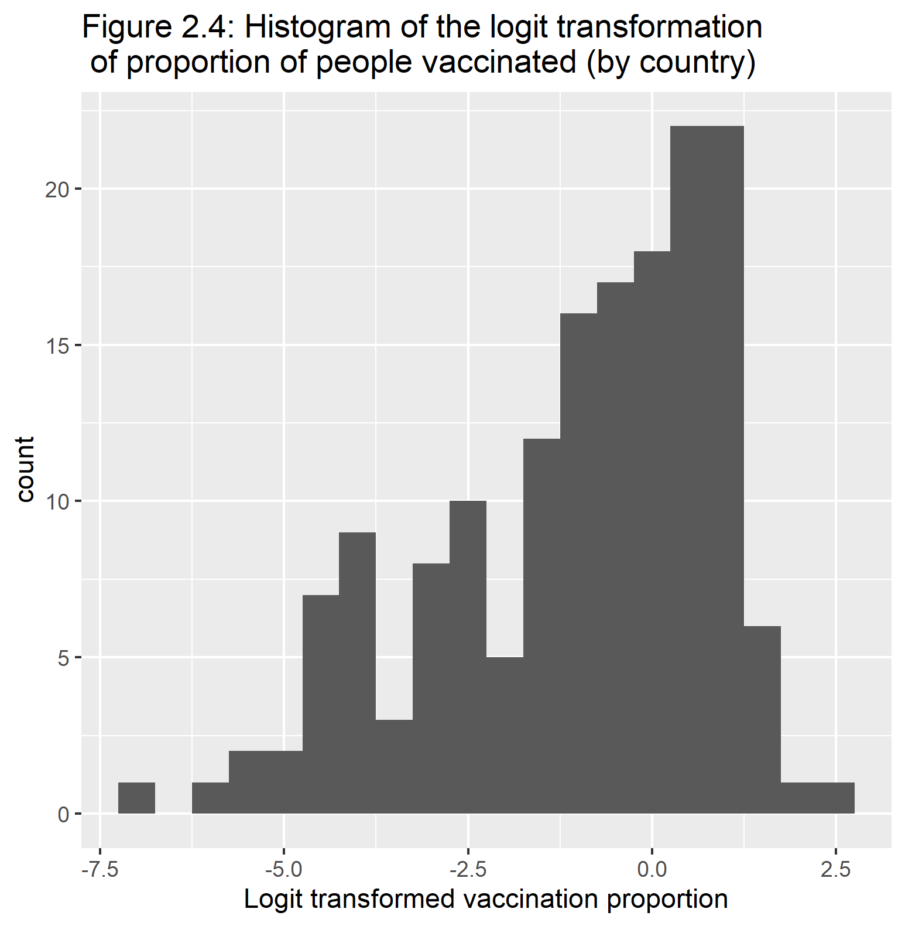

### 3.3.3 Main Analysis

As specified within the methods section, the first part of my analysis will be comparing the RMSE of my full model to the null model. However, before I do this I will run a correlation matrix of the numeric variables to see if some variables are highly correlated.

In Table 2.2 we can see that the two variable, which I suspected, that are highly correlated are health care funds (Value) and GDP per capita. Since those two variables are highly correlated and the health care funds variable only includes 48 observations, I will remove health care funds out of the full model.

Table 2.2: Correlation martrix of predictors and outcome

|  |  |  |  |  |  |
| --- | --- | --- | --- | --- | --- |
|  | prop_vacc | pct_cases | test_per_person | Value | gdp_per_capita |
| prop_vacc | 1.0000000 | 0.1684084 | 0.2318597 | 0.5676869 | 0.5756738 |
| pct_cases | 0.1684084 | 1.0000000 | 0.1536646 | 0.1593376 | 0.0140531 |
| test_per_person | 0.2318597 | 0.1536646 | 1.0000000 | 0.2479436 | 0.2898869 |
| Value | 0.5676869 | 0.1593376 | 0.2479436 | 1.0000000 | 0.8735441 |
| gdp_per_capita | 0.5756738 | 0.0140531 | 0.2898869 | 0.8735441 | 1.0000000 |

Now that I have my full model solidified, Table 2.3 shows the summary table and some other statistics of this full model. We can see that our adjusted R-sqaured value is around 0.64 and most of our factors are significant except the proportion of this who died and the COVID tests per person.

Table 2.3: Summary statistics for full model

|  |  |  |  |  |
| --- | --- | --- | --- | --- |
| term | estimate | std.error | statistic | p.value |
| (Intercept) | -2.8714980 | 0.2641891 | -10.8691000 | 0.0000000 |
| pct_cases | 0.0989961 | 0.0302531 | 3.2722585 | 0.0013594 |
| locationAsia | 1.7113258 | 0.2846914 | 6.0111607 | 0.0000000 |
| locationEurope | 1.3885657 | 0.3774886 | 3.6784307 | 0.0003397 |
| locationN. America | 1.4184950 | 0.3623432 | 3.9147833 | 0.0001438 |
| locationOceania | 0.9185536 | 0.6221918 | 1.4763190 | 0.1422220 |
| locationS. America | 2.3587484 | 0.4477937 | 5.2674885 | 0.0000005 |
| test_per_person | 0.0110275 | 0.0698538 | 0.1578660 | 0.8748018 |
| gdp_per_capita | 0.0000304 | 0.0000071 | 4.2899945 | 0.0000341 |
| prop_death | -7.6785506 | 8.6071937 | -0.8921085 | 0.3739460 |
| governmentMonarchy | 0.4722383 | 0.2693520 | 1.7532383 | 0.0818650 |
| governmentProvisional | -0.9040176 | 0.4699679 | -1.9235729 | 0.0565448 |

|  |  |  |  |  |  |  |  |  |  |  |  |
| --- | --- | --- | --- | --- | --- | --- | --- | --- | --- | --- | --- |
| r.squared | adj.r.squared | sigma | statistic | p.value | df | logLik | AIC | BIC | deviance | df.residual | nobs |
| 0.668835 | 0.6414454 | 1.125072 | 24.41932 | 0 | 11 | -216.571 | 459.142 | 497.8395 | 168.3496 | 133 | 145 |

**Simple Comparison of RMSE**

To start comparing the full model to the null model in terms of RMSE, we need to create training and test data sets. I used a 0.75 split for the training set. I am working on this project using Tidyverse and Tidymodels packages which uses the functions of recipes and workflows. The recipe I am specifying is the creation of the model which in this case, I need to make two. One of the recipes is for the full model and the other is for the null model. Since my outcome is numeric, we need to specify the type of model as well which is linear regression for our project. Once we have our model type and our recipe, we can combine them and put it in a workflow. This workflow will be able to combine the two settings we have and create a fit object which eventually creates the statistics of our models and our predictors. However, since our main objective is looking at the fit of our data, we want to look at the RMSE.

We can fit our fit object with both our test and training sets to see how well it does for both data sets. A general consensus on RMSE is that models with a value close to 1 is good and those who go farther away in the positive direction have a worse fit. We want our test and train values to be similar as well as that shows the model does not overfit the training data and results in a lower fit on the test data.

Table 2.4 shows the two values for the full model where the top is the training value and the bottom is the testing value. We can see that these two values are somewhat similar and possibly we want to a bit closer. However, these two values are relatively low which is a good sign.

Comparing Table 2.4 to Table 2.5, which shows the null models results, we can see our full model does a lot better than the null model. The RMSE is a lot worse for the null model. This is a good sign for the data as we now know that these predictors do have some type of association since it is way better than the null model. We can now proceed to creating our LASSO model and tuning this full model to find the best performing model.

Table 2.4: RMSE values for full model (training and test data, respectively)

|  |  |  |
| --- | --- | --- |
| .metric | .estimator | .estimate |
| rmse | standard | 1.080064 |
| rmse | standard | 1.158282 |

Table 2.5: RMSE values for null model (training and test data, respectively)

|  |  |  |
| --- | --- | --- |
| .metric | .estimator | .estimate |
| rmse | standard | 1.847835 |
| rmse | standard | 1.954252 |

**LASSO Model**

For the LASSO model, there is some preparation we need to run this. We will use cross validation to create the multiple models included in the LASSO model. This cross validation will be a 5-fold stratified by the outcome. We then, like previously, create a workflow using a specific model type and recipe. The recipe will be the full model recipe but the model type will be different. The LASSO model uses a specific model that has a tuning factor into a linear regression type. Once we have our workflow, we need to make a grid as the LASSO model created multiple models based on the 5-fold cross validation and other factors. From the workflow, we can apply a tuning grid to it. This will produce the variety of models. To find the best model, we an apply a function called show_best and specify RMSE to find the best model in terms of RMSE. After putting this model into a workflow and creating a fit object, we get the statistics of the best model.

Figure 2.5 shows the predicted values to the observed values. Most of the points follow the trend and there seems to show no pattern. We can see this more within Figure 2.6 which is the residual plot. Within Figure 2.6, we could see a slight pattern at the begging points where they are grouped up more.

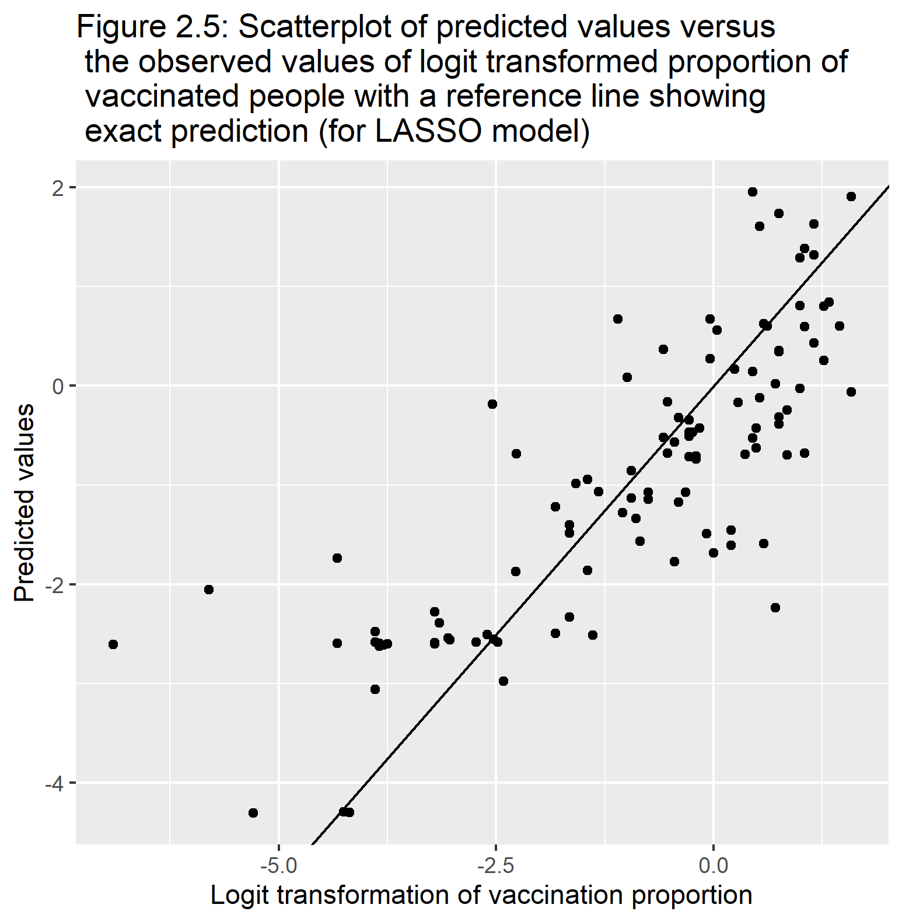

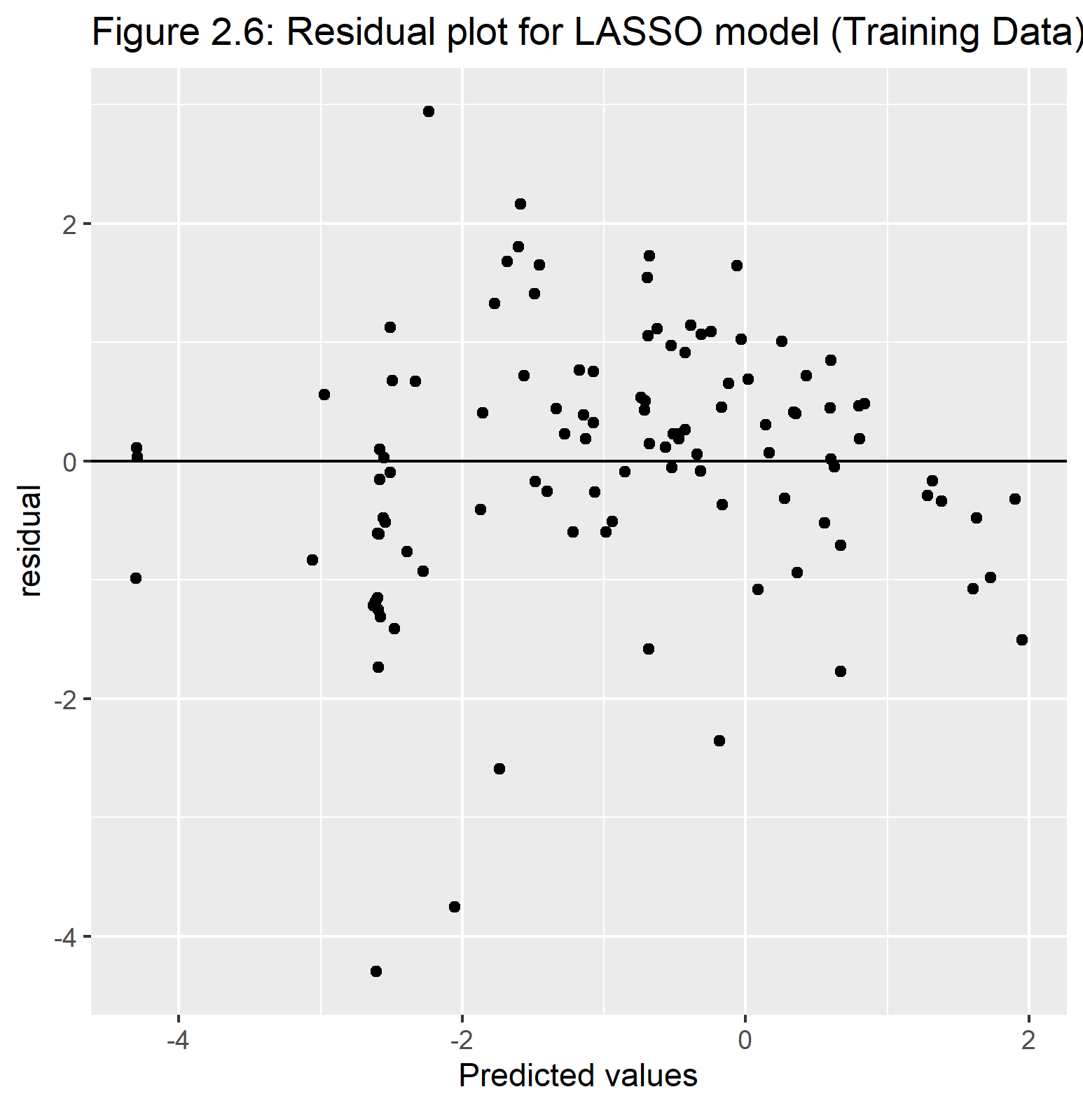

The last part of the LASSO modeling analysis is fitting the model to the test data to see how well they both look together. To look at the test data results, we need to run a last fit function which just applies the test data to the best model found above. Figure 2.7 and Figure 2.8 show the predicted values versus observed and its residual plot for the test data. Just like the training test, most of the predicted values do have a similar trend and it close to the observed value. The residual plot shows that concerning line of observations for the lower values. This residual plot show more variability in the lower values more. Table 2.6 shows the RMSE values created from this LASSO model. We can see unfortunately these are overall higher compared to the full model numbers. It is still better than the null model however.

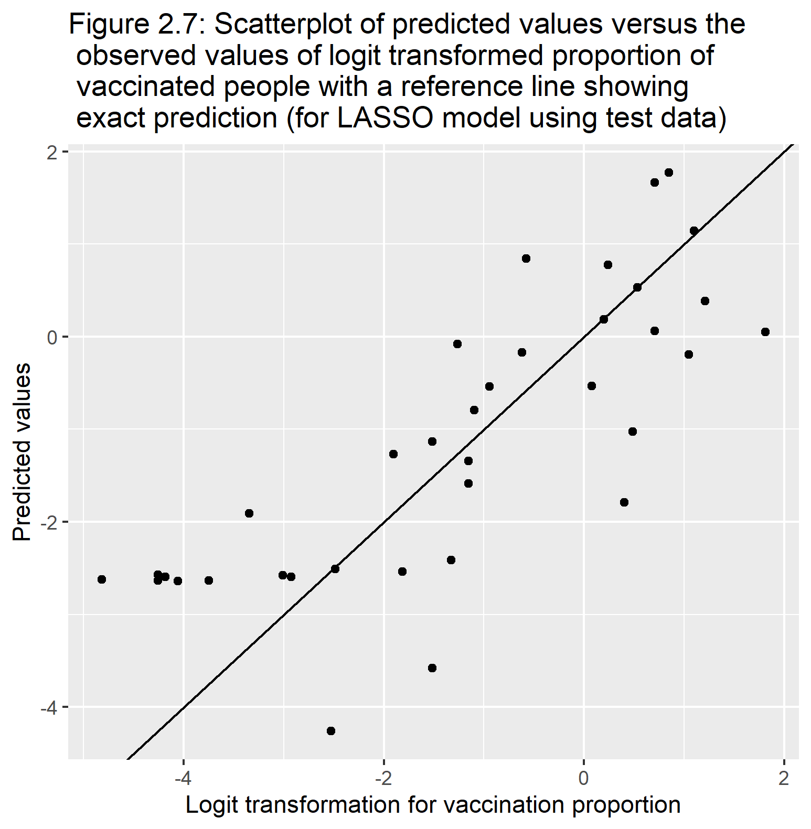

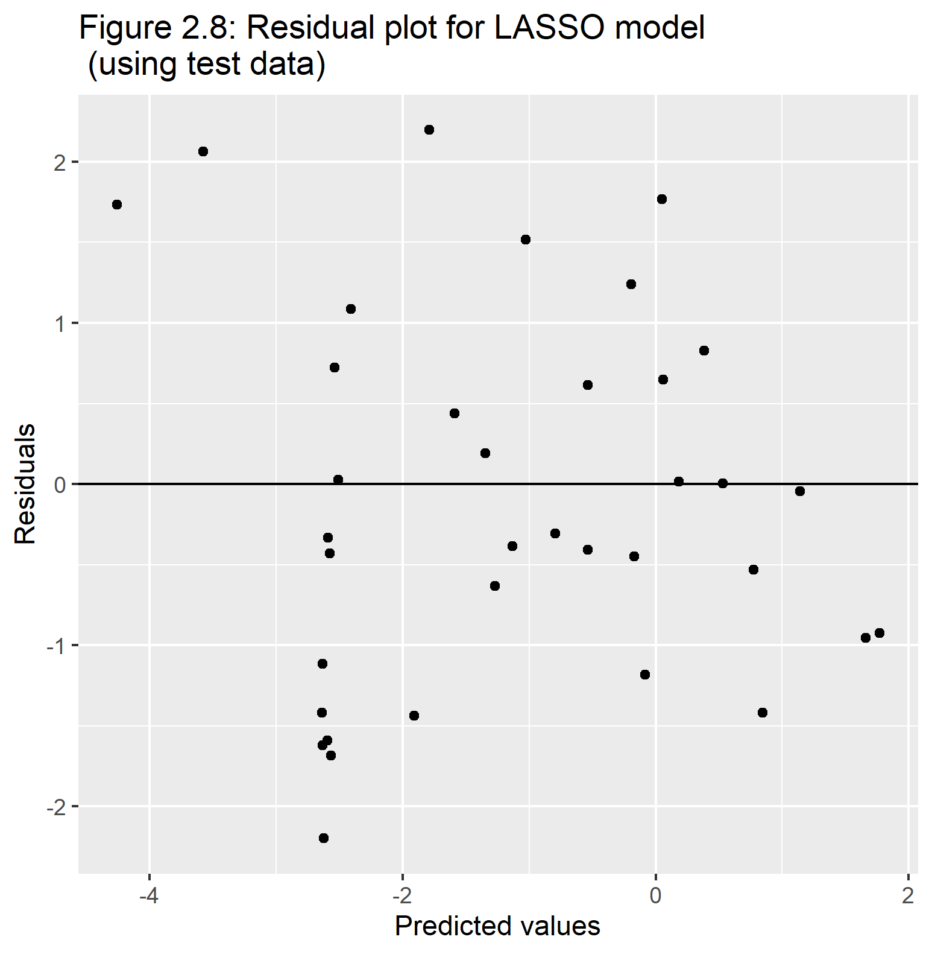

Table 2.6: Comparing RMSE for training and test split data for LASSO model, respectively

|  |  |  |  |  |  |  |
| --- | --- | --- | --- | --- | --- | --- |
| penalty | .metric | .estimator | mean | n | std_err | .config |
| 0.048939 | rmse | standard | 1.218491 | 25 | 0.0481934 | Preprocessor1_Model27 |

|  |  |  |  |
| --- | --- | --- | --- |
| .metric | .estimator | .estimate | .config |
| rmse | standard | 1.187789 | Preprocessor1_Model1 |

This is the product from the LASSO modeling. This is the model produced by LASSO. In Table 2.7, we can see there are 4 predictors and 2 were removed. The predictors that were removed was the proportion of those who died in each country and test per person. However these estimates are based on the logit transformation of our outcome. The last column is the transformation to display the transformed of each predictor applying the exp() function to the estimates.

From the estimates, we can see although there was 2 variables that suppressed to a value of 0 based on the LASSO model, the predictor gdp per capita have roughly a value of 0 which translates to a odds ratio close to 1. Those who include 1 or close to 1 results in a non-significant variable in predicting the outcome. We can see the continent that the country is in also has an affect on proportion vaccinated where the continent Africa is the reference group. The continents that increases the proportion of being vaccinated the most are Asia and South America. We can also see that in terms of government type where a republic government is the reference group, those countries that are a monarchy increase the proportion of having more vaccinations. In opposite affect, a provisional government country lowers the proportion of getting people vaccinated.

Table 2.7: Summary statistics of LASSO model and predictors with their respected transformed values

|  |  |  |  |
| --- | --- | --- | --- |
| term | estimate | penalty | Transformed_value |
| (Intercept) | -2.6588215 | 0.048939 | 0.0700307 |
| pct_cases | 0.1342715 | 0.048939 | 1.1437033 |
| gdp_per_capita | 0.0000316 | 0.048939 | 1.0000316 |
| location_Asia | 1.2032127 | 0.048939 | 3.3308006 |
| location_Europe | 0.5995112 | 0.048939 | 1.8212284 |
| location_N..America | 0.5420638 | 0.048939 | 1.7195520 |
| location_Oceania | 0.1796438 | 0.048939 | 1.1967910 |
| location_S..America | 1.4786906 | 0.048939 | 4.3871972 |
| government_Monarchy | 0.6308822 | 0.048939 | 1.8792677 |
| government_Provisional | -1.6703589 | 0.048939 | 0.1881795 |

# 4 Discussion

## 4.1 Summary and Interpretation

The analysis was split up into two different analyses specified by the two questions. The first analysis was looking at the difference of proportions between recovery and death rates. With some exploratory analysis, no association according to the simple linear regression between multiple predictors and the outcome. Since within some exploratory analysis and very small r-square values, I decided to stop that analysis on the first question and go to the next question.

The second question pertains to vaccination proportions. Using the logit transformation and applying the LASSO modeling, out of the 6 predictors within the full model, only 4 remained within the equation. These include percent of cases for a country, gdp per capita, the continent the country resides, and the type of government. Out of these, those who have the most impact are location and government type, and gdp per capita has roughly an estimate of 0 which probably has no impact on the proportion of people vaccinated.

## 4.2 Strengths and Limitations

Some strengths to this analysis was that since this topic of COVID-19 is in todays news which means much of the countries information is available in public use. Along with COIVD-19 information, most information of countries are of public use therefore lots of information was easy to find.

Some limitations for this analysis was that I was using cumulative data which means as more days pass, this data will become old analyses. Another limitation was although I got the information I wanted, I had to use multiple sources to find them which results in combining data sets and ultimately errors.

## 4.3 Conclusions

We find that due to high high recovery right is for most countries compared to death rates, and no predictors have a large association, according to the simple linear regression r-squared values, the difference in proportion between recovery and death rates is not affected by most predictors.

We see that the proportion of people vaccinated is associated with the amount of COVID-19 cases, which continent the country is in, and type of government. Given all other variable constant, Asia and South America gives the highest proportional increase compared to Africa, and monarchy governments increase vaccinations compared to republic government countries.

# References

Choi, E. M. (2021). COVID-19 vaccines for low- and middle-income countries. *Trans R Soc Trop Med Hyg*, *115*(5), 447–456. <https://doi.org/10.1093/trstmh/trab045>

COVID vaccines: Widening inequality and millions vulnerable. (2021). https://news.un.org/en/story/2021/09/1100192.

Liang, L.-L., Tseng, C.-H., Ho, H. J., & Wu, C.-Y. (2020). Covid-19 mortality is negatively associated with test number and government effectiveness. *Sci Rep*, *10*(1), 12567. <https://doi.org/10.1038/s41598-020-68862-x>