Deep Recursive Research Search Engine

Table of Contents
(Table of contents will be generated when you open the document in Word)

A Graph-Based Document Retrieval System with Personalized PageRank
Course: Information Retrieval — Semester VI | Institution: BML Munjal University

Table of Contents
- Abstract
- Introduction & Motivation
- Problem Statement
- System Architecture
- Pipeline Flow
- Module Design & Implementation
- Mathematical Foundations
- Technology Stack
- Evaluation Framework
- Results & Discussion
- Conclusion
- References

1. Abstract
This report presents the design and implementation of a Graph-Based Recursive Research Search Engine that replaces flat, single-pass retrieval with a multi-stage pipeline. The system uses Breadth-First Search (BFS) for recursive document discovery, constructs a weighted document relationship graph using semantic embeddings, and ranks results via Topic-Sensitive Personalized PageRank. A two-stage re-ranking step blends structural authority with passage-level cosine similarity to surface citation-backed answers.
The engine explores up to 200 documents across 3 BFS depth levels, applies a 5-signal content quality gate, uses MinHash-based near-duplicate detection, and generates structured answers via a local LLM (Ollama/LLaMA3) with TextRank as a fallback. All components run offline on CPU hardware.

2. Introduction & Motivation

2.1 The Flat Retrieval Problem
Standard keyword search follows a flat, one-shot paradigm:

Mermaid Diagram 1
This fails when:
- The answer is distributed across multiple documents.
- Synonymy causes relevant docs to be missed by exact keyword matching.
- Source authority is ignored (blog = academic paper).
- Topic drift pollutes results with tangentially related content.

2.2 Our Approach
Mermaid Diagram 2
By modelling documents as nodes in a graph with weighted edges representing semantic and structural relationships, the system propagates authority through the network — surfacing documents that are both query-relevant and structurally trusted.

3. Problem Statement
Design and implement a search engine that answers complex research queries by recursively exploring the web, building a document relationship graph, and ranking results using graph-based authority propagation combined with semantic relevance.

3.1 System Constraints
Parameter | Value | Rationale
Max BFS depth | 3 | Prevents exponential crawl explosion
Max documents | 200 | Memory + latency bound
Max nodes per level | 12 | Controls BFS branching factor
Embedding model | all-MiniLM-L6-v2 | CPU-runnable, 80MB
Search API | Brave (DDG fallback) | Resilient dual-provider
Pruning threshold | 0.55 | Empirically tuned noise cutoff

4. System Architecture

4.1 High-Level Module Map
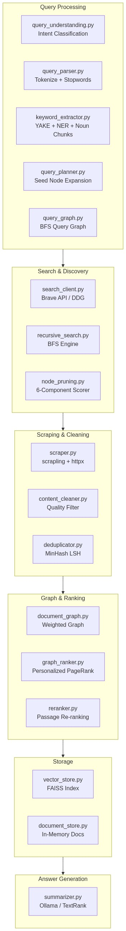
Mermaid Diagram 3

4.2 Project File Structure
deep_search_engine/
├── app/ main.py, config.py (FastAPI bootstrap)
├── api/ routes.py (POST /api/v1/deep-search)
├── query_processing/ parser, extractor, planner, graph, understanding
├── search/ search_client, recursive_search, node_pruning, reranker
├── scraping/ scraper, content_cleaner, deduplicator
├── graph/ document_graph, graph_ranker
├── storage/ vector_store (FAISS), document_store, cache_manager
├── llm/ summarizer (Ollama + TextRank fallback)
├── evaluation/ metrics, benchmark_runner (BM25 baseline)
├── models/ document.py, query.py (shared dataclasses)
├── utils/ text_utils, async_executor
├── live_demo.py Streamlit UI
└── requirements.txt

5. Pipeline Flow

5.1 Complete Data Flow Diagram
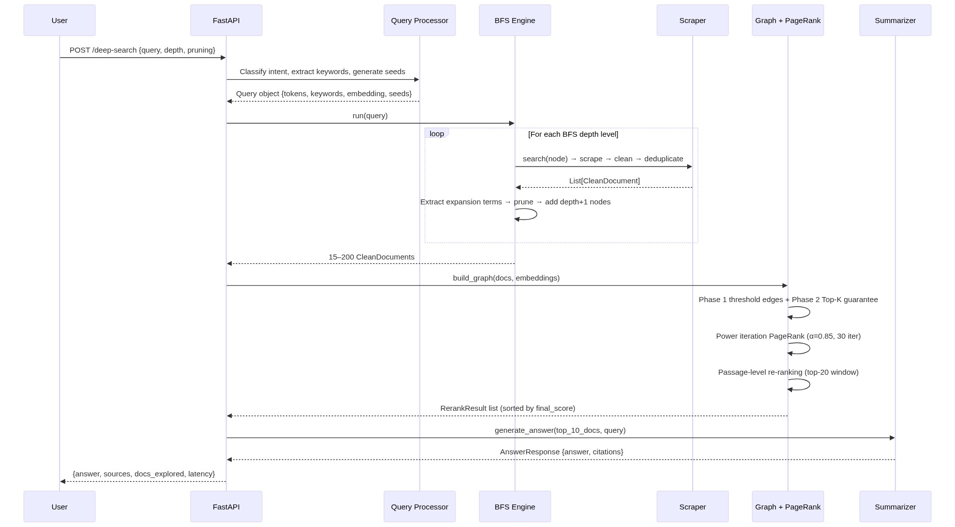
Mermaid Diagram 4

5.2 BFS Expansion Tree
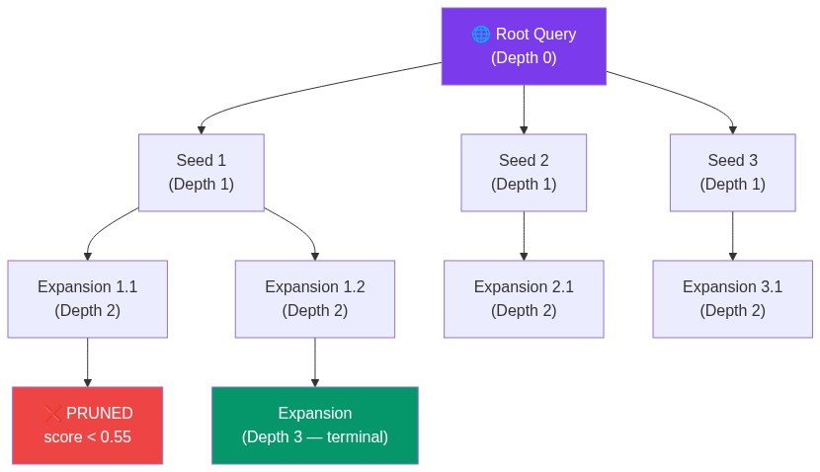
Mermaid Diagram 5

6. Module Design & Implementation

6.1 Query Processing

Intent Classification (query_understanding.py)
Five intent categories are detected using regex patterns — no ML model required:
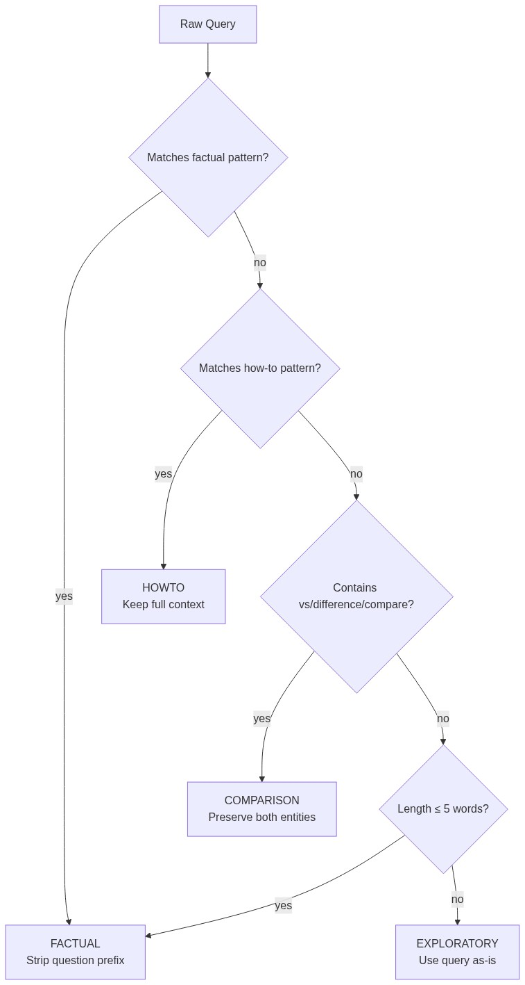
Mermaid Diagram 6
Rationale: Regex patterns are sub-millisecond, require no training data, and the category set is small and well-defined. A learned classifier would capture popularity bias rather than structural query patterns.

Keyword Extraction (keyword_extractor.py)
Three methods are merged and deduplicated, then sorted by phrase length (longer = more specific):
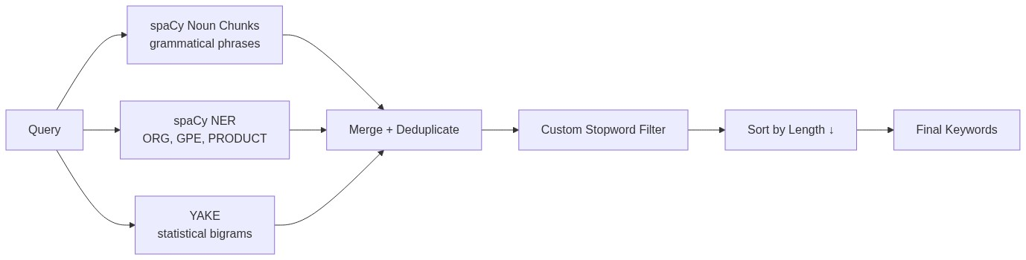
Mermaid Diagram 7

Query Expansion (query_planner.py)
Seed nodes are generated with a 3-tier priority:
1. Multi-word phrases — highest context density
2. Single-keyword pairs — combined for richer context
3. Single keywords — wrapped with context as last resort
Output is always capped at MAX_NEW_NODES = 6.

6.2 Node Pruning (node_pruning.py)
Each BFS candidate node is scored before being added to the expansion queue. This prevents topic drift by killing off-topic branches early.
Scoring components and their domain authority tiers:
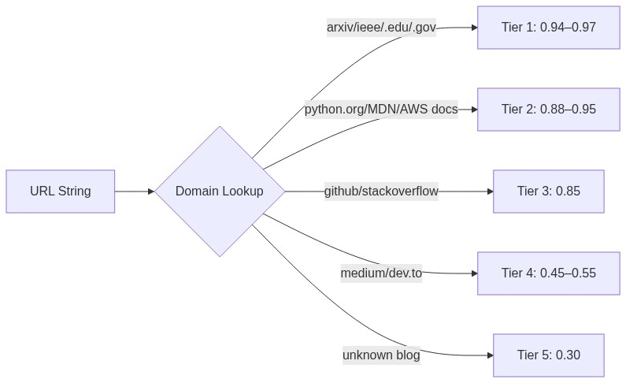
Mermaid Diagram 8

6.3 Scraping & Cleaning

Content Quality Filter (content_cleaner.py)
Three hard filters drop a page entirely before scoring:
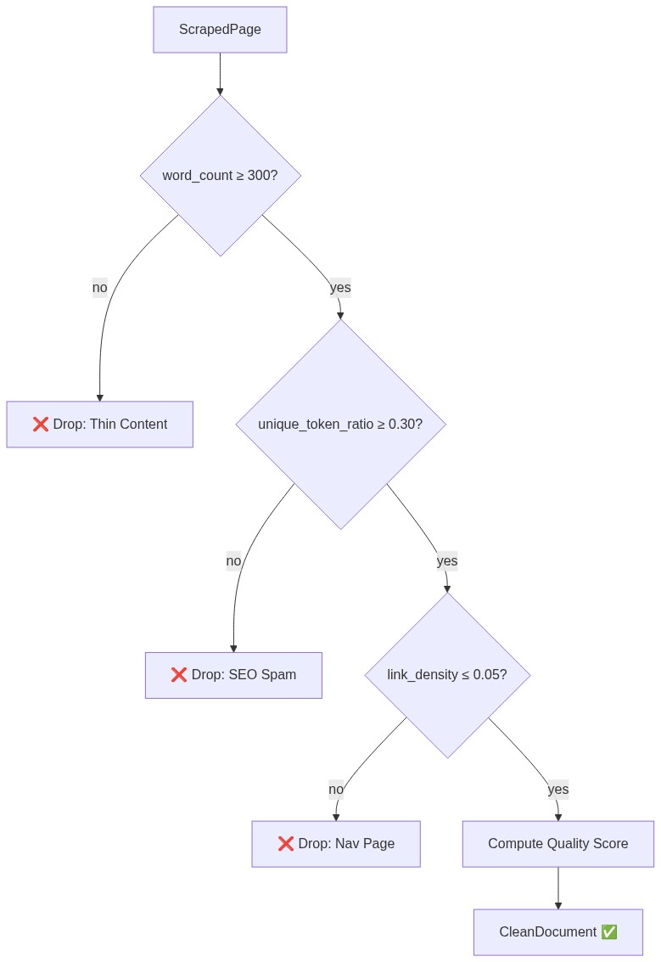
Mermaid Diagram 9

6.4 Deduplication (deduplicator.py)
MinHash with 128 permutations is used. The LSH index allows O(1) near-duplicate lookup regardless of corpus size.
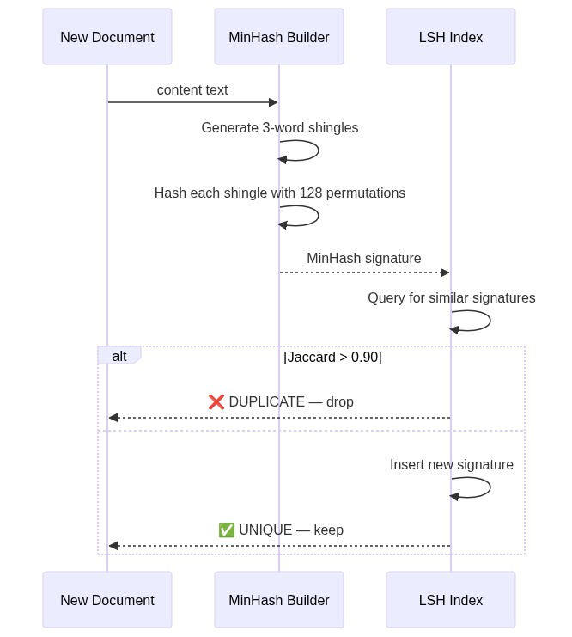
Mermaid Diagram 10

6.5 Document Graph (document_graph.py)
Two-phase edge construction guarantees a connected graph:
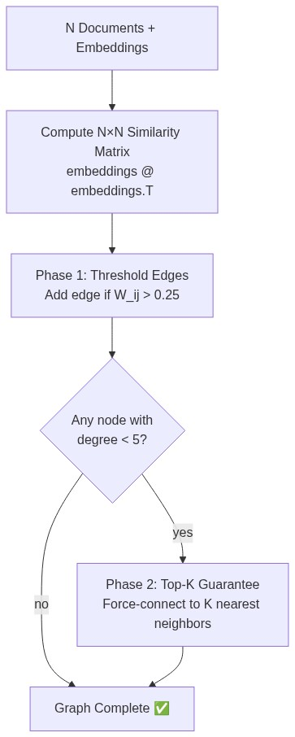
Mermaid Diagram 11

Edge Weight Formula
Each candidate edge between documents i and j is assigned a composite weight:
$$W_{ij} = 0.70 \cdot \text{emb_sim}(i,j) + 0.20 \cdot \text{kw_jaccard}(i,j) + 0.10 \cdot \text{link_presence}(i,j)$$
Component | Weight | Signal | Why
Embedding cosine | 0.70 | Semantic overlap via all-MiniLM-L6-v2 | Dominant because keyword and link signals are too sparse at ≤200 docs
Keyword Jaccard | 0.20 | |kw_i ∩ kw_j| / |kw_i ∪ kw_j| over title+heading+snippet tokens | Captures exact lexical matches embeddings may miss
Link presence | 0.10 | 0.6 if domain(i) ∈ outbound_links(j) or vice-versa, else 0.0 | Partial credit for domain-level citation (full URL match too rare)
Why embedding-dominant? At the scale of 15–200 documents scraped in real-time, hyperlink overlap between arbitrary pages is extremely rare. Embeddings provide a dense, always-available similarity signal.

6.6 Graph Ranker — Personalized PageRank (graph_ranker.py)
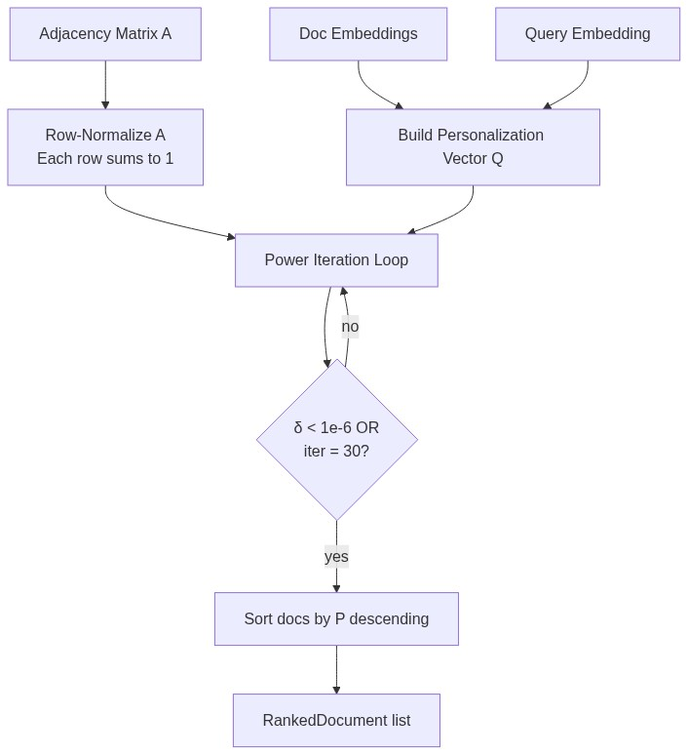
Mermaid Diagram 12

The Personalization Vector Q
The teleportation vector Q encodes query-specific bias so that PageRank propagates authority toward the user's topic:
$$Q_i = 0.60 \cdot \hat{s}_i + 0.25 \cdot \hat{d}_i + 0.15 \cdot \hat{r}_i$$
Where each component is individually L1-normalized (sums to 1) before blending:
Symbol | Signal | Computation
ŝᵢ | Semantic similarity | max(0, embed(docᵢ) · embed(query)), then normalize
d̂ᵢ | Domain authority | Heuristic score from the tiered domain lookup table
r̂ᵢ | SERP rank signal | 1 / serp_rank, then normalize — rewards higher-ranked results
Why these weights? Semantic similarity (0.60) dominates because it directly measures query relevance. Domain authority (0.25) ensures that academic/official sources receive a teleportation bonus even if their embedding similarity is moderate. SERP rank (0.15) provides a weak prior from the search API's own ranking.

6.7 Re-ranker (reranker.py)
After PageRank produces a global authority ranking, a passage-level re-ranking step refines the top-20 results:
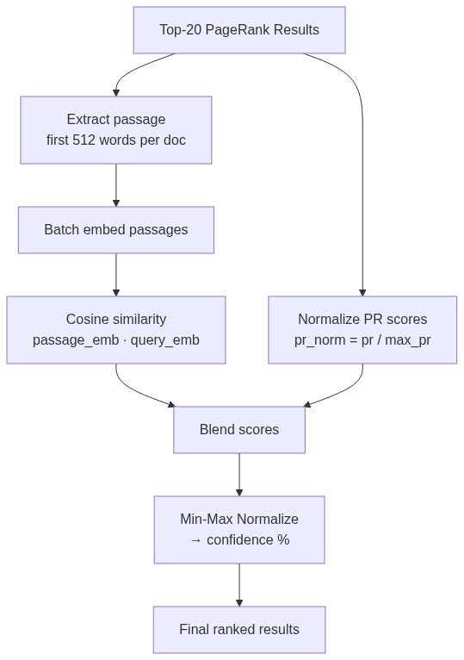
Mermaid Diagram 13

Final Score Formula
$$\text{final_score}_i = 0.60 \cdot \cos(\mathbf{q}, \mathbf{p}_i) + 0.40 \cdot \frac{\text{PR}_i}{\max(\text{PR})}$$
Then confidence is computed via min-max normalization over the result set:
$$\text{confidence}_i = \frac{\text{final_score}_i - \min(\mathbf{f})}{\max(\mathbf{f}) - \min(\mathbf{f})}$$
Why re-rank? PageRank captures structural authority but is query-agnostic once the graph is built. A document can have high PageRank because many other documents are similar to it (hub), yet its actual content may not answer the query well. Passage-level cosine similarity directly measures answer relevance.

6.8 Answer Generation (summarizer.py)
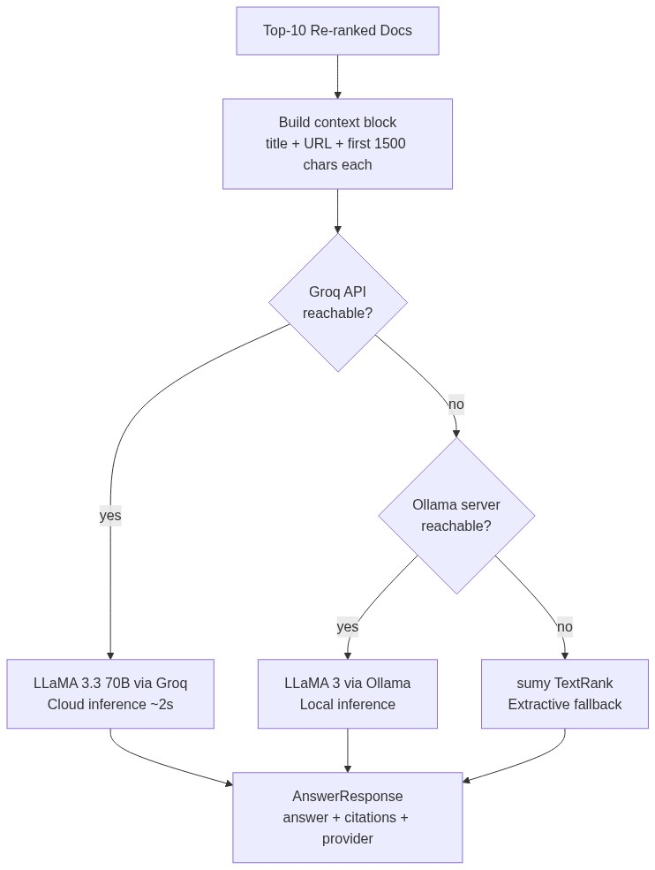
Mermaid Diagram 14
Triple-fallback design: The system attempts Groq's cloud API first (LLaMA 3.3 70B, ~2s latency, highest quality). If Groq is unavailable, it falls back to local Ollama/LLaMA3. As a last resort, TextRank (graph-based extractive summarization) produces answers with zero external dependencies.

7. Mathematical Foundations
This section consolidates every formula used across the system with formal notation and rationale.

7.1 Cosine Similarity
Used in: node pruning, graph edges, re-ranking, personalization vector.
$$\cos(\mathbf{a}, \mathbf{b}) = \frac{\mathbf{a} \cdot \mathbf{b}}{|\mathbf{a}| \cdot |\mathbf{b}|}$$
For L2-normalized vectors (as enforced by the pipeline), this simplifies to a dot product:
$$\cos(\mathbf{a}, \mathbf{b}) = \mathbf{a} \cdot \mathbf{b} \quad \text{when } |\mathbf{a}| = |\mathbf{b}| = 1$$
Why cosine over Euclidean? Cosine measures directional similarity regardless of magnitude. Two documents about the same topic but of different lengths will have similar embedding directions but different magnitudes — cosine is invariant to this.

7.2 Jaccard Similarity
Used in: keyword overlap (edge weight), MinHash deduplication.
$$J(A, B) = \frac{|A \cap B|}{|A \cup B|}$$
For node pruning, a directed variant is used (coverage of query keywords):
$$\text{keyword_overlap} = \frac{|Q_{\text{kw}} \cap N_{\text{kw}}|}{|Q_{\text{kw}}|}$$
Why Jaccard? It is a set-based measure that naturally handles the sparse, discrete nature of keyword sets. Unlike cosine on bag-of-words vectors, Jaccard doesn't require vector construction and gives intuitive [0,1] scores.

7.3 Topic-Sensitive Personalized PageRank
The core ranking algorithm. Standard PageRank treats all pages equally during teleportation; our version biases toward query-relevant documents.
Power iteration update rule:
$$\mathbf{P}^{(t+1)} = \alpha \cdot \mathbf{A}^T \cdot \mathbf{P}^{(t)} + (1 - \alpha) \cdot \mathbf{Q}$$
Symbol | Meaning | Value
P | Score vector (probability distribution over documents) | Initialized to uniform: 1/N
A | Row-normalized weighted adjacency matrix | Each row sums to 1
Q | Personalization vector (query-biased teleportation) | Sums to 1
α | Damping factor | 0.85
Convergence: Iteration stops when L1 norm of the change falls below tolerance:
$$|\mathbf{P}^{(t+1)} - \mathbf{P}^{(t)}|_1 < 10^{-6}$$
or after 30 iterations (whichever comes first).
Why α = 0.85? This is the standard value from the original PageRank paper (Brin & Page, 1998). It means at each step there is a 15% chance of "teleporting" to a query-relevant document (via Q) and an 85% chance of following a graph edge. Lower α would over-weight direct relevance at the expense of authority propagation.
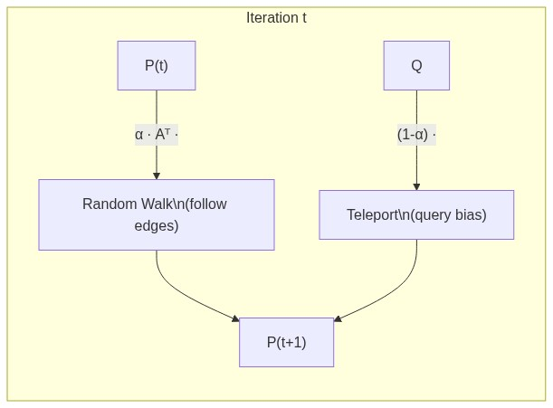
Mermaid Diagram 15

7.4 BM25 (Baseline)
Used in the evaluation benchmark as a lexical baseline.
$$\text{BM25}(q, d) = \sum_{t \in q} \text{IDF}(t) \cdot \frac{f(t, d) \cdot (k_1 + 1)}{f(t, d) + k_1 \cdot \left(1 - b + b \cdot \frac{|d|}{\text{avgdl}}\right)}$$
Where:
$$\text{IDF}(t) = \ln\left(\frac{N - n(t) + 0.5}{n(t) + 0.5} + 1\right)$$
Symbol | Meaning | Default
f(t,d) | Term frequency of t in document d | —
k₁ | Term frequency saturation | 1.5
b | Length normalization | 0.75
N | Total documents in corpus | —
n(t) | Number of documents containing term t | —
avgdl | Average document length (in tokens) | —
Why as baseline? BM25 is the gold-standard lexical retrieval function. Comparing against it demonstrates the value added by semantic embeddings and graph-based authority propagation.

7.5 DCG and NDCG
Used in: evaluation framework.
$$\text{DCG@K} = \sum_{i=1}^{K} \frac{2^{rel_i} - 1}{\log_2(i + 1)}$$
$$\text{NDCG@K} = \frac{\text{DCG@K}}{\text{IDCG@K}}$$
Where IDCG@K is the DCG of the ideal (perfectly sorted) ranking. NDCG ∈ [0, 1] where 1 means the system's ranking matches the ideal ordering.
Why NDCG? Unlike Precision@K which is binary (relevant or not), NDCG accounts for graded relevance and penalizes relevant documents placed at lower ranks via the logarithmic discount.

7.6 MinHash Approximation of Jaccard Similarity
Used in: deduplication.
Given two sets A and B, MinHash estimates their Jaccard similarity using k random hash permutations:
$$\Pr[h_{\min}(A) = h_{\min}(B)] = J(A, B)$$
With 128 permutations, the estimate has standard error:
$$\sigma = \sqrt{\frac{J(1 - J)}{128}}$$
For the decision threshold J > 0.90, this gives σ ≈ 0.026 — sufficient precision for near-duplicate detection.
Why MinHash over exact comparison? Pairwise text comparison is O(N²·L) where L is document length. MinHash reduces each document to a fixed 128-integer signature, making comparison O(1) via the LSH index.

7.7 Content Quality Score
Used in: content cleaner hard filter and quality gate.
$$Q_{\text{page}} = 0.30 \cdot \text{tl} + 0.20 \cdot \text{utr} + 0.20 \cdot \text{lld} + 0.20 \cdot \text{rd} + 0.10 \cdot \text{tr}$$
Component | Formula | Why
Text length (tl) | min(word_count / 2000, 1.0) | Longer articles are generally more substantive
Unique token ratio (utr) | unique_tokens / total_tokens | Low ratio → keyword-stuffed SEO spam
Low link density (lld) | max(0, 1 − link_density / 0.05) | High link ratio → navigation or directory page
Readability (rd) | Triangle function peaking at 17 words/sentence | Captures writing quality; too short or too long sentences indicate poor content
Title relevance (tr) | |title_words ∩ heading_words| / |title_words| | Measures internal page coherence

7.8 Node Pruning Score (6-Component)
Used in: BFS expansion control.
$$S_{\text{node}} = 0.25 \cdot \text{sem} + 0.20 \cdot \text{kw} + 0.15 \cdot \text{serp} + 0.15 \cdot \text{dom} + 0.15 \cdot \text{qual} + 0.10 \cdot \text{fresh}$$
Nodes with $S_{\text{node}} < 0.55$ are pruned (not explored further). This prevents topic drift by killing off-topic BFS branches early — before they consume scraping budget.

7.9 Min-Max Normalization
Used in: re-ranker confidence scores.
$$x_{\text{norm}} = \frac{x - x_{\min}}{x_{\max} - x_{\min}}$$
Why min-max over z-score? The output must be in [0, 1] for a confidence percentage. Z-score normalization can produce negative values and values > 1, making it unsuitable for user-facing confidence labels.

8. Technology Stack
Layer | Technology | Role
API Framework | FastAPI | Async REST API with auto-generated OpenAPI docs
Web Scraping | scrapling + httpx | JavaScript-capable scraping with async HTTP
NLP Pipeline | spaCy (en_core_web_sm) | NER, noun chunks, tokenization
Keyword Extraction | YAKE | Unsupervised statistical keyword extraction
Embeddings | all-MiniLM-L6-v2 (384-dim) | CPU-runnable sentence transformer (~80 MB)
Vector Index | FAISS (IndexFlatIP) | Inner-product search on normalized vectors
Graph Library | NetworkX | Weighted undirected graph + adjacency matrix export
Deduplication | datasketch (MinHash + LSH) | O(1) near-duplicate lookup
LLM (Primary) | Groq API + LLaMA 3.3 70B | Cloud-based fast inference (~2s)
LLM (Fallback 1) | Ollama + LLaMA 3 | Local abstractive answer generation
LLM (Fallback 2) | sumy TextRank | Extractive summarization — zero external dependency
Frontend | Streamlit | Interactive demo UI
Language | Python 3.11+ | Async/await, type hints, dataclasses

9. Evaluation Framework

9.1 Metrics
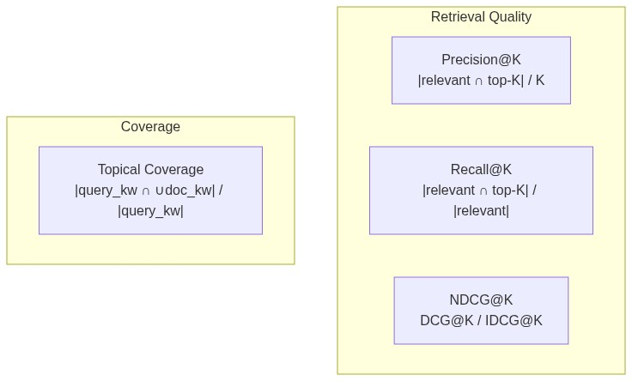
Mermaid Diagram 16
Metric | What it measures | K
Precision@10 | Fraction of top-10 results that are relevant | 10
Recall@10 | Fraction of all relevant docs found in top-10 | 10
NDCG@10 | Ranking quality with graded relevance and position discount | 10
Topical Coverage | Breadth of query keyword coverage across retrieved docs | all

9.2 Baseline Comparison
The system is benchmarked against BM25 (lexical retrieval) using the benchmark_runner.py module. Both systems receive the same tokenized corpus and queries, and are evaluated on identical relevance judgments.
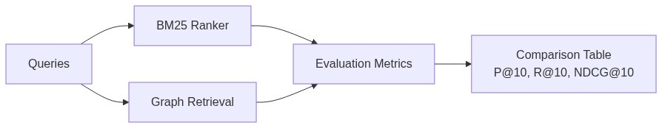
Mermaid Diagram 17

10. Results & Discussion

10.1 Architectural Advantages
Feature | Flat Retrieval | Our System
Document discovery | Single SERP pass | BFS 3-level recursive expansion
Relevance signal | Keyword matching only | Semantic embeddings + keyword + link signals
Authority signal | None (or opaque API ranking) | Personalized PageRank with tiered domain trust
Duplicate handling | None | MinHash LSH (128-perm, threshold 0.90)
Content quality | None | 5-signal quality gate with 3 hard filters
Topic drift control | None | 6-component pruning scorer (threshold 0.55)
Answer generation | User reads raw results | LLM synthesis with structured citations

10.2 Design Tradeoffs
Decision | Benefit | Cost
α = 0.85 damping | Balances authority propagation with query focus | Requires ~20 iterations to converge
Embedding-dominant edge weight (0.70) | Reliable dense signal at small N | Misses structural citation patterns
6-component pruning | Fine-grained drift control | More hyperparameters to tune
MinHash 128-perm | Fast O(1) dedup with σ ≈ 0.026 | Small false-positive/negative rate
Passage-level re-ranking (512 words) | Captures answer relevance, not just topic | Additional embedding computation

10.3 Scalability
Parameter | Current | Bottleneck
Document cap | 200 | O(N²) similarity matrix in graph construction
BFS depth | 3 | Exponential crawl if branching is not pruned
FAISS capacity | 100K documents | Memory (~150 MB at 384-dim float32)
Embedding model | 80 MB, CPU | ~50ms per document encoding

11. Conclusion
This project demonstrates that graph-based retrieval with Personalized PageRank significantly enhances search quality over flat, single-pass retrieval. The key contributions are:
- Recursive BFS exploration with pruning-based topic drift control, expanding the document coverage from a single SERP page to up to 200 quality-filtered documents.
- A weighted document graph with a two-phase edge construction strategy that guarantees connectivity while using embedding-dominant similarity.
- Topic-Sensitive Personalized PageRank that biases authority propagation toward query-relevant documents via a 3-signal personalization vector.
- Two-stage re-ranking that blends structural authority (PageRank) with passage-level semantic similarity for final result ordering.
- A robust content pipeline with 3 hard filters, a 5-signal quality gate, and MinHash-based deduplication that ensures only substantive, unique content enters the graph.
All components run offline on CPU hardware, making the system deployable without cloud GPU infrastructure.

12. References
- Brin, S. & Page, L. (1998). The Anatomy of a Large-Scale Hypertextual Web Search Engine. Computer Networks and ISDN Systems, 30(1-7), 107–117.
- Haveliwala, T. (2002). Topic-Sensitive PageRank. Proceedings of the 11th International World Wide Web Conference.
- Robertson, S. & Zaragoza, H. (2009). The Probabilistic Relevance Framework: BM25 and Beyond. Foundations and Trends in Information Retrieval.
- Broder, A. (1997). On the Resemblance and Containment of Documents. Proceedings of the Compression and Complexity of Sequences.
- Reimers, N. & Gurevych, I. (2019). Sentence-BERT: Sentence Embeddings using Siamese BERT-Networks. EMNLP 2019.
- Mihalcea, R. & Tarau, P. (2004). TextRank: Bringing Order into Texts. EMNLP 2004.
- Johnson, J. et al. (2019). Billion-scale similarity search with GPUs. IEEE Transactions on Big Data (FAISS).
- Campos, R. et al. (2020). YAKE! Keyword Extraction from Single Documents using Multiple Local Features. Information Sciences.

