Question 1. Create a Flask application with an /api route. When this route is accessed, it should return a JSON list. The data should be stored in a backend file, read from it, and sent as a response.

Below is snippet of app.py file

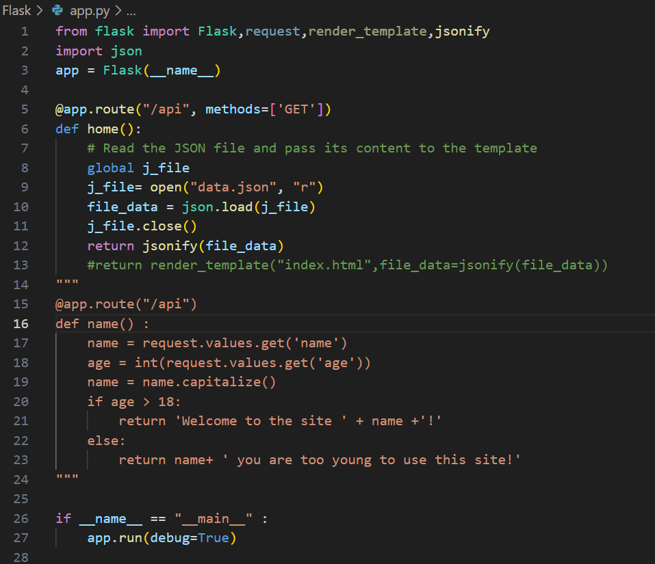

Data.json file snippet

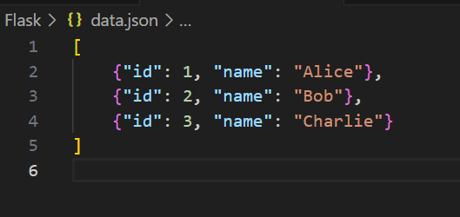

Once we will execute the file app.py below is the snippet from web browser when access the route “localhost:5000/api”

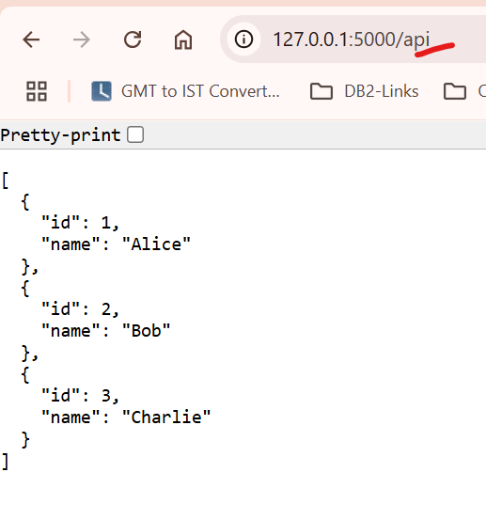

2. Create a form on the frontend that, when submitted, inserts data into MongoDB Atlas. Upon successful submission, the user should be redirected to another page displaying the message **"Data submitted successfully"**. If there's an error during submission, display the error on the same page without redirection.

2.1 Frontend HTML page for Name and Password.

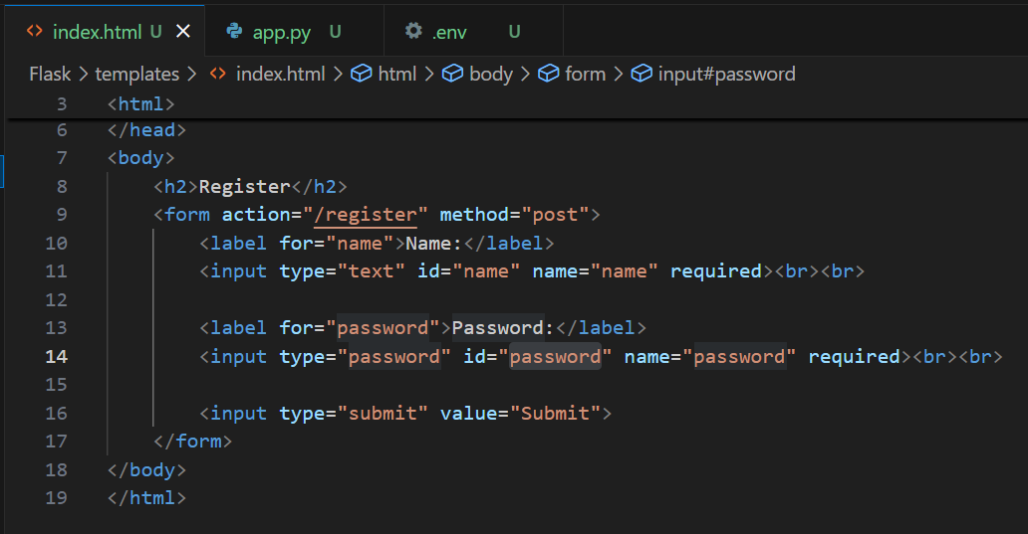

2.2 Backend app.py file

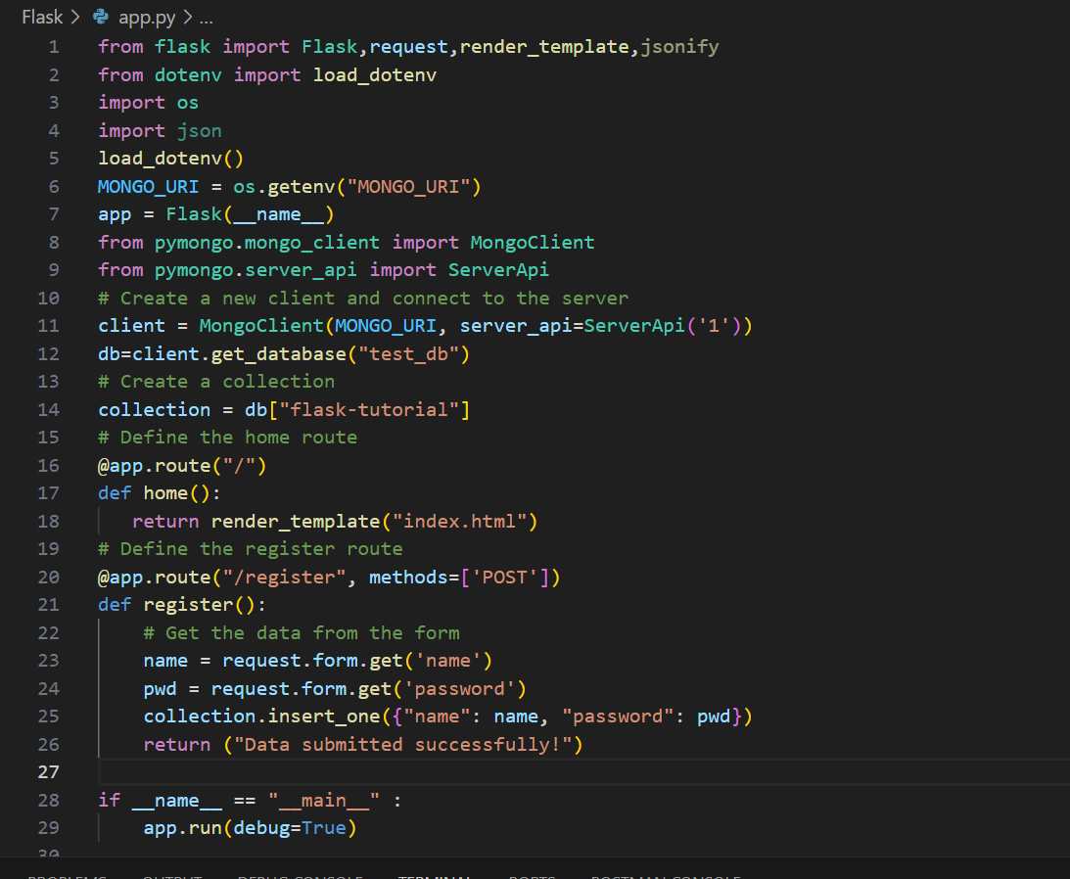

2.3 Execute the app.py file to run the application.

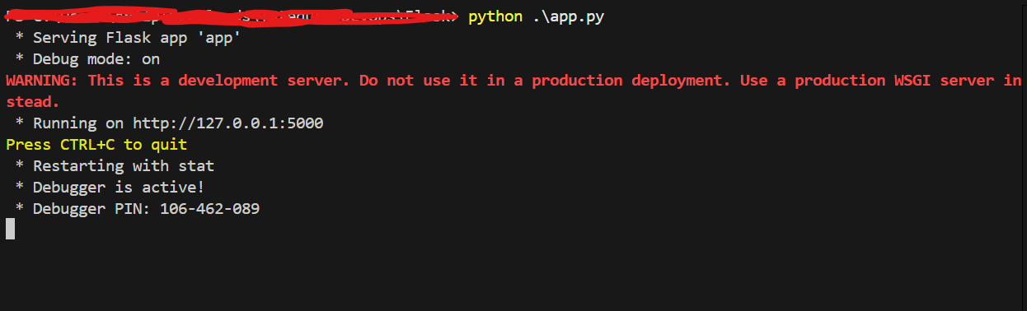

2.3 Front page

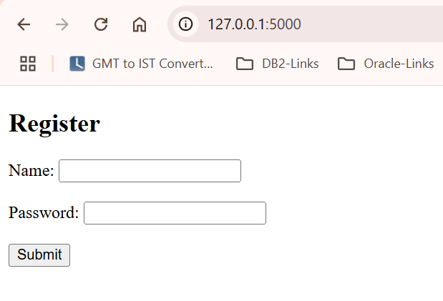

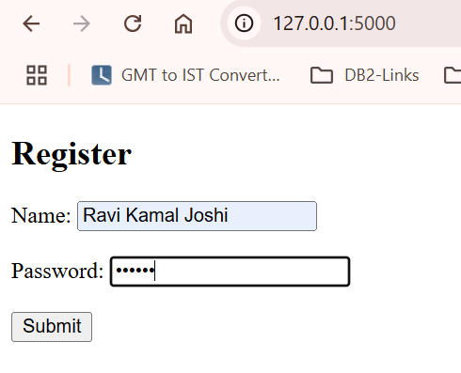

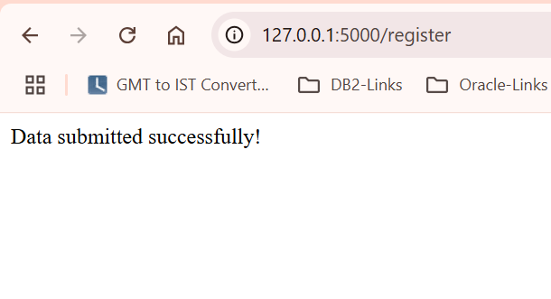

2.4 Data in MongoDB

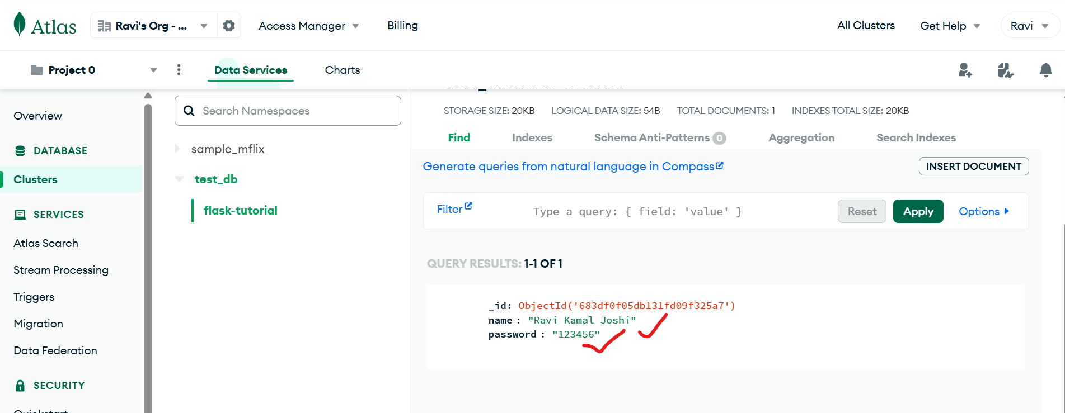

2.5 Error when data is not input in the Name and/or password

