Question 1 Grade Checker

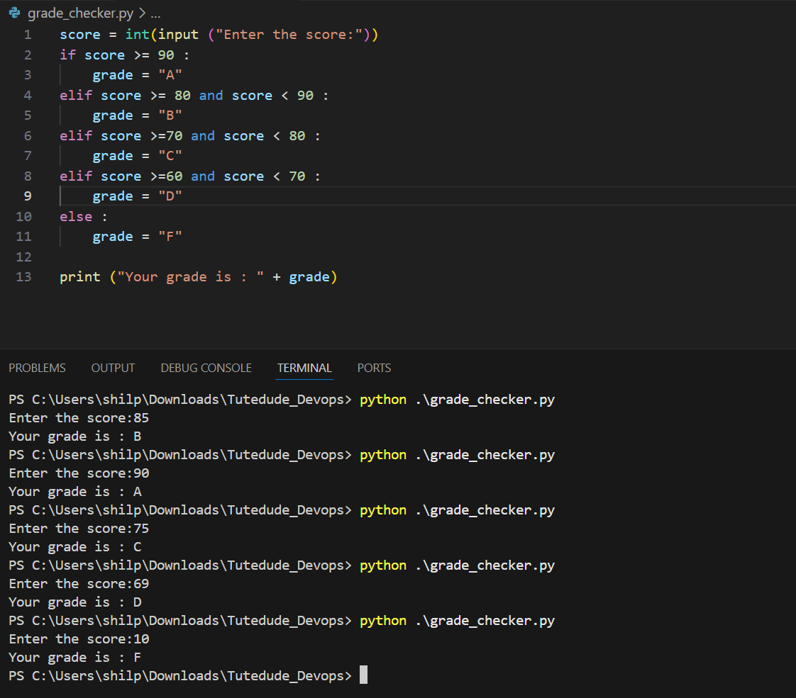

Question 2 Student Grade (using Dictionary)

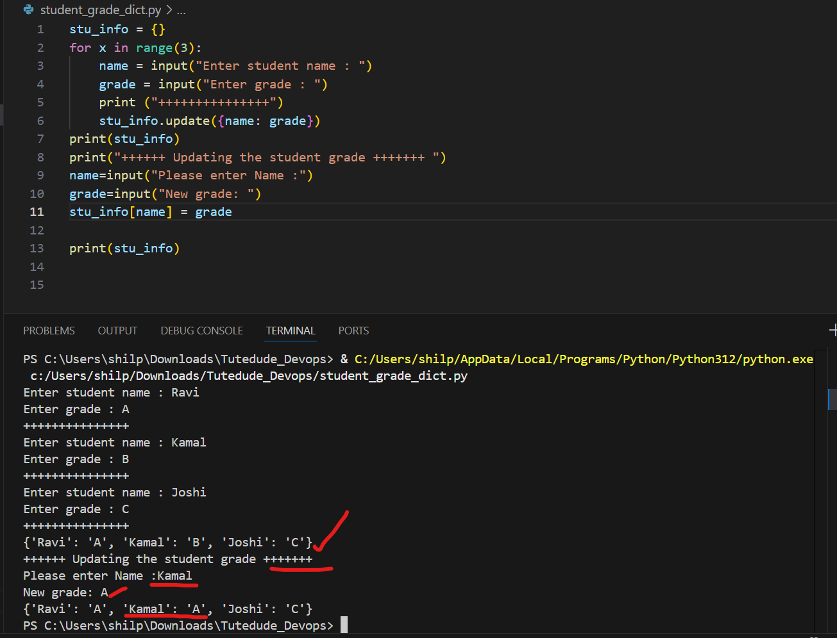

Question 3 and 4 File Operations (Write into file and read from file)

