1. Create a new GitHub repository.
   1. Created a new Repo Tutedude_devops in github

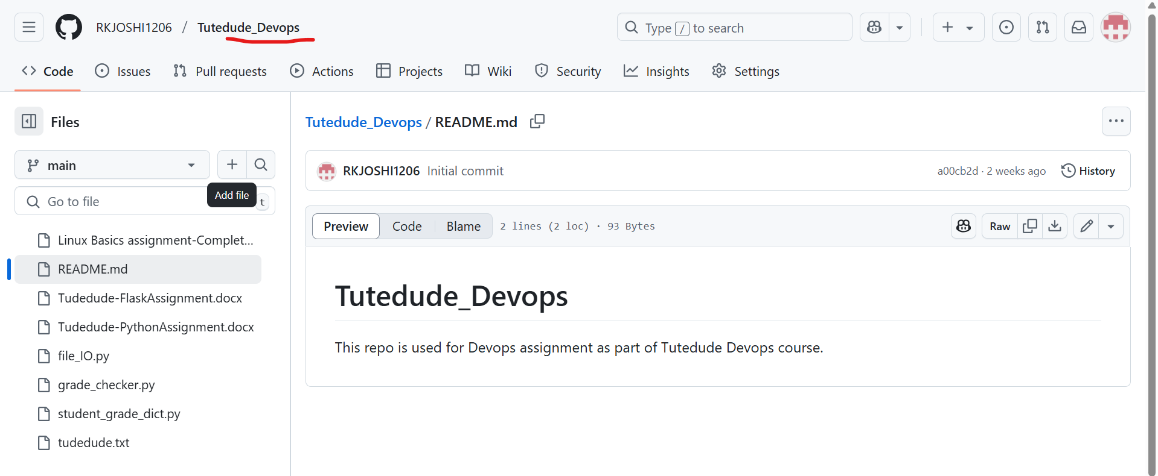

* 1. Cloned it using git clone in local working area using “**git clone** [**https://github.com/RKJOSHI1206/Tutedude_Devops.git**](https://github.com/RKJOSHI1206/Tutedude_Devops.git)”
  2. Created branch in local working area using “**git branch Tutedude**”

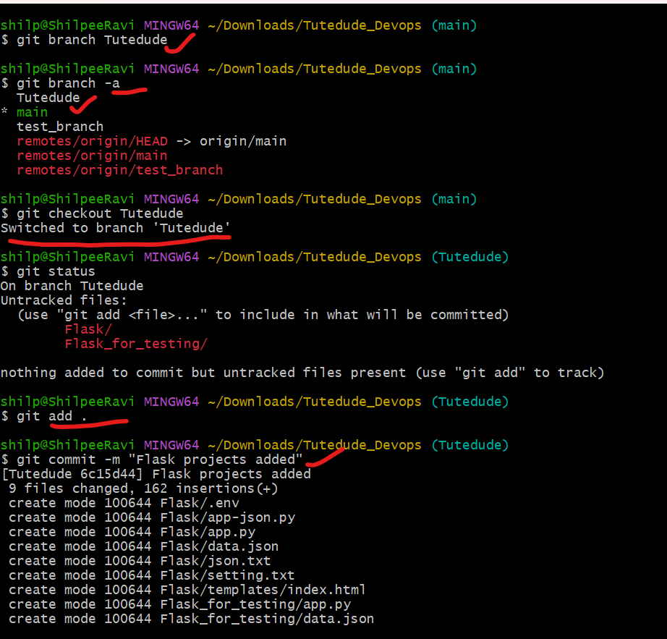

* 1. Merged the changes to master(main) branch using **git merge Tutedude** command.

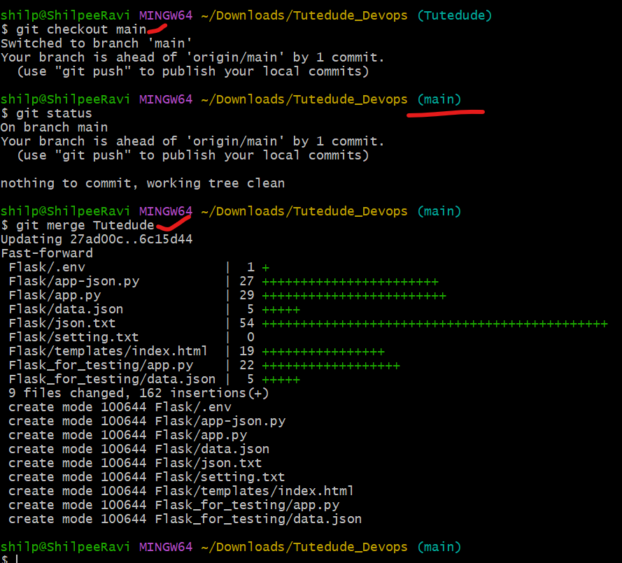

1. Create a new branch Tutedude_new
   1. Modify the file data.json

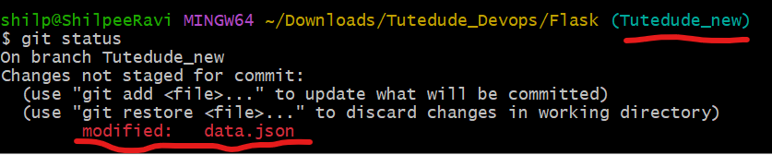

* 1. Commit the change to branch Tutedude_new by **git add and git commit command**

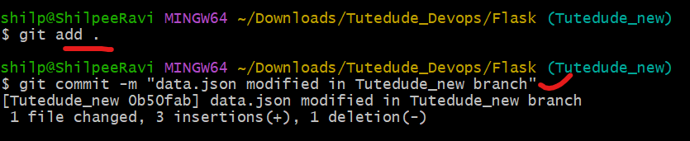

* 1. Merge new branch to main/master branch locally.

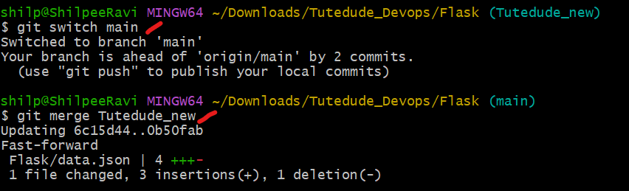

* 1. Push the change to remote github repository.

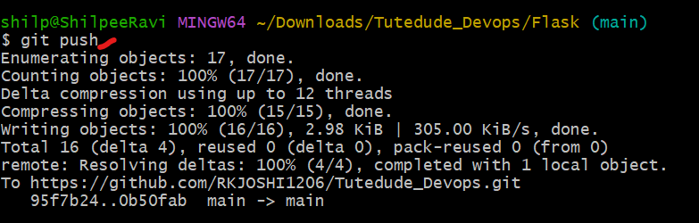

* 1. Changes are visible in github repo.

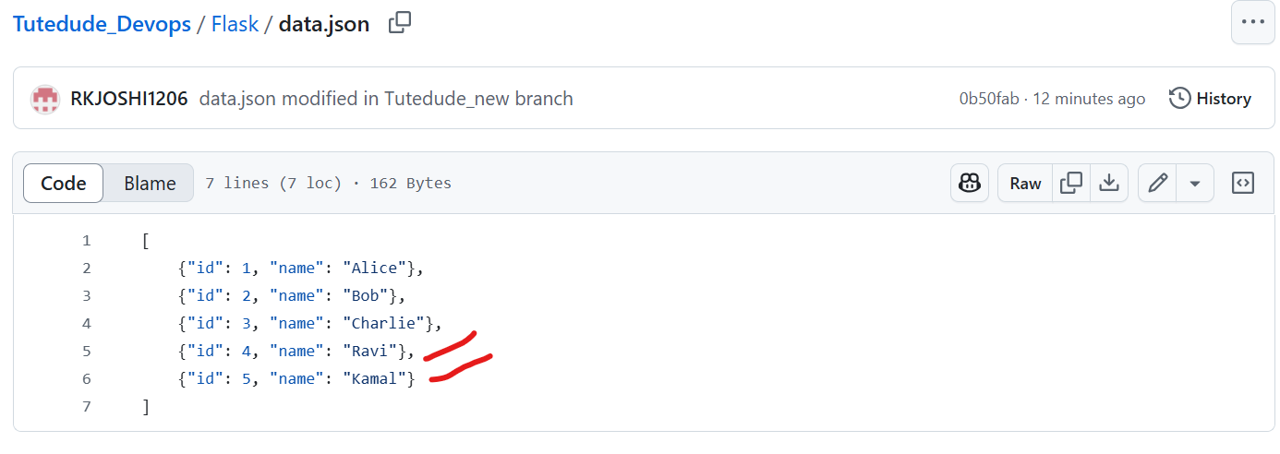

1. Branch Creation
   1. Two branches **master_1** and **master_2** from main branch

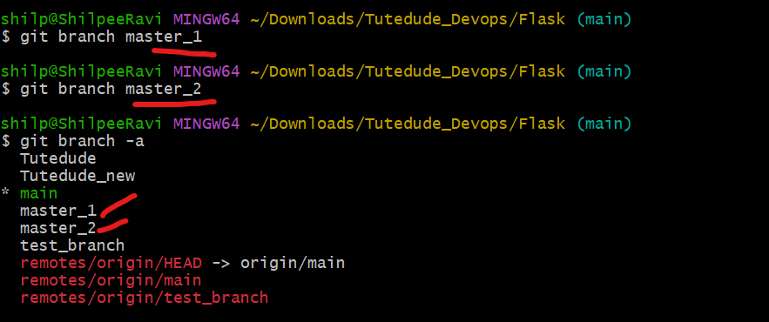

* 1. Create a frontend page for To-Do list (to_do.html)

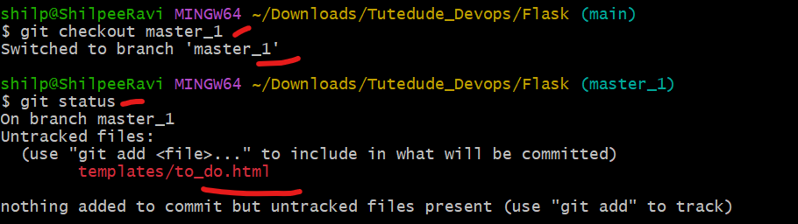

* 1. Commit the changes to master_1 branch.

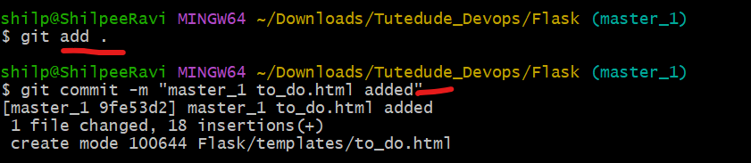

* 1. Checkout master_2 branch.

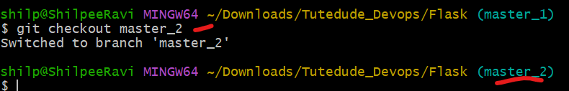

* 1. Make the changes for the route “/submittodoitem”

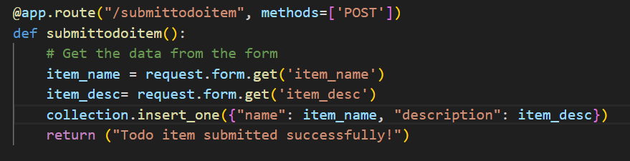

* 1. Commit the changes to the master_2 branch.

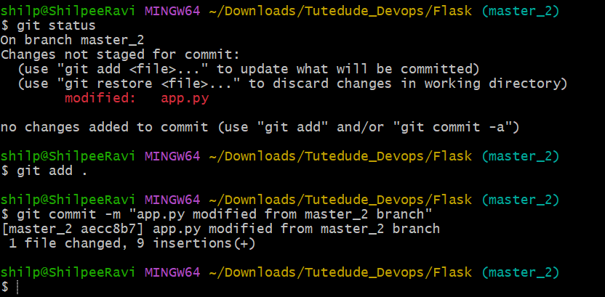

* 1. Merge the changes to main branch from both master_1 and master_2 branch.

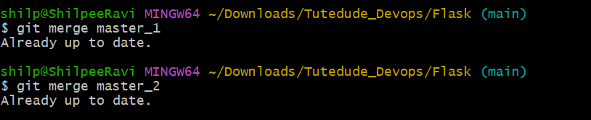

1. Enhancing the To-Do Form in master_1.
   1. Commit first change

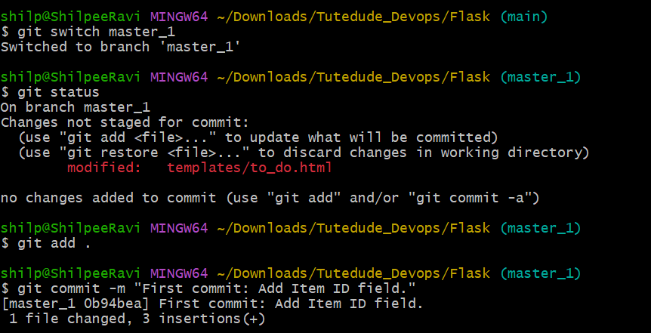

* 1. Commit second change.

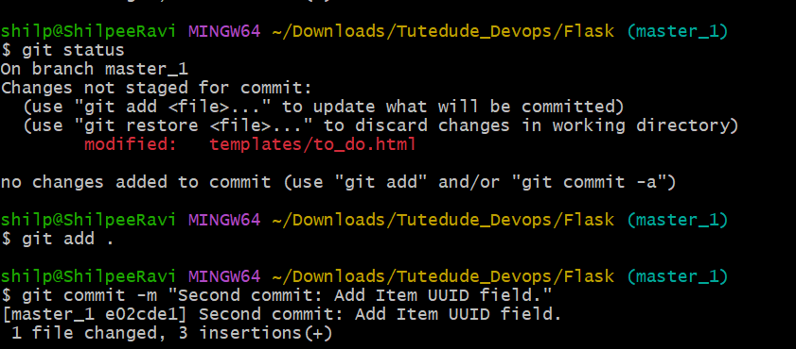

* 1. Commit third change.

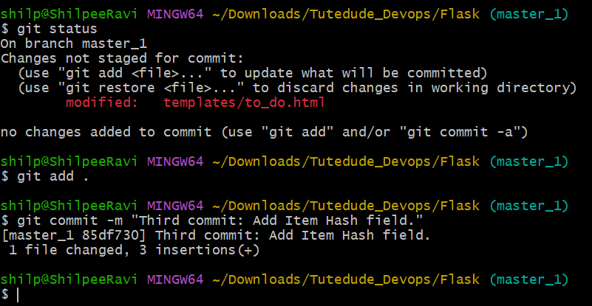

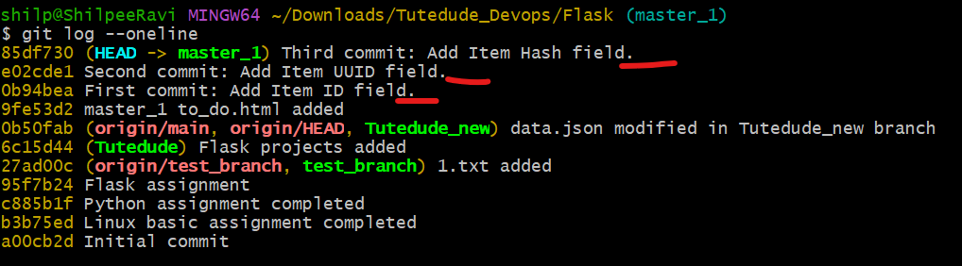

* 1. Merge master_1 to main branch (“**git merge master_1**”).

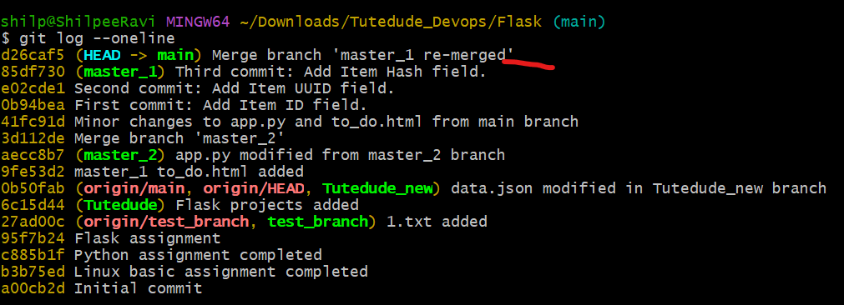

* 1. Git reset and commit deletion.

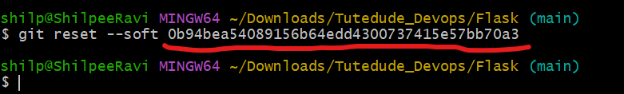

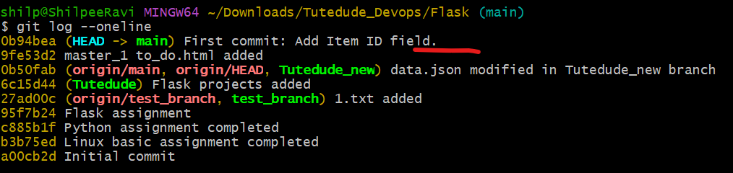

* 1. Recommit the changes.

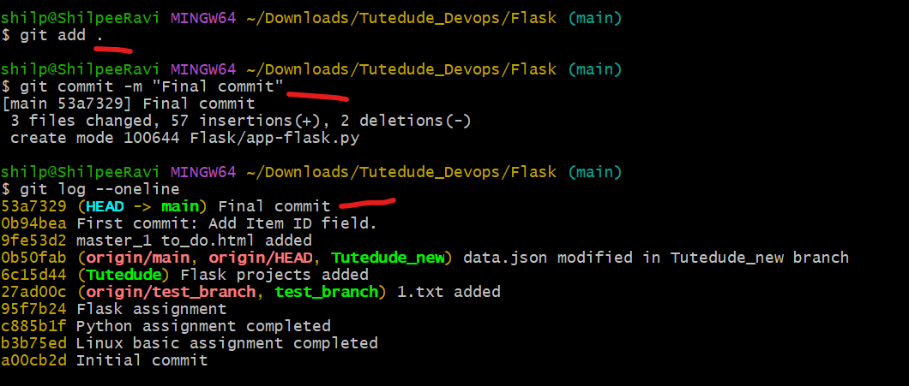

1. Rebase the changes from main to master_1
   1. Got merged conflict which I resolved via vscode and continue to rebase.

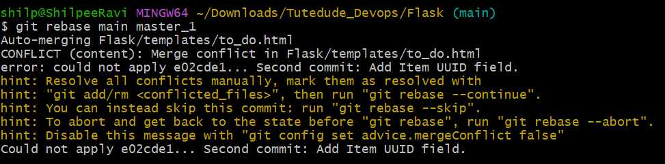

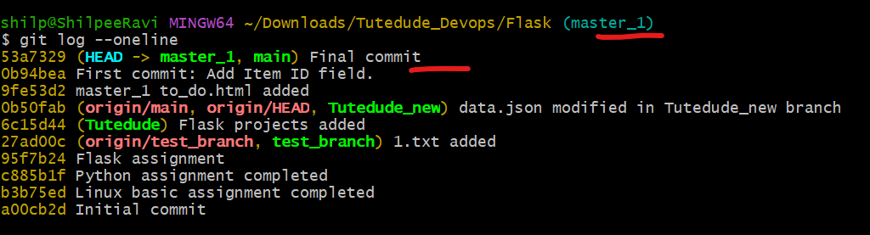

Frontend Snippet

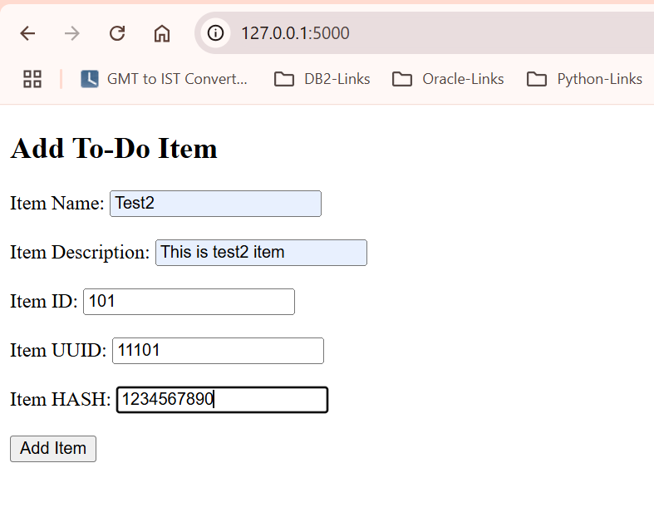

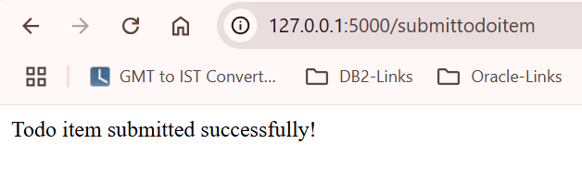

Data from MongoDB collection.

