***2 MARKS QUESTIONS AND ANSWERS***

*Page No*

***LIST OF CENTENTS:***

* *UNIT: 07 NURSHING MANAGEMENT OF PATIENTS*

(*WITH DISORDER OF MALE REPRODUCTIVE SYSTEM) ----------------------02*

* *UNIT: 09 NURSING MANAGEMENT OF PATIENTS*

*(WITH DISORDER OF INTEGUMENTARY SYSTEM) ----------------------------06*

* *UNIT: 12 NURSING MANAGEMENT OF PATIENTS*

*(WITH COMMUNICABLE DISEASE) -----------------------------------------------10*

* *UNIT: 13------------------------------------------------------------------------------------13*

***UNIT: 07 NURSHING MANAGEMENT OF PATIENTS***

(***WITH DISORDER OF MALE REPRODUCTIVE SYSTEM)***

**1. List the indication of cystoscopy.**

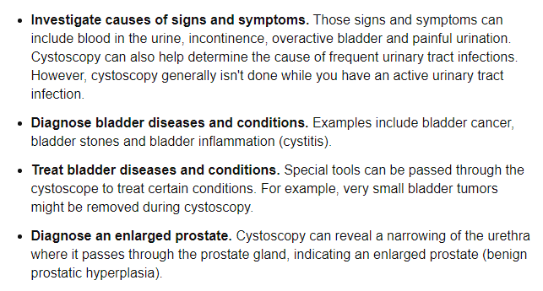

**2. List the complications of cystoscopy.**

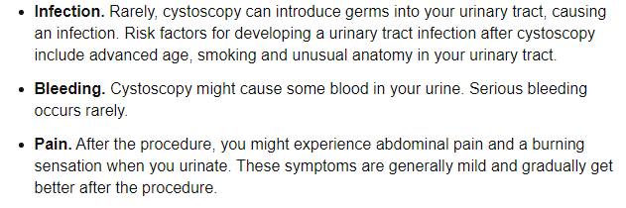

**3. List the surgical techniques to treat Beningn prostatic hyperplasia.**

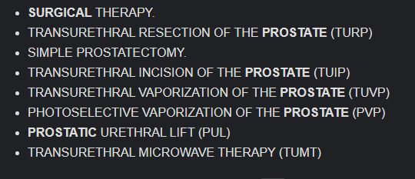

**3. List the complication of TURP.**

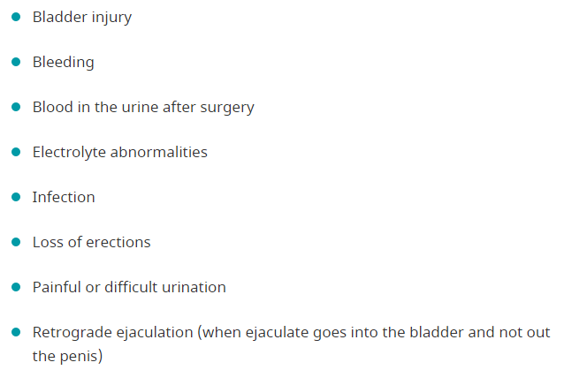

**5. Enlist the treatment option for male infertility.**

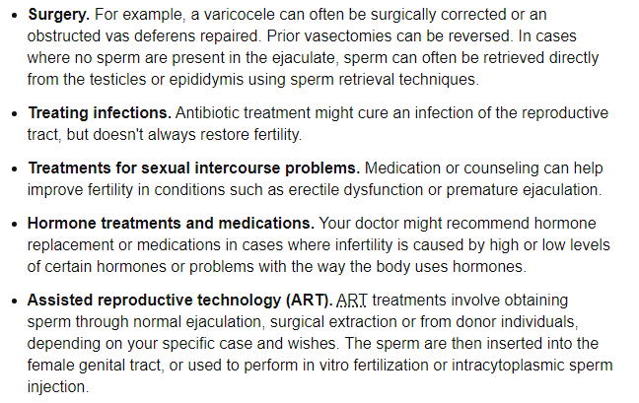

**6. Enlist the treatment option for female infertility.**

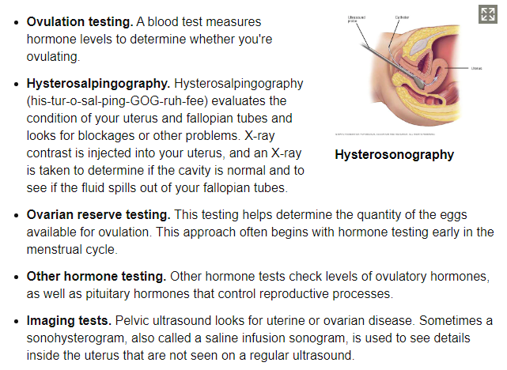

**7. Differentiate between epispadias and hypospadias.**

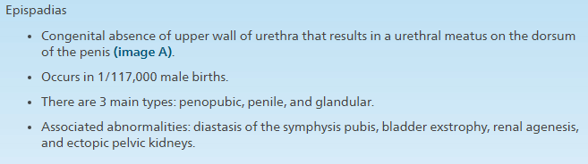

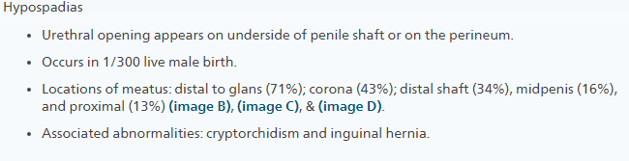

**8. Enlist the diagnostic test for Cystitis.**

* Urine Analysis
* Cystoscopy
* Imaging

**9. Define Gynecomastia.**



**10. Enlist the symptoms of orchitis.**

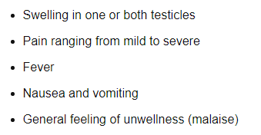

**11. Define cryptorchidism.**

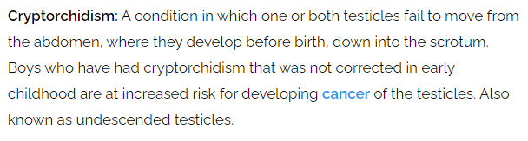

***UNIT: 09 NURSING MANAGEMENT OF PATIENTS***

***WITH DISORDER OF INTEGUMENTARY SYSTEM***

**1. Define Urticaria.**

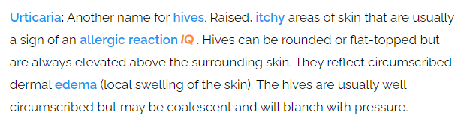

**2. Enlist causes of Urticaria.**

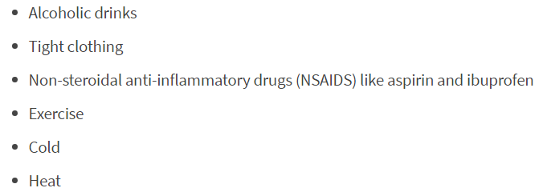

**3. Enlist drugs used to treat Urticaria.**

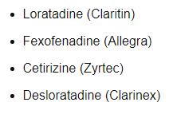

**4. Define Eczema.**

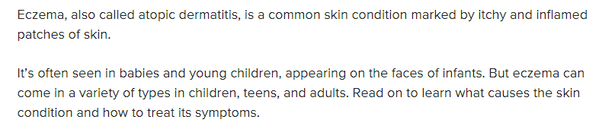

**5. Enlist clinical manifestations of eczema.**

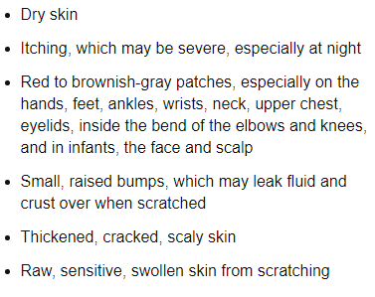

**6. Enlist the medications to treat eczema.**

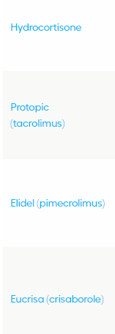 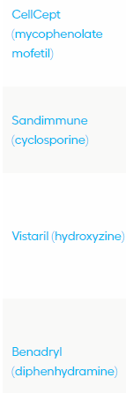

**7. Define skin graft.**

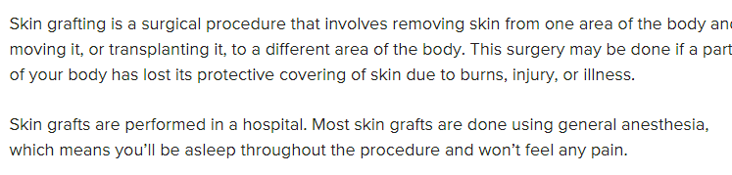

**8. Enlist the types of skin graft.**

* Partial or split thickness skin graft.
* Full thickness skin graft.

**9. Define Pediculosis.**

**Pediculosis** is an infestation of lice (blood feeding ectoparasitic insects of the order Phthiraptera). The condition can occur in almost any species of warm-blooded animal (i.e. mammals and birds), including humans.

**10. Enlist the complication of Pediculosis.**

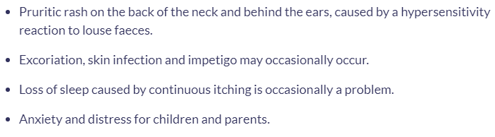

**11. Enlist the types of skin lesions.**

* Primary skin lesions:
  + Birthmarks
  + Blisters
  + Macules
  + Nodules
  + Papule
  + Pustule
  + Wheals
* Secondary skin lesions:
  + Crust
  + Ulcer
  + Scales
  + Scar
  + Skin atrophy

**12. Enlist medications used in Pediculosis.**

Permethrin, pyrethroids, malathion, lindane, oral ivermectin, cotrimoxazole were known treatments of pediculosis.

**13. Define acne vulgaris.**

Acne vulgaris is a skin condition that occurs when hair follicles are blocked with dead skin cells, bacteria, and oil (sebum). The blocked follicles cause blemishes on the skin, including pimples, blackheads, whiteheads, and cysts. Also known as common acne, one of its main causes is hormones, especially around puberty.

**14. Define malignant melanoma.**

Melanoma, the most serious type of skin cancer, develops in the cells (melanocytes) that produce melanin — the pigment that gives your skin its colour. Melanoma can also form in your eyes and, rarely, inside your body, such as in your nose or throat.

**15. Enlist infectious dermatoses.**

* Impetigo

### Serratia marcescens infection

### Leprosy

### Chicken pox

### Herpes zoster

### Herpes simplex

### Hand-foot-mouth disease

### Tinea pedis

### Syphilis

### Mycoplasma infection

**16. Enlist non-infectious dermatoses.**

* Dermatitis
* Acne
* Drug Rashes
* Poison Ivy/Poison Oak
* Toxic Epidermal Necrolysis

***UNIT: 12 NURSING MANAGEMENT OF PATIENTS***

***WITH COMMUNICABLE DISEASE***

**1. Enlist National and International agencies to control AIDS.**

* International Agencies:
* The Joint United Nations Programme on HIV/AIDS (UNAIDS)
* Australian AID (AusAID)
* British AID (DFID)
* US Government Assistance (USG)
* German AID (GTZ)
* Bill and Melinda Gates Foundation (BMGF)
* Clinton Foundation (CF)
* Global Fund for HIV/AIDS, Tuberculosis and Malaria (GFATM)

## International Labour Organization (ILO)

## United Nations Development Programme (UNDP)

## UNFPA

## United Nations Office of Drug Control & Crime in South Asia (UNODC)

## United Nations Children’s Fund (UNICEF)

## World Bank (WB)

## World Health Organization (WHO)

**2. Define Hansen’s Disease.**

**Hansen disease:** Leprosy, a chronic granulomatous infection caused by a bacterium which affects various parts of the body, including in particular the skin and nerves. (Granulomatous refers to the formation of granulomas, inflammatory nodules that are usually small, granular, firm, and persistent.) The bacterium responsible for leprosy is called Mycobacterium leprae or, for short, M. leprae.

**3. List four symptoms of tetanus.**

* Jaw cramping
* Sudden, involuntary muscle tightening (muscle spasms) – often in the stomach
* Painful muscle stiffness all over the body
* Trouble swallowing
* Jerking or staring (seizures)
* Headache
* Fever and sweating
* Changes in blood pressure and fast heart rate

**4. Define parotitis.**

Parotitis is an inflammation of one or both parotid glands, the major salivary glands located on either side of the face, in humans. The parotid gland is the salivary gland most commonly affected by inflammation.

**5. Enlist the diagnostic test for hepatitis.**

* **Blood tests.** Blood tests can detect signs of the hepatitis B virus in your body and tell your doctor whether it's acute or chronic. A simple blood test can also determine if you're immune to the condition.
* **Liver ultrasound.** A special ultrasound called transient elastography can show the amount of liver damage.
* **Liver biopsy.** Your doctor might remove a small sample of your liver for testing (liver biopsy) to check for liver damage. During this test, your doctor inserts a thin needle through your skin and into your liver and removes a tissue sample for laboratory analysis.

**6.** **Enlist the diagnostic test for meningitis.**

* **Blood cultures.** A blood sample is placed in a special dish to see if it grows microorganisms, particularly bacteria. A sample may also be placed on a slide and stained (Gram's stain), then studied under a microscope to see whether bacteria are present.
* **Imaging.** Computerized tomography (CT) or magnetic resonance imaging (MRI) scans of the head may show swelling or inflammation. X-rays or CT scans of the chest or sinuses also may show infection that may be associated with meningitis.
* **Spinal tap (lumbar puncture).** For a definitive diagnosis of meningitis, you'll need a spinal tap to collect cerebrospinal fluid (CSF). In people with meningitis, the CSF often shows a low sugar (glucose) level along with an increased white blood cell count and increased protein.

**7. Define Kernig’s sign.**

**Kernig sign:** A sign indicating the presence of meningitis (inflammation of the meninges covering the brain and spinal cord). The test for Kernig sign is done by having the person lie flat on the back, flex the thigh so that it is at a right angle to the trunk, and completely extend the leg at the kneejoint. If the leg cannot be completely extended due to pain, this is Kernig sign.

**8. List the features of Koplik’s spots.**

Koplik's spots: Little spots inside the mouth that are highly characteristic of the early phase of measles (rubeola). The spots look like a tiny grains of white sand, each surrounded by a red ring. They are found especially on the inside of the cheek (the buccal mucosa) opposite the 1st and 2nd upper molars. Named for the New York paediatrician Henry Koplik (1858-1927) who described them.

***UNIT: 13***

***(name don’t know)***

**1. Enlist indication for spinal anaesthesia.**

Indications for spinal anaesthesia include lower abdominal, perineal, and LE surgery. Technically one could use it for upper abdominal surgery however because these procedures impact breathing so profoundly, general anaesthesia is generally preferred.

**2. Enlist the stages of general anaesthesia.**

* Stage 1 - Analgesia or Disorientation:
* Stage 2 - Excitement or Delirium
* Stage 3 – Surgical Anaesthesia
* Stage 4 – Overdose

**3. Differentiate between medical and surgical Asepsis.**

**Medical Asepsis**

* “clean technique”/reduces number and transfer of pathogens
* Hand washing
* Before touching patient
* Before a clean or aseptic procedure
* After body fluid exposure risk
* After touching a patient
* After touching patient surroundings
* **Surgical Asepsis**
* “sterile technique”/makes surfaces free from all microorganisms
* Used in the operating room, labour and delivery areas, certain diagnostic testing areas

**4. Enlist the types of suture materials.**

* Nylon. A natural monofilament suture.
* Polypropylene (Prolene). A synthetic monofilament suture.
* Silk. A braided natural suture.
* Polyester (Ethibond). A braided synthetic suture.

**5. Enlist the anaesthesia drug.**

* Barbiturates. Amobarbital (trade name: Amytal) Methohexital (trade name: Brevital) Thiamylal (trade name: Surital) ...
* Benzodiazepines. Diazepam. Lorazepam. Midazolam.
* Etomidate.
* Ketamine.
* Propofol.

**6. Enlist the types of surgical drains.**

* Open drains
* Closed drains
* Active drains
* Passive drains

**7. Enlist the needs of informed consent.**

* It’s ethical thing to do
* It’s a safety and quality of care issue
* It’s the law
* Regularity Requirement
* Hospital Policy

**8. List the complications of Thoracentesis.**

* Air in the space between the lung covering (pleural space) that causes the lung to collapse (pneumothorax)
* Bleeding
* Infection
* Liver or spleen injury (rare)

**9. Differentiate between Hydrothorax and pneumothorax.**

**Hydrothorax:** Hemothorax refers to the presence of blood in the pleural cavity. Hemo- means blood and -thorax means chest. The pleural cavity is located in the chest. It's the space between the lungs and inner chest wall, sort of like the space between a nut and the inside of its shell, where the nut is like our lung.

**Pneumothorax:** Unlike hemothorax, the word pneumothorax refers to air in the pleural space. Pneumo- can refer to the lungs or air and -thorax means chest, just as before. So, in this case, it's not blood that is found in the pleural cavity, it's air. This is just as bad for proper breathing as a hemothorax is.

**10. Pulse oximetry – purpose**

It may be used to monitor the health of individuals with any type of condition that can affect blood oxygen levels, especially while they’re in the hospital. These conditions include:

* chronic obstructive pulmonary disease (COPD)
* asthma
* pneumonia
* lung cancer
* anaemia
* heart attack or heart failure
* congenital heart defects

**11. Define Hypoxia.**

Hypoxia is a condition or state in which the supply of oxygen is insufficient for normal life functions; hypoxemia is a condition or state where there is a low arterial oxygen supply.

**12. List the types of suctioning.**

* Nasal suction (suctioning in the nose)
* Oral suction (suctioning the mouth)
* Nasopharyngeal and oropharyngeal suction (suctioning the throat)
* Deep suctioning

**13. List the action of deriphyllin.**

Theophylline(deriphyllin) directly relaxes the smooth muscle of the bronchial airway and pulmonary blood vessels, thus acting mainly as a bronchodilator and smooth muscle relaxant. It has also been demonstrated that aminophylline has a potent effect on diaphragmatic contractility in normal persons and may then be capable of reducing fatigability and thereby improve contractility in patients with chronic obstructive airway disease. Theophylline is also a central respiratory stimulant.

**14. List the types of pneumothorax.**

* Traumatic pneumothorax
* Non-traumatic pneumothorax

**15. List the sites for pleural aspiration.**

The conventional site for aspiration is posteriorly, approximately 10 cm lateral to the spine (mid-scapular line) and 1-2 intercostal spaces below the upper level of the fluid.

**16. List the indications for central venous pressure.**

* Volume resuscitation.
* Emergency venous access.
* Nutritional support.
* Administration of caustic medications (eg, vasopressors)
* CVP monitoring.
* Transvenous pacing wire introduction.
* Haemodialysis.

**17. Define Military tuberculosis.**

Military tuberculosis (TB) is the widespread dissemination of Mycobacterium tuberculosis (see the image below) via hematogenous spread. Classic military TB is defined as millet like (mean, 2 mm; range, 1-5 mm) seeding of TB bacilli in the lung, as evidenced on chest radiography.

**18. Clinical manifestations of pharyngitis.**

* sneezing
* runny nose
* headache
* cough
* fatigue
* body aches
* chills
* fever (a low-grade fever with a cold and higher-grade fever with the flu)

**19. Define rhinorrhoea.**

**Rhinorrhoea:** The free discharge of a thin nasal mucus. Medical term for a runny nose. From the Greek words "rhinos" meaning "of the nose" and "rhoia" meaning "a flowing."

**20. List the emergency management of Epistaxis.**

Nasal tampons, often made of Merocele, are used for nasal packing. Patients may be pre-treated with topical lidocaine (2%) and/or oxymetazoline. Nasal tampons can be coated with bacitracin for lubrication before inserting along the nasal floor. Apply saline to expand the tampon. Tampons can also be inserted into the contralateral nostril for further compression.

**21. Define bronchial asthma.**

Bronchial asthma is a chronic inflammatory disease of the airways characterized by bronchial hyperreactivity and a variable degree of airway obstruction. It is diagnosed on the basis of the clinical history, physical examination, and pulmonary function tests, including reversibility testing and measurement of bronchial reactivity.

**22. List the causes for cystic lung.**

The majority of adults with cystic lung disease have one of four underlying diseases:

* lymphangioleiomyomatosis (LAM)
* pulmonary Langerhans cell histiocytosis (PLCH)
* Birt-Hogg-Dube syndrome (BHD)
* or lymphoid interstitial pneumonia (LIP).

**23. Explains the action of bronchodilators.**

Bronchodilators work by relaxing the muscles in the airways. The relaxation causes the airways to open up and the bronchial tubes to widen. Various types work in slightly different ways.

Classifications of bronchodilators include beta 2-agonists, anticholinergics, and xanthine derivatives. These medications open the airways, but they work on different receptors in the body.

**24. Clinical manifestations of bronchitis.**

* Cough
* Production of mucus (sputum), which can be clear, white, yellowish-gray or green in color — rarely, it may be streaked with blood
* Fatigue
* Shortness of breath
* Slight fever and chills
* Chest discomfort

**25. Define bronchogram.**

**Bronchogram:** A radiograph of the [bronchial](https://www.merriam-webster.com/dictionary/bronchial#medicalDictionary) tree after injection of a radiopaque substance

**26. List the causes of respiratory failure.**

* chronic obstructive pulmonary disease (COPD)
* complicated pneumonia
* cystic fibrosis
* spinal cord injuries
* stroke
* muscular dystrophy
* ALS (Lou Gehrig’s disease)
* injury to the chest
* drug or alcohol misuse
* smoking

**27. Define farmers lung.**

Farmer's Lung is an allergic disease usually caused by breathing in the dust from moldy hay. However, dust from any moldy crop - straw, corn, silage, grain, or even tobacco - can also cause Farmer's Lung.