Week 1 Git and GitHub Assignment

**Points possible:** 70

|  |  |  |
| --- | --- | --- |
| Category | Criteria | % of Grade |
| Completeness | All requirements of the assignment are complete. | 100 |

**Instructions:** Follow the steps below to complete this assignment. Add the URL for this week’s repository to this document as instructed and submit this document in the LMS when complete.

**Assignment Steps:**

1. ­­The link below has a zipped file that contains an empty directory (folder) for your assignments. Download the file to your computer and unzip it. This directory (folder) may be utilized to organize projects for this course.

<https://drive.google.com/file/d/1WDc_WJ8I0MfwbrbmtMsxHdTpupZsPjXT/view>

2. Following the Git/GitHub tutorial in your week 0 video:

* 1. Create a directory (folder) for your week 1 assignment.
  2. Create a repository on the GitHub website.
  3. Push your directory of files to GitHub as instructed in the video.
  4. After your first push, please ensure that you make some changes to your directory (folder), such as adding a new file or changing your code. Push those changes to your repository a second time (as shown in the video).

<https://www.youtube.com/watch?v=NGeksLUB1e8>

3. When complete, paste a screenshot of your terminal or command prompt that shows your push was successful.

4. Copy and paste the URL to your GitHub repository as instructed below.

**Screenshot of Terminal / Command Prompt:** 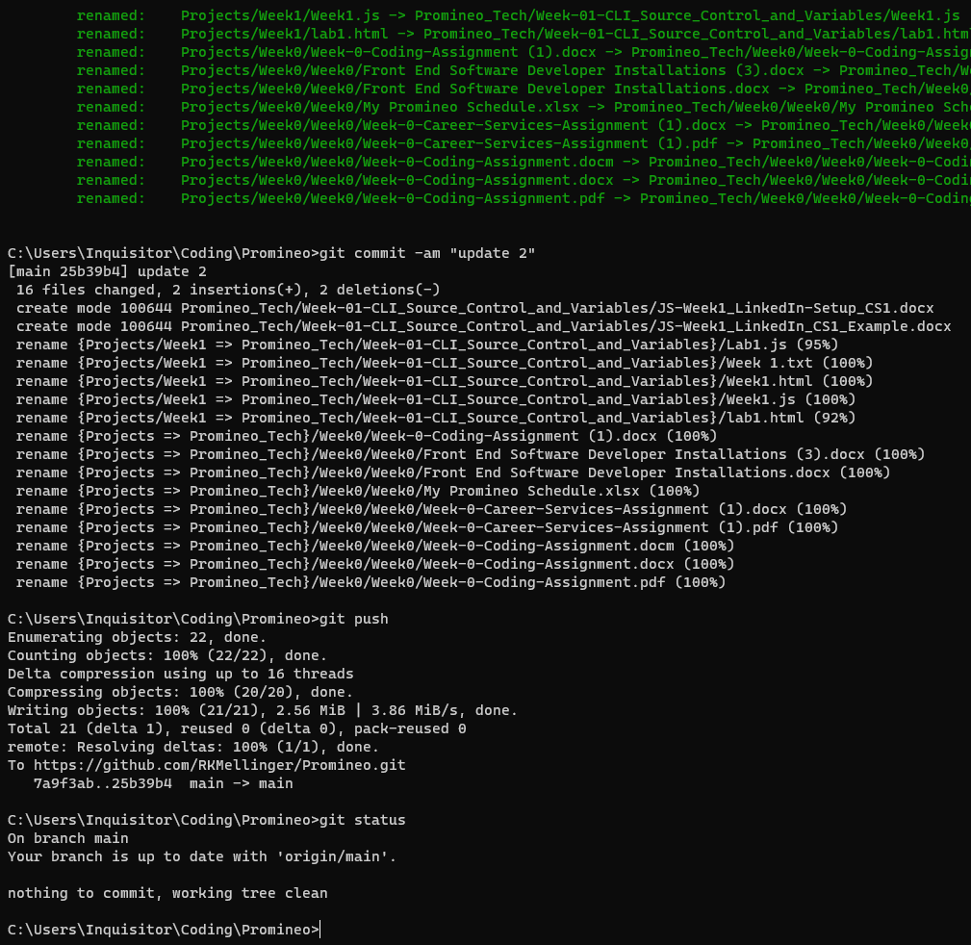

**URL to GitHub Repository:**

<https://github.com/RKMellinger/Promineo>