VLSI HACKATHON · SUDARSHANA SEMICONDUCTORS · PS-01
RNN-Based Voice Stability Monitor
RTL-to-GDS on a 0.18 µm Library
A fixed-point GRU accelerator with AXI-Stream input and a register interface, taken through Genus, Innovus, Tempus and ncsim.
TEAM | MEMBER | MEMBER
18 | Magesh · 24BVD1048 | R Naga Arjun · 24BVD1102
powerhouse

1 Summary
The design is a GRU with 16 inputs and 16 hidden units that scores each 16-feature frame for voice stability, smooths the score with a shift-based moving average and raises an alert with hysteresis.
1573  cycles per frame, last beat to score (measured) | 2000/2000  frames matching the bit-accurate model, seeds 1, 2, 3 | +0.165 ns  post-route setup WNS at 15 ns clock
+0.122 ns  post-route hold WNS | 0  DRC violations, connectivity clean | 23.9 mW  SAIF-based power, slow corner, 1.62 V

2 Architecture
One time-shared MAC and one shared gating multiplier process the whole GRU. Weights sit in flops inside vsm_wmem and are loaded through the register interface.
AXI-Stream 16 × INT8 | → | Pass 1: z, r gates | → | Pass 2: n gate with r⊙h | → | Output pass | → | EMA + hysteresis | → | alert / irq

GRU form implemented
z = σ(Wz·x + Uz·h + bz), r = σ(Wr·x + Ur·h + br), n = tanh(Wn·x + Un·(r⊙h) + bn), h' = h + z⊙(n − h), score = σ(Wo·h' + bo). The score is computed on the updated hidden state.

Cycle schedule
Phase | Work | Cycles
Pass 1 | 2 gates × 16 units × 32 MACs | 1024
Pass 2 | 16 units × 32 MACs | 512
Output | 16 MACs | 16
Drain and transitions | pipeline and state changes | about 21
Total | measured, last beat to score | 1573

Datapath details
- MAC: 16-bit activation × 8-bit weight, 24-bit product, 32-bit accumulator. Terms k<16 are inputs, k≥16 are recurrent terms.
- After the accumulator: bias add (bias << 6 to align), shift right 6, saturate to ±131072 (18-bit Q.14, range [−8, 8)), LUT index from lsum[17:10], then the shared gating multiplier.
- Activation LUTs: 256 entries over [−8, 8), step 1/16, sampled at bin centres.
- EMA: 16-bit average, reset and flush set it to 16384 (1.0). avg' = avg + ((score − avg) >>> k). Alert sets when avg' < THRESH and clears when avg' ≥ THRESH + HYST. irq = alert & irq_en.
- An early tlast (before beat 16) drops the frame. tready = en & idle & ~flush. Flush clears h, avg, alert and the frame count.

Word lengths
Quantity | Format
Weights | INT8, Q.6
Biases | INT16, Q.14
Activations | INT16, Q1.14 (16384 = 1.0)
Accumulator | INT32
Pre-activation | 18-bit Q.14, saturated to ±8

Register map
Offset | Name | Fields
0x00 | CTRL | bit0 en, bit1 flush, bit2 irq_en
0x04 | THRESH | reset 9830
0x08 | HYST | reset 1000
0x0C | WINDOW | [2:0] k, reset 4
0x10 | STATUS | busy, alert, sticky frame_done (write 1 to bit 2 clears)
0x14 | SCORE | latest score
0x18 | AVG | running average
0x1C | FRAMES | frame count
0x20 | WADDR | [12:0], bit12 selects bias space
0x24 | WDATA | auto-increment write

Weights are indexed {g, j, k} with g0 = z, g1 = r, g2 = n, with output weights at 1536–1551. Biases: bz 0–15, br 16–31, bn 32–47, bo 48. Storage totals 1536 + 16 INT8 weights and 49 INT16 biases.

3 Verification
Check | Result
RTL regression, seeds 1, 2, 3 | 2000 of 2000 frames each, 0 errors, max latency 1573 cycles
Gate-level simulation | 200 of 200 frames, 0 errors (functional models, no timing back-annotation)
Directed tests | reset and flush mid-compute, flush mid-frame, early tlast, saturated rails, back-to-back frames, random gaps, alert assert and deassert
Long stream (model only) | 360,000 frames, |h| max 15809 of 32767, 442 alert assertions, continuity passes

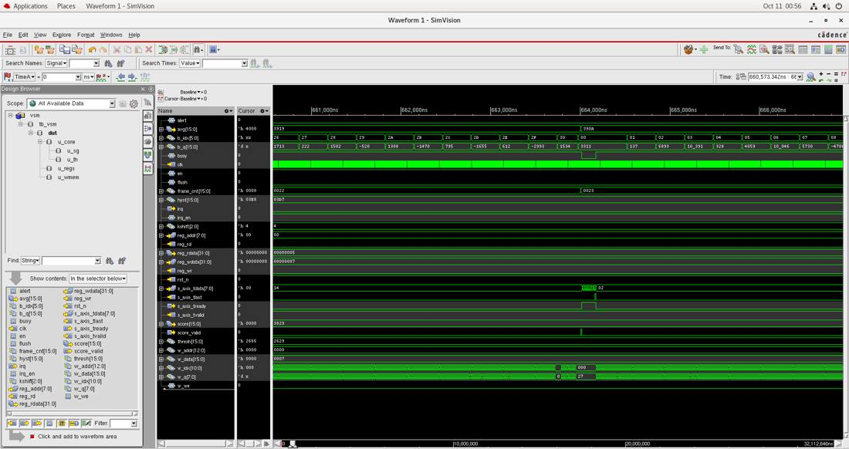
Fig. 1 · SimVision waveform from the RTL testbench.

Accuracy against floating point
Error source | Max | Mean | RMS
Quantisation only | 0.01891 | 0.00216 | 0.00258
LUT only | 0.01044 | 0.00266 | 0.00332
Total, float vs RTL | 0.02599 | 0.00334 | 0.00431
Running average | 0.00683 | 0.00186 | 0.00237

Sigmoid LUT error: max 0.0078, mean 0.00098. Tanh LUT error: max 0.03107, mean 0.00196. Score correlation is 0.99993. The average correlates with the synthetic quality label at 0.956 (target ≥ 0.80), and 0 of 2000 alert decisions differ from floating point.

4 Synthesis (Genus 21.1)
30,970  cells (16,572 combinational) | 14,398  flops, 76.5% of cell area
1.25 mm²  cell area (1.75 mm² with nets) | +25 ps  setup slack at 15 ns

The critical path ends at the gating multiplier register. The weight memory takes 13,200 bits, about 92% of the flops. Vectorless power is 80.8 mW with 84% in registers and no clock-gated flops.
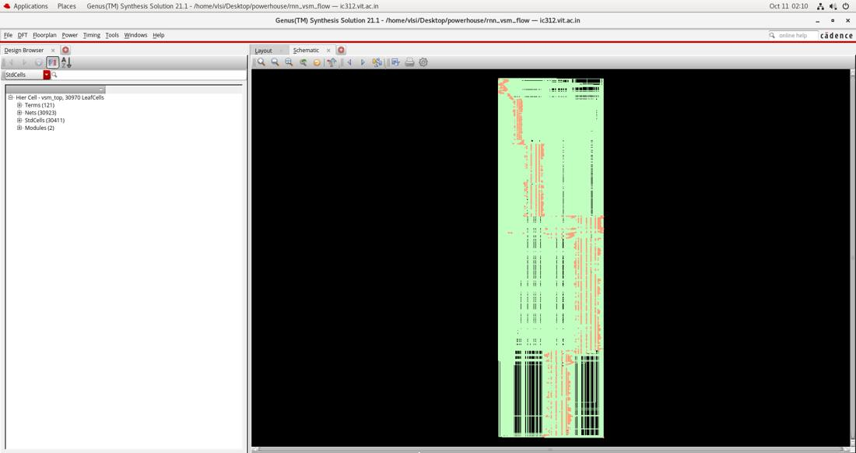
Fig. 2 · Genus schematic: 30,970 leaf cells, 2 modules.

5 Place and route (Innovus 21.15)
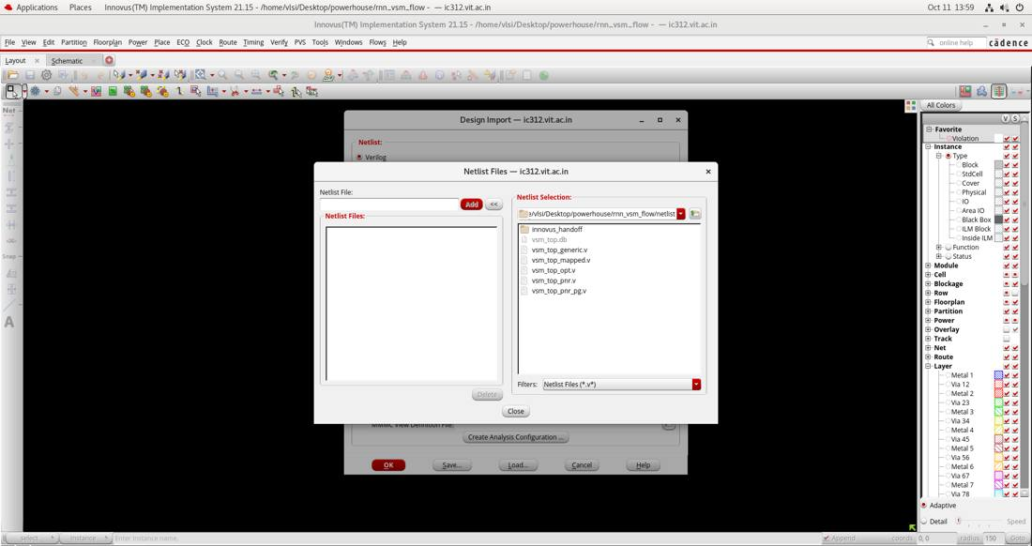
Fig. 3 · Design import with the Genus netlist.
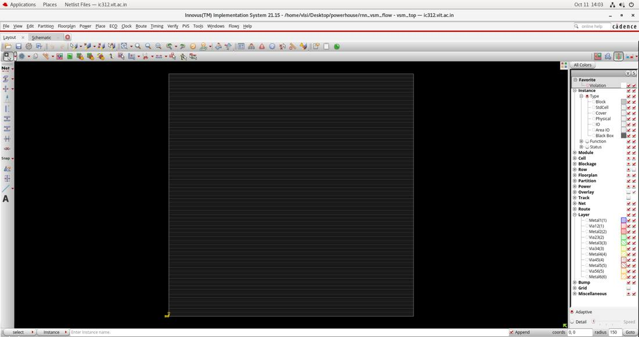 | 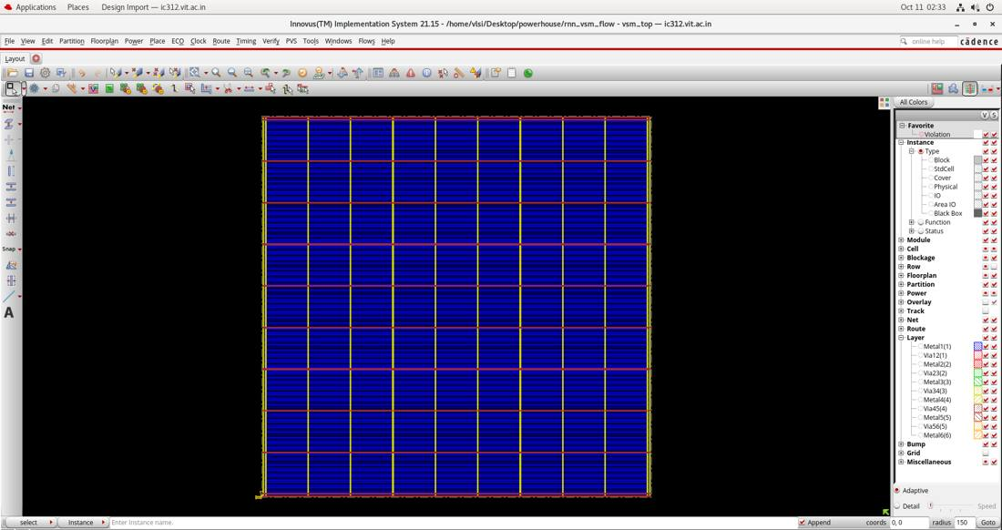
Fig. 4 · Floorplan rows. | Fig. 5 · Power rings and stripes.
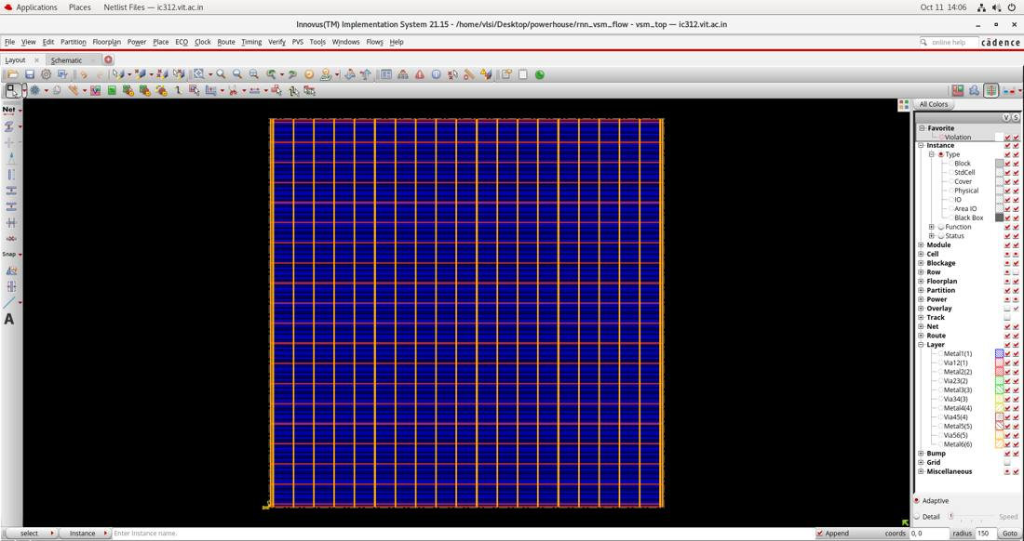 | 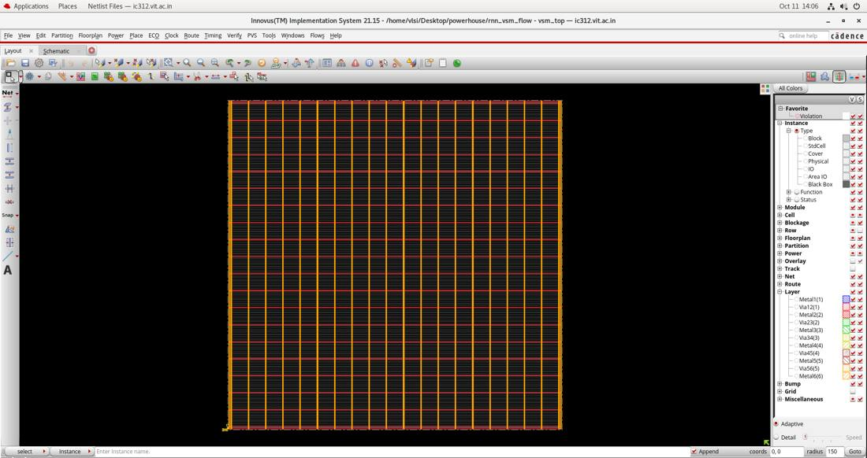
Fig. 6 · Power grid, Metal1 view. | Fig. 7 · Power grid, alternate layer display.

Clock tree
14,398 sinks. Slow-corner latency 0.677–0.748 ns, skew 0.071 ns slow, 0.054 ns typical, 0.052 ns fast.
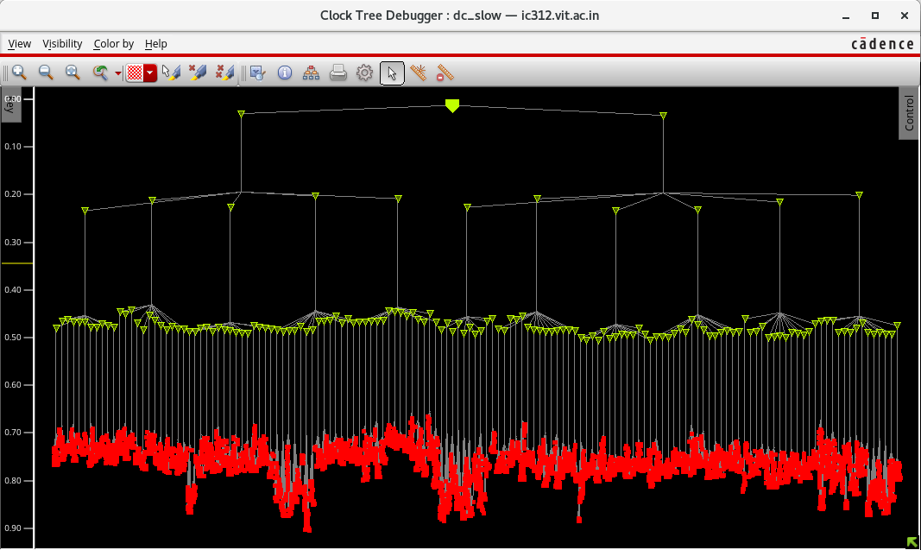
Fig. 8 · Clock Tree Debugger, dc_slow.

Routed result
Metric | Value
Setup WNS | +0.165 ns (reg2reg +0.901 ns)
Hold WNS | +0.122 ns
Violating paths | 0 of 42,814
Density | 55.486%
Instances (with fillers) | 77,677
DRC / connectivity | 0 / clean
Antenna | 1 violation on 1 net (Metal4); the first run had 150
Max-fanout | 497 nets over the limit of 32, worst by 43

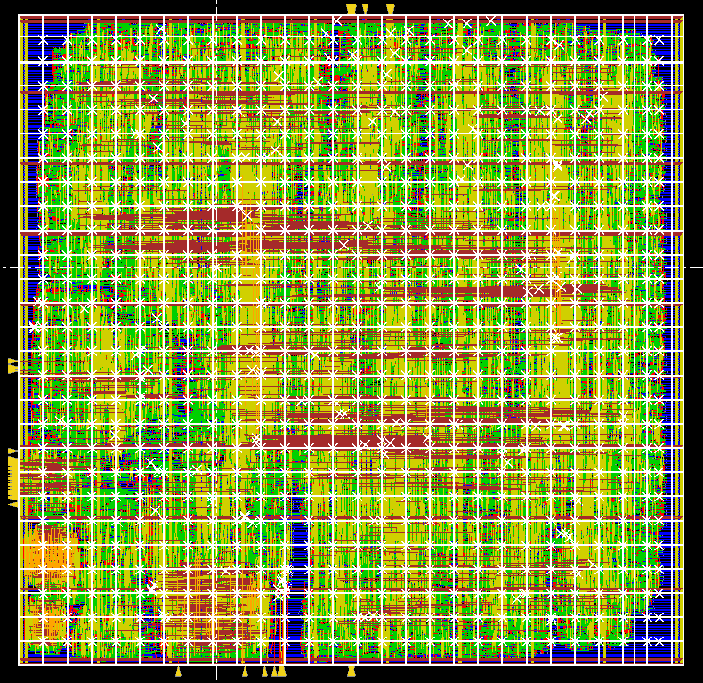
Fig. 9 · Final routed layout.
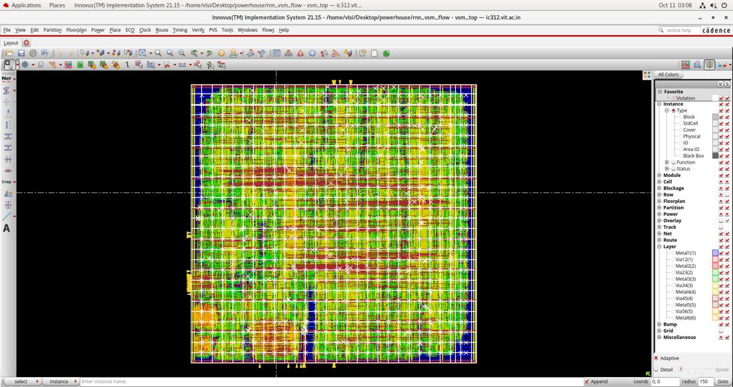
Fig. 10 · Antenna markers, first view.

6 Signoff timing and power (Tempus 22.11)
Metric | Value
Worst setup | +0.237 ns (reg_rdata output paths, slow corner)
Worst hold | +0.840 ns (fast corner)
Violators | none
Total power (SAIF, slow.lib, 1.62 V) | 23.88 mW
Sequential / combinational | 17.65 mW (73.9%) / 6.23 mW
Internal / switching / leakage | 86% / 3.30 mW / 0.0365 mW

The testbench default clock is 10 ns, so the SAIF activity corresponds to 100 MHz.

7 Limitations
• The GDS was written without a foundry layer map and without merging the cell GDS. The repo's stream-out map is a placeholder with sequential layer numbers, so the file is not tape-out ready.
• Power is above the target. Flops dominate, and Genus inferred no clock gating.
• 497 nets exceed the max-fanout limit of 32.
• The SDC period is 15 ns (66.7 MHz) while a comment and the README latency figure assume 100 MHz. Frame latency is 15.73 µs at 100 MHz and 23.6 µs at 15 ns.
• Gate-level simulation used functional models without timing back-annotation.
• The 360,000-frame long run was done on the model only, not on the RTL.

Team 18 · Magesh (24BVD1048) · R Naga Arjun (24BVD1102) · powerhouse
Repository: https://github.com/RKNAGA18/vsm-gru-asic
Thank you.

