# **On-Page SEO Techniques**

## **What is On-Page SEO?**

On-page SEO (sometimes referred to as on-site SEO), is the process of optimizing the structure and content of a webpage. The ultimate goal of on-page SEO is to speak the ‘search engines’ language’ and help search engine crawlers understand the *meaning* and *context* of your pages.

### **Why is on-page SEO important?**

On-page SEO is important because it provides search engines with a number of signals to help them understand what your content is about.

During the indexing and ranking processes, search engines try to associate webpages with keywords and **[search terms](https://www.reliablesoft.net/what-are-search-terms/)** users type in the search box.

It’s through on-page SEO elements that you can guide them as to which keywords you want your pages to rank.

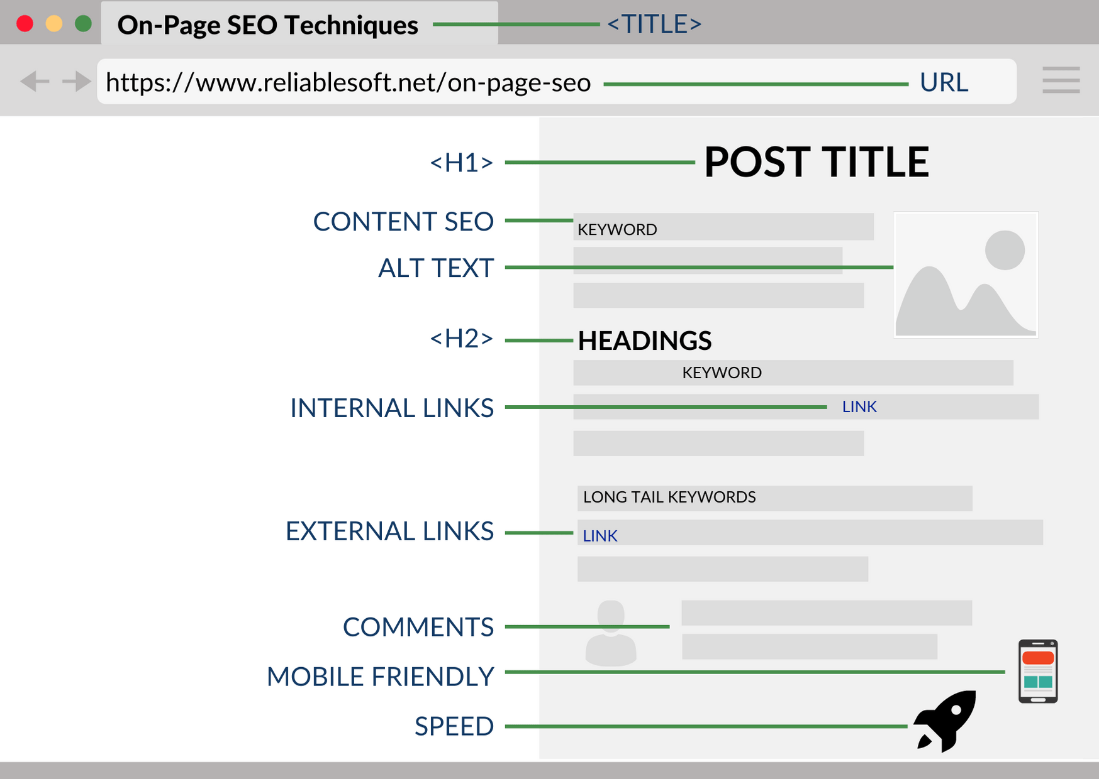

# On page optimization workflow

## 1.Keywords Research

Keyword research is the process of identifying popular search queries that are relevant to customers’ interests. Businesses utilize this process in order to determine which search phrases are used by their target audience the most, so that they can rank higher on search engine results pages (SERPs) and reach more potential customers.

**How to Find Keyword Ideas**

##### **=> Firstly will check the search the keywords on Wikipedea, then will look into the content section and will find the related topics and keywords of searched phrases. Because google knows whatever the information has been mentioned on the wikipedia, that would right information, then search engine learned from wikipedia about the relevance.**

**=> Then will check the keywords on google search bar, and then will check buttoms of the page, there could find more related searches to keywords, that called LSI (Latent searches Indexed ) keywords.**

**We can also see some semantic keywords, whenever we type anyword keywords in google search, then automatically some referance word will display below search tab, that all are semantic keywords. We take some suggestion from there.**

**=> Then will check the keywords on some of big content platfrom, like Digg, Reddit, to find the trending topics and keywords, where people do hangout related keywords.**

**=> We can also go to relevant Forums to check treding topic related to that keywords to find realted topic that** target audience struggles with:

=> Then after we do move ahead on google keywords planner to discover the searches trends. Means, what is the volume of the keywords

=> To know the volume of the keywords, there are many keywords tools like < Keywords Everywhere>, < Ubber Suggest>, <<https://searchvolume.io/>>. Then will consider the keywords difficulties to while considering.

=> Then will verify that keywords trends on the google trends to ensure the keywords visibilities or user searches trends in which phase of time.

=> After That we will check which website ranking the TOP through that keywords, what kind of topic they have mentioned on the website, what keywords and topic they have covered in the H-Tags.

=> Then will check the topic that we could find related to keywords on < Answer the Public> platform.

**=> Then after place the keywords with topic to content department along with few suggestion of website to write best articles, based on that keywords.**

## URL Creation & Structuring

**Once we would have conent, then we will place the content on the website, then we will create perfect match of URL structure to render the website. Keywords should avaible in the URL.** [A keyword-rich URL can improve your organic CTR](https://backlinko.com/google-ctr-stats" \o "Google CTR Stats" \t "https://backlinko.com/_blank).

The following is a good example of URL structure:

* http://www.example.org/games/video-game-history

This URL clearly shows the hierarchy of the information on the page

The following is a bad example of URL structure:

* http://www.imdb.com/title/tt0468569

## Title Tag

**What is a meta title tag?**

A title tag is an HTML element that specifies the title of a web page. Title tags are displayed on search engine results pages (SERPs) as the clickable headline for a given result, and are important for usability, SEO, and social sharing.

Title tag shold be clickable, as it inversely pla vital role to generate more percentage of CTR (Click through Rates), title is not about to only describe the pages, it is something that going to convey or approach to visitor to visit on our web-page for relevant information.

To do research on title, we can collect big website while searching the kewords on ashrefs or ubbesuggest or we can also extract through Screaming Fog.

We can also take Suggestion from the displayed ads title, because they always monetized in the best way.

**Rule** :-

* . Google starts cutting off title tags in the SERPs after around 50–60 characters.
* All-caps is poor etiquette when it comes to title tags. ****Sentence case:**** Capitalize the first letter of the first word (e.g., “[Dwell time](https://ahrefs.com/blog/dwell-time/" \t "https://ahrefs.com/blog/title-tag-seo/_blank): is it really a ranking factor
* ****Write for humans, not search engines:****
* ****Make sure all title tags are unique (no matter what):****
* ****Make sure a title tag exists on all pages:****
* ****Include your keywords:****
* ****Add brackets/parentheses :-Brackets/parentheses can help break up your title tag and improve readability.****
* ****your keyword at the beginning of your title tag.****
* ****Don't overdo SEO keywords****
* ****Give every page a unique title****
* ****Put important keywords first****

Code sample

<head><title>Example Title</title></head>

**What is a meta description?**

The meta description is an HTML attribute that provides a brief summary of a web page. Search engines such as Google often display the meta description in search results, which can influence click-through rates.

**Meta descriptions can be any length, but Google generally truncates snippets to ~155–160 characters.**

### Code sample

<head> <meta name="description"

content="This is an example of a meta description.

This will often show up in search results."></head>

* **Write compelling ad copy :- Crafting a readable, compelling description using important keywords can improve the click-through rate for a given webpage. it's important to note that Google and other search engines bold keywords in the description when they match search queries. This bold text can draw the eyes of searchers, so you should match your descriptions to search terms as closely as possible.**
* **Avoid duplicate meta description tags :- As with title tags, it's important that meta descriptions on each page be unique.**
* **Don't include double quotation marks**

## Image Optimization Alt Text

**What is Alt Text?**

Alt text (alternative text), also known as "alt attributes", “alt descriptions", or technically incorrectly as "alt tags,” are used within an HTML code to describe the appearance and function of an image on a page

<img src="pupdanceparty.gif" alt="Puppies dancing">

* **Choose the Right Format:- the PNG and JPEG are the most common for the web.**
* **Compress Your Images :- According to HTTP Archive, images make up on average 21% of a total webpage’s weight. You can do this in Photoshop or you can use a tool like TinyPNG or WP Smush.**
* **If you’re unsure how your images are affecting your page speed, I recommend using Google’s PageSpeed Insights tool or Webpage Test Tool.**
* **Beware of Copyright:-Regardless of the image files you choose to use, make sure there’s no copyright conflict. We know 41 different websites to find free images.**
* **Write SEO-Friendly Alt Text:- Write the long tail keywords in the image alt tag.**

**<img src=”chocolate-1.jpg” alt=”dark chocolate coffee flavored bar”/>**

* **Add Images to Your Sitemap**

## Meta robots & Robots.txt

**What is a robots.txt file?**

Robots.txt is a text file webmasters create to instruct web robots (typically search engine robots) how to crawl pages on their website.  The robots.txt file is part of the the robots exclusion protocol (REP), a group of web standards that regulate how robots crawl the web, access and index content, and serve that content up to users.

The REP also includes directives like [meta robots](https://moz.com/learn/seo/robots-meta-directives), as well as page-, subdirectory-, or site-wide instructions for how search engines should treat links (such as “follow” or “nofollow”).

In practice, [robots.txt files indicate](https://moz.com/blog/interactive-guide-to-robots-txt) whether certain user agents (web-crawling software) can or cannot crawl parts of a website. These crawl instructions are specified by “disallowing” or “allowing” the behavior of certain (or all) user agents.

- To create Robot txt

User-agent: * -----It will block all bot agent, if you want to allow any individual you can mention here.

Crawl-delay: 120 ----Means it will tells bot to wait for 120 min

Disallow: /cgi-bin/--------it is disallowing the bot to crawl this slang information

Disallow: /tmp/

Disallow: /cancel.png

Disallow: /update*

Disallow: /mail*.php

User-agent: googlebot

Allow: /css/

Allow: /js/

Sitemap: <https://www.contentwriting.us/sitemap.xml>

NOTe :- To create sitemap, write syntax into notepad then save that into .txt format and then upload on website.

**Meta robots**

The meta robots tag tells search engines if and how they should crawl your web pages.

<meta name=”robots” content="index, follow">

<meta name=”robots” content="noindex, nofollow">

<meta name=”robots” content="index, follow">

<meta name=”robots” content="noindex, follow">

<meta name=”robots” content="index, nofollow">

**With that in mind, here are the values you can use in this tag:**

* ****index****: tells bots to index the page;
* ****noindex****: tells bots not to index the page;
* ****follow****: tells bots to crawl links on the page, and that you also vouch for them;
* ****nofollow****: tells bots not to crawl links on the page, and that no endorsement is implied.

**Why do you need robots.txt?**

Some common use cases include:

* Preventing duplicate content from appearing in SERPs (note that meta robots is often a better choice for this)
* Keeping entire sections of a website private (for instance, your engineering team’s staging site)
* Keeping internal search results pages from showing up on a public SERP
* Specifying the location of sitemap(s)
* Preventing search engines from indexing certain files on your website (images, PDFs, etc.)
* Specifying a crawl delay in order to prevent your servers from being overloaded when crawlers load multiple pieces of content at once

## Canonicalization

**What is a canonical tag?**

A canonical tag (aka "rel canonical") is a way of telling search engines that a specific URL represents the master copy of a page. Using the canonical tag prevents problems caused by identical or "duplicate" content appearing on multiple URLs.

You might be thinking "Why would anyone duplicate a page?" and wrongly assume that canonicalization isn’t something you have to worry about.

For example, search crawlers might be able to reach your homepage in all of the following ways:

* http://www.example.com
* https://www.example.com
* http://example.com
* http://example.com/index.php
* <http://example.com/index.php?r...>

Sample Code

<link rel="canonical" href="https://www.contentwriting.us"/>

<link rel="shortlink" href="https://www.contentwriting.us"/>

## Sitemaps

Having XML sitemaps allows search engines to crawl and index a website sufficiently, and allowing all search engines to be notified of the site map by inserting it into the robots.txt file.  
  
To create the sitemap we can use :- Sitemap Generator tool or Screaming Fog/.

Once the sitemap would generated then upload the html file on website into root directory

Once the sitemap we will be uploaded then need to add sitemap into Search Console ( Webmaster ).

<https://www.contentwriting.us/sitemap.xml>

## Schema.org Markup

**What is Schema.org Structured Data?**

Schema.org is the result of collaboration between Google, Bing, Yandex, and Yahoo! to help you provide the information their search engines need to understand your content and provide the best search results possible at this time. Adding Schema markup to your HTML improves the way your page displays in SERPs by enhancing the rich snippets that are displayed beneath the page title.

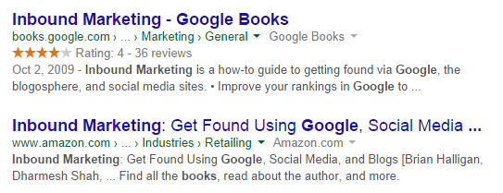

For example, the first search result above contains both a star rating and a publication date. Both of these can be added using Schema

<div itemprop="aggregateRating" itemscope itemtype="https://schema.org/AggregateRating"> <span itemprop="ratingValue">[Aggregate rating given]</span> stars – <span itemprop="reviewCount">[Number of reviews]</span> reviews</div>

.

To generate your own code, you can use [Google's Structured Data Markup Helper](https://www.google.com/webmasters/markup-helper/u/0/) or https://technicalseo.com/tools/

**Then paste the code into head section**

## Open Graph meta tags

Open Graph meta tags are snippets of code that control how URLs are displayed when shared on social media. Open Graph is a type of markup used by Facebook to parse out information like what image and description to display

<meta property="og:title" content="How to Become an SEO Expert (8 Steps)" />

<meta property="og:description" content="Get from SEO newbie to SEO pro in 8 simple steps." />

<meta property="og:image" content="https://ahrefs.com/blog/wp-content/uploads/2019/12/fb-how-to-become-an-seo-expert.png" />

**To find all OG Tags :-** <https://gist.github.com/lancejpollard/1978404>

## Domains

**What are domains?**

Domain names are the unique, human-readable Internet addresses of websites. They are made up of three parts: a top-level domain (sometimes called an extension or domain suffix), a domain name (or IP address), and an optional subdomain.

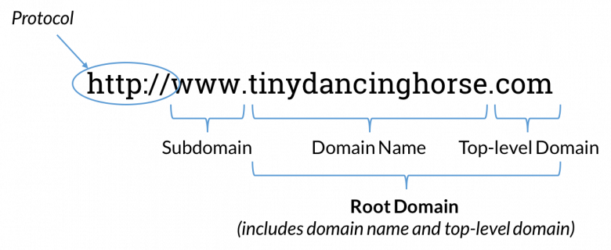

**Top-level domain**

Top-level domain (TLD) is the formal term for the suffix that appears at the end of a domain name. Some example of top-level domains include:

* .com
* .net
* .org
* .edu

There are actually over 1,000 possible TLDs from which webmasters can choose. This includes things like .book, .clothing, .dog, and .lifeinsurance (to name a few), as well as TLDs associated with specific countries or territories like .uk (United Kingdom) or .dk (Denmark). These country- (and sometimes region-)specific TLDs are known as country code top-level domains, or ccTLDs.

**Root domain**

While the term "root domain" was originally created in the context of DNS (domain-name servers), it typically refers to the combination of a unique domain name and a top-level domain (extensions) to form a complete "website address."

Examples of root domains include:

* moz.com
* Ilovedogs.net
* PawneeIN.gov

**Subdomain**

Subdomains are the third level of a domain's hierarchy and are parts of a larger top-level domain.

The two most common subdomain choices are:

* [http://www.example.com](http://www.example.com/) ("www" is the subdomain)
* [http://example.com](http://example.com/) (has no subdomain)

These are also the subdomains that commonly result in [canonicalization errors](https://moz.com/learn/seo/canonicalization).

**SEO best practices for domains**

1. **Make your domain name memorable**

Strive for domain names that are short, easy to remember, easy to type, and easy to say.

**2. Use broad keywords when sensible**

If you can include a keyword that helps make it obvious what your business does while keeping your domain name catchy, unique, and brand-friendly, go for it. But, stay away from domain names that might be considered "keyword-rich" or "keyword-targeted" (such as best-pancake-pans-for-pancakes.com or senior-eldercare-retirement-home-finder.com) that also called Exact match domains (EMD)

****Pros of an EMD****

* Great for a startup to gather some relevant longtail traffic
* Easier to get targeted anchor text
* Easier to get social mentions with keywords
* Can dominate a single niche (IE: “Category Killer”)
* Good for targeting variations in the long tail keyword phrase set
* Brand mentions and keyword mentions become one in the same
* They can be very effective for generic commercial intent queries
* They can be very effective in local search
* Great way to build startup “bootstrapper” traction
* Can be an effective strategy with a well built microsite to target a single niche.
* Some businesses have very limited keyword sets – this is a decent approach in these areas.

**Cons of an EMD**

* Limits future brand expansion
* Can create “brand confusion”
* You don’t get the same “credit” for brand mentions.
* Your brand can come off as “generic”
* It can be harder to claim social media profiles
* It can be more difficult to associate mentions with your brand
* Hatorade on your site quality if you outrank competitors
* More chance of “over-optimization” (seriously, does anyone else hate this phrase as much as I do?)
* There are a limited amount of them
* They can be very expensive
* The effectiveness of the advantages are slowly being neutralized

1. **Avoid hyphens if possible**

If your domain name is two words (like www.examplesite.com), you may want to separate the words with a hyphen for readability: www.example-site.com. But, keep in mind that use of hyphens also strongly correlates with spammy behavior and decreases domain name readability and memorability.

4. Favor subfolders/subdirectories over subdomains

Search engines keep different metrics for domains than they do for subdomains, from a ranking perspective — content in subdomains and subdirectories is treated roughly equally, it's still recommended that webmasters place link-worthy content like blogs [in subfolders rather than subdomains](https://moz.com/blog/subdomains-vs-subfolders-rel-canonical-vs-301-how-to-structure-links-optimally-for-seo-whiteboard-friday) (i.e. [www.example.com/blog/](http://www.example.com/blog/) rather than blog.example.com).

1. **Don't sweat over domain age**

The notion that the age of a domain (i.e. how long it's been registered) is an important SEO ranking factor is a myth.

[Matt Cutts assures](https://www.youtube.com/watch?v=-pnpg00FWJY&feature=player_embedded) that "the difference between a domain that's six months old and one year old is really not that big at all."

1. **Moving domains**

SEOs should avoid redirecting all pages from one domain to the homepage of another domain.

## Redirects

Redirection is the process of forwarding one URL to a different URL. The three most commonly used redirects are 301, 302, and Meta Refresh.

#### Types of Redirects

* 301, "Moved Permanently"—recommended for SEO
* 302, "Found" or "Moved Temporarily"
* Meta Refresh

#### 301 Moved Permanently

A 301 redirect is a permanent redirect which passes between 90-99% of link equity (ranking power) to the redirected page.

#### 302 Found (HTTP 1.1) / Moved Temporarily (HTTP 1.0)

Some of Google's employees have indicated that there are cases where 301s and 302s may be treated similarly, but our evidence suggests that the safest way to ensure search engines and browsers of all kinds give full credit is to use a 301 when permanently redirecting URLs.

#### Meta Refresh

#### Meta refreshes are a type of redirect executed on the page level rather than the server level. They are usually slower, and not a recommended SEO technique.

## Conversion Rate Optimization

### What is Conversion Rate Optimization?

Conversion rate optimization (CRO) is the systematic process of increasing the percentage of website visitors who take a desired action — be that filling out a form, becoming customers, or otherwise. The CRO process involves understanding how users move through your site, what actions they take, and what's stopping them from completing your goals.

**Examples of conversions**

****Macro-conversions:****

* Purchasing a product from the site
* Requesting a quote
* Subscribing to a service

****Examples of micro-conversions:****

* Signing up for email lists
* Creating an account
* Adding a product to the cart

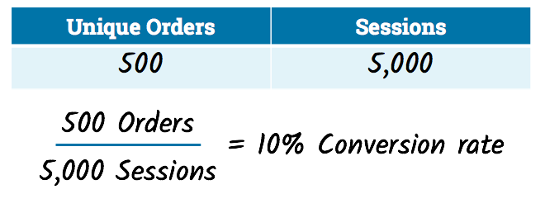

## Content Optimization Strategies

**Use Your Keyword in Your Content**

Adding keywords to your content is a BIG part of SEO content writing.

* Your URL
* Your title tag
* The first 100 words of your page
* In an H1 tag
* In an H2 tag

Most SEO experts believe that an ideal keyword density is around 1-2%. This means the target keyword appears about one to two times per 100 words. At this rate, the keyword appears enough times to show search engines what the page is about without engaging in keyword stuffing.

### **Keyword Stuffing?**

[Keyword stuffing](https://blog.alexa.com/keyword-stuffing/) is the act of repeating the same target keyword over and over to rank the page for the target term. At one time, this was a popular [black hat SEO tactic](https://blog.alexa.com/black-hat-seo/).

**Use keyword stemming to add variations of the target keyword**

Google can read and analyze texts very well. It understands that walk, walks and walking all boil down to the same thing. Also, Google knows that baby is basically the same as babies. How? By using something called keyword stemming.

Stemming or keyword stemming refers to Google’s ability to understand different word forms of a specific search query. It’s called stemming because it comes from the word stem, base or root form.

**Use semantic keywords to give context and support the target keyword**

Semantic keywords are terms that are synonyms, variations, or contextually related to the target keyword.

example, semantic keywords for the target term project manager might include project management or managing projects.

**Use Related Words and Phrases (LSI)**

[LSI keywords](https://backlinko.com/hub/seo/lsi" \o "LSI keywords" \t "https://backlinko.com/hub/seo/_blank) are terms that are closely tied to your content’s topic. And LSI keywords are GREAT for SEO.

**Use Multimedia In Your Content**

Multimedia may not strictly fall under the category of “SEO writing”. But images, infographics and videos are super important for SEO.

**Link to External Pages and Resources**

According to Moz, using outbound links [can help improve your page’s Google rankings](https://moz.com/blog/20-illustrations-on-search-engines-valuation-of-links" \o "Using outbound links can help improve your page's Google rankings" \t "https://backlinko.com/hub/seo/_blank).

### Why does duplicate content matter?

#### ****For search engines****

Duplicate content can present three main issues for search engines:

* They don't know which version(s) to include/exclude from their indices.
* They don't know whether to direct the link metrics (trust, authority, [anchor text](https://moz.com/learn/seo/anchor-text), [link equity](https://moz.com/learn/seo/what-is-link-equity), etc.) to one page, or keep it separated between multiple versions.
* They don't know which version(s) to rank for query results.

### How do duplicate content issues happen?

Let's take a look at some of the most common ways duplicate content is unintentionally created:

### URL variations

URL parameters, such as click tracking and some analytics code, can cause duplicate content issues.

****For example:****

* [www.widgets.com/blue-widgets?c...](http://www.widgets.com/blue-widgets?color=blue) is a duplicate of [www.widgets.com/blue-widgets?c...](http://www.widgets.com/blue-widgets</li><li><a href=)&cat=3" class="redactor-autoparser-object">[www.widgets.com/blue-widgets](http://www.widgets.com/blue-widgets) is a duplicate of [www.widgets.com/blue-widgets](http://www.widgets.com/blue-widgets)?cat=3&color=blue

### HTTP vs. HTTPS or WWW vs. non-WWW pages

If your site has separate versions at "www.site.com" and "site.com" (with and without the "www" prefix), and the same content lives at both versions, you've effectively created duplicates of each of those pages. The same applies to sites that maintain versions at both http:// and https://. If both versions of a page are live and visible to search engines, you may run into a duplicate content issue.

### How to fix duplicate content issues

Fixing duplicate content issues all comes down to the same central idea: specifying which of the duplicates is the "correct" one.

Whenever content on a site can be found at multiple URLs, it should be [canonicalized](https://moz.com/learn/seo/canonicalization) for search engines. Let's go over the three main ways to do this: Using a 301 redirect to the correct URL, the rel=canonical attribute, or using the parameter handling tool in Google Search Console.

## **What Is Copywriting?**

Copywriting is the practice of crafting written text in order to inform, inspire or persuade. In most cases, copywriting is used to increase sales and conversions. Mediums where copywriting is implemented include sales letters, blog posts, advertisements and social media posts.

### How To Become a Copywriter

Fortunately, you don’t need any formal training or education to become a copywriter. Instead, you need to get good at the following skills:

* Customer research
* Sentence structure
* [Web copywriting](https://backlinko.com/hub/content/web-copywriting" \o "Fundamentals of Web Copywriting" \t "https://backlinko.com/_blank)
* Grammar and spelling
* Persuasion
* Content structure
* Online advertising

### Customer - Focused Copy

**This topic talks about to find the customer need related to product, what kind of word they are using and what they demand with what kind of query.**

If you want to write like your customers talk, Reddit is one of the first places to look.Then, take a look at some of the most popular recent threads:And look at the ****language**** people use to describe what they like and don’t like about the current bars on the market.

As you’ve probably seen firsthand, people on Amazon ****don’t hold back:**** And you can mine these honest reviews for killer copy.

Specifically, you want to ask customers these questions:

* “Why did you decide to buy [Your Product]?”
* “What was the #1 thing that made you say: Yes, this is for me?”
* “What have you tried before?”
* “What was your experience with those other products?”

# International SEO

## What is international SEO?

Let’s first get our lingo right and define what international SEO is.

International SEO is the process of optimizing your website(s) to drive organic traffic from

* multiple regions (called **multiregional SEO**)
* and/or languages (called **multilingual SEO**).

If you’re catering to people in Canada with an English and a French website, you’re doing multilingual SEO.

If you’re catering to people in the US, Canada, UK, and Australia in English you’re doing multiregional SEO.

## Why should you care about international SEO?

International SEO can be a great way to grow a business, because international SEO may very well be in your competition’s blind spot.

Another example: one of our customers sells bicycles and bicycle parts online. As they’re a Dutch company, they started out catering to the Dutch market. Soon, they saw the huge potential to start selling across borders, so they set up an English website focused on the English speaking markets. Organic traffic started coming in. From the United States, United Kingdom, and even as far as Australia. (This presents all sorts of new challenges, but we’ll get to that later.)

**OK, now it’s time to burst one bubble: international SEO is about far more than just translating content.**

## How do search engines determine your intended audience?

In an ideal world, search engines would always rank your site for your intended audience. Unfortunately, we don’t live in an ideal world, and search engines need hints as to what audiences you’re catering to.

* **Content analysis:** what language is it written in? Localization is key here; for example British English is different from American English.
* **Domain hints:** are you using a ccTLD, such as .de? If that’s the case, search engines will assume it’s likely you’re targeting the United Kingdom. [Jump down to domain structure](https://www.contentkingapp.com/academy/international-seo/" \l "step-3).
* **Backlink profile:** where are your backlinks primarily coming from? Say a website is getting most of its backlinks from domains with the .de ccTLDand German content—it’s likely the website will be associated with the German market.
* **Hreflang hints:** whether or not you’re using hreflang to communicate what audiences you’re targeting. [Jump down to hreflang](https://www.contentkingapp.com/academy/international-seo/" \l "hreflang).
* **Content‐language HTML attribute:** while Google and Yandex support hreflang, Bing and Baidu don’t. Instead, they use the content-language HTML attribute for hints about the intended target audience.
* **Webmaster tools:** configured language and/or geo targeting in Google Search Console and geo targeting in Bing Webmaster Tools. [Jump down to configuring language and geo targeting using webmaster tools](https://www.contentkingapp.com/academy/international-seo/" \l "targeting-tools).
* **Business listings:** Google My Business listings and Bing’s Places for Business.

## International SEO strategy: 8 steps to success

* [Do market research](https://www.contentkingapp.com/academy/international-seo/" \l "step-1)
* [Get buy-in for international SEO roll-out](https://www.contentkingapp.com/academy/international-seo/" \l "step-2)
* [Research the best way to cater to your audiences](https://www.contentkingapp.com/academy/international-seo/" \l "step-3)
* [Define how you’ll be managing your SEO](https://www.contentkingapp.com/academy/international-seo/" \l "step-4)
* [Do full-blown keyword research](https://www.contentkingapp.com/academy/international-seo/" \l "step-5)
* [Create a keyword strategy](https://www.contentkingapp.com/academy/international-seo/" \l "step-6)
* [Define how your localization process works](https://www.contentkingapp.com/academy/international-seo/" \l "step-7)
* [Create a link building strategy](https://www.contentkingapp.com/academy/international-seo/" \l "step-8)

### Step 1: Do market research

* Define which audiences may be interested in your product or service
* Define what’s important to effectively cater to these audiences
* Research how these audiences typically find products and services
* Do limited keyword research
* Do competitor research
* Define what you need to do to get started
* Choose what audiences you’re interested in catering to first

#### Define what’s important to effectively cater to these audiences

* Having a ccTLD (e.g. example.de).
* Having truly localized content—not just text but also visuals.
* Having local prices, and enabling payments in local currencies.
* Having local live chat (pro-tip: check out [LiveAgent](https://www.liveagent.com/)).
* Having a local phone number visitors can call.
* Presenting social proof from local companies (e.g. case studies and reviews).
* Whether or not you’re going to offer all of your products and services to all audiences. If you’re selling heavy products, it may not make sense to ship them all over the world.

### Step 2: Get buy-in for international SEO roll-out

International SEO is about a lot more than just translating keywords from one language to another. Understanding context is key. Make them understand international SEO is a way of thinking, not just slapping on a subfolder with translated content.

### Step 3: Research the best URL structure to cater to your audiences

Research what the best way is to appeal to your audiences. A good [URL structure](https://www.contentkingapp.com/academy/urls/" \l "best-practices) inspires confidence and trust.

Here are the most common options:

* Country code top-level-domains (ccTLDs for short)  
  Example: example.de
* ccTLDs or global top-level-domains (gTLDs for short) in combination with subdomains  
  Example: de.example.com
* ccTLDs or gTLDs in combination with subfolders  
  Example: example.com/es/
* ccTLDs or TLDs with a combination of subdomains and subfolders  
  Example: es.example.com/es-mx/

Each option has its pros and cons. Use the table below to guide your decision.

| Method | Pros | Cons |
| --- | --- | --- |
| **ccTLDs** | - Great for click-through rates - A natural advantage for ranking locally | - Expensive - Each domain has separate domain authority - Having ccTLDs for every market is often impossible |
| **Subdomains** | - The “next best thing” after ccTLDs because it’s easier to organize and manage than subfolders | - Not great for click-through rates - A weaker signal to search engines as to where you want to rank - No benefit from the domain authority, as subdomains are treated as separate domains |
| **Subfolders** | - You benefit from domain authority synergy - Maintenance is easier | Not great for click-through rates - A weaker signal to search engines as to where you want to rank - If penalized, chances are the whole domain gets penalized |

#### The shorter the better

When it comes to URLs, and by extension domain names: the shorter the better!

Examples:

* apple.com
* netflix.com

#### Consider a short modifier or new TLD

If you want to go for the ccTLD option, but not all your desired domain names are still available you can consider a short modifier to your domain names.

**Alternatively, you can use one of the new TLDs such as .io, .me, .dev, and .tec**

**NOTE:- Domains with dashes, such as some-domain-name.com, aren’t great.**

### Step 4. Define how you’ll be managing your international SEO strategy

Often we see an approach where the SEO team at the head office is responsible for defining the international SEO strategy, while local teams are responsible for executing it.

### Step 5: Do full-blown keyword research

Continue with the keyword research you’ve already done . Focus on the audiences you’ll be catering to first.

### Step 6: Don’t auto-redirect

Don’t automatically redirect visitors and/or search engines based on their IP addresses, or browser settings. It’s annoying for users and can be very confusing for search engines too. It can even cause visitors and search engines to **never find certain content**!

### Step 7: Don’t use cloaking

Cloaking refers to serving different versions of content to users and search engines. This is a popular practice among black-hat SEOs to mislead search engines.

For example, they’ll feed search engines keyword-rich content that’s barely readable for visitors. At the same time, they’ll serve a much more readable version to visitors.

In international SEO cloaking is sometimes used as a solution to present auto-redirect to users, but not search engines. As we’ve covered in the previous section, auto-redirection isn’t recommended in most cases anyway, but serving users page A and search engines page B only makes matters worse.

### Step 7: Don’t close off your site for part of the world

With the introduction of GDPR, a lot of businesses in the US panicked and made their website inaccessible to European visitors. Making your site inaccessible to 11% of the world population, which could very well be within your target audience, is generally a very bad idea.

### Step 8: Don’t use automatic translation tools

When localizing websites, don’t use automatic translation tools (machine translation). As we mentioned earlier, lots of words don’t translate 1-on-1 from one language to another. Aside from that, few translation tools really produce human-readable content.

### Step 9: Use the hreflang attribute

You can implement the hreflang attribute by:

* including it in the <head> section of your HTML,
* including it in your XML sitemap markup, or
* including it in your HTTP headers.

When using the hreflang attribute, stick to these best practices:

* Reference both the page itself and its translated variants.
* Make sure to have bidirectional hreflang attribute references.
* Correctly define language and region combinations.
* Always set hreflang="x-default".
* Ensure that the hreflang attribute and the canonical URL match.
* Use absolute URLs when defining the hreflang attribute.
* Use only one method to implement the hreflang attribute.

### Step 10: Defining geo- or language targeting in Google Search Console and other tools

Aside from hreflang, you can define your preferences regarding your target audience using for example Google Search Console and Bing Webmaster Tools.

# Local SEO

Local SEO is search engine optimization for [local marketing](https://www.podium.com/local-marketing/). It’s the practice of optimizing your website to be crawled and indexed by search engine bots called crawlers in order to be found by nearby customers in search engine results page (also known as SERP).

To optimize your business listing for local SEO, first, you need to understand the three main ranking factors that Google uses for local search.

## How Google determines local search rankings?

**Relevance:** The goal of Google’s local search algorithm is to connect searchers with answers. So when they search for a nearby tire shop, they get the best recommendations. Making sure your Google My Business listing is accurate and up-to-date guarantees that potential customers looking for a business like yours will find you instead of a competitor who’s not open.

**Distance:** Proximity of the searcher to your business is another major factor Google takes into account when determining local search ranking. Because of this, it is important to include your address and other relevant contact information in your Google My Business listing and in other directories across the internet.

**Prominence:** Finally, Google takes into account the prominence of your business. What they mean by prominence is how well is this business known. Prominence also factors in things like directory listings, and online reviews. According to Google both a business’ overall star rating and the number of reviews are used to determine local search rankings.

## **A Super Simple Step-by-Step Guide to Local SEO Optimization**

You don’t even need an [SEO strategy](https://www.podium.com/article/local-seo-strategy/) to improve your local SEO and start getting found in more search results. You just need to make a few updates to your Google My Business listing. Below is a local SEO checklist to help you follow each piece step-by-step.

**Local SEO Checklist**

* Adding complete information to your Google My Business listing
* Verifying your locations
* Keeping your hours accurate and up-to-date
* Managing and responding to reviews
* Adding high-quality photos

### 1. Adding Complete Info to Your Google My Business Listing

According to Google, “businesses with complete and accurate information are easier to match with the right searches.” If your GMB listing is incomplete, or worse, non-existent, then it’s harder for search engines to match your business with local customers on Google.

* ****Who You Are****
* Name
* Website
* Business Description
* Category
* Attributes
* Opening Date
* Photos
* ****Where You Are****
* Address
* Service Area
* ****When They Can Visit You****
* Hours of Operation
* Holiday Hours

### 2. Verifying Your Locations

|  |  |
| --- | --- |
| STEP 1 – Go to <https://www.google.com/business>  STEP 2 – Sign in to your Google Account, or create one. Then, click ****Next****.  STEP 3 – Enter your business’ or chain’s address and create or claim your listing.  STEP 4 – Fill out basic information about your business.  STEP 5 – Submit for verification. | STEP 1 – On your phone or tablet, open the My Business app.  STEP 2 – Sign in to your Google Account you’d like to use to manage your business  STEP 3 – Enter your business’ or chain’s address and create or claim your listing.  STEP 4 – Fill out basic information about your business  STEP 5 – Submit for verification |

### 3. Keeping Hours Accurate and Up-to-Date

It’s also important to include accurate, up-to-date hours of operation in your listing. Make sure that you include special holiday hours, to avoid frustrating customers who make their way to your business only to find out you are closed.

### 4. Managing and Responding to Reviews

Businesses that want to improve their local SEO ranking should collect and manage online reviews. Moz estimates that your Google My Business listing and Google Reviews account for [40% of local pack ranking factors](https://moz.com/local-search-ranking-factors).

### 5. Adding High-Quality Photos

Once the verification process is complete, you can begin optimizing your listing. You should start by uploading high-quality photos. Pictures help tell a visual story about your business and let customers know what it’s like to do business with you.

[According to Google](https://support.google.com/business/answer/3038063?hl=en), listings with photos receive 42% more requests for driving directions and 35% more clicks to their websites. There are a number of different types of photos you can upload, but at the very minimum you should include:

* Profile photo
* Logo
* Cover photo

## Local Search Marketing

Local search marketing is anything you do on the web to promote a physical business that makes face-to-face contact with its customers. It applies to both single-location small and medium businesses (SMBs), national enterprise brands, and chains. If a company meets with its customers directly — either through a storefront or service area — it’s termed a “local business”.

Your Google My Business listing is the most important listing you build for your company;

“NAP” is the common acronym for “name, address, phone number.” These three pieces of data make up the core of your business information in the world of local search.

Much of this work hinges on building structured citations (local business listings) on important platforms like Google My Business, Facebook, Bing, Yelp, Superpages, etc.

Reviews may be the most influential Internet factor for any local business. It’s estimated that [92% of consumers read online reviews and 68% state](https://www.brightlocal.com/2015/08/20/92-of-consumers-now-read-online-reviews-for-local-businesses/) that positive reviews influence their feelings of trust in a business. Every local business needs a strategy for encouraging customers to leave reviews on a variety of platforms.

## Local Citations

A local citation is any online mention of the name, address, and phone number for a local business. Citations can occur on local business directories, on websites and apps, and on social platforms. Citations help Internet users to discover local businesses and can also impact local search engine rankings. Local businesses can actively manage many citations to ensure data accuracy.

### What are the components of a local citation?

The core components of a citation are a company’s name, address, and phone number (NAP) and can also include a reference or link to a designated page of the company’s website. In addition to this, a citation may incorporate some or all of the following elements:

* Business categories
* Hours of operation
* Driving directions
* Business description
* Images
* Videos
* Payment forms accepted
* Geo-coordinates
* Reviews
* Owner responses
* Taglines
* Links to social and other forms of media
* Email addresses
* Fax numbers
* Alternate phone numbers
* Attributes

## Duplicate Business Listings

The local SEO world takes its cues from [Google’s guidelines](https://support.google.com/business/answer/3038177?hl=en) when it comes to duplicate listings:

“Do not create more than one page for each location of your business, either in a single account or multiple accounts.”