# AIM:

To construct a 4-bit counter that counts from 0 to 15 and the appropriate decimal is displayed on the 7-Segment Display.

# Components Required:

|  |  |  |  |
| --- | --- | --- | --- |
| S.No | Components | Specification | Quantity |
| 1 | Timer IC | NE555 | 1 |
| 2 | Counter IC | IC 74LS163 | 1 |
| 3 | Magnitude Comparator | IC 74LS85 | 1 |
| 4 | Full Adder | IC 74LS83 | 1 |
| 5 | BCD Driver | IC 74LS47 | 2 |
| 6 | 7-Segment Display | Red Colour | 2 |
| 7 | LED | 5.0 mm | 1 |
| 8 | Resistor | 16kΩ, 64kΩ, 220Ω, 330Ω | 1,1,1,14 |
| 9 | Power Source | --- | 1 |

# Theory:

This project aims to output a loop from 00 – 15 in two separate 7 – Segment Displays. This is achieved using a 4 – bit counter whose clock source is generated from NE555 Timer IC. The output of the counter is given to a magnitude comparator to compare with 9 and the greater than output is given to the full adder which adds 6 , if the output from Magnitude Comparator’s A>B is 1.

The Sum Output from the Full Adder is then given to the Display Driver which is connected to a 7 – Segment Display. The carry output is also connected to the LSB of another Display Driver which is responsible for displaying the Tenth’s place.

# Schematic Diagram:

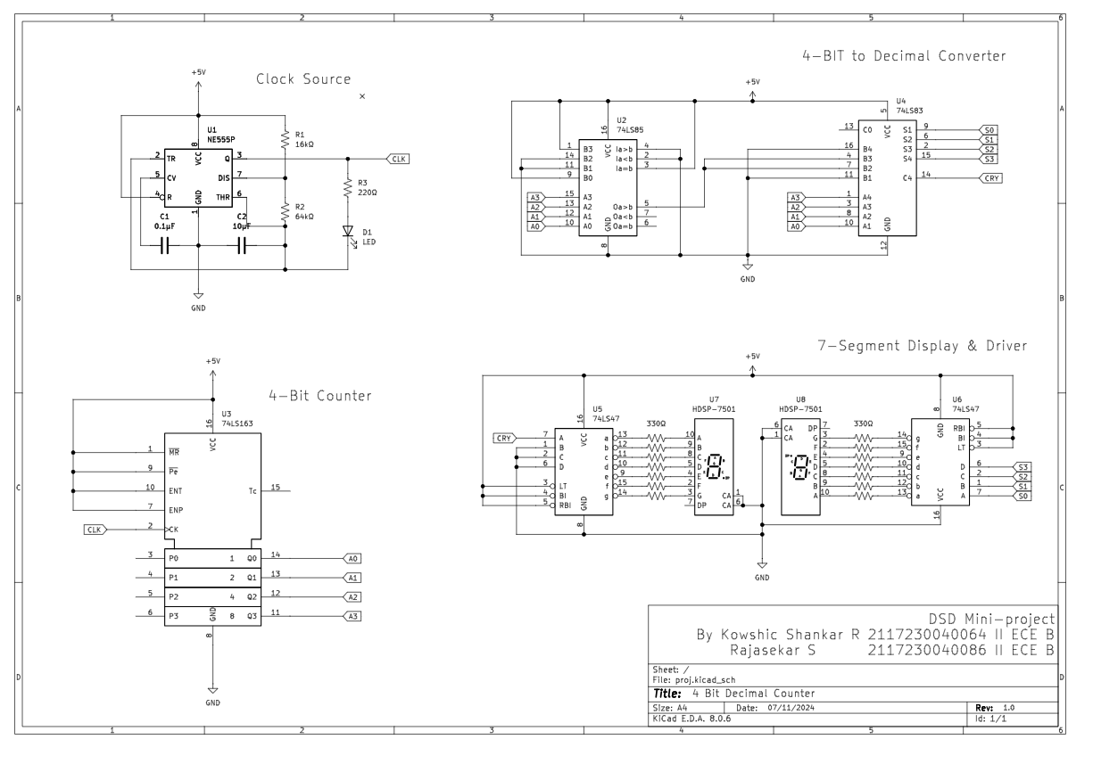

# Procedure:

1. Give the connections as per the Circuit Diagram.
2. Connect the circuit to the power source & check for any heating or short circuit.
3. Check the output which should count up from 00 to 15 in a loop.

# Output:

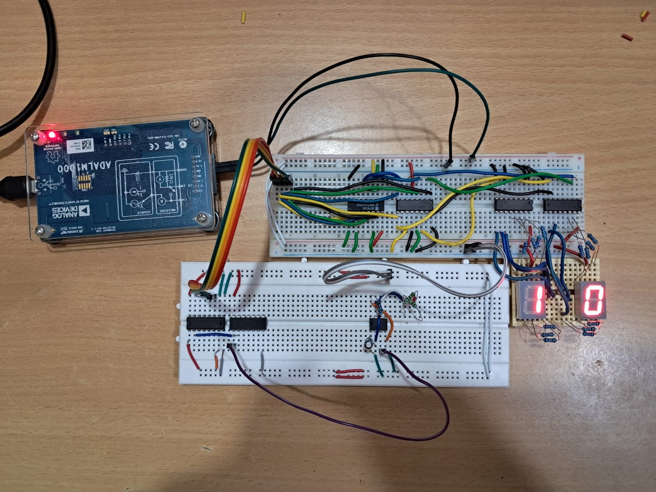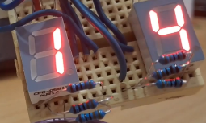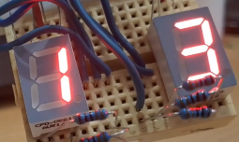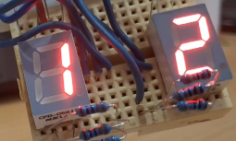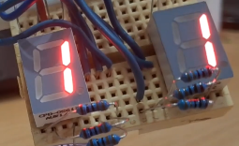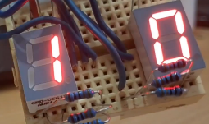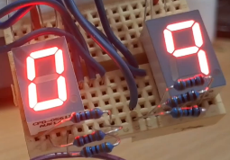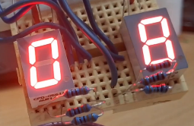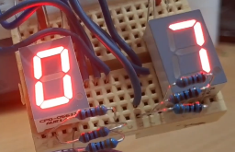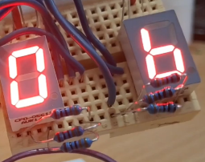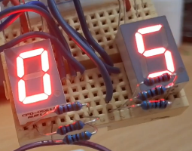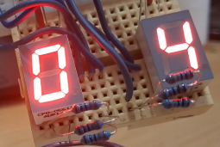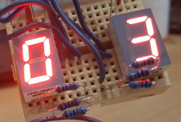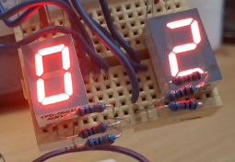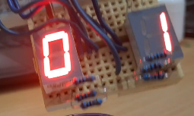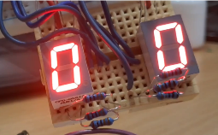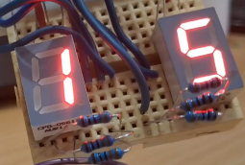

# Inference and Conclusion:

Thus the 4 – Bit Decimal counter with 7 Segment Display is constructed and the output on the display is verified.