Lab Title: Stored XSS into HTML context with nothing encoded
Date: 10/08/2023
Introduction:
I successfully completed the "Stored XSS into HTML context with nothing encoded" lab as part of my internship tasks at INTERNSHIP STUDIO . This report outlines the discovered vulnerability, my approach to exploiting it, and provides recommendations for mitigation.
Vulnerability Details:
Lab Description: This lab simulates a scenario where user inputs are stored on the server and later displayed on a page without any encoding, leading to a potential stored cross-site scripting (XSS) vulnerability in an HTML context.
Vulnerability Type: Stored XSS
Affected Input Field: The vulnerable input field is the comment section of the Blog .
Payload: Payload I used is given below
<script>alert("Stored XSS Vulnerability");</script>

Exploitation: By submitting the crafted payload into the comment section, the malicious script is stored on the server. When a user visits the profile page, the script is executed in their browser context.
Screenshots:
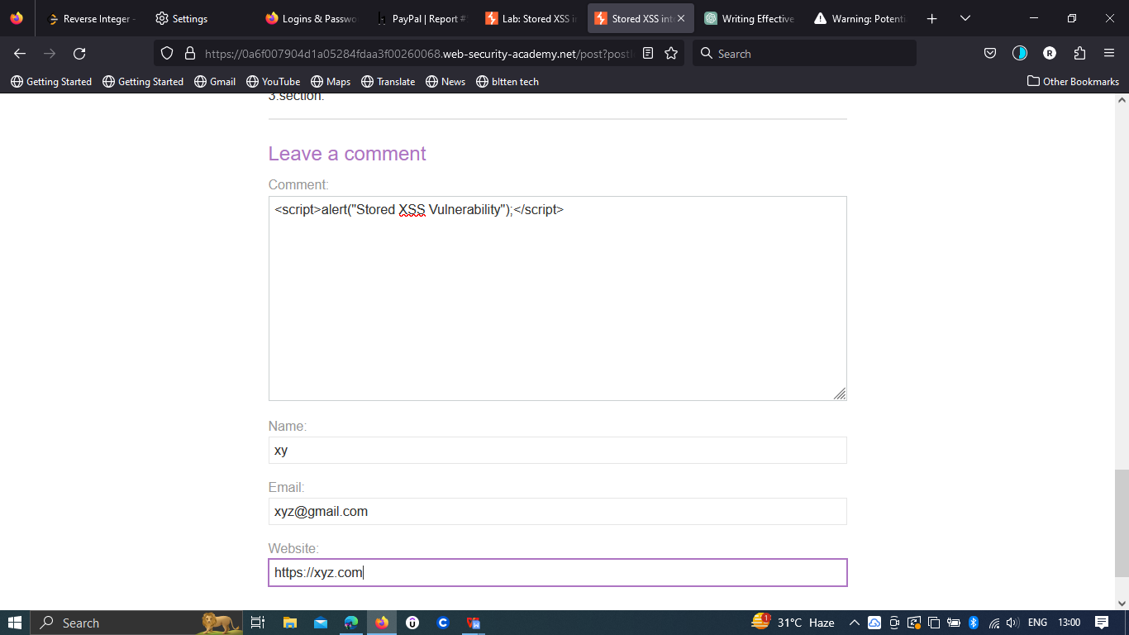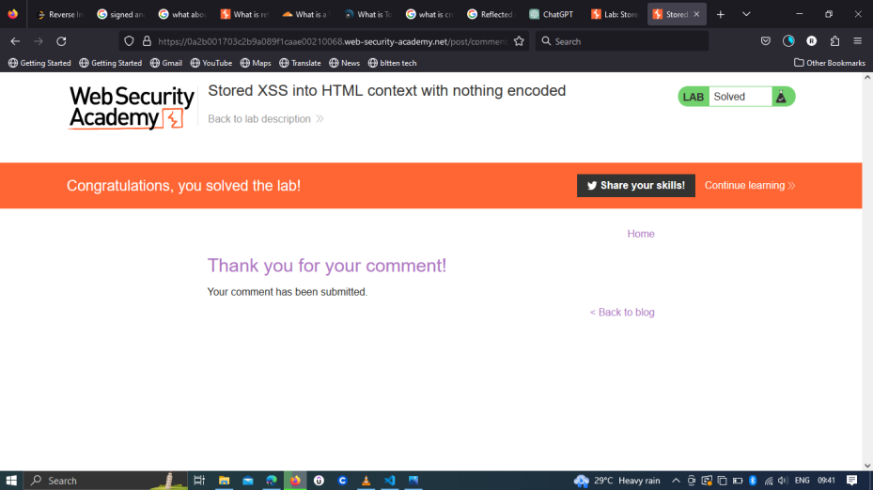
Impact:
An attacker could take advantage of this vulnerability to inject malicious scripts into a user's profile, affecting anyone who views the profile. This could lead to unauthorized data access, session hijacking, or phishing attacks.
Risk Assessment:
The risk associated with this vulnerability is significant, as it enables attackers to execute arbitrary scripts within the context of other users' sessions.
Proof of Concept (PoC):
To replicate the vulnerability:
- Log in as a registered user.
- Navigate to the On of the Blog’s Comment section.
- Insert the following payload into the "Comment " section: <script>alert("Stored XSS Vulnerability");</script>
- Post the comment.
- Refresh the page.
- The alert should pop up, indicating successful execution of the XSS payload
Recommendations:
To mitigate this vulnerability, the following measures should be taken:
1.Input Sanitization: Thoroughly sanitize and validate user inputs before storing them. Encode any user-provided data that is later displayed in HTML to prevent script execution.
2.Content Security Policy (CSP): Implement a robust CSP to limit the sources from which scripts can be executed, reducing the potential for successful XSS attacks.
3.Output Encoding: Always encode user-generated content that is displayed within HTML context to prevent script execution.

