Lab Title: DOM XSS in document.write sink using source location.search
Date: 10/08/2023
Introduction:
I successfully completed the "DOM XSS in document.write sink using source location.search" lab as part of my internship tasks at INTERNSHIP STUDIO. This report outlines the identified vulnerability, the steps taken to exploit it, and recommendations for addressing the issue.
Vulnerability Details:

Lab Description: This lab demonstrates a scenario where user input in the form of a URL parameter is used within a document.write statement in the DOM, leading to a potential DOM-based cross-site scripting (XSS) vulnerability.

Vulnerability Type: DOM-based XSS

Payload: I crafted a simple payload to demonstrate the vulnerability
<script>alert("DOM XSS Vulnerability");</script>

Exploitation: By passing the crafted payload in the message parameter, the JavaScript code extracts the user input from the URL and directly injects it into the DOM using document.write, thereby executing the malicious script.
Screenshots: 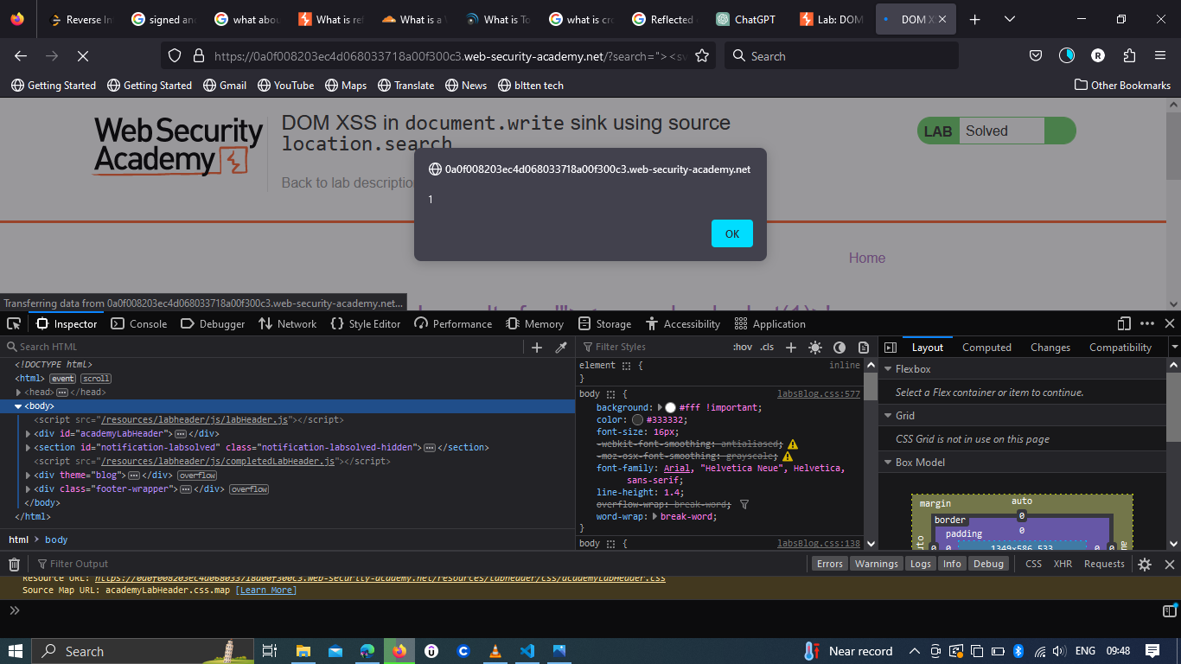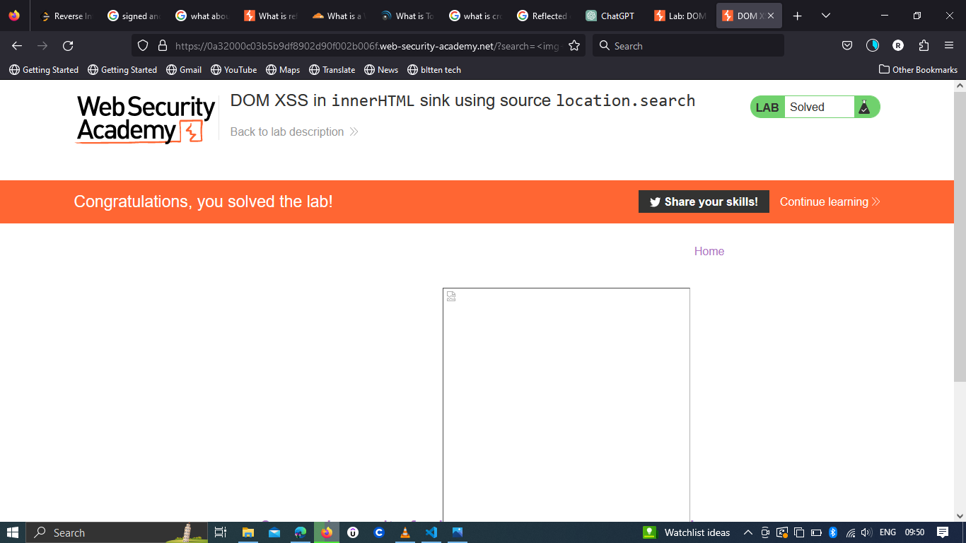

Impact:
An attacker could exploit this vulnerability to inject and execute arbitrary scripts directly into the DOM of the affected page. This could lead to unauthorized data access, session hijacking, or defacement of the page.
Risk Assessment:
The risk associated with this vulnerability is high, as it enables attackers to execute scripts in the context of other users' browsers.
Proof of Concept (PoC):
To replicate the vulnerability:
- Visit the https://portswigger.net/web-security/all-labs
- Select the lab DOM XSS in document.write sink using source location.search LAB.
- Enter a random alphanumeric string into the search box.
- Right click and inspect the element, and observe that your random string has been placed inside an img src attribute.
- Break out the img attribute by searching for : “><svg onload=alert(1)>
Recommendations:
To mitigate this vulnerability, consider implementing the following measures:
Input Validation: Properly validate and sanitize any user input that is used within dynamic parts of the DOM.
Output Encoding: Ensure that user-generated content is properly encoded before being inserted into the DOM to prevent script execution.
DOM Manipulation Libraries: Consider using secure DOM manipulation libraries that handle encoding and sanitation automatically.

