Lab Title: DOM XSS in innerHTML sink using source location.search
Date: 10/08/2023
Introduction:
I successfully completed the "DOM XSS in innerHTML sink using source location.search" lab as part of my internship tasks at INTERNSHIP STUDIO. This report outlines the vulnerability discovered, the steps taken to exploit it, and recommendations for mitigating the issue.
Vulnerability Details:

Lab Description: This lab scenario involves a situation where user input is used within the innerHTML property of an element in the DOM. This can potentially lead to a DOM-based cross-site scripting (XSS) vulnerability.

Vulnerability Type: DOM-based XSS

<img src=1 onerror=alert(1)>
Payload: I crafted a payload to exploit the vulnerability:

Exploitation: By entering the crafted payload in the search box, the JavaScript code extracts the user input from the URL, and sets it as the content of an element with the ID "search-results" using the innerHTML property, resulting in the execution of the malicious script.
Screenshots:

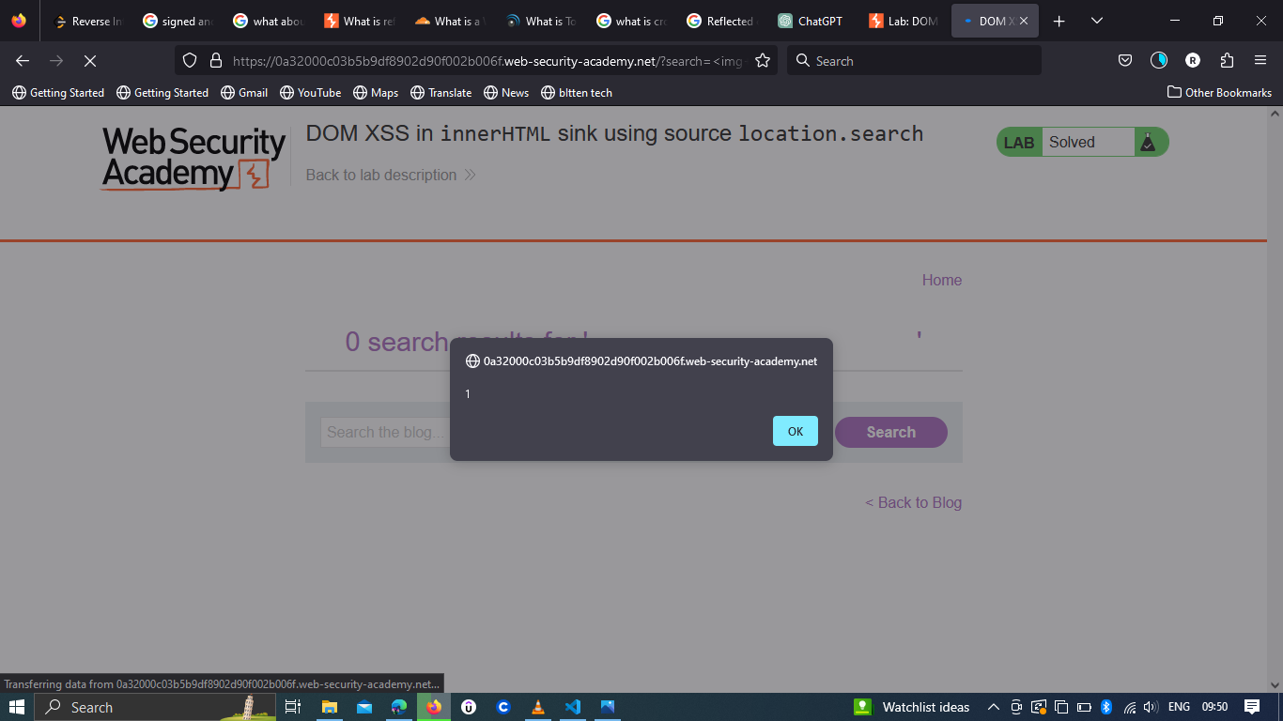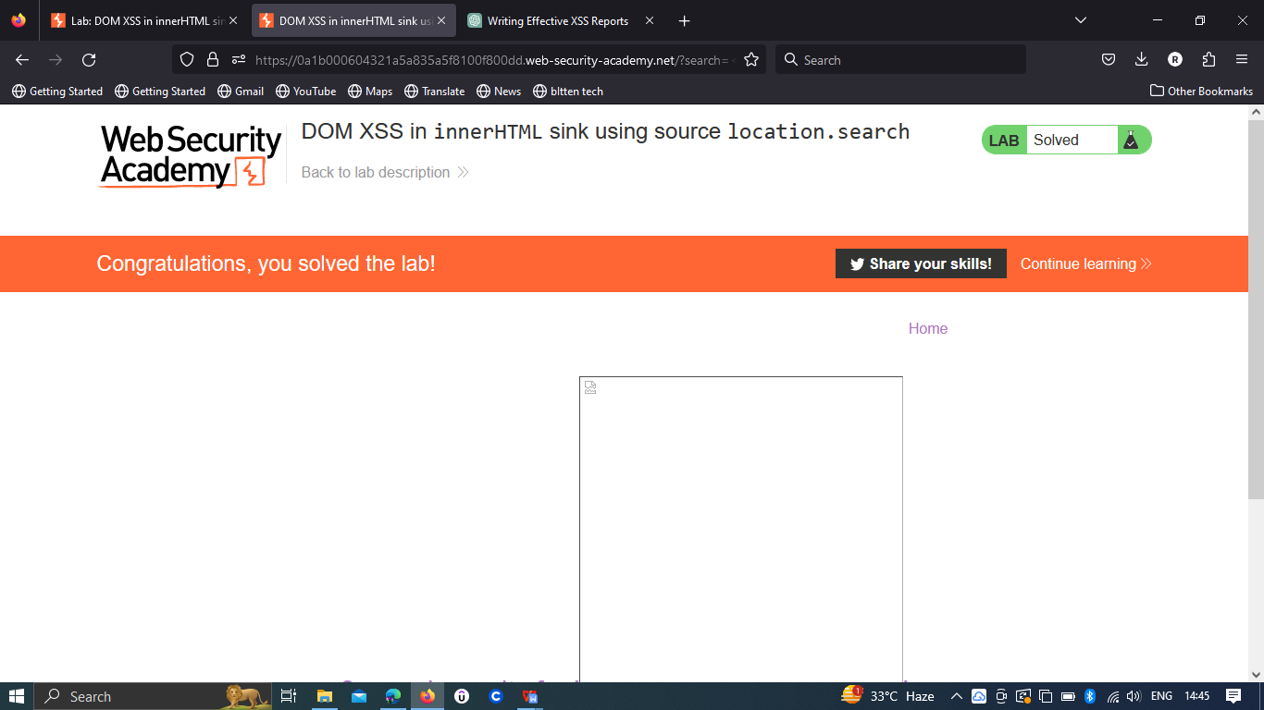
Impact:
Exploiting this vulnerability could enable an attacker to inject and execute arbitrary scripts directly into the DOM of the affected page. This could lead to unauthorized data access, session hijacking, or defacement of the page.
Risk Assessment:
The vulnerability's risk level is substantial, as it empowers attackers to execute scripts within the context of other users' browsers.
Proof of Concept (PoC):
To reproduce the vulnerability:
- Visit the https://portswigger.net/web-security/all-labs.
- Select DOM XSS in innerHTML sink using source location.search.
- Enter the <img src=1 onerror=alert(1)> script in the search box
- The alert should pop up, indicating successful execution of the XSS payload.
Recommendations:
To mitigate this vulnerability, consider implementing these measures:
Input Validation: Rigorously validate and sanitize any user input used within dynamic sections of the DOM.
Output Encoding: Properly encode user-generated content prior to insertion into the DOM, preventing script execution.
DOM Manipulation Libraries: Consider using secure DOM manipulation libraries that handle encoding and sanitation automatically.

