Lab Title: DOM XSS in jQuery anchor href attribute sink using location.search source
Date: 10/08/2023
Introduction:
I have successfully completed the "DOM XSS in jQuery anchor href attribute sink using location.search source" lab as part of my internship tasks at INTERNSHIP STUDIO. This report outlines the vulnerability identified, the steps taken to exploit it, and recommendations for mitigating the issue.

Vulnerability Details:

Lab Description: This lab presents a scenario where user input provided through the URL's search query parameter is used within the href attribute of a jQuery anchor element, potentially resulting in a DOM-based cross-site scripting (XSS) vulnerability.

Vulnerability Type: DOM-based XSS

Payload: Payload that I use is given below
javascript:alert(document.cookie)

Exploitation: By appending the crafted payload to the URL, the JavaScript code retrieves the user input from the URL and sets it as the value of the href attribute of an anchor element with the ID "xss-link". This triggers the execution of the malicious script.
Screenshots:
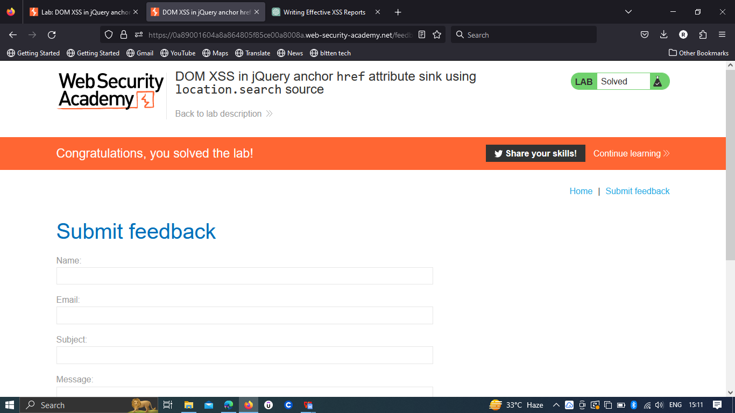
Impact:
Exploiting this vulnerability could allow attackers to inject and execute arbitrary scripts within the context of the affected page. This could lead to unauthorized data access, session hijacking, or defacement of the page.
Risk Assessment:
The risk associated with this vulnerability is substantial, as it enables attackers to execute scripts within the context of other users' browsers.
Proof of Concept (PoC):
To replicate the vulnerability:
- Visit the https://portswigger.net/web-security/all-labs
- Select the lab DOM XSS in jQuery anchor herf attribute sink using location.search
- Click on the submit feedback .
- Put the script javascript:alert(document.cookie) in the url after the returnPath
- Hit enter .
Recommendations:
To mitigate this vulnerability, consider implementing these measures:

Input Validation: Rigorously validate and sanitize any user input used within dynamic parts of the DOM.
Output Encoding: Properly encode user-generated content before inserting it into DOM attributes, preventing script execution.

DOM Manipulation Libraries: Consider using secure DOM manipulation libraries that handle encoding and sanitation automatically.

