Lappeenrannan teknillinen yliopisto

School of Business and Management

Sofware Development Skills

Rebekka Kaartinen, 002614711

LEARNING DIARY, Software Development Skills: Mobile MODULE

16.6.2025

I got familiar with the course and its general information. I read about the module tasks and the project. Additionally, I made a checkbox-list for the course and its tasks to help me track down my progress.

30.6.2025

Even though I was already familiar with Git I watched the intro to version control and installed SourceTree and created an account in BitBucket. I’ve decided to use VS Code as my editor for the course hence it’s the one I’ve used before during my studies. I’m also familiar already with Android Studio.

1.7.2025

I created a public Git repository for the course.

I started the Introduction Module. I already have experience with Java and Android Studio

and I had everything installed so I didn’t have the need to install anything.

Knowing beforehand how to move around Android Studio environment, I didn’t learn much new. But I wasn’t consciously aware of ‘values’ folder before nor options for import in the settings.

Finishing the YouTube video of Introduction Module I had finished the “My First App” task that is a simple calculator on Android Studio.

4.7.2025

I watched the second YouTube video Core Elements and followed the instructions on the Quick Launcher application. I learned in theory how to launch an activity outside of the application. Unfortunately, I didn’t manage to get my Google -launch working. I tried finding help from the internet and even asked ChatGPT but couldn’t find the help I needed nor worked at this moment. I’ll try to take a look it later at a better time again.

Despite not learning anything else, it was nice refreshing to memorize the usage of Android Studio better.

7.7.2025

I went through the last YouTube video about lists, layouts and Images. During a course about object-oriented programming, where I also learned Android Studio, I learned a different method for listing and image handling. It was nice being taught another method for it, even though I found it a bit confusing at first. For the OOP course project, I used the legacy List View with which I had some struggles, so unless my project requires another method, I prefer using Recycler View.

Now that I’ve gone through the YouTube videos, I created a public repository on GitHub called SDS-Mobile-24-25. With Git bash I initiated and pushed projects from the YouTube videos into the git repository.

21.7.2025

After finally deciding on what to do for the application, I drew paper prototypes to gather my thoughts and ideas for the Android Studio project. I created a new project on Android Studio called Fangs, the main character’s name on the game. It’s a clicker-type game where you’re helping the character climb levels and evolve into the most powerful vampire. The idea was born through a mess that included concepts of other games such as V-Rising and Pou. The idea for a clicker game came a while later, watching my boyfriend play denssi-clicker on INTTI -application.

I created MainActivity and GameActivity, and a simple main menu on the main activity xml-file checking the buttons on it work.

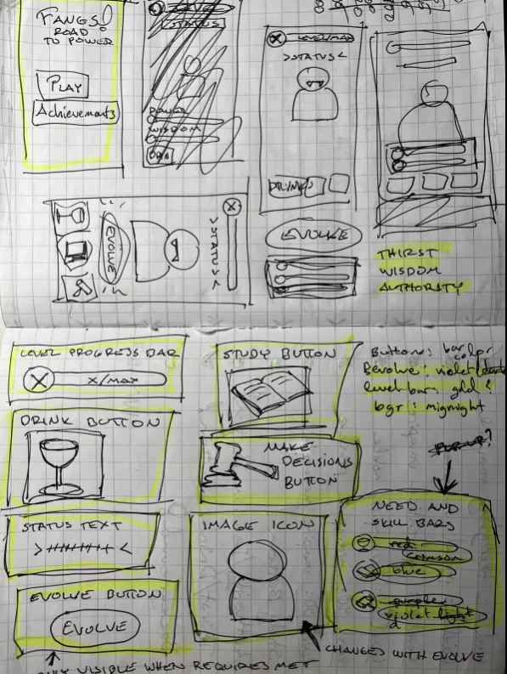

Image: Paper prototyping

22.7.2025

I decided I wanted the game to have a simple achievement system, so I created AchievementActivity and Achievement -class. I used RecyclerView to list the achievements, and I also made sure the button on the main menu worked. I also worked on the xml-file of the game activity, putting everything on the place I had visualized and planned them to go on.

23.7.2025

I created a GameManager -class and worked on it and the GameActivity. I’m a very visual person, and the basic Android Studio buttons I have been using normally, weren’t pleasing my eye. For visual purposes I created several custom buttons each with their own purpose and other custom content e.g. round colored background to visualize level numbers. I added the custom content onto the game activity’s xml-file.

24.7.2025

I used plenty of hours trying to search images for my work on the internet, to complete the look I had in mind, but unfortunately after the long search I couldn’t find what I wanted. So, I decided to draw them.

4.8.2025

I’ve finished the drawings a while ago, for character images I used AI enhancing due to lack of time to color them myself. The rest of the pieces are handmade. I also created background for the Main Menu and the Game Activity using AI tools for convenience.

5.8.2025

I added the images and backgrounds to the game and worked more on the Game Activity.

Ran a test on the game. Buttons work, but not accordingly and the xml display doesn’t fit the screen as planned.

6.8.2025

I worked more on the Game Activity and its logic, I had some trouble getting the character evolution working the way I wanted to, but I eventually managed to make it work.

7.8.2025

I finished the visualization of Achievements and added unlocking them to the game. They’ll be almost see-through, when locked and colors and text are getting their usual visuals, when they’re unlocked.

After all that I am finished with the project. Lastly, I cleaned up the code removing occasional duplicates and had my boyfriend test the application on his phone, Nothing 2a, on which the application run has been recorded.

Then I pushed the finished project into GitHub and added a README.md for the project.

I want to point out that aside from the background and character images, all artwork is mine by hand. I also draw sketches of the characters I used as a base for AI enhancement. Only backgrounds were made by AI, ChatGPT, completely.