**UCS749: Conversational AI: Speech Processing and Synthesis**

**LAB EVAL 1**



Computer Science and Engineering Department

Thapar Institute of Engineering and Technology

(Deemed to be University), Patiala – 147004

Submitted By:

Reitika Kumar(102116008)

Submitted To:

Dr. B.V. Raghav

1. **Summary of the paper**

The Speech Commands dataset presents 105,000 utterances of 35 words from 2618 speakers for training and evaluating speech recognition models. This dataset is designed for efficient computation and real-time applications. The baseline model achieves an accuracy of 88.2%. This dataset is valuable for developing small-footprint models, especially for mobile devices and privacy-sensitive environments. Future research can focus on further optimizing the model for low-powered devices.

1. **Performance Results using standard benchmarks**:

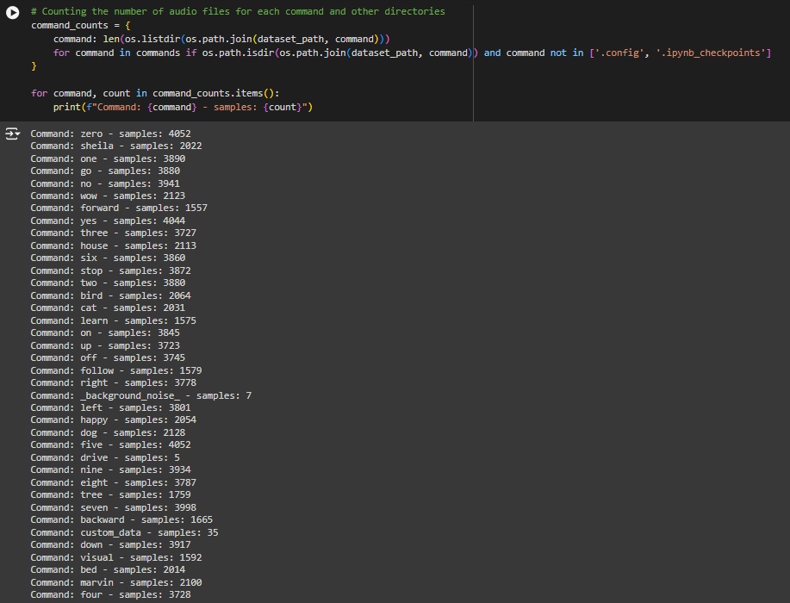

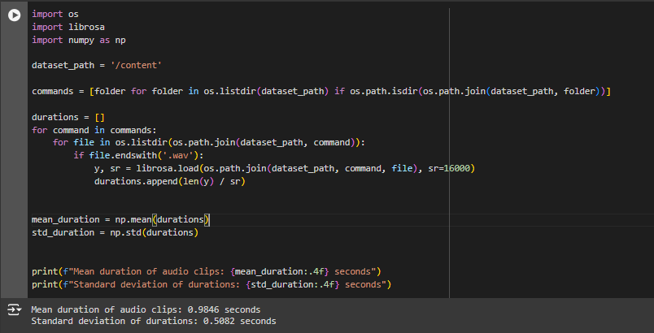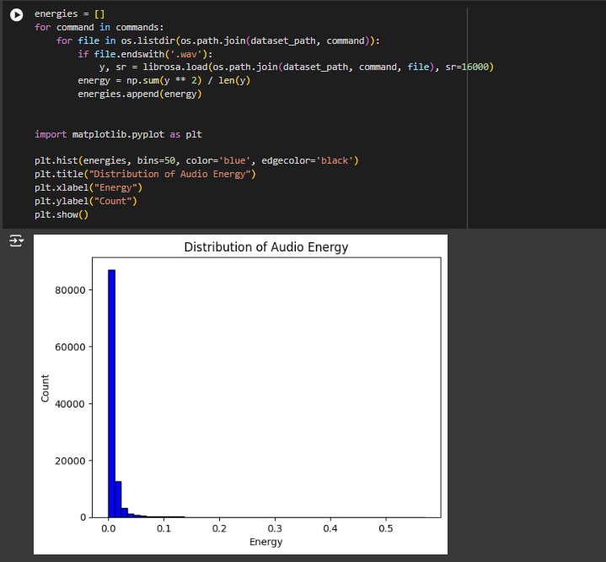

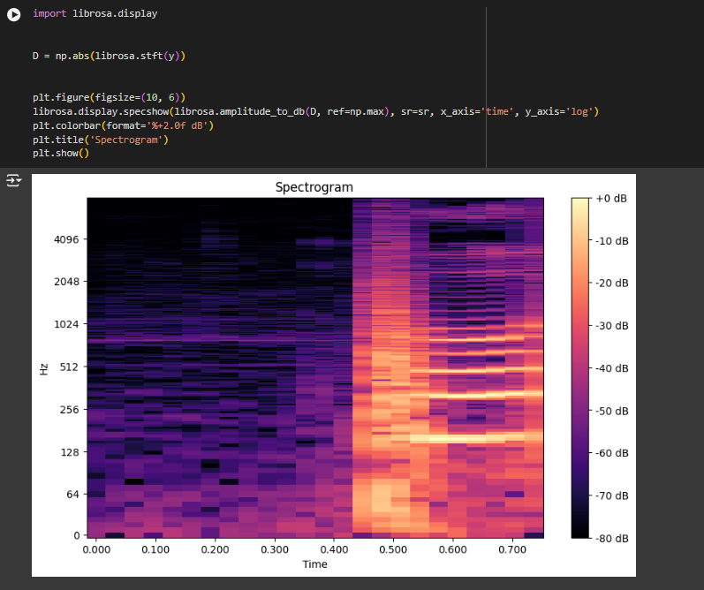

1. **Results after fine tuning the classifier.  
     
   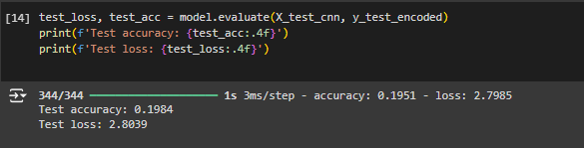**

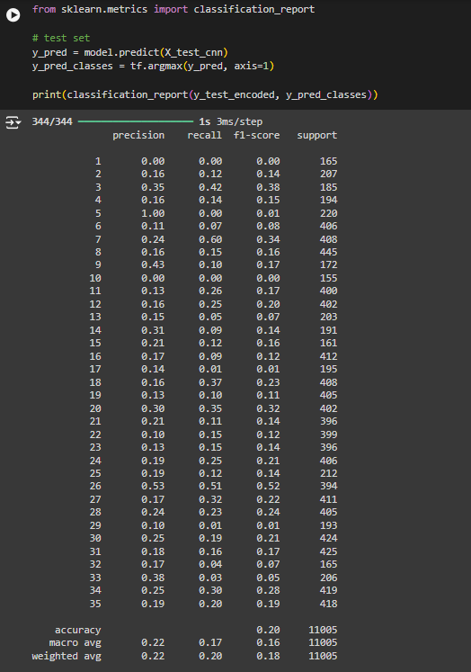

1. **Results after fine tuning on custom dataset**

