# McIntosh Control Interface

By: Rob Kikta ([www.linkedin.com/in/robkikta](http://www.linkedin.com/in/robkikta))

## Introduction

This application note integrates several published sources along with some additional content in order to provide a single comprehensive overview of interfacing to the RS-232 control interface of McIntosh audio equipment.

This application note provides a general overview of the McIntosh RS-232 control interface and is provided “as is.” The author assumes no responsibility for any typographical, technical, content or other inaccuracies in this document. The author of this document does not represent McIntosh Labs in any way.

Equipment that support the Control Interface include a connector on the back panel. 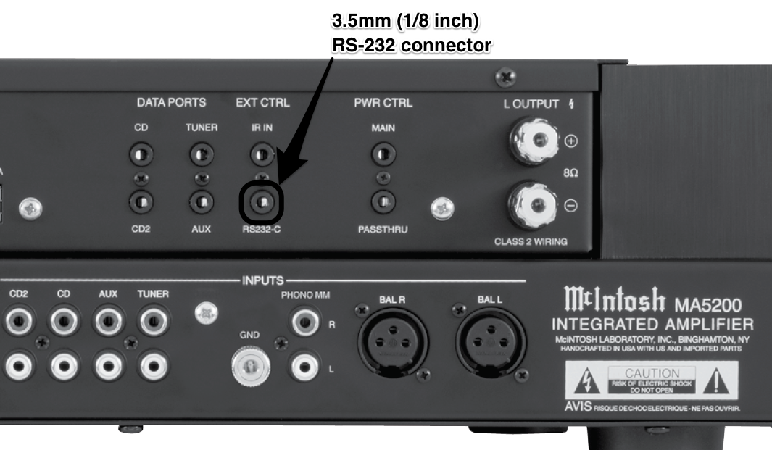

Figure MA5200 Rear Panel (from MA5200 Owner's Manual)

## Physical

The control interface is implemented using 3-wire RS232. In the context of RS232, the McIntosh equipment acts as the DCE (data circuit-terminating equipment). The connector used is a standard 3.5mm (1/8 inch) stereo headphone connector wired as shown in Figure 2. The pins are further described in Table 1.

Table 1 McIntosh Control Interface Pin Descriptions

|  |  |  |  |
| --- | --- | --- | --- |
| Title | 3mm Connector | DB9 Connector | Description |
| Data In | Tip | 2 | Data **FROM** McIntosh equipment |
| Data Out | Ring | 3 | Data **TO** McIntosh equipment |
| Ground | Sleeve | 5 | Ground |

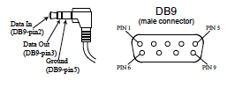

Figure McIntosh Control Interface Pinout (from MA5200 Owner’s Manual)

The RS232 specification defines the voltage levels corresponding to logical one and zero levels. Valid signals are either in the range of +3 to +15 volts or the range -3 to -15 volts with respect to ground. As depicted in Figure 3, the measured values are well within the specification at +/- 7 volts.

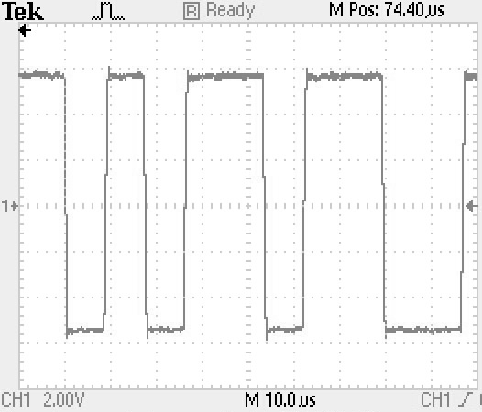

Figure 3 McIntosh Control Interface Voltage Levels

The control interface can operate at multiple speeds but defaults to 115,200 bits per second (bps). The data is formatted as described in Table 3.

Table 2 Control Interface Data Values

|  |  |
| --- | --- |
| Parameter | Value |
| Data bits | 8 |
| Stop bits | 1 |
| Parity | None |

## Command Set

The list of supported commands is dependent upon the specific piece of unit. The commands and parameters supported by a specific unit can be obtained using the HLP command described Table 2.

The commands are sent / received using the ASCII character set. Every command must start with an open parenthesis (“(“, 0x28) and end with a close parenthesis (“)”, 0x29). Carriage returns and line feeds are not necessary and are not used to parse the commands, but should be included for readability. Responses from McIntosh equipment are terminated by carriage return (0x0D) and line feed (0x0A).

The command format is:

(Command [Zone] [Parameter1] [Parameter 2] [Parameter n])

For example the command:

(INP Z1 3)

Will set the input select to CD1.

A full list of commands is provided in Table 2.

Table Commands

|  |  |  |  |  |  |
| --- | --- | --- | --- | --- | --- |
| Message | Command | Zone | Parameters | Example | Description |
| Help | HLP | N/A | None | (HLP) | Display list of commands supported by specific unit |
| RS232 Control | CTL | N/A | 0 – Off  1 – On | (CTL 1) | Enables / Disables RS232 interface |
| Power On | PON | Z1 | None |  | Power on unit. If the unit is in Standby, send power on twice with 100ms delay between commands. |
| Power Off | POF | Z1 | None |  | Power off unit |
| System Off | SY0 | N/A | None |  | Power off system |
| Volume Up | VUP | Z1 | None | (VUP Z1) | Volume up one step |
| Volume Up | VUP | Z1 | Step size (1 – 9) | (VUP Z1 5) | Volume up specified step size |
| Volume Down | VDN | Z1 | None | (VDN Z1) | Volume down one step |
| Volume Down | VDN | Z1 | Step size (1 – 9) | (VDN Z1 5) | Volume down specified step size |
| Volume Set | VST | Z1 | Level (0 – 100) | (VST Z1 30) | Set volume to specified level |
| Output 1 | OP1 | Z1 | 0 – On  1 – Off | (OP1 Z1 1) | Turn output 1 on/off |
| Output 2 | OP2 | Z1 | 0 – On  1 – Off | (OP2 Z1 1) | Turn output 2 on/off |
| Mute | MUT | Z1 | 0 – Unmuted  1 – Muted | (MUT Z1 1) | Mute or unmute unit |
| Input Up | INU | Z1 | None | (INU Z1) | Increment input select |
| Input Down | IND | Z1 | None | (IND Z1) | Decrement input select |
| Input Select | INP | Z1 | 1 – MC  2 – MM  3 – CD1  4 – CD2  5 - DVD  6 – AUX  7 - Server  8 – D2A  9 – Tuner | (INP Z1 3) | Input select |
| Trim Up | TRU | Z1 | 0 – Off  1 – Balance  2 – Bass  3 – Treble  4 – Level  5 – Output  6 – Bypass  7 – Mono  8 – Phono  9 – Display  10 – Info  11 – Meter  12 – Tuner  13 – Radio Text  14 – Tuner Mode | (TRU Z1 0) | Increment selected trim value |
| Trim Down | TRD | Z1 | Same as TRU | (TRD Z1 0) | Decrement selected trim value |
| USB Audio | TPC | Z1 | 0 – Play  1 – Stop  2 – Pause  3 – Next  4 – Back  5 – Reverse  6 – Forward | (TPC Z1 0) | Send control commend to USB source unit. The parameters are as reported by McIntosh, but don’t seem to match use on Apple computer |
| IR Converter | CNV | N/A | 0 – Off  1 – On | (CNV 1) | CNV |
| RS232 to IR | KEY | Z1 | IR Hex Code | (KEY Z1 5F) | Send hex value to IR port |
| System Query | QRY | N/A | None | (QRY) | See Table 3 |

Table 4 Reply Messages

|  |  |  |  |  |  |
| --- | --- | --- | --- | --- | --- |
| Message | Command | Zone | Parameters | Example | Description |
| IR to RS232 | IRC | Z1 | IR Hex Code | (IRC Z1 10) | Report value of command received on IR interface |
| Volume Status | VST | Z1 | Volume Level (0 – 100) | (VST Z1 30) | Report volume level |
| Mute Status | MUT | Z1 | 0 – Unmuted  1 – Muted | (MUT Z1 1) | Report mute status |
| Input Selected | INP | Z1 | 2 – MM  3 – CD1  4 – CD2  6 – AUX  8 – D2A  9 – Tuner | (INP Z1 3) | Report selected Input |
| Trim Status | TRS | Z1 | **Parameter1** –  Selected Trim  0 – Off  1 – Balance  4 – Level  5 – Output  7 – Mono  9 – Display  10 – Info  11 – Meter  **Parameter2** –  Trim Value | (TRS Z1 1 +10) | Value of specified trim parameter |

Table Error Messages

|  |  |  |  |
| --- | --- | --- | --- |
| Message | Command | Example | Description |
| Command Error | ERR 1 | (ERR 1) | Unrecognized command |
| Zone Error | ERR 2 | (ERR 2) | Use only Z1 |
| Parameter Error | ERR 3 | (ERR 3) | Format or value in error |
| Request Blocked Error | ERR 4 | (ERR 4) | Trim or Setup Mode is active |
| Zone Off Error | ERR 5 | (ERR 5) | Requested Zone must first be on |
| Input Error | ERR 6 | (ERR 6) | Wrong input selected for request |
|  |  |  |  |