HiRISE v3 AlexNet Metrics

10 epochs

Learning rate 0.0005

Dataset balance:

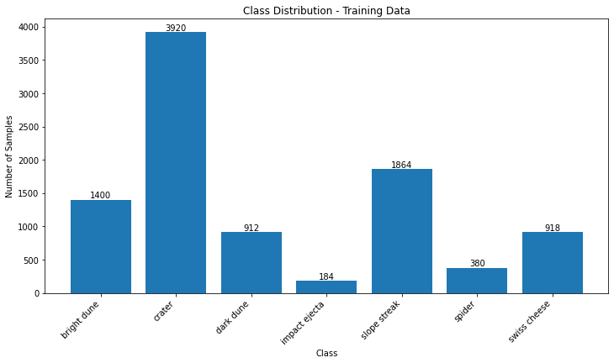

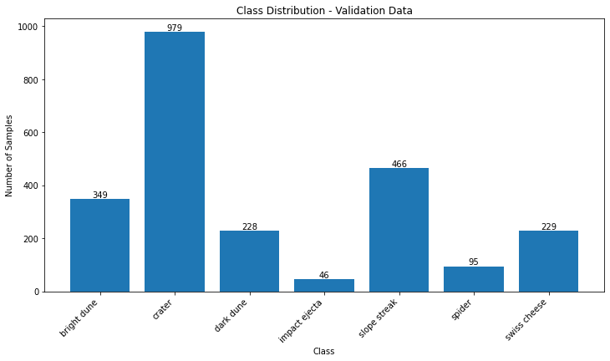

Oversample:

27440 images in training set

6853 images in validation set

Equal number of images for each class

Class: bright dune

Precision: 0.96

Recall: 0.97

------------

Class: crater

Precision: 0.91

Recall: 0.82

------------

Class: dark dune

Precision: 0.93

Recall: 0.91

------------

Class: impact ejecta

Precision: 0.96

Recall: 0.99

------------

Class: slope streak

Precision: 0.88

Recall: 0.89

------------

Class: spider

Precision: 0.96

Recall: 0.98

------------

Class: swiss cheese

Precision: 0.89

Recall: 0.93

------------

Overall Precision: 0.9261527556981892

Overall Recall: 0.926309645410769

Classification Report:

precision recall f1-score support

bright dune 0.96 0.97 0.96 979

crater 0.91 0.82 0.86 979

dark dune 0.93 0.91 0.92 979

impact ejecta 0.96 0.99 0.97 979

slope streak 0.88 0.89 0.88 979

spider 0.96 0.98 0.97 979

swiss cheese 0.89 0.93 0.91 979

accuracy 0.93 6853

macro avg 0.93 0.93 0.93 6853

weighted avg 0.93 0.93 0.93 6853

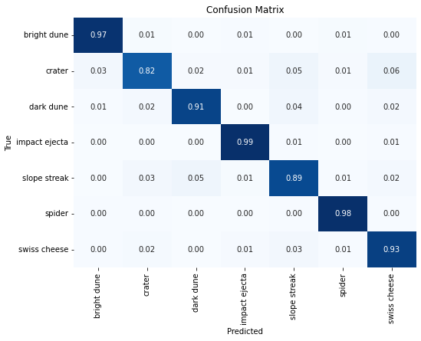Class weights:

9578 images in training set

2392 images in validation set

Class: bright dune

Precision: 0.78

Recall: 0.57

------------

Class: crater

Precision: 0.81

Recall: 0.34

------------

Class: dark dune

Precision: 0.57

Recall: 0.82

------------

Class: impact ejecta

Precision: 0.04

Recall: 0.33

------------

Class: slope streak

Precision: 0.36

Recall: 0.72

------------

Class: spider

Precision: 0.00

Recall: 0.00

------------

Class: swiss cheese

Precision: 0.22

Recall: 0.12

------------

Overall Precision: 0.5926559680602113

Overall Recall: 0.4552675585284281

Classification Report:

precision recall f1-score support

bright dune 0.78 0.57 0.66 349

crater 0.81 0.34 0.47 979

dark dune 0.57 0.82 0.67 228

impact ejecta 0.04 0.33 0.08 46

slope streak 0.36 0.72 0.48 466

spider 0.00 0.00 0.00 95

swiss cheese 0.22 0.12 0.16 229

accuracy 0.46 2392

macro avg 0.40 0.41 0.36 2392

weighted avg 0.59 0.46 0.46 2392

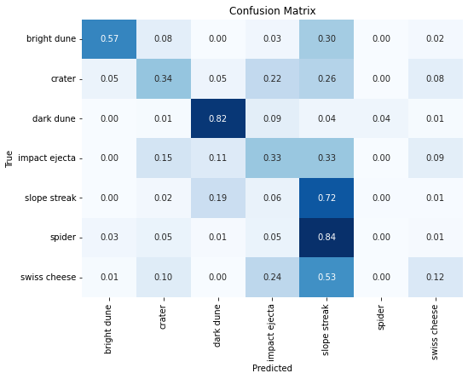Raw:

9578 images in training set

2392 images in validation set

Class: bright dune

Precision: 0.91

Recall: 0.38

------------

Class: crater

Precision: 0.65

Recall: 0.92

------------

Class: dark dune

Precision: 0.72

Recall: 0.72

------------

Class: impact ejecta

Precision: 0.00

Recall: 0.00

------------

Class: slope streak

Precision: 0.62

Recall: 0.68

------------

Class: spider

Precision: 0.06

Recall: 0.01

------------

Class: swiss cheese

Precision: 0.67

Recall: 0.29

------------

Overall Precision: 0.6534695327561161

Overall Recall: 0.6605351170568562

Classification Report:

precision recall f1-score support

bright dune 0.91 0.38 0.54 349

crater 0.65 0.92 0.76 979

dark dune 0.72 0.72 0.72 228

impact ejecta 0.00 0.00 0.00 46

slope streak 0.62 0.68 0.65 466

spider 0.06 0.01 0.02 95

swiss cheese 0.67 0.29 0.40 229

accuracy 0.66 2392

macro avg 0.52 0.43 0.44 2392

weighted avg 0.65 0.66 0.62 2392

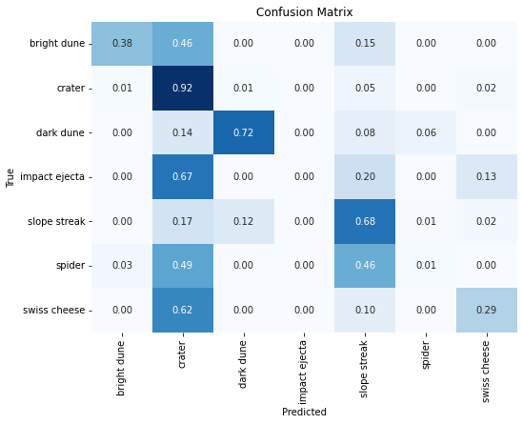Conclusion:

Oversampling is our best method for balancing the dataset.