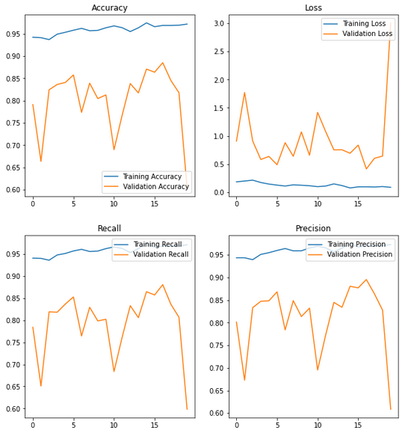

Raw AlexNet

Class Weights AlexNet

Data Augmentation AlexNet

Min Validation Loss: 0.4150935411453247

Max Validation Accuracy: 0.8852795958518982