HiRISE v3 AlexNet Metrics
10 epochs
Learning rate 0.0005

Dataset balance:
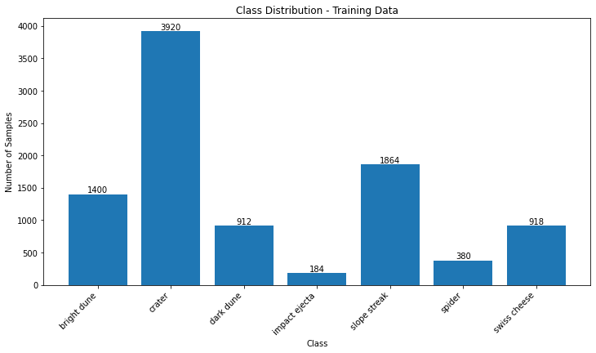
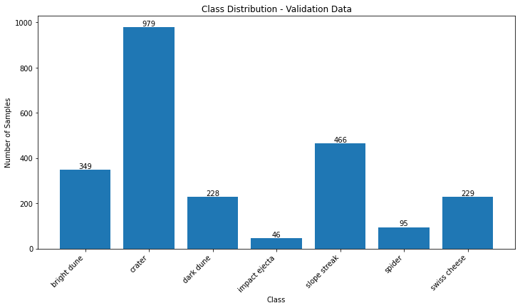
Oversample:
27440 images in training set
6853 images in validation set
Equal number of images for each class

Class: bright dune
Precision: 0.96
Recall: 0.97
------------
Class: crater
Precision: 0.91
Recall: 0.82
------------
Class: dark dune
Precision: 0.93
Recall: 0.91
------------
Class: impact ejecta
Precision: 0.96
Recall: 0.99
------------
Class: slope streak
Precision: 0.88
Recall: 0.89
------------
Class: spider
Precision: 0.96
Recall: 0.98
------------
Class: swiss cheese
Precision: 0.89
Recall: 0.93
------------
Overall Precision: 0.9261527556981892
Overall Recall: 0.926309645410769
Classification Report:
precision recall f1-score support

bright dune 0.96 0.97 0.96 979
crater 0.91 0.82 0.86 979
dark dune 0.93 0.91 0.92 979
impact ejecta 0.96 0.99 0.97 979
slope streak 0.88 0.89 0.88 979
spider 0.96 0.98 0.97 979
swiss cheese 0.89 0.93 0.91 979

accuracy 0.93 6853
macro avg 0.93 0.93 0.93 6853
weighted avg 0.93 0.93 0.93 6853

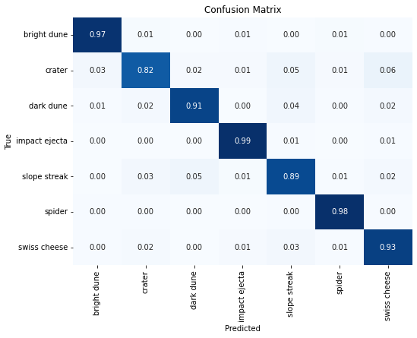
Class weights:
9578 images in training set
2392 images in validation set

Class: bright dune
Precision: 0.78
Recall: 0.57
------------
Class: crater
Precision: 0.81
Recall: 0.34
------------
Class: dark dune
Precision: 0.57
Recall: 0.82
------------
Class: impact ejecta
Precision: 0.04
Recall: 0.33
------------
Class: slope streak
Precision: 0.36
Recall: 0.72
------------
Class: spider
Precision: 0.00
Recall: 0.00
------------
Class: swiss cheese
Precision: 0.22
Recall: 0.12
------------
Overall Precision: 0.5926559680602113
Overall Recall: 0.4552675585284281
Classification Report:
precision recall f1-score support

bright dune 0.78 0.57 0.66 349
crater 0.81 0.34 0.47 979
dark dune 0.57 0.82 0.67 228
impact ejecta 0.04 0.33 0.08 46
slope streak 0.36 0.72 0.48 466
spider 0.00 0.00 0.00 95
swiss cheese 0.22 0.12 0.16 229

accuracy 0.46 2392
macro avg 0.40 0.41 0.36 2392
weighted avg 0.59 0.46 0.46 2392

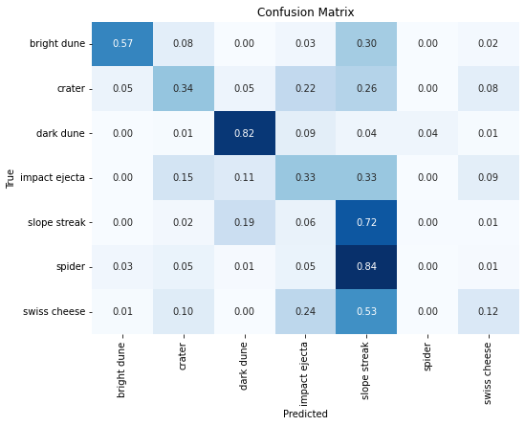
Raw:
9578 images in training set
2392 images in validation set
Class: bright dune
Precision: 0.91
Recall: 0.38
------------
Class: crater
Precision: 0.65
Recall: 0.92
------------
Class: dark dune
Precision: 0.72
Recall: 0.72
------------
Class: impact ejecta
Precision: 0.00
Recall: 0.00
------------
Class: slope streak
Precision: 0.62
Recall: 0.68
------------
Class: spider
Precision: 0.06
Recall: 0.01
------------
Class: swiss cheese
Precision: 0.67
Recall: 0.29
------------
Overall Precision: 0.6534695327561161
Overall Recall: 0.6605351170568562
Classification Report:
precision recall f1-score support

bright dune 0.91 0.38 0.54 349
crater 0.65 0.92 0.76 979
dark dune 0.72 0.72 0.72 228
impact ejecta 0.00 0.00 0.00 46
slope streak 0.62 0.68 0.65 466
spider 0.06 0.01 0.02 95
swiss cheese 0.67 0.29 0.40 229

accuracy 0.66 2392
macro avg 0.52 0.43 0.44 2392
weighted avg 0.65 0.66 0.62 2392

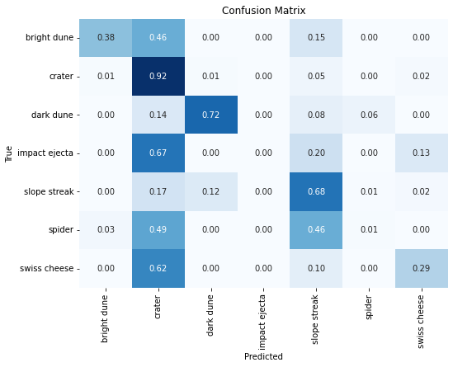
Conclusion:
Oversampling is our best method for balancing the dataset.

