Man the Walls!

Half-Life 2

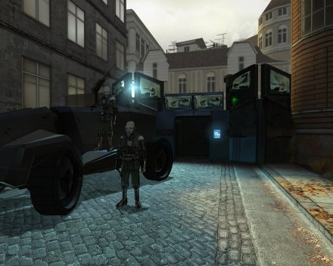

SinglePlayer Level Design Document

Designer: Russell Krueger
Document Date: 06/22/2009
Intended Level Delivery Date: 07/15/2009

Document Revisions Table

VERSION | DESCRIPTION | REQUESTOR | DATE
1.0 | Initial Version of document | Prof. Oulette | 06/17/2009
1.1 | Completed version of document. Added maps and visual references | Prof. Oulette | 06/21/2009

Figure 1: City 17 features tall buildings and narrow side-streets. 3
Figure 2: The Residential Cul-De-Sac features a playground behind a chain-link fence. 4
Figure 3: The Combine gate stands approximately 15 to 18 feet tall. 5
Figure 4: Examples of residential architecture. 6
Figure 5: City 17 shows a wide variety of shape and form in the architectural style. 7
Figure 6: Grass grows behind chain-link fences. 10
Figure 7: "Man the Walls!" takes place primarily in a residential area that the Combine now occupy. 11
Figure 8: The level takes place at sunset. 12
Figure 9: Concept of Combine computer. 12
Figure 10: Example of wall hangings and publications 13
Figure 11: Typical graffiti of City 17 13
Figure 12: Gordon Freeman 14
Figure 13: Cowardly Resistance Fighter. 14
Figure 14: A large gate divides the residential neightborhood. 15
Figure 15: Freeman must keep the Combine from retaking their stronghold. 16
Figure 16: The Combine gate provides a height advantage to the player. 16
Figure 17: City 17 concept.. 17
Figure 18: Twilight sky concept. 17
Figure 19: Metro Police 18
Figure 20: Combine Soldier 18
Figure 21: Manhack 19
Figure 22: Manchester, England bears strong resemblances to City 17. 20
Figure 23: City 17 skyline 21
Figure 24: Concept of Combine controlled residential area. 21
Figure 25: City Street concept 22
Figure 26: Alyx Vance spawns in Area 3 during the final wave 23
Figure 27: Resistance Fighter spawns in Area 3 during the final wave 24
Figure 28: Metro Police spawns in Area 3 25
Figure 29: Combine soldier spawns in Area 3 25
Figure 30: Manhack spawns in Area 3 26
Figure 31: Initial layout of level. 1
Figure 32: Close-up of Area 1 2
Figure 33: Area 1 houses friendly spawn points. 2
Figure 34: Combine spawn in Area 3 and move towards Area 1. 3
Figure 35: Critical path for Combine soldiers 4
Figure 36: Critical path for resistance fighters during final wave 5
Figure 37: Player finds pickups in the Combine stronghold 6
Figure 38: Black boxes indicate solid cover 6
Figure 39: Area 1 with critical points 7
Figure 40: Combine computer console 8
Figure 41: Chain link fence concept 8
Figure 42: Playgrounds stand behind chain link fences, inaccessible to the player. 9
Figure 43:Many buildings sport grafitti 9
Figure 44: Examples of wall hangings and news articles inside combine base 10
Figure 45: Defend the Combine computers 10
Figure 46: Area 2 with critical points 11
Figure 47: Combine gate 12
Figure 48: The gate turns Area 1 into a fortress 13
Figure 49: Combine attack the main gate's door 13
Figure 50: Area 3 with critical points 14
Figure 51: City street architectural model 15
Figure 52: City Street concept 15
Figure 53: Juxtaposition of residential and combine elements 16
Figure 54: The citadel looms in the distance 16
Figure 55: Combine dropship 17
Figure 56: Combine fortress 17
Figure 57: City 17 bears real-world similaries 18

Table of Contents

Document Revisions Table 2
Table of Contents 5
Quick Summary 1
Gameplay 1
Objective Summary 1
Overview 2
Campaign 2
Mission Location 2
Mission Difficulty 2
Mission Metrics 2
7
Level Details 8
Level Atmosphere/Mood 8
Story 8
Introduction 8
In-Game 8
Extro 9
“60 seconds of gameplay”. 9
Major Areas/Visual Themes 10
Area 1: Residential Cul-De-Sac 10
Text Description: 10
Visual References 10
Area 2: Combine Gate 15
Text Description: 15
Visual References 15
Area 3: City Street 20
Text Description: 20
Visual References 20
Level Objectives 27
Challenge Highlights 27
WOW Moments 27
Actors 28
Player 28
Key Actors 28
Supporting Actors: None 29
User Interface 30
Pre-Game Information: None 30
In-Game Information 30
Post Game Information: None 30
HUD Elements 30
Gameplay Details 1
Level Progression Chart 1
Gameplay Mechanics 1
Overhead Level Map 1
Key 2
Detailed Map Descriptions 7
Area 1: Residential Cul-De-Sac 7
Area 2: Combine Gate 11
Area 3: City Street 14
References 18

Quick Summary
“Man the Walls” places the player in charge of four cowardly resistance fighters attempting to protect Combine military secrets from Metro Police kill squads. The player takes the role of Gordon Freeman and must enforce discipline on the cowardly resistance fighters by any means necessary. “Man the Walls” takes place in a cul-de-sac in City 17 at twilight. The player has raided a Combine outpost and discovered equipment containing Combine secrets. However, a last-minute distress call has alerted local police forces, so the player has sealed the gate and gathered his allies to him. Now the player must survive until members of the resistance arrive and help take the data away for analysis.

Gameplay
“Man the Walls” focuses on putting the player in a desperate situation, with unreliable comrades. This presents a different experience form the typical Half-Life 2 fare in that most of the time, the player directly attacks the Combine with fearless squad mates at his side. “Man the Walls” reverses the situation, by giving the player a defensible position and forcing them to hold their ground against superior numbers and firepower. The player must ensure that at least one of the three Combine computers survives the assault.

The new main mechanic that this project introduces revolves around keeping the morale of your allies high, by any means necessary. Demoralized allies require little more than a crowbar upside the head. Once struck, the resistance fighters rediscover their will to fight, or at the very least fear the player more than the Combine. However, this courage does not last forever. After a few well placed shots from the Metro Police, their resolve weakens and eventually, breaks. At this point, the player must reinforce the courage he previously instilled in them with another crowbar blow to the head. If the player manages to hold out through the increasingly large waves of Combine soldiers and Metro Police, eventually help arrives, and the level ends.

Objective Summary
- Objective: Protect the captured Combine data
  - One of three Combine computers must survive the assault

  - Sub-Objective 1: Enforce discipline amongst the troops
    - Hit the resistance fighters in the head with the crowbar
    - Checkpoint after each fighter has been hit
  - Sub-Objective 2:Fight off the first wave
    - 5 Metro Police (handguns)
    - Checkpoint after the all enemies are dead
  - Sub-Objective 3:Fight off the second wave
    - 5 Metro Police (Submachine Guns)
    - 3 Combine Soldiers (AR-2s)
    - Checkpoint after all enemies are dead
  - Sub-Objective 4: Fight off the third wave
    - 8 Metro Police (Submachine Guns)
    - 5 Combine Soldiers(AR-2s)
    - 5 Manhacks
    - Checkpoint after all enemies are dead
  - Sub-Objective 5: Fight off the final wave
    - 10 Metro Police (Submachine Guns)
    - 8 Combine Soldiers(AR-2s)
    - 10 Manhacks
    - 15 seconds after final wave spawns, resistance fighters arrive
    - Level ends after all enemies are dead

Overview

Campaign
- Name: “Concrete Jungle”
  - Alternate Universe in which guerilla warfare and intelligence gathering act as a prelude to the all-out-war in “Anti-Citizen One”.
- Level Position in Campaign:
  - Before:
    - Gordon returns from Nova Prospekt, and must gather information on the Combine’s troop disposition and weak points.
    - Gordon raids a small Combine stronghold, and finds the data, a distress call is sent out to the Combine
    - Gordon gathers the locals to fight with him, and seals the stronghold back up.
  - Combine troops harry the player on their way back to Kleiner’s Lab, once there, Kleiner analyzes the data and an all out attack begins.

Mission Location
- Theme: Desperate fight for survival.
- Mood: Fearful and tense
- Setting: City 17 Residential Block
- Time: Sunset
- Season: Summer
- Weather: Partly Cloudy

Mission Difficulty
On a scale of 1 to 5:
- Start: 1
- Middle: 2.5
- End: 3.5

Mission Metrics
- Play Time: 4-5 Minutes
- Physical Length: 2000-3000 units
  - Lots of movement within a confined space
  - Must chase frightened resistance fighters down
- Physical Area: 4096 x 4096 units (hammer editor) or 256 x 256 feet
- Max New Characters: 1
  - Cowardly Resistance Fighter
    - Cowers in fear when hit by combine bullets
    - Recovers courage when struck by player’s crowbar
    - Uses standard Resistance Fighter models

- Max Visual Themes: 3
  - Area 1: Residential Cul-De-Sac
    - After Gordon raids the Combine Stronghold, he closes the large Combine gate and seals off the nearby area. Area 1 consists of the area behind the Combine gate. This includes the interior area that houses the Combine computers. The area features tall residential buildings, usually three floors or more, converted into Combine strong points. One building is open and houses the combine machinery. This building has several floors, but only one floor is accessible by the player.
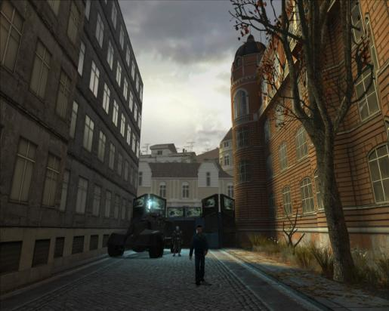
Figure 1: City 17 features tall buildings and narrow side-streets.

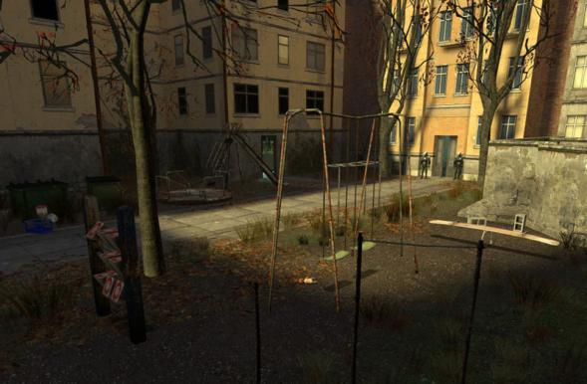
Figure 2: The Residential Cul-De-Sac features a playground behind a chain-link fence.

  - Area 2: Combine Gate
    - While very small, most of the action revolves around the Combine gate. The Gate is similar to other Combine gates around City 17, but features a destructible gate and one destructible machine gun, mounted on top of the gate. The Combine gate also has a stairway leading up to the catwalk on top of the gate. The gate stands as the player’s first line of defense against the Combine assault, and as such, should be protected at all costs.
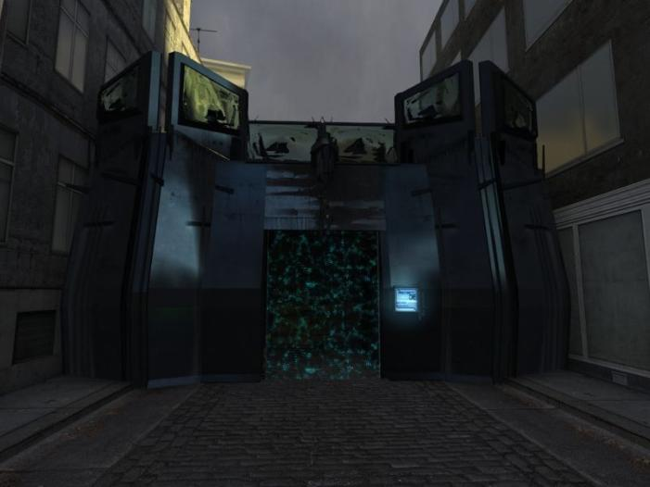
Figure 3: The Combine gate stands approximately 15 to 18 feet tall.

  - Area 3: City Street
    - While part of the same visual theme as Area 1, the City Street acts as the main avenue of attack for the Combine. Area 3 consists of a straight street with several buildings, at the far end of the street, Area 3 breaks off into a T-intersection, where the waves of Combine spawn out of the player’s line of sight. Like Area 1, the buildings are tall, usually three stories or more, but do not feature interiors.
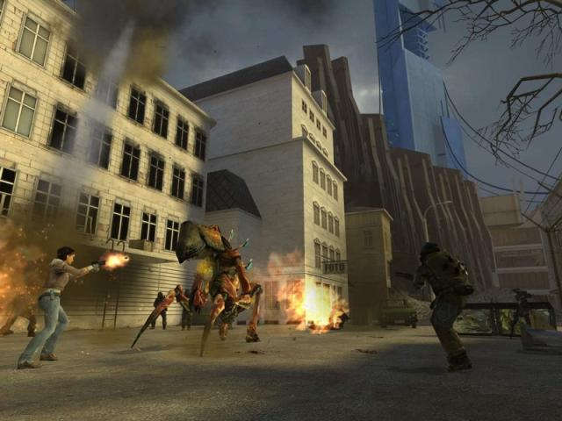
Figure 4: Examples of residential architecture.

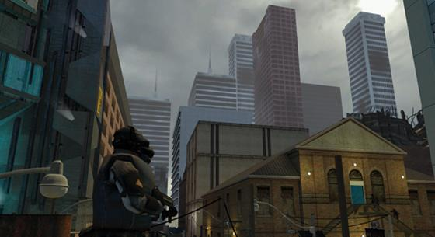
Figure 5: City 17 shows a wide variety of shape and form in the architectural style.

Level Details

Level Atmosphere/Mood
“Man the Walls!” captures the feel of a twilight city under the iron boot of Combine occupation. Once bustling streets now stand deserted due to the Combine curfew. Boarded up doors and windows cover some of the buildings. Most of the lighting comes from the setting sun, but a few windows have the lights on. The architecture, like most of City 17, calls to mind the narrow streets of a European city. Deserted vehicles and possessions litter the street, as most of the occupants fled when the Combine seized the neighborhood. Helicopters and propaganda echo in the distance.

The Combine gate stands like a monolith, in the middle of the street, blocking all passage to and from the stronghold on the other side. On the other side of the gate, the Combine have set up numerous supply crates and communications devices. A few barricades provide a second line of defense, should attackers breach the main gate. The interior section of the Combine base consists of a stripped out apartment. Computer equipment has taken the place of what few personal effects the previous occupants had.

Story
The resistance fighters were a mess, four shell-shocked and fear crazed individuals cowering in the corners of the cul-de-sac. They knew the Metro Police were coming to take them to Nova Prospekt, all that could be done is to hope the Combine just saved themselves the bother and executed them where they stood. Gordon Freeman looked upon them with disgust. How were they ever going take back the City from the Combine if all they knew was cowering in fear? Gordon tried to find the right words to say, but they just wouldn’t come… so he had to resort to what he knew best. No, not Quantum Physics… hitting things with a two foot length of solid steel!

Minutes later all five of them stood on the walls, weapons trained on the street ahead of them. They were bruised and battered, but no worse for the wear. They were ready to defend their prize: three Combine computers, tucked away inside the stronghold. Eli said Alyx would arrive with more resistance fighters, but until then, Gordon and his hastily disciplined militia were on their own. Gordon could hear the sound of Combine drop ships in the distance. It would not be long until they rushed down the street, desperate to take back or destroy what the resistance had taken from them…

Introduction
Player stands inside the cul-de-sac, the resistance fighters are cowering in fear, and the Combine are approaching. The player receives a message instructing him to hit his cowardly militia in the head with his crowbar in order to straighten them out and get them to fight.

In-Game
Gordon hefts the mounted machine gun as the first group of Metro Police officers round the corner and charge the Combine gate, firing as they advance. All four resistance fighters open fire on the Combine, and in seconds they manage to fell two of the Police. Gordon opens fire with the machine gun and takes another two down instantaneously. The last one manages to make it halfway down the street before a shot from one of the resistance fighter’s pistols drops him. Seconds later, another wave of soldiers and police charge the position, firing their submachine guns at the resistance fighters on the wall. One resistance fighter takes a shot to the chest, but the flak vest stops the round. However, their survival instincts kick in and they flee the wall, and cower in the corner. Not having time to deal with the cowardly soldier, Gordon opens fire again, but many of the Combine soldiers manage to make it to cover, and begin to open fire on the Combine gate’s wall. The wall begins to give under the weight of fire, but the Combine’s casualties are heavy, soon all of them fall under sustained machine gun fire from Gordon. Once he is sure they were all dead, he pulls out his trusty crowbar and jumps down from the gate. The cowardly soldier lies in the fetal position in one of the corners of the cul-de-sac. A light tap on the head reminds the fearful soldier of how courageous he is. Nursing a bloody nose, the resistance fighter climbs the stairs to the game and aims his weapon down the street again. Gordon hears the next wave before he actually sees them. The high-pitched whine of manhacks grows steadily louder until a small swarm of the small mechanical robots hovers around the corner and makes for the gate. The manhacks bob and weave, making them harder to hit, as the resistance fighters fire blindly at them, but only manage to destroy two of the robots. Gordon sprays the air with the machine gun, and manages to take down the last three, but only as they last one died did he realize it was all a distraction. More than a dozen soldiers had already managed to make their way half-way down the street, and were already opening fire on the gate, trying to blow it down with small arms fire. The gate begins to buckle, and eventually it collapses under the weight of the Combine fire. While this was a setback, none of the Combine managed to reach the gate alive. The victory was short-lived however, because almost a dozen manhacks flew around the corner, with eighteen Combine soldiers quick on their heels. The next few moments passed in what seemed like an instant, several of the resistance fighters were hit, and abandoned the walls, sure that their doom was upon them, but all of the manhacks and almost half of the Combine soldiers and Metro Police lay dead. Gordon hops down from the gate and fires indiscriminately into the advancing mob of enemies, but only manages to hit a couple before a withering amount of fire forces him to retreat inside the building. Gunfire can be heard in the distance, and the remaining Combine soldiers turn back towards the street entrance, Alyx and the resistance had finally arrived. Gordon seizes the opportunity and charges out of the building, catching the soldiers by surprise. Now that they were pinned between the advancing group of resistance fighters and Gordon, they quickly fall in the crossfire.

Key Sequences:
- Gordon Freeman beats his ragtag militia into shape
- First wave spawns
- Gordon defeats the first wave
- Second wave spawns
- Gordon defeats the second wave
- Third wave spawns
- The Combine destroy the stronghold’s gate
- Gordon defeats the third wave
- Fourth wave spawns
- Resistance fighters spawn
- Gordon and the resistance fighters defeat the final wave

Extro
Gordon finishes off the last of the Combine soliders. For the purposes of the assignment, the game reverts back to the menu screen here. As part of a larger campaign, Alyx and Gordon set off for Kleiner’s lab with Dog carrying the equipment.

“60 seconds of gameplay”.
The most action packed minute of the level occurs during wave three and continues until the end of the level. At this point the gate has likely taken significant damage and is about to buckle. At his point, the Combine may have also destroyed Gordon’s machine gun. This would leave small arms fire as the only option to deal with the Combine. As the player struggles to defeat ever growing numbers on enemies, the gate falls, and the Combine begin to rush into the breached stronghold. The computer equipment indoors must be defended at all costs, and the player may be forced to abandon their height advantage in order to assure no Combine slip through to the objective. The final wave pits the player against overwhelming odds, and just as things seem to be hopeless, hope arrives in the form of resistance fighters led by Alex Vance.

Major Areas/Visual Themes

Area 1: Residential Cul-De-Sac

Text Description:
The residential cul-de-sac exemplifies the transformation City 17 underwent as a result of Combine occupation. The combine converted these apartment buildings into a base of operations and sealed off the area from the rest of the street. Inside the cul-de-sac, the combine set up crates, communications equipment, and barricades. The area inside the Combine stronghold is neat, minimalist and organized.

Visual References
- Terrain/Vegetation

Figure 6: Grass grows behind chain-link fences.
- Models/Architecture
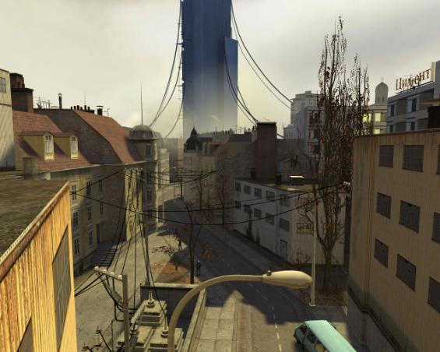
Figure 7: "Man the Walls!" takes place primarily in a residential area that the Combine now occupy.

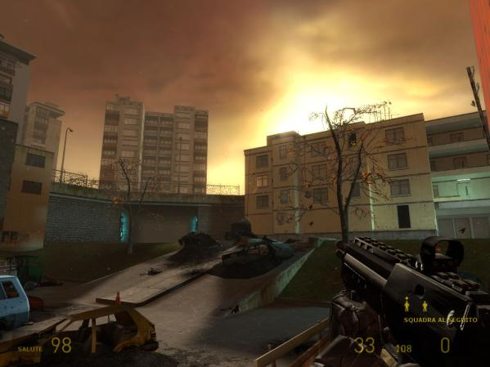
Figure 8: The level takes place at sunset.

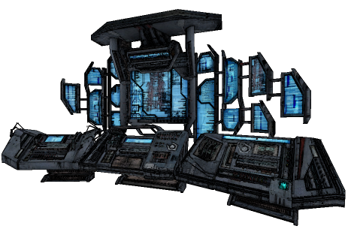
Figure 9: Concept of Combine computer.
- Textures/Lighting
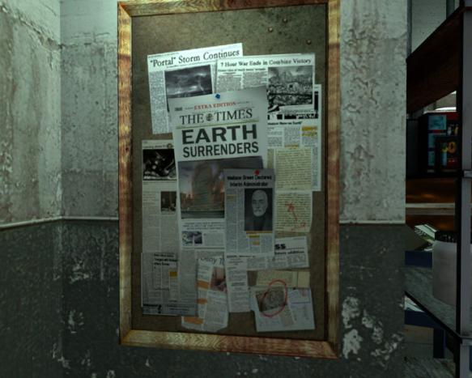
Figure 10: Example of wall hangings and publications
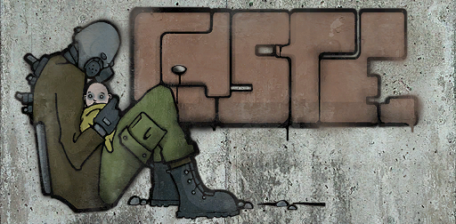
Figure 11: Typical graffiti of City 17

- Characters/Vehicles
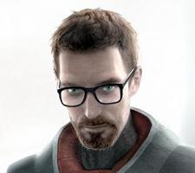
Figure 12: Gordon Freeman

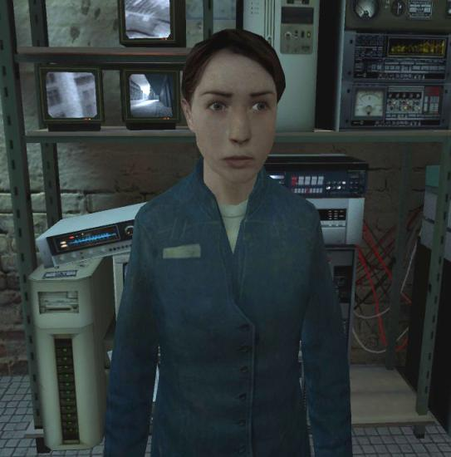
Figure 13: Cowardly Resistance Fighter.

Area 2: Combine Gate

Text Description:
The Combine gate is a symbol of the oppressive nature of the alien invaders. The tall black gate cuts the neighborhood in half, and forms a defensive area with only one major lane of attack: from the street. A thick metal door is the only entrance in or out of the structure. The door has already taken heavy damage in previous engagements, but still functions, at least for now. A machine gun rests on top of the gate. Stairs lead to the top part of the structure, allowing fighters to fire out into the street from the top of the wall.

Visual References
- Terrain/Vegetation: None
- Models/Architecture

Figure 14: A large gate divides the residential neightborhood.

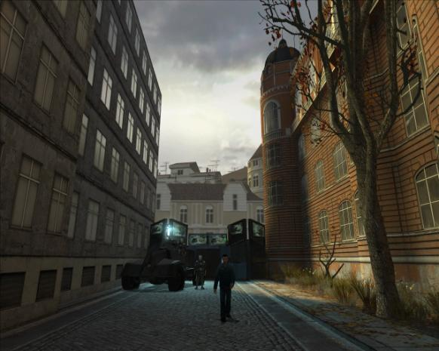
Figure 15: Freeman must keep the Combine from retaking their stronghold.

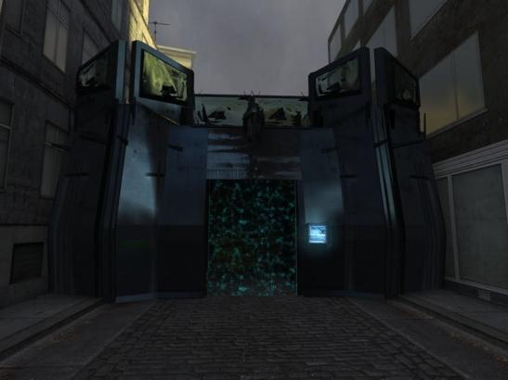
Figure 16: The Combine gate provides a height advantage to the player.
- Textures/Lighting
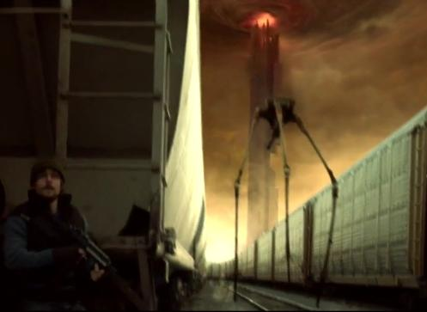
Figure 17: City 17 concept..

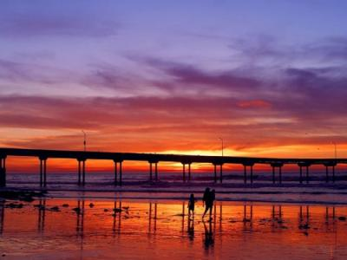
Figure 18: Twilight sky concept.

- Characters/Vehicles
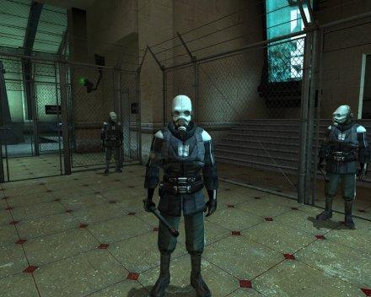
Figure 19: Metro Police

Figure 20: Combine Soldier

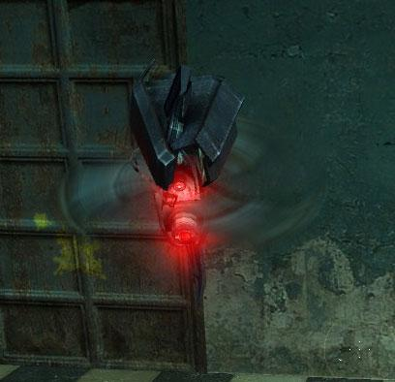
Figure 21: Manhack

Area 3: City Street

Text Description:
The city street stands mostly abandoned by its previous residents. Abandoned cars and possessions litter the street, and form defensive barriers for attackers to hide behind. Previous residents have boarded up some of the windows and doors of the buildings lining the street. At the far end of the street, the road splits into a T-intersection. The rest of the city looms up from behind the apartment buildings and stretches off into the distance.

Visual References
- Terrain/Vegetation: None
- Models/Architecture:
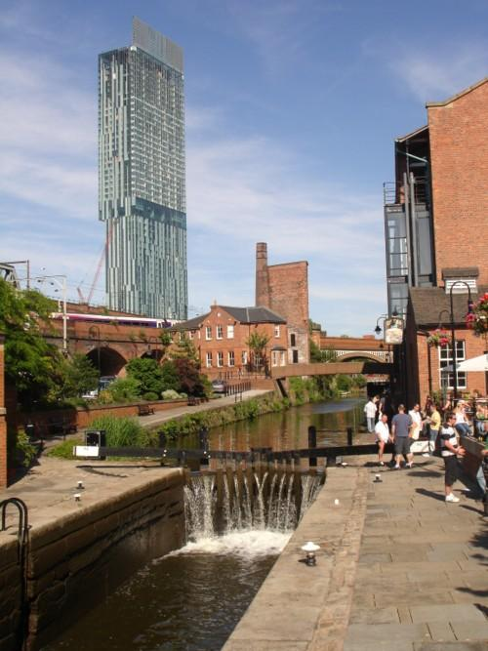
Figure 22: Manchester, England bears strong resemblances to City 17.

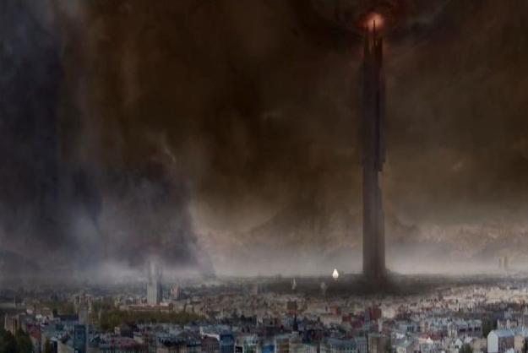
Figure 23: City 17 skyline

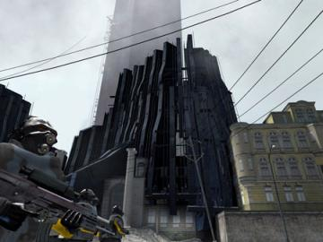
Figure 24: Concept of Combine controlled residential area.

- Textures/Lighting
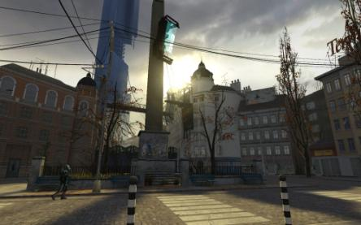
Figure 25: City Street concept

- Characters/Vehicles
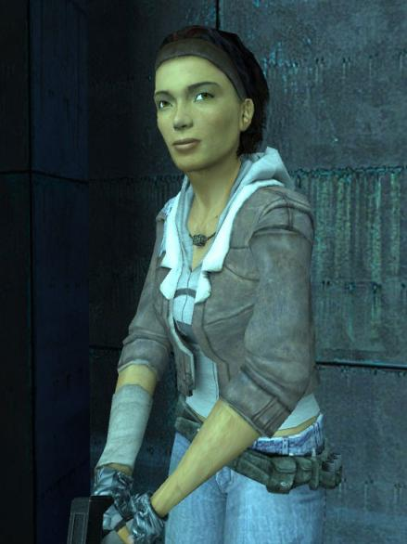
Figure 26: Alyx Vance spawns in Area 3 during the final wave

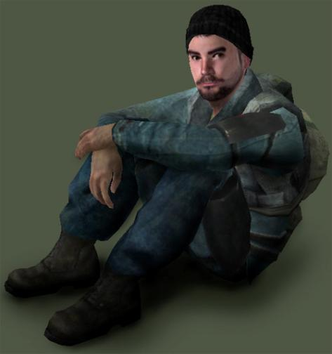
Figure 27: Resistance Fighter spawns in Area 3 during the final wave

Figure 28: Metro Police spawns in Area 3

Figure 29: Combine soldier spawns in Area 3

Figure 30: Manhack spawns in Area 3

Level Objectives
- Primary:
  - Protect the three Combine computers.
  - At least one computer must survive.
- Secondary:
  - Enforce discipline amongst the soldiers.
- Bonus:
  - Keep the Combine from breaching the gate.
- Hidden: None

Challenge Highlights

Combat
- Defeat the Final wave of enemies

Stealth
- None, this is an action/defense oriented mission

Puzzles
- None, this is an action/defense oriented mission

Conversation
- None, this is an action/defense oriented mission

Boss Battles
- The final wave features difficulty equal to that of a boss fight, but does not actually include a unique boss character.

WOW Moments
- Moment 1 (Area 1 and 2): Before first wave: Several Combine drop ships fly low overhead. Warns the player of incoming attack
- Moment 2 (Area 3): Final wave: Massive group of Combine soldiers rush the gate, in order to destroy the computer equipment.

Actors


Player
- Model(s): Gordon Freeman
- Inventory:
  - Crowbar
  - AR-2
  - SMG
- Start Location: Area 1: Cul-De Sac
- Motives/Objectives: Protect the computer
equipment and survive the Combine assault.
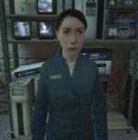

Key Actors

Actor 1: Cowardly Resistance Fighter
- Model(s):npc_citizen
- Inventory: Pistol or SMG
- Motives/Objectives:
  - Not dying.
  - Protect the computers
- Starting Location: Area 1

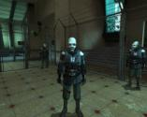
Actor 2: Metro Police
- Model(s):npc_metropolice
- Inventory: Pistol or SMG
- Motives/Objectives:
  - Destroy the compter
  - Kill Gordon Freeman
- Starting Location: Area 3
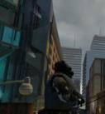

Actor 3: Combine Soldier
- Model(s):npc_combine_s
- Inventory: AR-2
- Motives/Objectives:
  - Destroy the compter
  - Kill Gordon Freeman
- Starting Location: Area 3

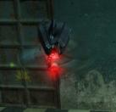
Actor 4: Manhack
- Model(s):npc_manhack
- Inventory: buzzsaw
- Motives/Objectives:
  - Destroy the compter
  - Kill Gordon Freeman
- Starting Location: Area 3

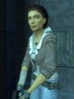
Actor 5: Alyx Vance
- Model(s):npc_alyx
- Inventory: weapon_alyxgun
- Motives/Objectives:
  - Rescue Gordon Freeman
- Starting Location: Area 3

Actor 6: Resistance fighter
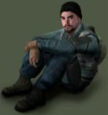
- Model(s):npc_citizen
- Inventory: SMG
- Motives/Objectives:
  - Rescue Gordon Freeman
- Starting Location: Area 3

Supporting Actors: None

User Interface

Pre-Game Information: None

In-Game Information
- Introduction: Protect the Combine computers (on-screen message)
- Hint: Beat the Cowardly Resistance Fighters with your crowbar.
- Hint: Do not let the Combine destroy the gate.
- Hint: Use the machine gun to kill combine soldiers
- Hint during final wave: Help is coming!
- Conclusion: Alyx: “Let’s get out of here!”
- Objectives: Protect the Combine computers

Post Game Information: None

HUD Elements
- Normal Elements Used
  - Health
  - Ammo
  - Selected Weapon
- Special Elements Required: None

Gameplay Details

Level Progression Chart
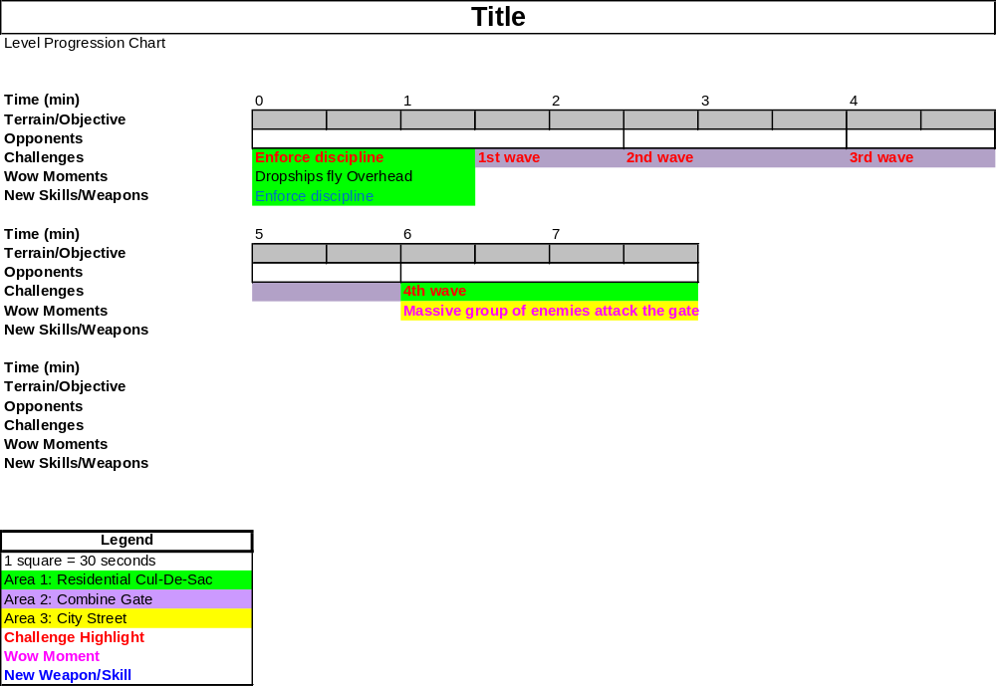

Gameplay Mechanics

Prerequisite Skills:
- Move
- Sprint
- Jump
- Shoot
- Switch weapon
- Use machine gun
- Duck

Skills Learned
- Do not let the Combine destroy the computers
- Hit cowardly resistance fighters with the crowbar to restore their courage

Overhead Level Map
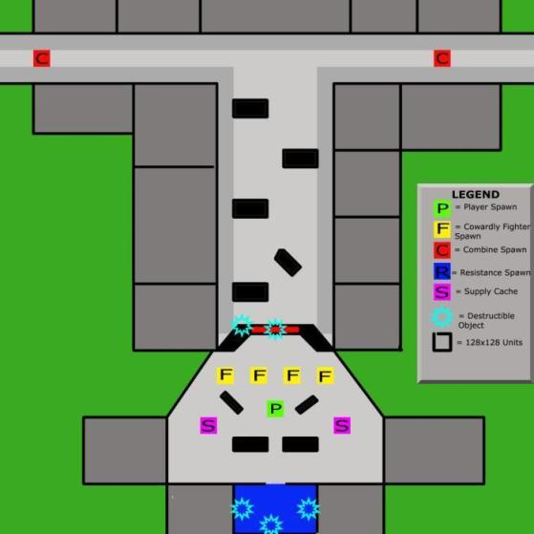
Figure 31: Initial layout of level.

Key
- Scale: As shown on legend one square is equal to 128x128 units
- Wow Moments
  - Area 1: Before first wave: Combine Drop ships fly over the player’s position to signal the first attack.
  - Area 3: Final Wave: Massive group of enemies spawns and charges the Combine gate.
- Challenge Highlights
  - Objectives:
    - Defend the three combine computers inside the building in Area 1.
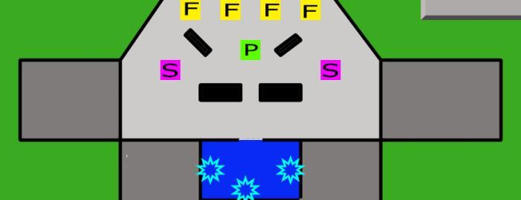
Figure 32: Close-up of Area 1
    - Destroy all the Combine soldiers
  - Skill Tests:
    - Keep the Combine from destroying the gate.
    - Keep the Cowardly Resistance Fighters from fleeing
- Player
  - Start Point: Player spawns inside Area 1
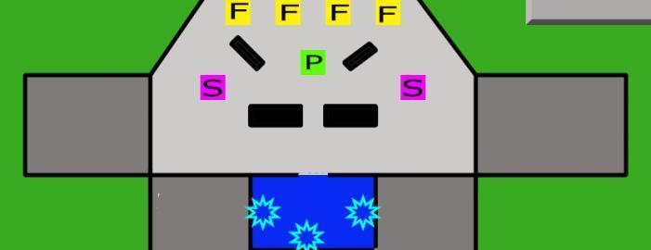
Figure 33: Area 1 houses friendly spawn points.
  - Optimal Route: Player remains in Area 1 and Area 2 for the duration of the mission
  - Alternate routes: Players may take the fight to the enemy if the front gate is destroyed
  - Area End: Level ends after the player kills the final wave of Combine soldiers.

- Key Actors
  - Spawn Points: Combine and Resistance soldiers spawn in Area 3
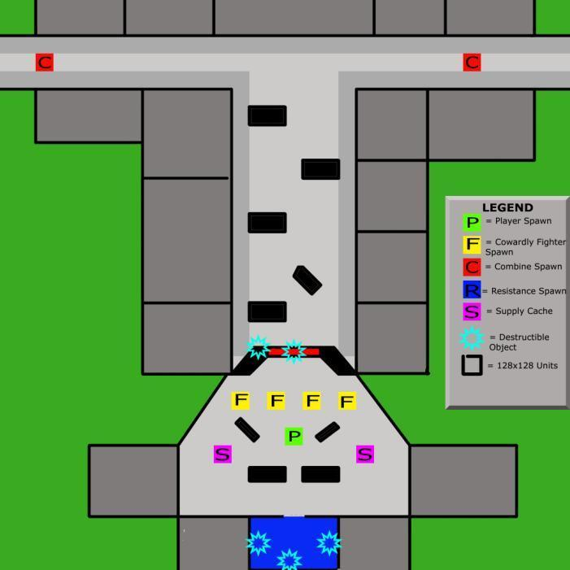
Figure 34: Combine spawn in Area 3 and move towards Area 1.

  - Routes/Behaviors
    - Combine Critical Path:
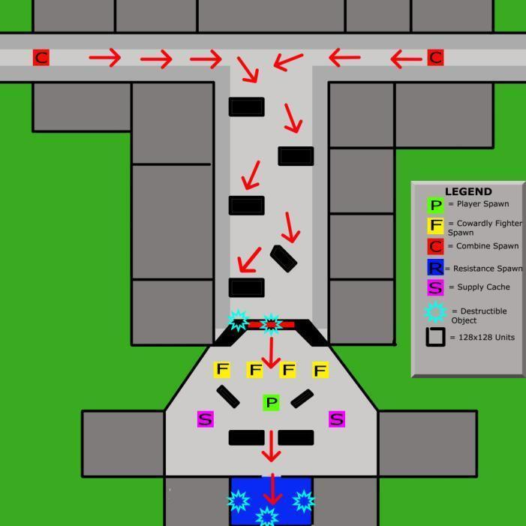
Figure 35: Critical path for Combine soldiers

    - Resistance Critical Path:
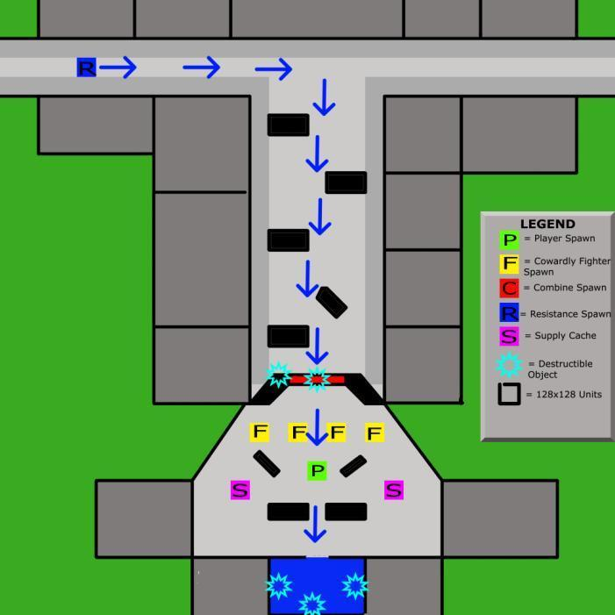
Figure 36: Critical path for resistance fighters during final wave

- Pickups (weapons/ammo/etc.)
  - Ammo crates (large, infinite supply box) sit behind barricades in Area 1. This provides a semi-safe area for players to replenish their ammo.
Figure 37: Player finds pickups in the Combine stronghold
- Key Gameplay Objects
  - Area 3 contains several wrecked or abandoned cars for the Combine to take cover behind.
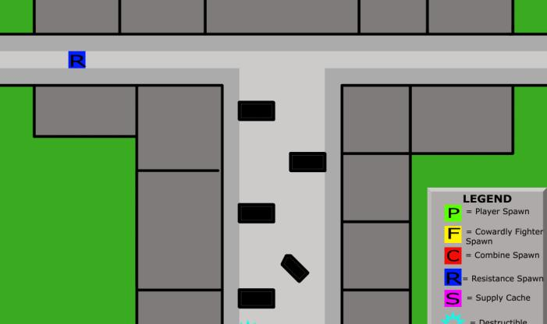
Figure 38: Black boxes indicate solid cover

Detailed Map Descriptions
- Initial player loadout:
  - Crowbar (restores morale)
  - SMG (short range, “pray and spray”)
  - AR-2 (Medium range, high accuracy)
- When player gets new weapons/abilities
  - Player receives a new ability at the start of the level, which revolves around hitting comrades with a crowbar to restore their courage, or at least make them fear the player more than they fear the Combine.

- Enemies drop health, but the player can only reach the health pick-ups after the Combine have managed to breach the gate. Fortunately, that will be when the player needs it most.

Area 1: Residential Cul-De-Sac

Map
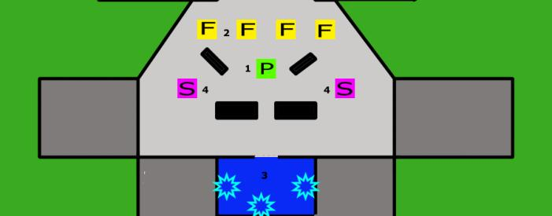
Figure 39: Area 1 with critical points
- Point 1: Player spawns here.
- Point 2: Cowardly resistance fighters spawn here. Player must first enforce discipline by hitting cowardly resistance fighters with his crowbar.
- Point 3: Combine computer equipment rests inside the building.
- Point 4: Ammo caches resupply player if they run low on ammo.

Gameplay
- Potential Encounters:
  - How: The Combine breaks the gate down and floods into Area 1. Barricades provide limited cover and safety, as does the building.
  - Loadout:
    - Metro Police: Pistol or SMG
    - Combine Soldier: AR-2
    - Manhack: Saw blade
  - Challenge: Enemies charge through the gate and assault the main building. If the Combine destroys the gate, Area 1 is highly exposed to enemy fire. Players complete the challenge by killing all of the Combine soldiers.

Dialog
- No dialog here

Visual References

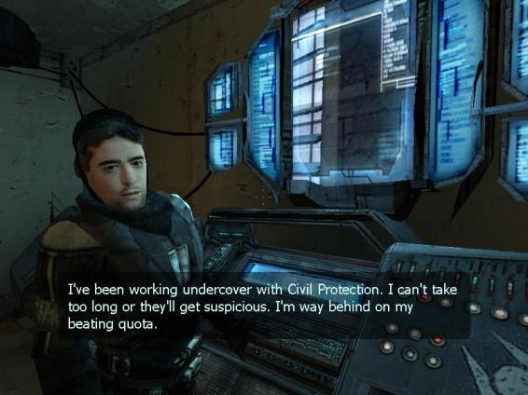
Figure 40: Combine computer console

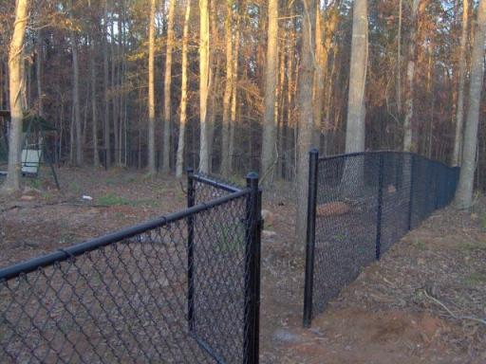
Figure 41: Chain link fence concept

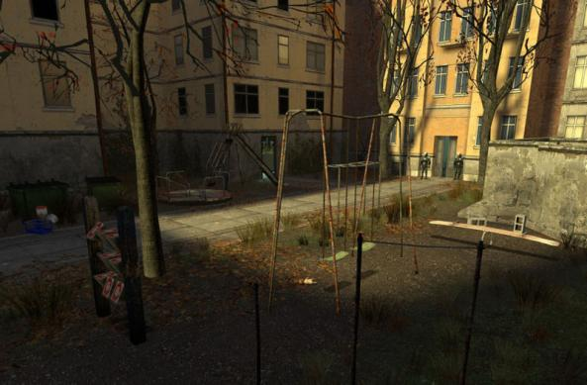
Figure 42: Playgrounds stand behind chain link fences, inaccessible to the player.

Figure 43:Many buildings sport grafitti

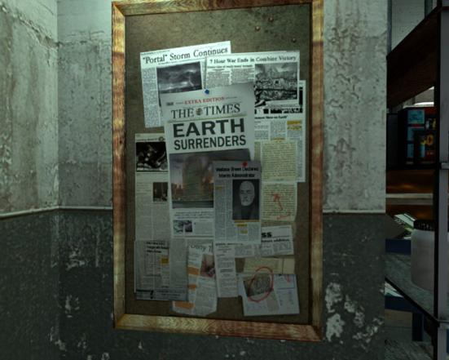
Figure 44: Examples of wall hangings and news articles inside combine base

Figure 45: Defend the Combine computers

Area 2: Combine Gate

Map

Figure 46: Area 2 with critical points
- Point 1: The Combine attack the gate until they destroy it.
- Point 2: Player has the opportunity to use a heavy machine gun to fight off the assault. Sustained damage destroys the machine gun.
- Point 3: Players and NPCs access the wall through a short set of stairs.

Gameplay
- Encounters:
  - How: The Combine assaults the gate.
  - Loadout:
    - Metro Police: Pistol or SMG
    - Combine Soldier: AR-2
    - Manhack: Saw blade
  - Challenge: Combine soldiers fire on the gate and try to destroy both the machine gun and the main door of the gate. Players must kill all Combine soldiers in order to prevent this from happening.

Dialog
No Dialog in this area

Visual References

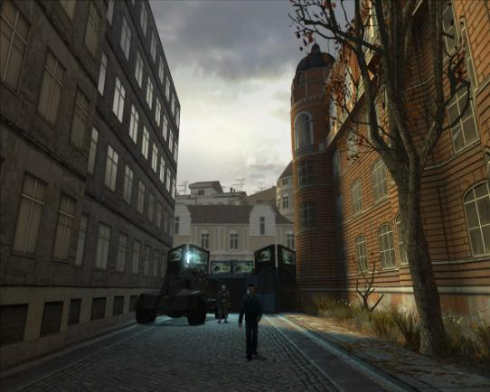
Figure 47: Combine gate

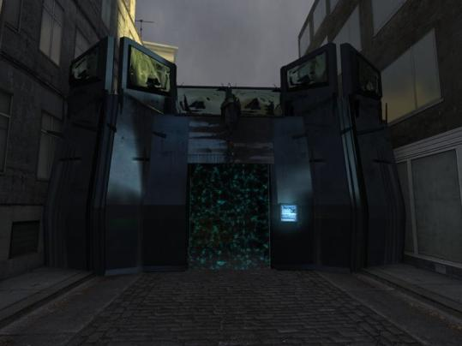
Figure 48: The gate turns Area 1 into a fortress

Figure 49: Combine attack the main gate's door

Area 3: City Street

Map
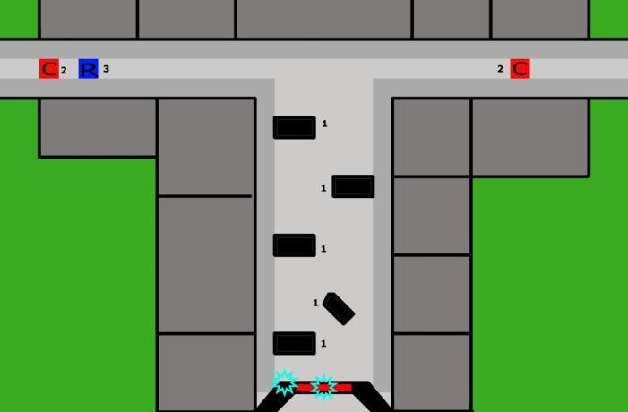
Figure 50: Area 3 with critical points

- Point 1: Abandoned vehicles provide cover for the Combine advance.
- Point 2: Combine Enemies spawn in here.
- Point 3: Resistance fighters spawn here at the end of the level.

Gameplay
- Encounters:
  - How: The Combine advances on the gate.
  - Loadout:
    - Metro Police: Pistol or SMG
    - Combine Soldier: AR-2
    - Manhack: Saw blade
  - Challenge: Stop the Combine from reaching the gate and destroying it. Players complete this challenge by prioritizing enemies and destroying the most dangerous (closest) ones first.

Dialog
No Dialog in this area

Visual References

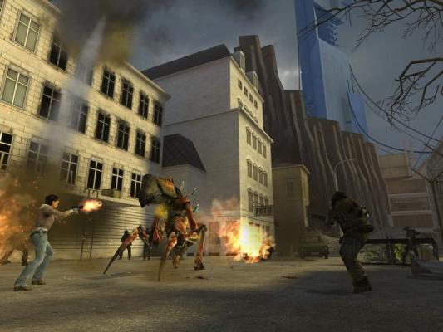
Figure 51: City street architectural model

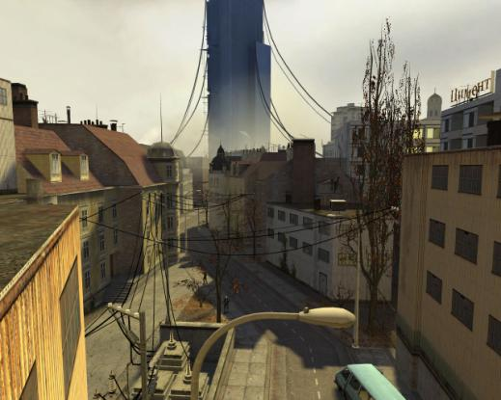
Figure 52: City Street concept

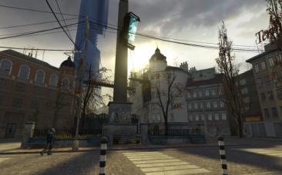
Figure 53: Juxtaposition of residential and combine elements

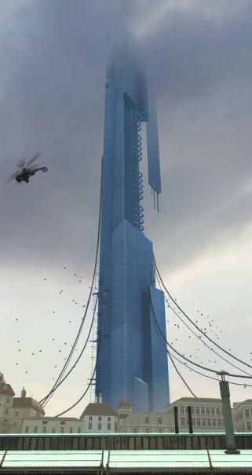
Figure 54: The citadel looms in the distance

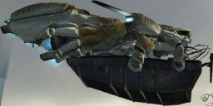
Figure 55: Combine dropship

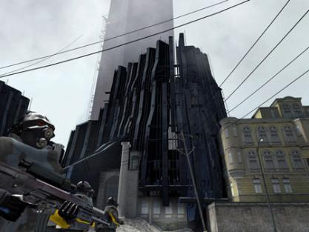
Figure 56: Combine fortress

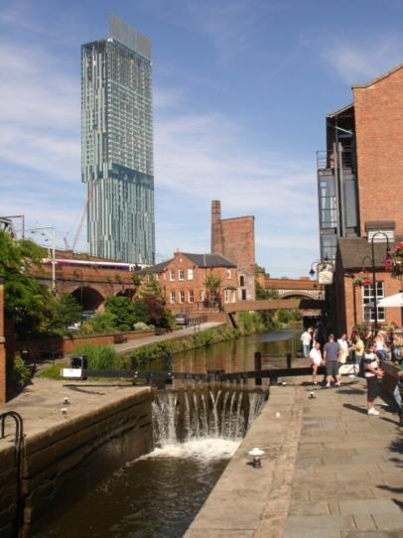
Figure 57: City 17 bears real-world similaries

References

www.brianmicklethwait.com/.../BeethamTower.jpg

http://newteevee.files.wordpress.com/2009/02/escape-from-city-17-still.jpg

http://nomoregoatsoup.files.wordpress.com/2009/04/halflife2_city17_trainstationsquare.jpg

http://images.wikia.com/half-life/en/images/5/54/HalfLife2_City17_Street.jpg

http://knol.google.com/k/-/-/3qekwxh18g0ry/y4ur95/halflife2citadel.jpg

http://media.photobucket.com/image/Half-life%202%20City%2017/Mastaxpeng/freeman.jpg

http://sdk-project.com/wp-content/uploads/2008/03/bax_rebel.jpg

http://www.hlfallout.net/images/content/enemies/full/manhack_full.jpg

http://images.google.com/imgres?imgurl=http://images2.wikia.nocookie.net/half-life/en/images/thumb/b/b8/D1_trainstation_020001.jpg/200px-D1_trainstation_020001.jpg&imgrefurl=http://half-life.wikia.com/wiki/List_of_Combine_technology&usg=__IFm54RlP_UH3vut0yjU-Nd49Z6s=&h=150&w=200&sz=5&hl=en&start=458&tbnid=nkhm3Js39UKX4M:&tbnh=78&tbnw=104&prev=/images%3Fq%3DHalf-life%2B2%2BCity%2B17%26gbv%3D2%26ndsp%3D20%26hl%3Den%26client%3Dfirefox-a%26rls%3Dorg.mozilla:en-US:official%26sa%3DN%26start%3D440

http://images.google.com/imgres?imgurl=http://images2.wikia.nocookie.net/half-life/en/images/thumb/b/b8/D1_trainstation_020001.jpg/200px-D1_trainstation_020001.jpg&imgrefurl=http://half-life.wikia.com/wiki/List_of_Combine_technology&usg=__IFm54RlP_UH3vut0yjU-Nd49Z6s=&h=150&w=200&sz=5&hl=en&start=458&tbnid=nkhm3Js39UKX4M:&tbnh=78&tbnw=104&prev=/images%3Fq%3DHalf-life%2B2%2BCity%2B17%26gbv%3D2%26ndsp%3D20%26hl%3Den%26client%3Dfirefox-a%26rls%3Dorg.mozilla:en-US:official%26sa%3DN%26start%3D440

http://www.hlfallout.net/images/content/characters/full/alyx_full.jpg

http://www.fpsteam.it/img2006/half-life-2-episode-one/half-life2_episode_one_09.jpg

http://media.photobucket.com/image/manchester,%20england/audiocoke/Manchester_Sky.jpg

http://www.freedigitalphotos.net/image/s_sunset23.jpg

http://cdn-write.demandstudios.com/upload//0000/400/20/1/30421.jpg

http://media.merchantcircle.com/25801947/chain%20link%20fence_full.jpeg

http://currentconfig.com/images/hl2images/combine_city17_citadel_sm.jpg

http://pcmedia.gamespy.com/pc/image/article/566/566240/d1_trainstation_010004_1100550604.jpg

http://pcmedia.gamespy.com/pc/image/article/566/566240/d1_trainstation_020014_1100550882.jpg

http://guide2games.org/wp-content/uploads/2008/02/927314-20050420-screen001.jpg

http://images.google.com/imgres?imgurl=http://upload.wikimedia.org/wikipedia/en/thumb/2/2d/Half_Life_Escape_from_City_17_Screen_shot.JPG/200px-Half_Life_Escape_from_City_17_Screen_shot.JPG&imgrefurl=http://en.wikipedia.org/wiki/Escape_From_City_17&usg=___rjwiL01u1dKExLzA0ndD0YyIAc=&h=134&w=200&sz=5&hl=en&start=196&tbnid=C5YUzBE2MnA9HM:&tbnh=70&tbnw=104&prev=/images%3Fq%3D%2522city%2B17%2522%2Bcombine%26gbv%3D2%26ndsp%3D20%26hl%3Den%26client%3Dfirefox-a%26rls%3Dorg.mozilla:en-US:official%26sa%3DN%26start%3D180

http://www.hlfallout.net/images/content/characters/full/citizen_full.jpg

http://www.freewebs.com/gamershots/HL2/Barney.JPG

http://images.google.com/imgres?imgurl=http://images1.wikia.nocookie.net/half-life/en/images/thumb/a/af/City_17_yellow_poster.jpg/71px-City_17_yellow_poster.jpg&imgrefurl=http://half-life.wikia.com/wiki/Combine&usg=__pL-h7Yj7a-s00F_FE9PUVex2c1k=&h=119&w=71&sz=3&hl=en&start=21&tbnid=0aCdjQsElATSLM:&tbnh=88&tbnw=53&prev=/images%3Fq%3D%2522city%2B17%2522%2Bdropship%26gbv%3D2%26ndsp%3D20%26hl%3Den%26client%3Dfirefox-a%26rls%3Dorg.mozilla:en-US:official%26sa%3DN%26start%3D20

http://images.google.com/imgres?imgurl=http://images1.wikia.nocookie.net/half-life/en/images/thumb/a/af/City_17_yellow_poster.jpg/71px-City_17_yellow_poster.jpg&imgrefurl=http://half-life.wikia.com/wiki/Combine&usg=__pL-h7Yj7a-s00F_FE9PUVex2c1k=&h=119&w=71&sz=3&hl=en&start=21&tbnid=0aCdjQsElATSLM:&tbnh=88&tbnw=53&prev=/images%3Fq%3D%2522city%2B17%2522%2Bdropship%26gbv%3D2%26ndsp%3D20%26hl%3Den%26client%3Dfirefox-a%26rls%3Dorg.mozilla:en-US:official%26sa%3DN%26start%3D20

http://images.google.com/imgres?imgurl=http://images1.wikia.nocookie.net/half-life/en/images/thumb/a/af/City_17_yellow_poster.jpg/71px-City_17_yellow_poster.jpg&imgrefurl=http://half-life.wikia.com/wiki/Combine&usg=__pL-h7Yj7a-s00F_FE9PUVex2c1k=&h=119&w=71&sz=3&hl=en&start=21&tbnid=0aCdjQsElATSLM:&tbnh=88&tbnw=53&prev=/images%3Fq%3D%2522city%2B17%2522%2Bdropship%26gbv%3D2%26ndsp%3D20%26hl%3Den%26client%3Dfirefox-a%26rls%3Dorg.mozilla:en-US:official%26sa%3DN%26start%3D20

