**NAME :- ROHIT KUMAR**

**ROLL NO :- 25MCF1R40**

**ASSIGNMENT – 4**

**PROBLEM NO 1**

**SOURCE CODE :-**

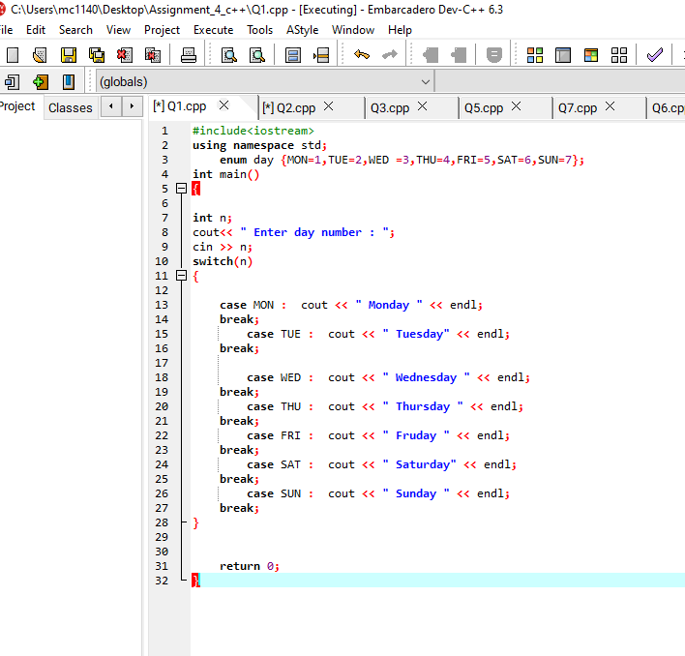

**OUTPUT:-**

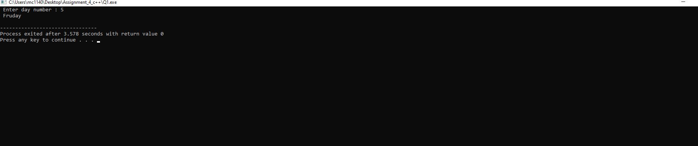

**EXPLANATION :-**

Use of enumerated structure implemented to define and access the days of the week. Using switch statements, we can get and compare user input with the enum declaration and give the desired output.

**PROBLEM NO 2**

**SOURCE CODE :-**

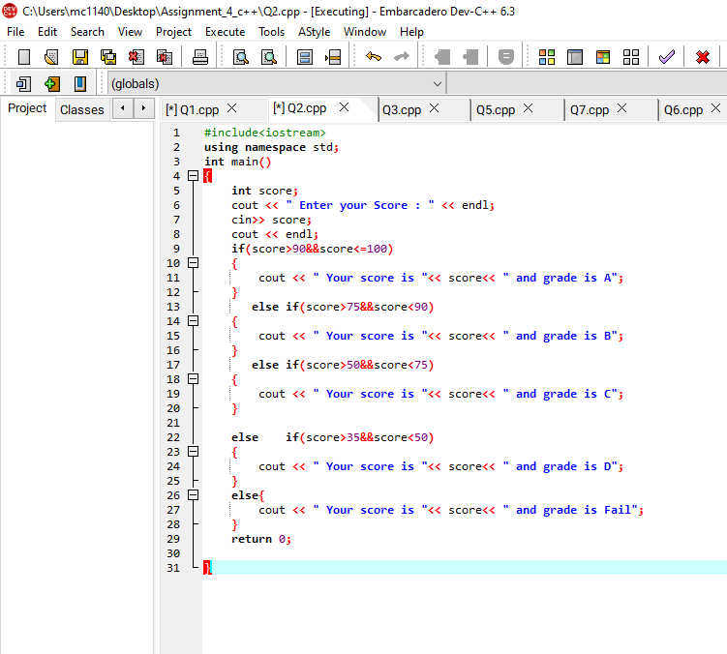

**OUTPUT:-**

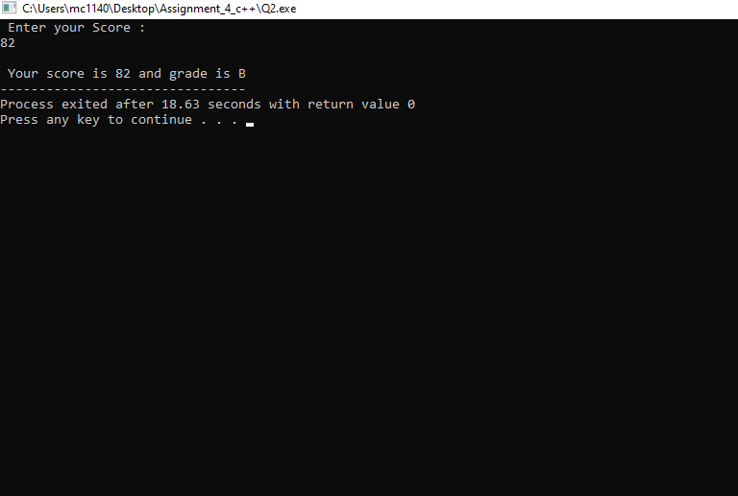

**EXPLANATION :-**

In this question user input was taken and then validated according to the given criteria using nested if-else statements.

**PROBLEM NO 3**

**SOURCE CODE :-**

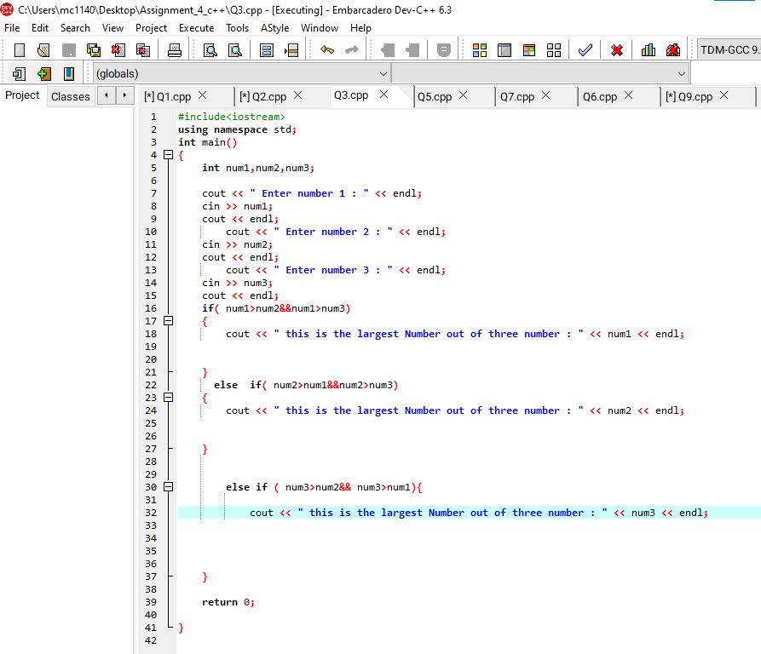

**OUTPUT:-**

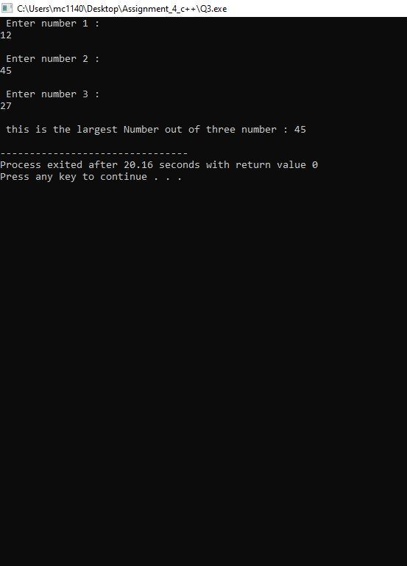

**EXPLANATION :-**

Use of nested if was implemented to compare three numbers based upon their value.

**PROBLEM NO 4**

**SOURCE CODE :-**

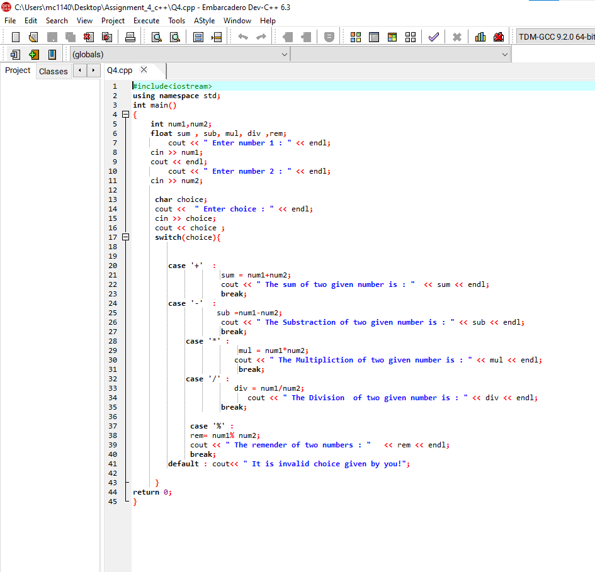

**OUTPUT:-**

**EXPLANATION :-**

Three variables were initialised to take user input for two numbers and a char type input for reading the operator, then the switch statement was used to evaluate the expression to give desired output.

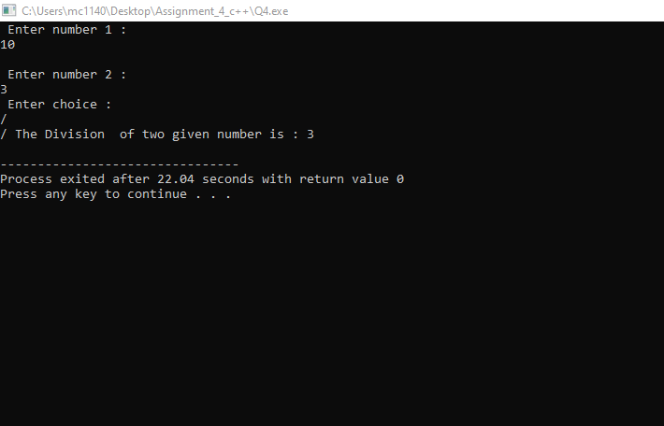

**PROBLEM NO 5**

**SOURCE CODE :-**

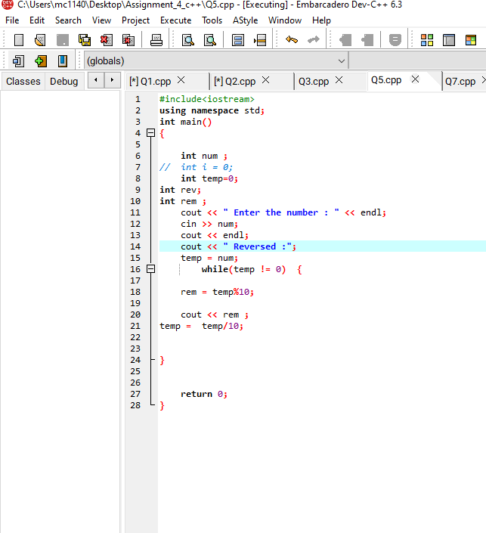

**OUTPUT:-**

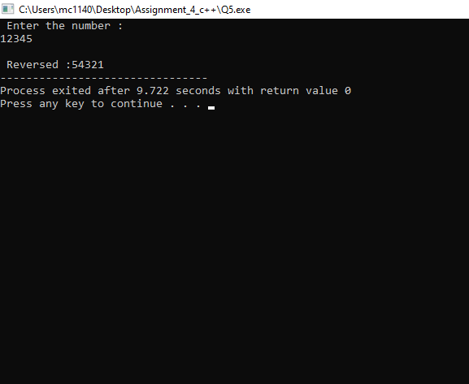

**EXPLANATION :-**

Use of while loop was done to implement the code until the initial variable < zero. Inside the loop the value was % by 10 to obtain the last digit and then it was printed first then the original number was / by 10 to remove the last digit.

**PROBLEM NO 6**

**SOURCE CODE :-**

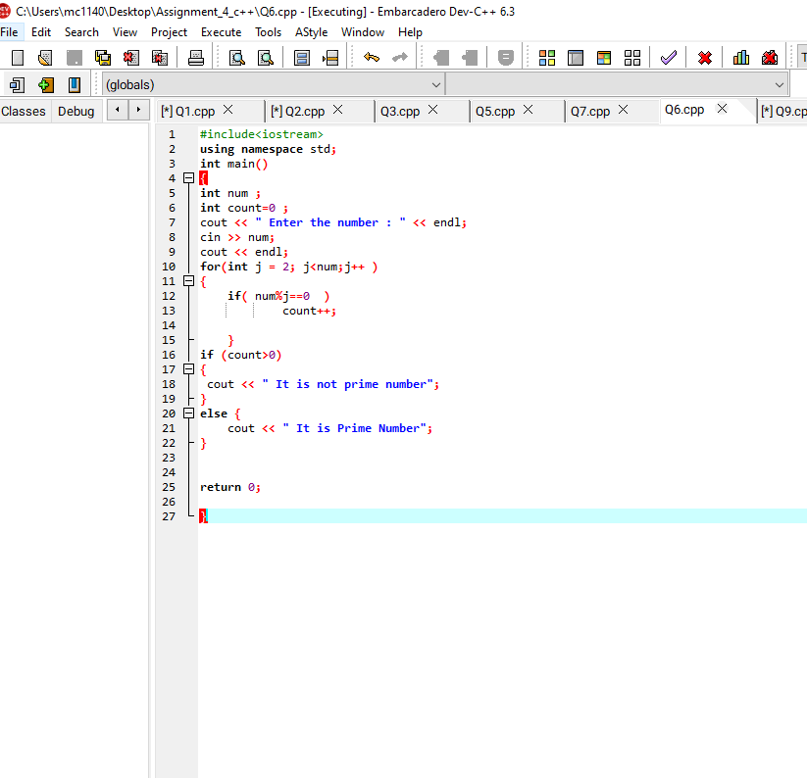

**OUTPUT:-**

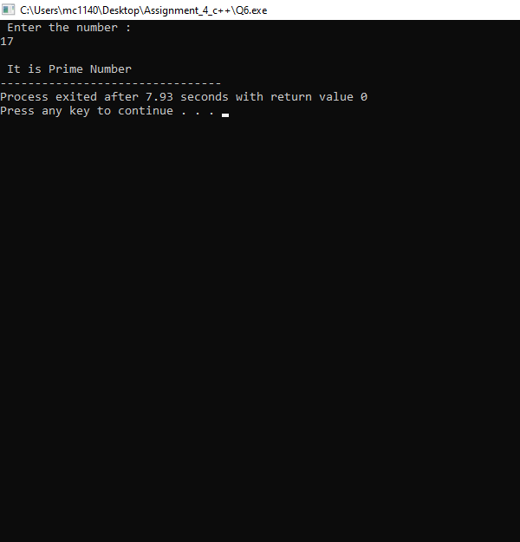

**EXPLANATION :-**

In this question the use of for loop was implemented to find the remainder when the given number is divided by every number form one to that number while the counter variable is incremented. If the counter variable equals to 2 i.e., the number is only divisible by 1 and itself then it is prime else not prime.

**PROBLEM NO 7**

**SOURCE CODE :-**

#include<iostream>

using namespace std;

int main() {

int n,a;

cout<<"Menu: \n";

cout<<"1. Square \n";

cout<<"2. Cube \n";

cout<<"3. Exit \n";

cout<<"Enter choice: \n";

cin>>n;

if(n==3) {

cout<<"Exiting...";

}

while(n!=3) {

cout<<"Enter a number: \n";

cin>>a;

switch(n) {

case 1: cout<<"Square "<<a*a<<endl; break;

case 2: cout<<"Cube "<<a*a*a<<endl; break;

case 3: cout<<"Exiting..."; break;

}

cout<<endl;

cout<<"Menu: \n";

cout<<"1. Square \n";

cout<<"2. Cube \n";

cout<<"3. Exit \n";

cout<<"Enter choice: \n";

cin>>n;

}

return 0;

}

**OUTPUT:-**

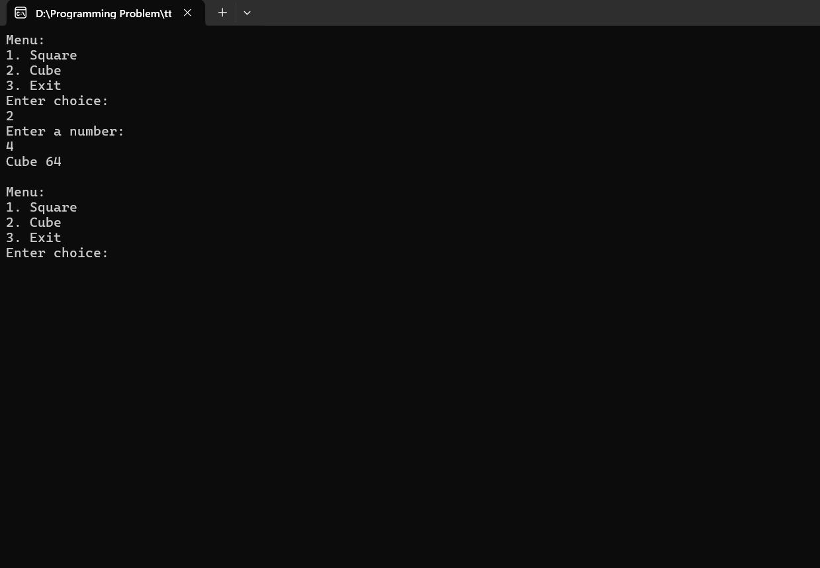

**EXPLANATION :-**

The use of for loop helped to run the code multiple number of times until the user entered 3 as the choice to exit the recursion. While in the loop the switch statement is used to generate user required data.

**PROBLEM NO 8**

**SOURCE CODE :-**

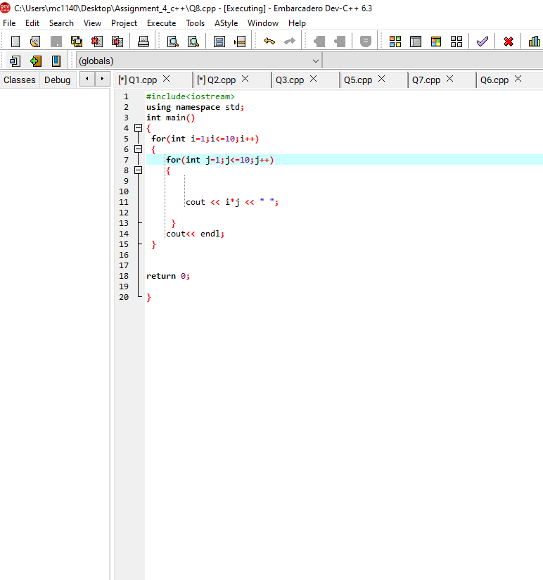

**OUTPUT:-**

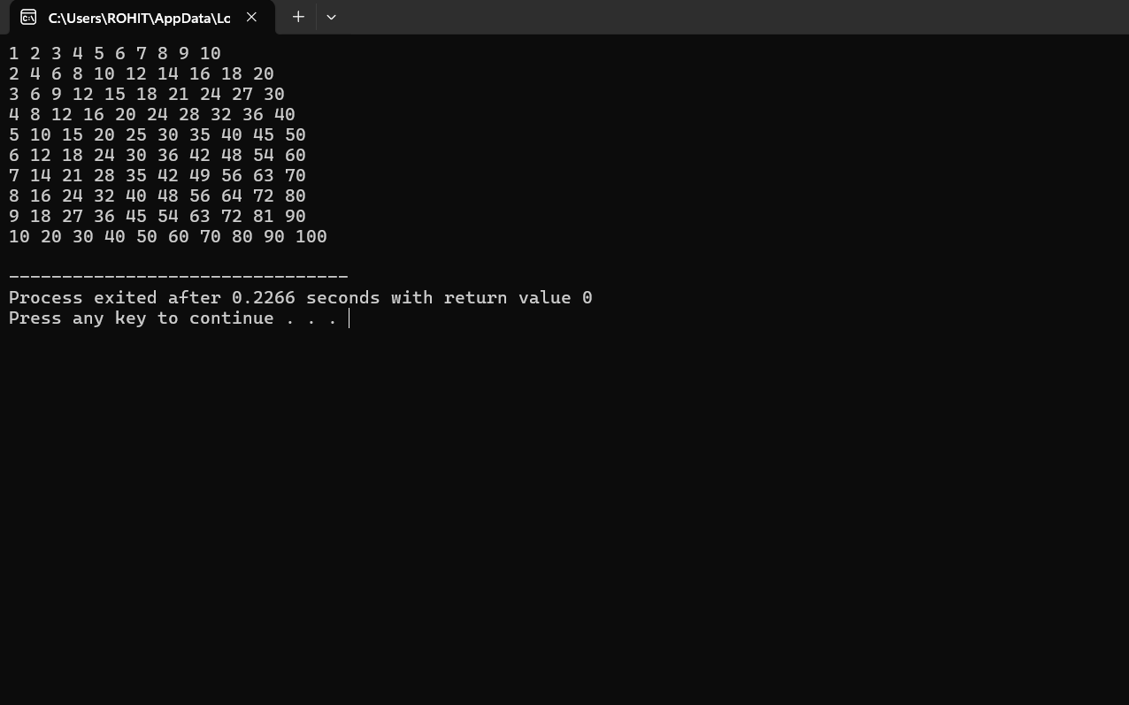

**EXPLANATION :-**

Use of nested for loop to calculate and print the tables of number from 1 – 10 up to 10 times.

**PROBLEM NO 9**

**SOURCE CODE :-**

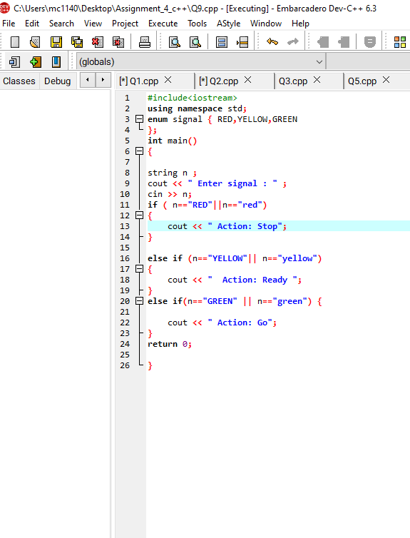

**OUTPUT:-**

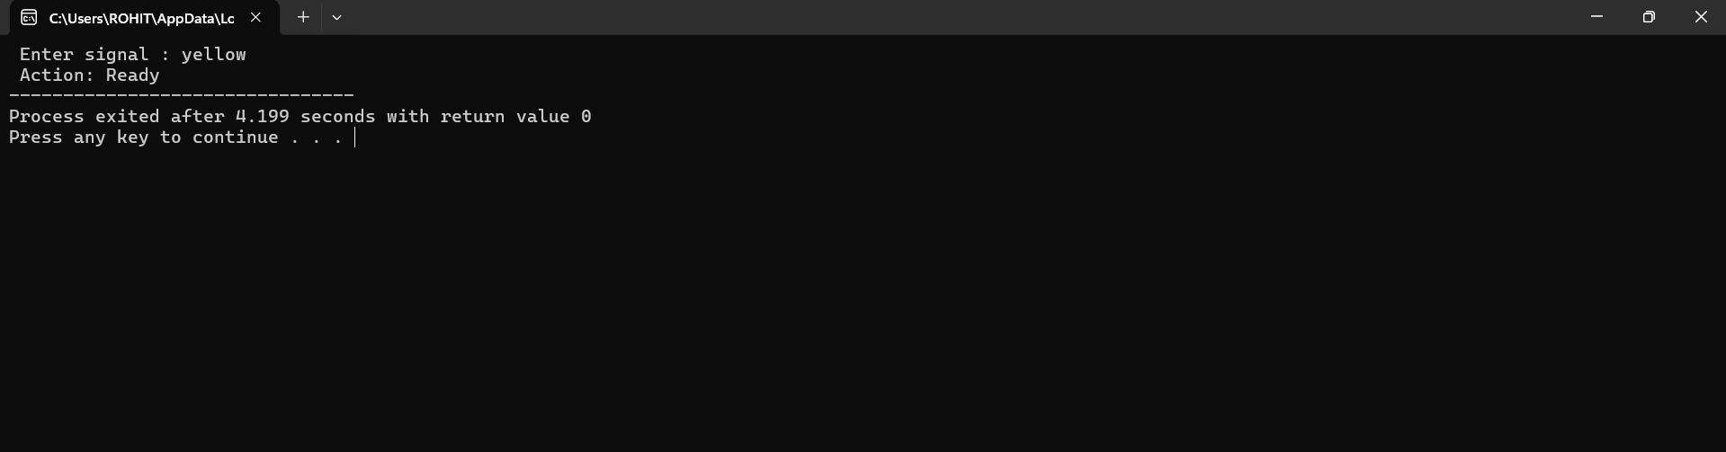

**EXPLANATION :-**

Use of enumerated structure implemented to define and access the colours of traffic signals. Using switch statements, we can get and compare user input with the enum declaration and give the desired output.

**PROBLEM NO 10**

**SOURCE CODE :-** 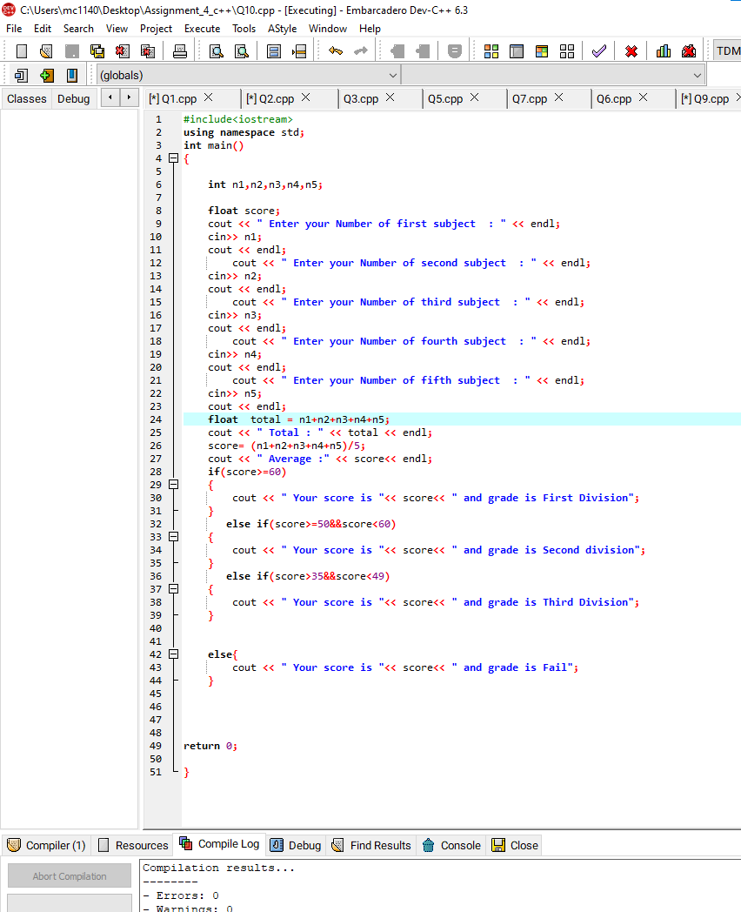

**OUTPUT:-**

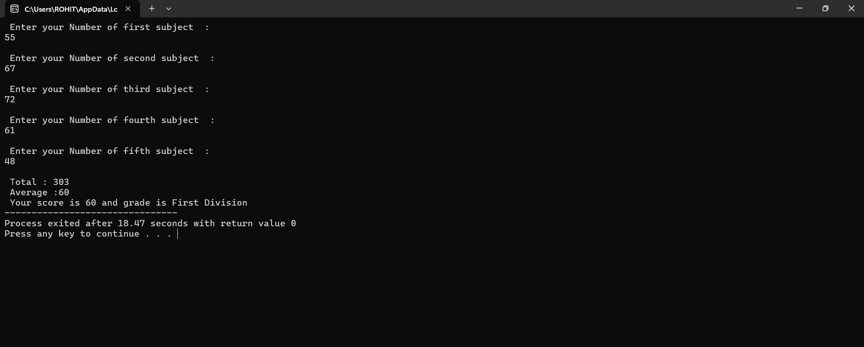

**EXPLANATION :-**

Using for loop the user input was stored in an input array where it was added to the sum variable. Then after calculating the average the if-else ladder was used to compare and give result as per the guidelines.