**Trainer's Guide: Creating a Dashboard in Tableau**

**Hey everyone! Welcome to our Tableau demo session. Today, we're going to create a dashboard using the Superstore Sales dataset. Let's dive right in!**

**Step 2: Validating Data**

This data is fairly clean but otherwise we could clean it up in Excel before bringing it into Tableau (or for paying users, Tableau Prep can be used to clean and transform data). For now, we will just need to check that each column is the correct datatype before loading it into Tableau and creating visualisations.

1. Ensure the data types are correct.
   * Check the datatypes by clicking on the icon to the left of each column name. (e.g., check that dates are in date format, numbers are in whole number or decimal formats).
   * Demonstrate changing the region to a geographic data type by clicking on icon to left of region column name and selecting geography > country/region.
   * *Note that Tableau won’t actually be able to recognise these regions in the US and we will not be working with region data during this particular demo but it is still good for the learners to see how to check data types and make changes to datatypes as needed.*

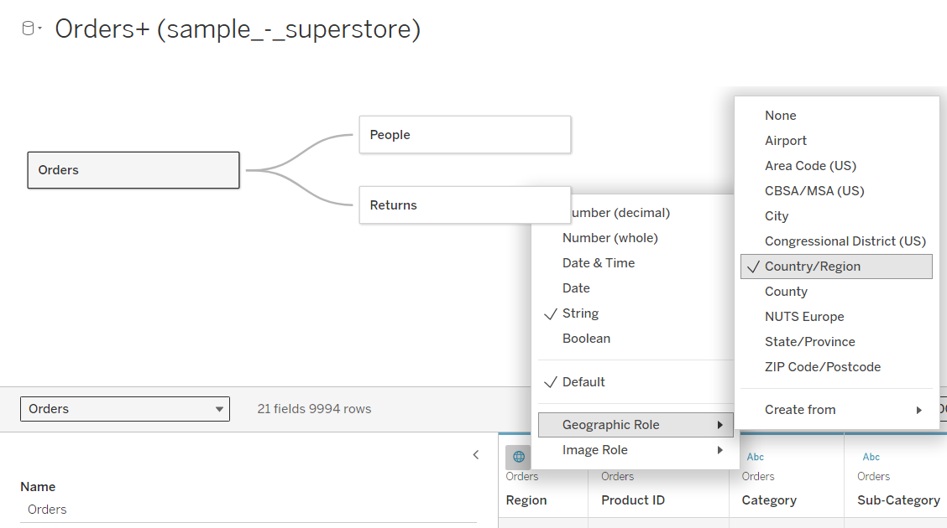

1. **Clean up any issues:**
   * Fix any typos or inconsistencies you find.
   * Make sure all columns have the correct data type.

Alright, our data looks good. Now let's move on to the next step!

**Step 2: Setting Relationships**

In Tableau, it's crucial to set relationships between tables for a comprehensive analysis. Let's do that now:

1. **Open Tableau and connect to the Superstore Sales dataset:**
   * Launch Tableau.
   * Click on 'Connect' and select your data source (Excel, in this case).
2. **Add multiple tables (if applicable):**
   * Drag the Orders, People, and Returns tables to the middle view (the mostly empty space in centre of screen).
3. **Define relationships:**
   * Click on 'Data' > 'Edit Relationships'.
   * Ensure that the relationships between tables (like Orders, Customers, Products) are correctly set based on common fields. Specifically, you will need to click on the line connecting the Orders and People tables and down in the pane at the bottom of the screen, correct that relationship.
   * Under Orders it should say **customer name** and under People it should say **person** so that the *orders-people* table relationship reads *customer name = person*.

Great! Now our data is linked properly. Let's move on to loading this data into Tableau.

**Step 3: Loading Data into Tableau**

Let's get our data into Tableau and ready for visualization:

1. **Load your dataset:**
   * Once the relationships are set, click 'Sheet 1' at the bottom.
   * Tableau will load your data and show you a data pane on the left with all the fields.

Perfect! Now, our data is in Tableau. Let’s create some visualizations!

**Step 4: Setting up Hierarchies**

We need to set up hierarchies first so that Tableau understands how to drill down between levels in your visualisation. For more information on this, see <https://help.tableau.com/current/pro/desktop/en-us/qs_hierarchies.htm>

1. **Geography Hierarchy**
   * In the Data pane to the left, drag Country to State in the tables to create a hierarchy.
   * Name the hierarchy "Geography."
2. **Category Hierarchy**
   * In the Data pane, drag Subcategory to Category to create a hierarchy.
   * Name the hierarchy "Categories."

**Step 5: Creating 3-4 Visualizations**

Let’s create a few different visualizations to communicate data insights visually:

1. **Create a bar chart showing Profit per Category and Subcategory:**
   * Drag *Profit* from the tables to the left to the Columns shelf. *Note: This will automatically be summed over the dates available.*
   * Drag *Category* to the Rows shelf.
   * Drag *subcategory* to the right of category on the rows shelf.
   * Drag *Profit* to the Colour field of the Marks card between the Tables and the Canvas.
   * Click on *Colour* and Select *Edit Colours*.
   * Change *Palette* from automatic to red-green diverging. (choose a different palette as needed to be more accessible/colour-blind friendly)
   * Click on *Advanced* and check that the *centre* (where the colours diverge from red to green) is set to zero and click **OK**.

1. **Create a line chart for Profits by Order Date:**
   * Click on a new sheet.
   * Drag Order Date to the Columns shelf.
   * Drag Profit to the Rows shelf.
   * Change the mark type to 'Line' to see sales trends over time.

1. **Create a map for Profit by State:**
   * Click on another new sheet.
   * Drag Country and State to the canvas (to the view).
   * Drag Profit to the Colour shelf in the marks card to visualise profit by state.
   * Right click on colour and edit colours to change palette to red-green diverging.
   * Right Click on tab at bottom of screen and rename this sheet, Profit by State.

1. **Create a pie chart for Profit per Segment:**
   * Click on one more new sheet.
   * Drag Profit to the Columns shelf.
   * Drag Segment to the Rows shelf.
   * Click on Show Me in the upper left side of your screen and select the pie chart visualisation. *Note: You can close the visualisation menu by clicking Show Me again.*
   * Change the pull down menu in the centre top ribbon from *standard* to *entire view* to make this pie chart larger.
   * Add *Profit* to *details* on the marks card
   * Right click on *profit* that you just added in the marks card and select **quick table calculation** > **percentage of total**.

* + Right click tab at bottom of screen to rename sheet to **Profit per Segment**.

For more info: <https://help.tableau.com/current/pro/desktop/en-us/buildexamples_pie.htm>

Fantastic! We've created some insightful visualizations. Now, let's combine them into a dashboard.

**Step 6: Making Visualizations into a Dashboard**

Time to bring it all together into a beautiful, interactive dashboard:

1. **Create a dashboard:**
   * Click on the 'New Dashboard' icon at the bottom.
   * You'll see a blank canvas with your visualizations on the left.
2. **Set the canvas size on the left side of screen**
   * Set size > range > fixed size > generic desktop
3. **Drag visualisations onto the dashboard:**
   * Drag each of your visualizations onto the dashboard canvas.
   * Arrange them as you see fit. You can resize and reposition them to create a cohesive layout.
4. **Remove Superfluous legends and space holder**
   * For the Sales by Category visualisation:
     1. Click to select the legend
     2. Click x to remove the legend as it is redundant.
   * For Sales per State Map visualisation:
     1. Click to select the legend
     2. Click on the down area in legend settings
     3. Select *Floating.*
     4. Drag legend over Map visualisation, to upper right corner of map.
   * Do the same for the *Profits by Segment* Pie Chart to move its legend on top of the visualisation in its upper right corner.
   * Click on any blank rectangle filling empty space on canvas and press x to remove this.
5. **Set** **each Visualisation to Fill the Entire Tile on Canvas**
   * Select visualisation.
   * Change pull-down menu in centre top ribbon to read **Entire View** rather than **Standard**.
   * Repeat for all the visualisations.

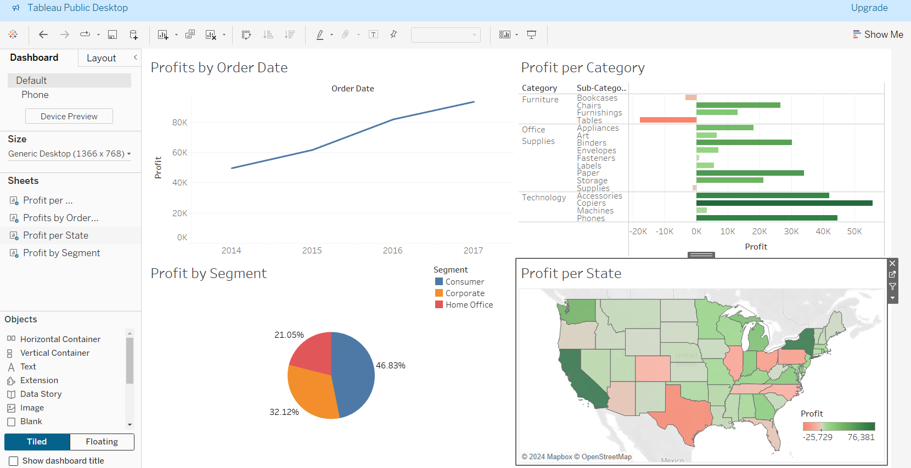

1. **Add interactivity:**
   * Click on each visualisation in the dashboard and select Use as Filter from the settings in the upper right (this option looks like a funnel).
   * Demonstrate how, with this *Use as Filter* option selected, when you click on one area of the visualisation such as the horizontal bar representingProfits from *Tables* from the Profit Per Category visualisation, then all the other visuals (e.g. the map, the line chart, and the pie chart too) now only show that segment of the data, e.g. the data pertaining to profits from tables.

1. **Finalize and publish:**
   * Make any final adjustments to your dashboard re formatting.
   * Save your work and demonstrate how to save this to Tableau Public. File > Save to Tableau Public. They will need to create a free account on tableau to publish dashboards online.

And there you have it! We've created a dynamic dashboard in Tableau from scratch.

That's it for today's demo. I hope you found it helpful and fun! You will get to practice these skills in Tableau with another dataset after our afternoon break.

Any questions? Feel free to ask away!