Laboratory 08: Pointers, Template, and Linked List

P1

main.cpp

Results of running P1

P2

main.cpp

Results of running P2

P3

main.cpp

Results of running P3

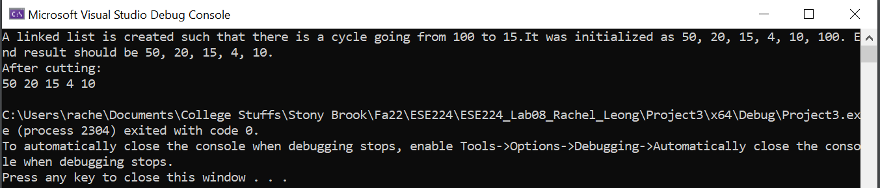

P4

main.cpp

Results of running P4

P5

main.cpp

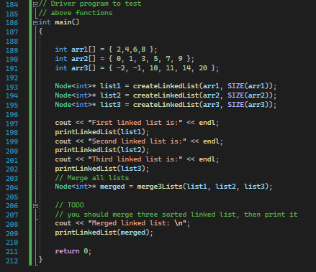

Results of running P5

