教辅--libpcap

1. **more /usr/include/sys/types.h**

#ifndef _SYS_TYPES_H

#define _SYS_TYPES_H 1

#include <features.h>

__BEGIN_DECLS

#include <bits/types.h>

#ifdef __USE_BSD

# ifndef __u_char_defined

typedef __u_char u_char;

typedef __u_short u_short;

typedef __u_int u_int;

typedef __u_long u_long;

# define __u_char_defined

# endif

#endif

typedef __loff_t loff_t;

#ifndef __ino_t_defined

# ifndef __USE_FILE_OFFSET64

typedef __ino_t ino_t;

# else

typedef __ino64_t ino_t;

# endif

# define __ino_t_defined

#endif

#if defined __USE_LARGEFILE64 && !defined __ino64_t_defined

typedef __ino64_t ino64_t;

# define __ino64_t_defined

#endif

#ifndef __gid_t_defined

typedef __gid_t gid_t;

# define __gid_t_defined

#endif

#ifndef __mode_t_defined

typedef __mode_t mode_t;

# define __mode_t_defined

#endif

#ifndef __uid_t_defined

typedef __uid_t uid_t;

# define __uid_t_defined

#endif

#ifndef __off_t_defined

# ifndef __USE_FILE_OFFSET64

typedef __off_t off_t;

# else

typedef __off64_t off_t;

# endif

# define __off_t_defined

#endif

#ifndef __pid_t_defined

typedef __pid_t pid_t;

# define __pid_t_defined

#endif

#ifndef __ssize_t_defined

typedef __ssize_t ssize_t;

# define __ssize_t_defined

#endif

**#ifdef __USE_MISC**

**/* Old compatibility names for C types. */**

**typedef unsigned long int ulong;**

**typedef unsigned short int ushort;**

**typedef unsigned int uint;**

**#endif**

/* These types are defined by the ISO C99 header <inttypes.h>. */

# ifndef __int8_t_defined

**# define __int8_t_defined**

**typedef char int8_t;**

**typedef short int int16_t;**

**typedef int int32_t;**

# if __WORDSIZE == 64

typedef long int int64_t;

# elif __GLIBC_HAVE_LONG_LONG

__extension__ typedef long long int int64_t;

# endif

# endif

/* But these were defined by ISO C without the first `_'. */

**typedef unsigned char u_int8_t;**

**typedef unsigned short int u_int16_t;**

**typedef unsigned int u_int32_t;**

**# if __WORDSIZE == 64**

**typedef unsigned long int u_int64_t;**

**# elif __GLIBC_HAVE_LONG_LONG**

__extension__ typedef unsigned long long int u_int64_t;

# endif

typedef int register_t;

#else

#ifdef __USE_BSD

/* In BSD <sys/types.h> is expected to define BYTE_ORDER. */

# include <endian.h>

/* It also defines `fd_set' and the FD_* macros for `select'. */

# include <sys/select.h>

#endif /* Use BSD. */

/* Now add the thread types. */

#if defined __USE_POSIX199506 || defined __USE_UNIX98

# include <bits/pthreadtypes.h>

#endif

__END_DECLS

#endif /* sys/types.h */

**2. pcap.h头文件**

#ifndef lib_pcap_pcap_h

#define lib_pcap_pcap_h

#if defined(WIN32)

#include <pcap-stdinc.h>

#elif defined(MSDOS)

#include <sys/types.h>

#include <sys/socket.h> /* u_int, u_char etc. */

#else /* UN*X */

**#include <sys/types.h>**

**#include <sys/time.h>**

#endif /* WIN32/MSDOS/UN*X */

#ifndef PCAP_DONT_INCLUDE_PCAP_BPF_H

#include <pcap/bpf.h>

#endif

#include <stdio.h>

**#define PCAP_ERRBUF_SIZE 256**

/* * Compatibility for systems that have a bpf.h that predates the bpf typedefs for 64-bit support. */

#if BPF_RELEASE - 0 < 199406

**typedef int bpf_int32;**

**typedef u_int bpf_u_int32;**

#endif

**typedef struct pcap pcap_t;**

**typedef struct pcap_dumper pcap_dumper_t;**

**typedef struct pcap_if pcap_if_t;**

**typedef struct pcap_addr pcap_addr_t;**

**struct pcap_file_header {**

**bpf_u_int32 magic;**

**u_short version_major;**

**u_short version_minor;**

**bpf_int32 thiszone; /* gmt to local correction */**

**bpf_u_int32 sigfigs; /* accuracy of timestamps */**

**bpf_u_int32 snaplen; /* max length saved portion of each pkt */**

**bpf_u_int32 linktype; /* data link type (LINKTYPE_*) */**

**};**

typedef enum {

PCAP_D_INOUT = 0,

PCAP_D_IN,

PCAP_D_OUT

} pcap_direction_t;

/* * Generic per-packet information, as supplied by libpcap. */

**struct pcap_pkthdr {**

**struct timeval ts; /* time stamp */**

**bpf_u_int32 caplen; /* length of portion present */**

**bpf_u_int32 len; /* length this packet (off wire) */**

**};**

/* * As returned by the pcap_stats() */

**struct pcap_stat {**

**u_int ps_recv; /* number of packets received */**

**u_int ps_drop; /* number of packets dropped */**

**u_int ps_ifdrop; /* drops by interface -- only supported on some platforms */**

#ifdef WIN32

u_int bs_capt; /* number of packets that reach the application */

#endif /* WIN32 */

};

/* * Item in a list of interfaces. */

**struct pcap_if {**

**struct pcap_if *next;**

**char *name; /* name to hand to "pcap_open_live()" */**

**char *description; /* textual description of interface, or NULL */**

**struct pcap_addr *addresses;**

**bpf_u_int32 flags; /* PCAP_IF_ interface flags */**

**};**

**#define PCAP_IF_LOOPBACK 0x00000001 /* interface is loopback */**

/* Representation of an interface address. */

**struct pcap_addr {**

**struct pcap_addr *next;**

**struct sockaddr *addr; /* address */**

**struct sockaddr *netmask; /* netmask for that address */**

**struct sockaddr *broadaddr; /* broadcast address for that address */**

**struct sockaddr *dstaddr; /* P2P destination address for that address */**

**};**

typedef void (*pcap_handler)(u_char *, const struct pcap_pkthdr *, const u_char *);

/* * Error codes for the pcap API. These will all be negative, so you can check for the success or

* failure of a call that returns these codes by checking for a negative value. */

**#define PCAP_ERROR -1 /* generic error code */**

**#define PCAP_ERROR_BREAK -2 /* loop terminated by pcap_breakloop */**

**#define PCAP_ERROR_NOT_ACTIVATED -3 /* the capture needs to be activated */**

**#define PCAP_ERROR_ACTIVATED -4 /* the operation can't be performed on already activated captures */**

**#define PCAP_ERROR_NO_SUCH_DEVICE -5 /* no such device exists */**

**#define PCAP_ERROR_RFMON_NOTSUP -6 /* this device doesn't support rfmon (monitor) mode */**

**#define PCAP_ERROR_NOT_RFMON -7 /* operation supported only in monitor mode */**

**#define PCAP_ERROR_PERM_DENIED -8 /* no permission to open the device */**

**#define PCAP_ERROR_IFACE_NOT_UP -9 /* interface isn't up */**

**#define PCAP_ERROR_CANTSET_TSTAMP_TYPE -10 /* this device doesn't support setting the time stamp type */**

**#define PCAP_ERROR_PROMISC_PERM_DENIED -11 /* you don't have permission to capture in promiscuous mode */**

**#define PCAP_ERROR_TSTAMP_PRECISION_NOTSUP -12 /* the requested time stamp precision is not supported */**

/* * Warning codes for the pcap API. These will all be positive and non-zero, so they won't look like errors. */

**#define PCAP_WARNING 1 /* generic warning code */**

**#define PCAP_WARNING_PROMISC_NOTSUP 2 /* this device doesn't support promiscuous mode */**

**#define PCAP_WARNING_TSTAMP_TYPE_NOTSUP 3 /* the requested time stamp type is not supported */**

/** Value to pass to pcap_compile() as the netmask if you don't know what the netmask is. */

#define PCAP_NETMASK_UNKNOWN 0xffffffff

char *pcap_lookupdev(char *);

int pcap_lookupnet(const char *, bpf_u_int32 *, bpf_u_int32 *, char *);

pcap_t *pcap_create(const char *, char *);

int pcap_set_snaplen(pcap_t *, int);

int pcap_set_promisc(pcap_t *, int);

int pcap_set_timeout(pcap_t *, int);

.......................................................................

PCAP库所有函数原型的定义

.......................................................................

#ifndef __NetBSD__

u_int bpf_filter(const struct bpf_insn *, const u_char *, u_int, u_int);

#endif

int bpf_validate(const struct bpf_insn *f, int len);

char *bpf_image(const struct bpf_insn *, int);

void bpf_dump(const struct bpf_program *, int);

#if defined(WIN32)

/* * Win32 definitions */

int pcap_setbuff(pcap_t *p, int dim);

int pcap_setmode(pcap_t *p, int mode);

int pcap_setmintocopy(pcap_t *p, int size);

Adapter *pcap_get_adapter(pcap_t *p);

#ifdef WPCAP

/* Include file with the wpcap-specific extensions */

#include <Win32-Extensions.h>

#endif /* WPCAP */

#define MODE_CAPT 0

#define MODE_STAT 1

#define MODE_MON 2

#else /* UN*X */

/* * UN*X definitions */

int pcap_get_selectable_fd(pcap_t *);

#endif /* lib_pcap_pcap_h */

1. 程序simplesniffer.c

/* To compile: gcc simplesniffer.c -o simplesniffer -lpcap * Run as root! */

#include <pcap.h>

#include <string.h>

#include <stdlib.h>

#define MAXBYTES2CAPTURE 2048

/* processPacket(): Callback function called by pcap_loop() everytime a packet */

/* arrives to the network card. This function prints the captured raw data in hexadecimal. */

void processPacket(u_char *arg, const struct pcap_pkthdr* pkthdr, const u_char * packet){

int i=0, *counter = (int *)arg;

printf("Packet Count: %d\n", ++(*counter));

printf("Received Packet Size: %d\n", pkthdr->len);

printf("Payload:\n");

for (i=0; i<pkthdr->len; i++){

if ( isprint(packet[i]) ) /* If it is a printable character, print it */

printf("%c ", packet[i]);

else

printf(". ");

if( (i%16 == 0 && i!=0) || i==pkthdr->len-1 )

printf("\n");

}

return;

}

/* main(): Main function. Opens network interface and calls pcap_loop() */

int main(int argc, char *argv[] ){

int i=0, count=0;

pcap_t *descr = NULL;

char errbuf[PCAP_ERRBUF_SIZE], *device=NULL;

memset(errbuf,0,PCAP_ERRBUF_SIZE);

if( argc > 1){ /* If user supplied interface name, use it. */

device = argv[1];

}

else{ /* Get the name of the first device suitable for capture */

if ( (device = pcap_lookupdev(errbuf)) == NULL){

fprintf(stderr, "ERROR: %s\n", errbuf);

exit(1);

}

}

printf("Opening device %s\n", device);

/* Open device in promiscuous mode */

if ( (descr = pcap_open_live(device, MAXBYTES2CAPTURE, 1, 512, errbuf)) == NULL){

fprintf(stderr, "ERROR: %s\n", errbuf);

exit(1);

}

/* Loop forever & call processPacket() for every received packet*/

if ( pcap_loop(descr, 10, processPacket, (u_char *)&count) == -1){

fprintf(stderr, "ERROR: %s\n", pcap_geterr(descr) );

exit(1);

}

return 0;

}

2. packet中的data部分

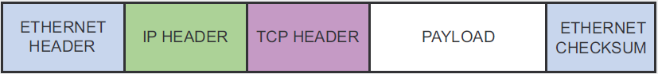

/* Ethernet addresses are 6 bytes */

#define ETHER_ADDR_LEN 6

/* Ethernet header */

struct sniff_ethernet {

u_char ether_dhost[ETHER_ADDR_LEN]; /* Destination host address */

u_char ether_shost[ETHER_ADDR_LEN]; /* Source host address */

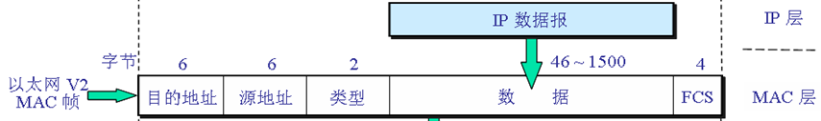

u_short ether_type; /* IP? ARP? RARP? etc */

};

/* IP header */

struct sniff_ip {

u_char ip_vhl; /* version << 4 | header length >> 2 */

u_char ip_tos; /* type of service */

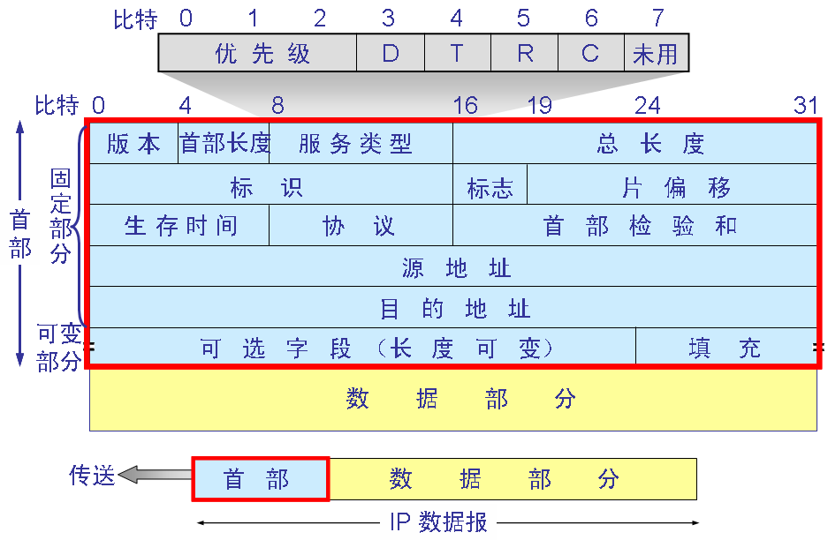

u_short ip_len; /* total length */

u_short ip_id; /* identification */

u_short ip_off; /* fragment offset field */

#define IP_RF 0x8000 /* reserved fragment flag */

#define IP_DF 0x4000 /* dont fragment flag */

#define IP_MF 0x2000 /* more fragments flag */

#define IP_OFFMASK 0x1fff /* mask for fragmenting bits */

u_char ip_ttl; /* time to live */

u_char ip_p; /* protocol */

u_short ip_sum; /* checksum */

struct in_addr ip_src,ip_dst; /* source and dest address */

};

#define IP_HL(ip) (((ip)->ip_vhl) & 0x0f)

#define IP_V(ip) (((ip)->ip_vhl) >> 4)

/* TCP header */

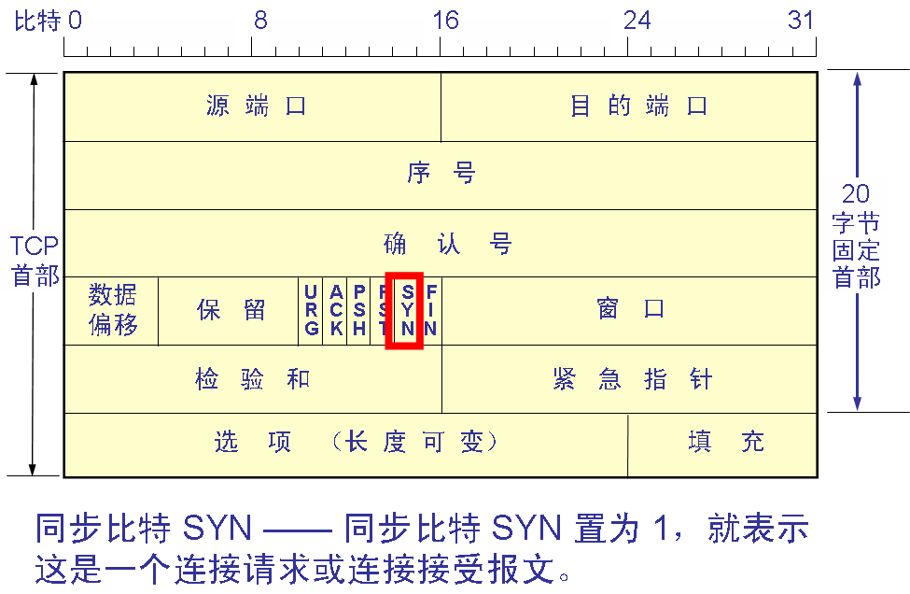

typedef u_int tcp_seq;

struct sniff_tcp {

u_short th_sport; /* source port */

u_short th_dport; /* destination port */

tcp_seq th_seq; /* sequence number */

tcp_seq th_ack; /* acknowledgement number */

u_char th_offx2; /* data offset, rsvd */

#define TH_OFF(th) (((th)->th_offx2 & 0xf0) >> 4)

u_char th_flags;

#define TH_FIN 0x01

#define TH_SYN 0x02

#define TH_RST 0x04

#define TH_PUSH 0x08

#define TH_ACK 0x10

#define TH_URG 0x20

#define TH_ECE 0x40

#define TH_CWR 0x80

#define TH_FLAGS (TH_FIN|TH_SYN|TH_RST|TH_ACK|TH_URG|TH_ECE|TH_CWR)

u_short th_win; /* window */

#include <sys/types.h>/usr/include/sys/types.h

#include <netinet/in.h> /usr/include/netinet/in.h

typedef uint32_t in_addr_t;

struct in_addr

{

in_addr_t s_addr;

};

u_short th_sum; /* checksum */

u_short th_urp; /* urgent pointer */

｝；

3.函数指针的使用

1）、简单函数指针的应用

格式： 返回类型（*函数名）（参数表）

例：char (*pFun)(int); 定义指针变量pFun, 它是一个指向某种函数的指针，函数参数是一个int型

返回值是char类型，但尚无法使用这个指针，因为还未对它进行赋值

char glFun(int a) {return ;} 定义了一个函数glFun()，它是一个以 int为参数，返回值是 char类型

从指针上理解函数：函数的函数名实际上就是一个指针，

函数名指向该函数的代码在内存中的首地址

void main()

{

pFun=glFun; 将函数glFun的地址赋值给变量pFun

(*pFun)(2); (*pFun)是取pFun所指向地址的内容，也就是取出函数glFun()的内容，

给定参数为2

}

2）. 使用typedef定义

原因：更加直观、方便

格式：typedef 返回类型 (*新类型)(参数表)

例：typedef char (*PTRFUN)(int); 定义了一种PTRFUN函数，并定义该类型为指向某种函数的指针

该函数以一个int为参数并返回char类型。后面的程序就可以使用

PTRFUN类型了

PTRFUN pFun; 使用新类型定义了变量pFun，此时就可以像使用简单函数指针一样使用

此变量

char glfun(int a) {return;}

void main()

{

pFun=glFun;

(*pFun)(2);

}