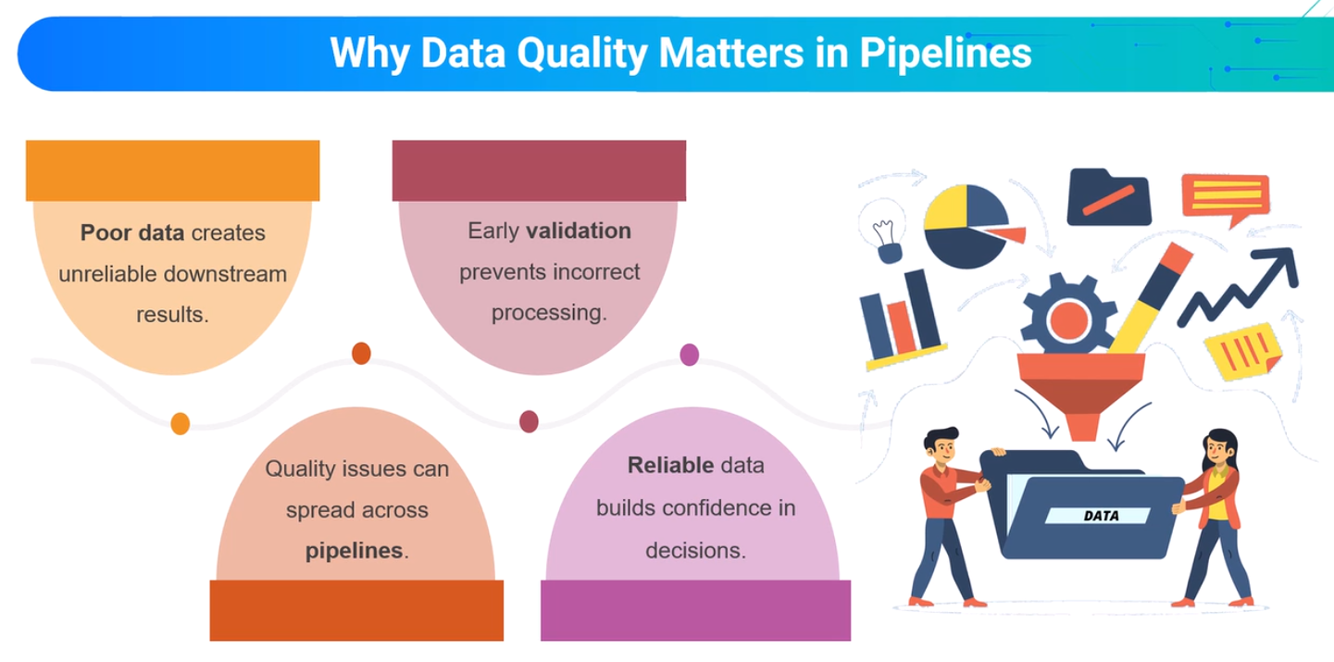
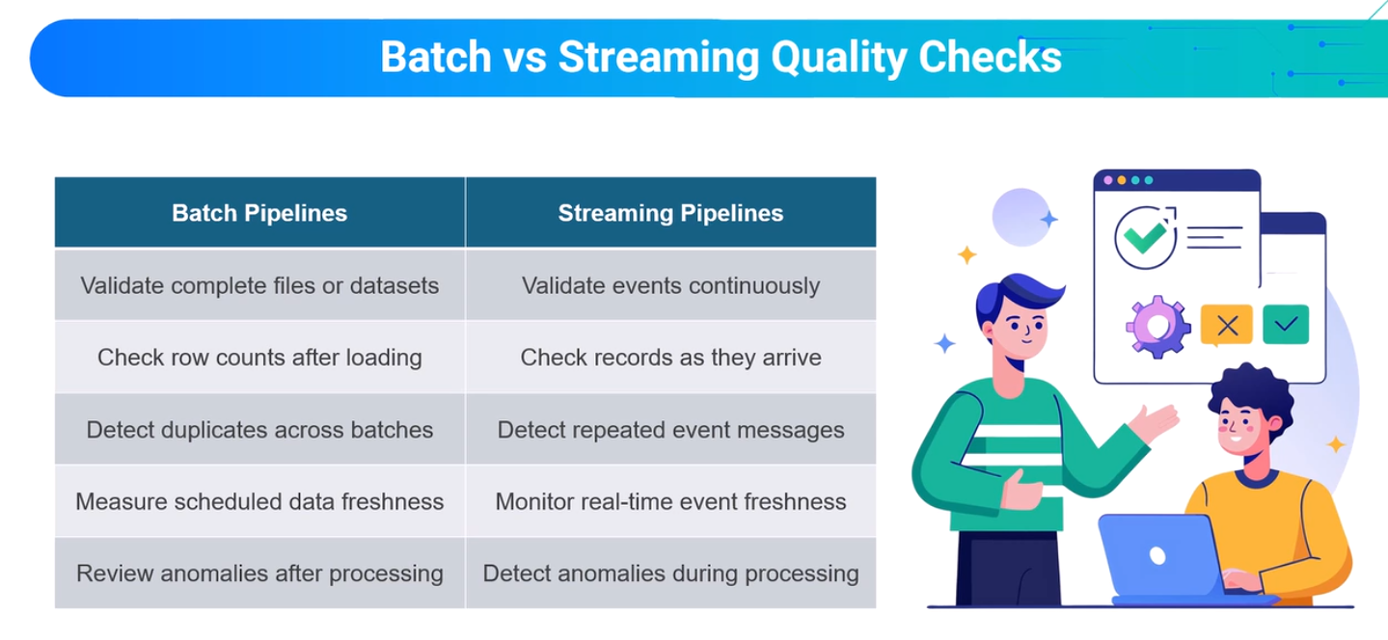

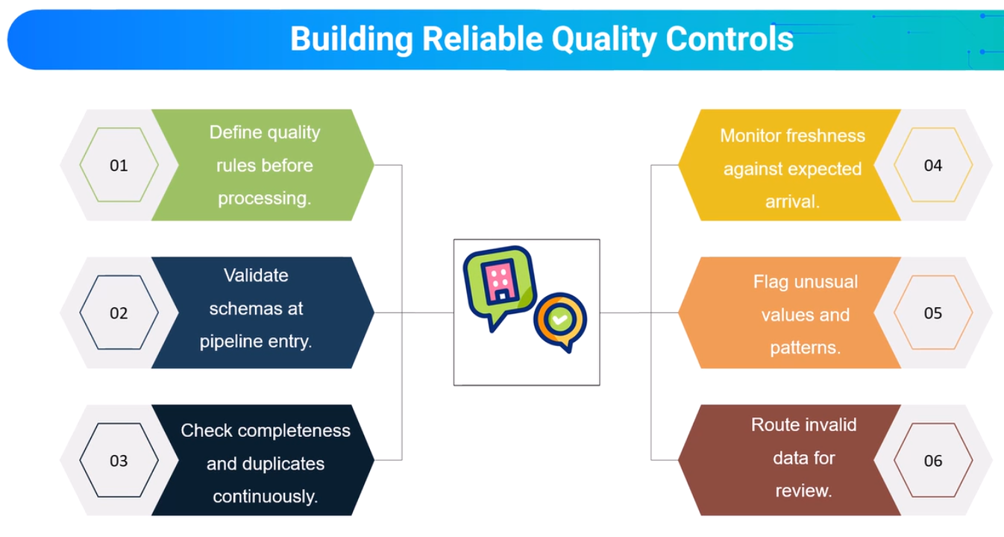

Dead-Letter Queues and Quarantine Patterns for Invalid Events

Introduction
Data quality is essential for building reliable batch and streaming pipelines. Even when a pipeline executes successfully, invalid or duplicated records can produce incorrect business results, misleading reports, and unreliable analytics.
Streaming systems continuously receive events from applications, devices, databases, and external services. Some events may contain missing fields, incorrect data types, invalid values, or unsupported formats. Others may fail because of temporary network or downstream system errors.
Simply discarding problematic events can cause data loss, while retrying them indefinitely can interrupt processing.
Dead-Letter Queues (DLQs) and quarantine patterns provide mechanisms for isolating problematic events while allowing valid data to continue through the pipeline.

1. Why Data Quality and Error Isolation Matter
A reliable data pipeline should not only process events efficiently but also ensure that downstream data remains accurate and trustworthy.
Poor-quality data can lead to:
- Incorrect financial calculations and business reports.
- Duplicate transactions and inflated revenue figures.
- Missing or inconsistent information.
- Failed transformations and unreliable aggregations.
- Incorrect dashboards, alerts, and automated decisions.
Early validation helps prevent these problems from spreading across downstream systems.
The main principle is:
A technically successful pipeline does not necessarily produce correct business results.

2. Core Data Quality Checks
Before processing or storing incoming events, pipelines should apply appropriate validation rules.
Quality Check | Purpose
Schema Validation | Verify that events follow the expected structure and data types.
Completeness | Ensure required fields are present and contain valid values.
Duplicates | Detect repeated transactions or events using appropriate identifiers.
Freshness | Confirm that data arrives within expected time limits.
Anomalies | Identify unusual values, patterns, or unexpected changes.
Business Rules | Validate transaction amounts, identifiers, statuses, and domain-specific conditions.
In batch pipelines, these checks are often performed after loading a complete dataset. In streaming pipelines, validation is performed continuously as events arrive.

3. Categories of Invalid Events
Different failures require different handling strategies.

Structural Failures
Events do not conform to the expected data format.
Examples:
- Missing required fields.
- Incorrect data types.
- Malformed JSON messages.
- Unsupported schema versions.

Business-Rule Failures
Events are structurally valid but violate business requirements.
Examples:
- Negative transaction amounts.
- Invalid order statuses.
- Missing or unknown product identifiers.
- Transactions outside permitted value ranges.

Processing Failures
Events cannot be processed because of application or infrastructure problems.
Examples:
- Transformation exceptions.
- Temporary database connection failures.
- Downstream service unavailability.
- Repeated processing timeouts.
Distinguishing between permanent validation failures and temporary processing failures is essential for selecting an appropriate recovery strategy.

4. Dead-Letter Queues and Quarantine Patterns
Both approaches isolate problematic records, but they typically address different operational needs.
Pattern | Primary Purpose | Typical Handling
Dead-Letter Queue (DLQ) | Preserve events that cannot be processed successfully. | Diagnose failures, correct the cause, and selectively retry.
Quarantine Storage | Isolate events that fail validation or do not meet data quality requirements. | Investigate, correct, approve, or reject before further processing.

Dead-Letter Queue (DLQ)
A DLQ stores events that cannot be successfully processed through the normal pipeline, often after a defined number of retry attempts.
In a Kafka-based architecture, a dedicated Kafka topic can serve as a DLQ.
For example:
- Main topic: orders
- Dead-letter topic: orders-dlq
A failed event can be redirected to the DLQ together with information explaining the failure.
This allows the main pipeline to continue processing valid events.

Quarantine Storage
Quarantine storage separates data that does not satisfy defined quality rules.
For example, an order with a negative transaction amount may be stored in a quarantine dataset instead of being included in financial aggregations.
Quarantined events can later be reviewed, corrected, and revalidated before being transferred into trusted datasets.
DLQs and quarantine storage are complementary patterns, and their responsibilities may overlap depending on the system design.

5. Preserving Failure Context
Saving only the original event is often insufficient for effective troubleshooting.
A failed-event record should preserve relevant metadata whenever possible.
Metadata | Purpose
Event ID | Identify the original event.
Original Payload | Preserve the received event for investigation.
Failure Reason | Explain why processing or validation failed.
Failure Category | Distinguish structural, business-rule, and processing failures.
Source Topic and Partition | Identify where the Kafka event originated.
Kafka Offset | Identify the record position within its partition.
Event Timestamp | Record when the event originally occurred.
Processing Timestamp | Record when the failure was detected.
Retry Count | Track repeated processing attempts.
Schema Version | Identify the expected event format.
This information supports debugging, operational monitoring, auditing, and controlled reprocessing.
Sensitive information should be protected according to the system's data security and retention requirements.

6. Recommended Processing Workflow
A reliable streaming pipeline can use the following workflow:
- Ingest: Receive incoming events from Kafka or another source.
- Validate: Check schema, completeness, duplicates, and business rules.
- Process valid events: Continue normal filtering, enrichment, and aggregation.
- Retry temporary failures: Apply bounded retries with an appropriate delay.
- Isolate failed events: Route unresolved processing failures to a DLQ and invalid data to quarantine storage.
- Preserve metadata: Store the failure reason and relevant event context.
- Investigate and correct: Resolve the underlying data or processing problem.
- Revalidate and reprocess: Replay only appropriate events using controlled recovery procedures.
This design allows healthy streaming traffic to continue without silently discarding problematic data.

7. Controlled Reprocessing and Reliability
Failed events should not automatically return to the main pipeline without investigation.
Repeatedly processing an unchanged invalid event may create a poison-message problem, where the same event continuously fails and consumes processing resources.
A safer recovery process includes:
- Identifying the root cause.
- Correcting invalid data or application logic.
- Revalidating the affected events.
- Reprocessing only eligible records.
- Preventing duplicate output through idempotent writes.
- Monitoring whether previously failed records have been handled successfully.
For example, when writing processed transactions to PostgreSQL, unique business identifiers and UPSERT operations can help prevent duplicate records during replay.
Spark checkpoints support the recovery of streaming progress and state, while idempotent output operations protect downstream systems from duplicate results.
Checkpointing and DLQ handling address different reliability concerns and should be designed together.

8. Monitoring and Operational Controls
Monitoring should cover both successful processing and rejected events.
Useful operational metrics include:
Metric | Description
Validation Failure Rate | Percentage of events rejected by quality checks.
Duplicate Rate | Percentage of identified duplicate records.
DLQ Message Count | Number of failed events awaiting investigation.
Quarantine Volume | Number of records isolated due to data quality issues.
Retry Count | Number of processing retries.
Event Freshness | Delay between event generation and processing.
Processing Latency | Time required to process incoming events.
Alerts can be configured when error rates, processing delays, or DLQ backlogs exceed acceptable thresholds.
These controls help engineers identify upstream problems before they affect business reporting and decision-making.

9. Practical Example: Kafka and Spark Structured Streaming
Consider a real-time order processing pipeline:
Python Producer → Apache Kafka → Spark Structured Streaming → PostgreSQL / Reporting
Incoming order events are validated before being included in downstream calculations.
- A valid order is processed normally and included in sales reporting.
- An order missing a required identifier is redirected to quarantine.
- An order with an invalid negative amount is rejected by business-rule validation.
- A temporarily unavailable downstream database triggers controlled retries.
- A repeatedly failing event may be redirected to a DLQ for investigation.
- Corrected events can be reprocessed with safeguards against duplicate writes.
This approach protects revenue calculations, operational dashboards, and analytical reports from incorrect source data.

Conclusion
Reliable streaming pipelines require more than successful event delivery and processing.
Data quality checks detect invalid, incomplete, duplicated, and anomalous records. Dead-Letter Queues preserve events that cannot be processed successfully, while quarantine patterns isolate data requiring additional validation or review.
Combined with checkpoints, controlled retries, idempotent writes, and monitoring, these patterns help engineers:
- Prevent invalid data from contaminating trusted datasets.
- Preserve problematic events for investigation.
- Avoid unnecessary interruption of healthy data processing.
- Recover safely after failures.
- Maintain accurate and trustworthy downstream reporting.
Key takeaway: A resilient data pipeline must protect both processing continuity and data correctness.

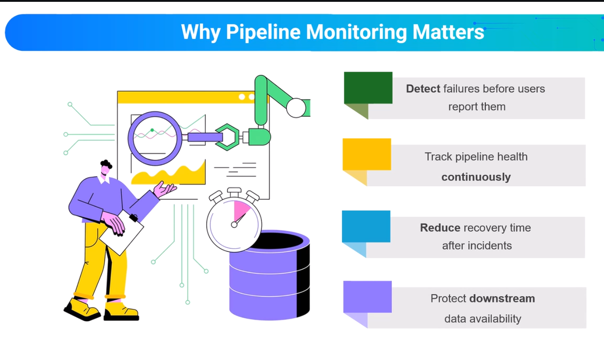

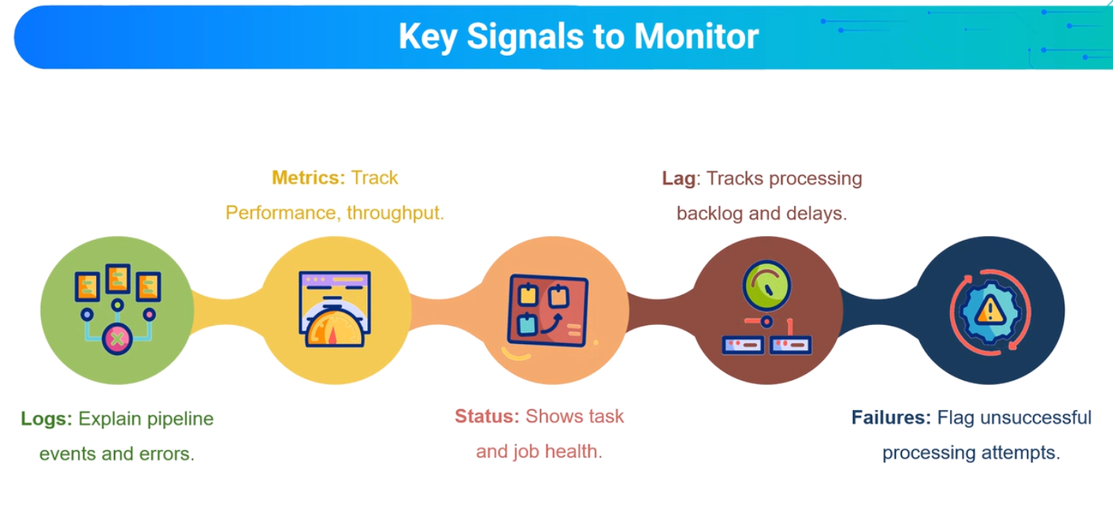

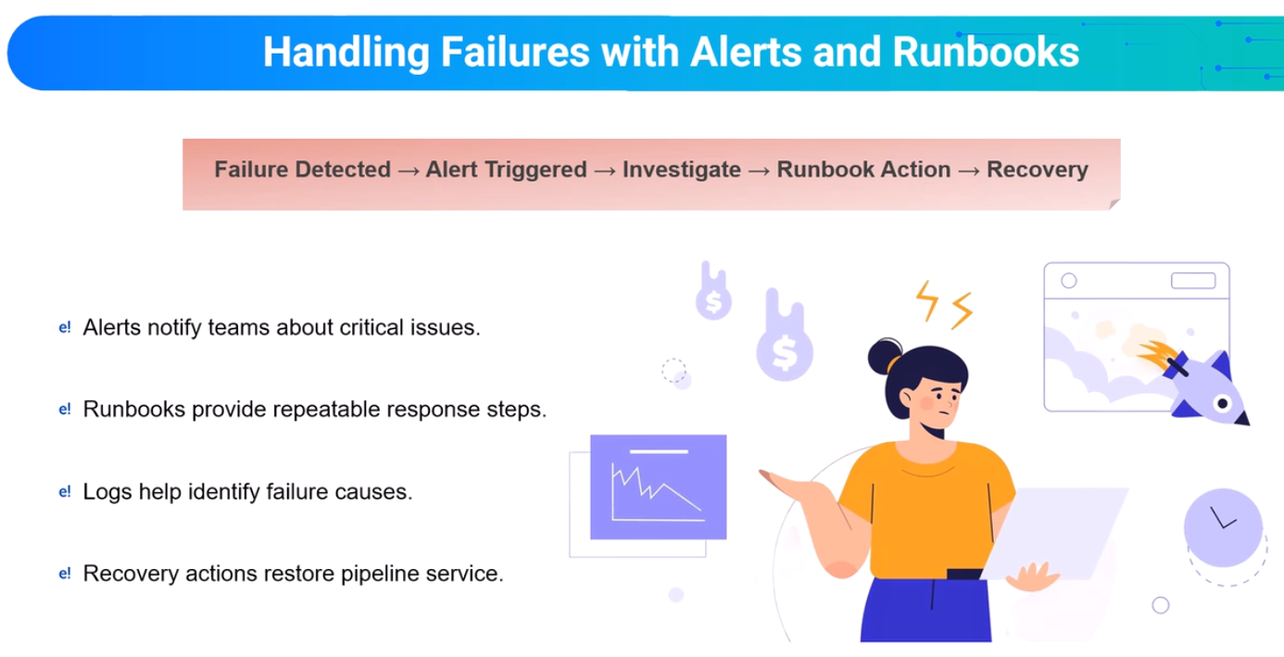

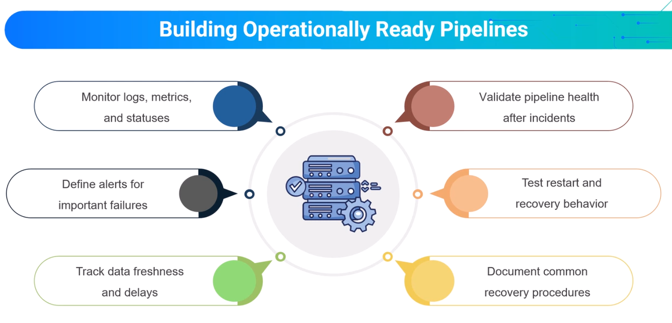

Backpressure, Consumer Lag, and Streaming Capacity Planning

Introduction
Streaming data pipelines are designed to process events continuously. However, incoming data does not always arrive at a constant rate. Traffic can increase during peak business hours, promotional campaigns, application releases, or unexpected system activity.
When events arrive faster than they can be processed, a processing backlog begins to grow. This can lead to increased latency, delayed analytics, and reduced pipeline performance.
Understanding backpressure, consumer lag, and capacity planning helps data engineers identify processing bottlenecks and ensure that streaming systems can handle changing workloads.

1. Processing Capacity Under Changing Workloads
Every streaming system has a limited processing capacity.
Two important metrics are:
- Arrival Rate: The number of incoming events per second or during a defined period.
- Processing Rate: The number of events successfully processed during the same period.
The relationship between these metrics determines whether the pipeline can keep up with incoming traffic.
Condition | Pipeline Behaviour
Processing Rate > Arrival Rate | The pipeline has available processing capacity and can reduce an existing backlog.
Processing Rate = Arrival Rate | The pipeline can keep pace but has limited spare capacity.
Processing Rate < Arrival Rate | Unprocessed events accumulate, increasing backlog and latency.
Temporary traffic spikes may be acceptable if the pipeline can recover afterward.
However, a sustained difference between the arrival and processing rates indicates a potential capacity bottleneck.

2. Consumer Lag as an Operational Signal
In Apache Kafka, consumer lag measures how far a consumer group is behind the latest available records in a topic partition.
It is determined by comparing the latest available offsets with the consumer group's committed progress.
Consumer lag is an important indicator of streaming processing performance.

Interpreting Consumer Lag
Observed Pattern | Operational Meaning
Low and stable lag | Consumers are generally keeping pace with incoming events.
Lag rises briefly, then falls | A temporary workload spike is being processed successfully.
Lag continuously increases | Incoming events may exceed the available processing capacity.
Lag remains high and unchanged | Consumer processing may be stalled or unable to advance.
Lag varies across partitions | Workload distribution or processing performance may be uneven.
Consumer lag should be monitored over time, rather than interpreted from a single measurement.
A growing lag does not always mean insufficient CPU resources. It may also indicate slow transformations, downstream database delays, processing errors, or unbalanced Kafka partitions.

3. Understanding Backpressure
Backpressure occurs when downstream processing cannot keep up with the rate of incoming events.
A bottleneck can appear at different stages of the pipeline:
- Kafka Consumption: Consumers cannot read incoming events quickly enough.
- Spark Processing: Transformations or aggregations require more processing time.
- Stateful Operations: Maintaining large aggregation states increases resource consumption.
- External Services: Network calls or APIs delay processing.
- Output Sinks: Databases or storage systems cannot accept results quickly enough.
Backpressure is therefore a problem affecting the entire streaming architecture, not only Kafka.

Common Warning Signals
Monitoring Signal | Possible Problem
Increasing Consumer Lag | Consumers are falling behind incoming events.
Increasing Processing Latency | Events require more time to complete processing.
Growing Processing Queues | Work is accumulating faster than it can be completed.
High CPU Utilization | Processing resources may be saturated.
High Memory Utilization | Large state or excessive buffering may affect performance.
Slow Sink Writes | Downstream storage may be the bottleneck.
Delayed Business Reports | Processed information is becoming less current.
Monitoring several signals together helps identify the actual cause of performance problems.

4. Streaming Capacity Planning
Capacity planning ensures that a streaming pipeline can support expected workloads while maintaining acceptable processing delays.
An effective capacity plan should consider:
- Normal and Peak Traffic: Estimate event volumes during typical and high-load periods.
- Processing Throughput: Determine how many events the pipeline can process within a given time.
- Kafka Partitions: Evaluate whether the partition configuration supports the required parallelism.
- Compute Resources: Monitor available CPU, memory, and processing capacity.
- Stateful Processing: Account for windowed aggregations and state management requirements.
- Output Sink Performance: Ensure databases and storage systems can handle incoming results.
- Workload Growth: Plan for increased event volumes and future system expansion.
Capacity should include reasonable headroom rather than being designed only for average traffic.

5. Approaches to Improving Streaming Capacity
When a pipeline experiences sustained processing delays, several improvements may be considered.
Approach | Purpose
Increase Processing Resources | Provide additional CPU and memory where appropriate.
Optimize Transformations | Reduce unnecessary calculations and expensive processing operations.
Adjust Parallelism | Improve the distribution of processing tasks.
Review Kafka Partitioning | Address uneven partition workloads and support appropriate consumer parallelism.
Optimize Stateful Operations | Limit unnecessary state retention and use suitable window and watermark configurations.
Improve Sink Performance | Reduce delays caused by database writes or external services.
Implement Monitoring and Alerts | Detect growing backlogs before they affect downstream systems.
Scaling should be based on the actual bottleneck.
For example, increasing the number of Kafka partitions may improve parallelism, but it will not automatically solve a problem caused by a slow downstream database.

6. Operational Monitoring
A production streaming pipeline should expose metrics that help engineers detect performance degradation.
Important monitoring indicators include:
- Consumer Lag: How far consumers are behind incoming Kafka records.
- Throughput: Number of events processed per second.
- Processing Latency: Time required to process events or batches.
- CPU and Memory Usage: Resource consumption of processing components.
- Error Rate: Frequency of processing failures.
- Data Freshness: How current the processed information is.
- Sink Performance: Time required to write processed results.
Monitoring dashboards, logs, and automated alerts help teams understand the condition of a pipeline and respond before processing delays become critical.

7. Practical Application: Kafka and Spark Structured Streaming
Consider the following architecture:
Python Producer → Apache Kafka → Spark Structured Streaming → PostgreSQL / Reporting
The Python Producer generates events and sends them to Kafka. Spark Structured Streaming consumes and processes these events before writing the results to a downstream database.
If the event arrival rate becomes higher than Spark's effective processing rate, unprocessed Kafka events may accumulate.
The engineering team should investigate:
- Whether incoming traffic has increased.
- Whether Spark micro-batches require more processing time.
- Whether CPU or memory resources are saturated.
- Whether stateful transformations are slowing processing.
- Whether PostgreSQL or another output sink is creating a bottleneck.
Based on these observations, engineers can optimize transformations, adjust resources, improve parallelism, or address downstream performance issues.
The objective is to maintain reliable event processing without continuously increasing backlog or delaying business reports.

Conclusion
Reliable streaming pipelines must adapt to changing workloads while maintaining acceptable processing latency.
Consumer lag helps identify whether Kafka consumers are keeping up with incoming events, while backpressure indicates that processing demand exceeds available capacity somewhere in the pipeline.
Capacity planning helps engineers prepare for normal traffic, temporary spikes, and future workload growth.
By monitoring throughput, processing latency, consumer lag, resource utilization, and downstream performance, data engineers can identify bottlenecks early and maintain scalable, responsive streaming systems.
Key takeaway: A streaming pipeline is operationally reliable when it can process incoming events at a sustainable rate, detect growing backlogs, and recover from temporary increases in workload without unacceptable delays.

