https://www.coursera.org/account/accomplishments/verify/TMXVQG6AQ8Q9

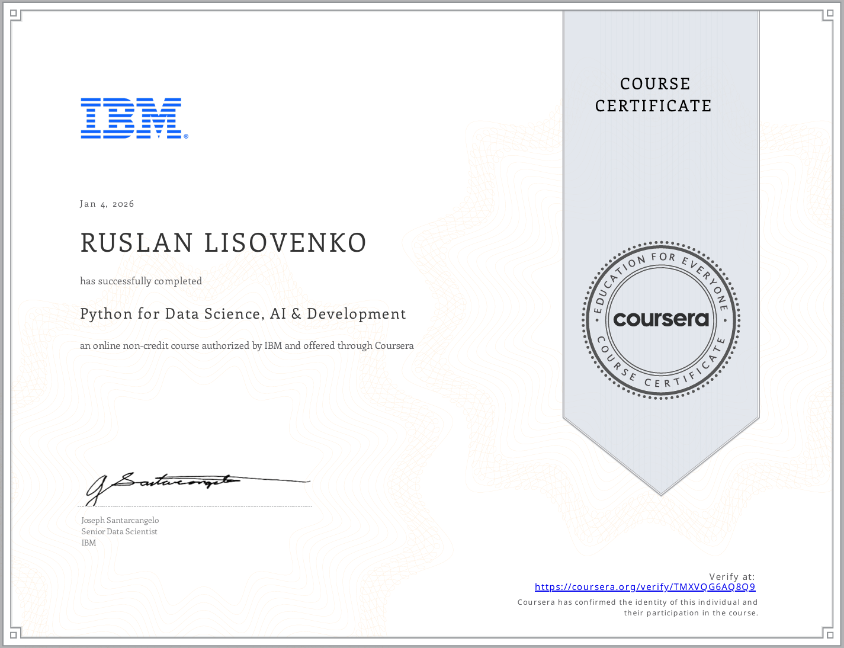

Python for Data Science, AI & Development
What I Learned
- Python Fundamentals: Syntax, data types, variables, expressions, and string operations.
- Programming Logic: Conditional statements, loops, functions, and exception handling.
- Object-Oriented Programming (OOP): Classes, objects, and fundamental OOP concepts.
- Data Analysis: Data manipulation and processing using Pandas and NumPy.
- Jupyter Notebooks: Interactive Python development and data exploration.
- REST APIs: Accessing and retrieving web-based data using Python Requests.
- Web Scraping: Extracting and processing information from websites using BeautifulSoup.
Key Skills: Python · Pandas · NumPy · Data Analysis · OOP · Jupyter · REST APIs · Requests · BeautifulSoup · Web Scraping

https://coursera.org/verify/7BWLGQVD8W65

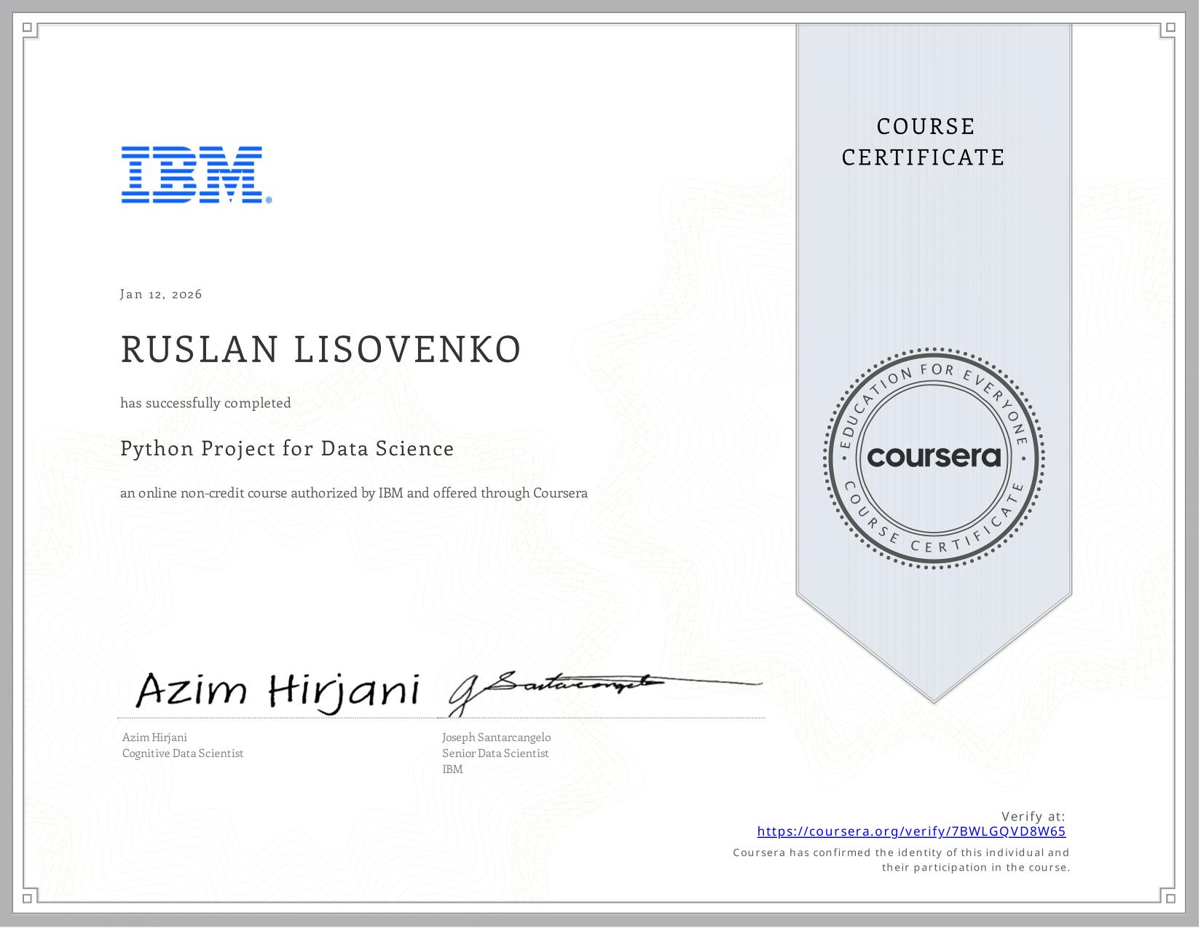

IBM — Python Project for Data Science
What I Learned
- Practical Data Science: Apply Python to real-world data science and data analysis projects.
- Python Programming: Use Python fundamentals, data structures, and data processing techniques.
- Data Collection: Extract and process web-based information using BeautifulSoup.
- Data Analysis: Clean, manipulate, and analyze datasets using Pandas.
- Data Visualization: Create interactive charts and visualizations using Plotly.
- Dashboard Development: Build data dashboards to present analytical results.
- Jupyter Notebooks: Develop and document practical data science workflows.
Key Skills: Python · Pandas · BeautifulSoup · Web Scraping · Data Analysis · Data Visualization · Plotly · Dashboard Development · Jupyter

https://www.coursera.org/account/accomplishments/verify/0AOWRHFFFMZ0

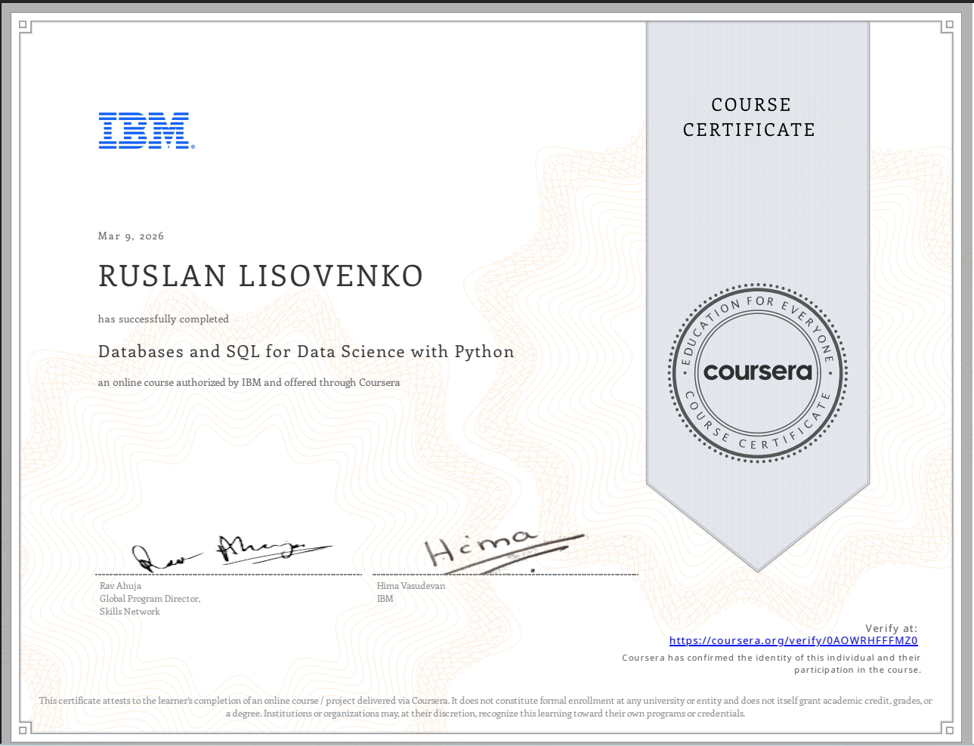

SQL and Python — Database Management & Data Analysis
What I Learned
- SQL & Python: Analyze and manipulate data stored in relational databases.
- Database Design: Create relational databases and manage multiple tables using DDL commands.
- SQL Queries: Write basic and intermediate queries using DML commands.
- Advanced SQL: Work with JOINs, views, transactions, and stored procedures.
- Data Analysis: Retrieve, process, and analyze structured data using SQL and Python.
- Jupyter: Use notebooks for database operations and data analysis.
Key Skills: SQL · Python · Relational Databases · DDL/DML · JOINs · Views · Stored Procedures · Transactions · Data Analysis · Jupyter

https://www.coursera.org/account/accomplishments/verify/5G09WGTTZWKY

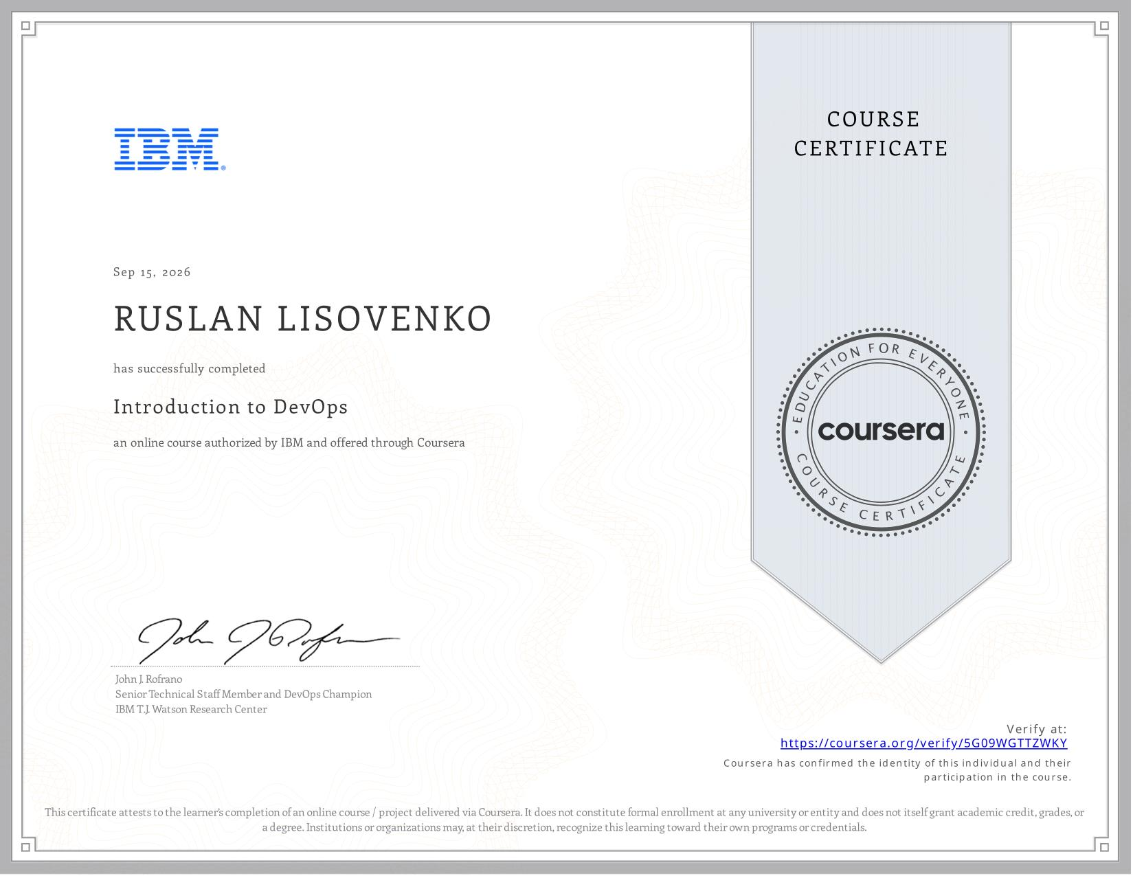

IBM — Introduction to DevOps
What I Learned
- DevOps Fundamentals: Shared responsibility, transparency, collaboration, and continuous improvement.
- CI/CD Practices: Continuous Integration, Continuous Delivery, and automated deployment.
- Software Engineering: Cloud-native microservices, resilient applications, and development practices.
- Development Methodologies: Test-Driven Development (TDD) and Behavior-Driven Development (BDD).
- Infrastructure as Code (IaC): Principles of automated infrastructure management.
- DevOps Culture: Breaking down organizational silos and building cross-functional teams.
Key Skills: DevOps · CI/CD · IaC · Microservices · TDD · BDD · Agile Collaboration

https://www.coursera.org/account/accomplishments/verify/WP3AMFQCVSPI

