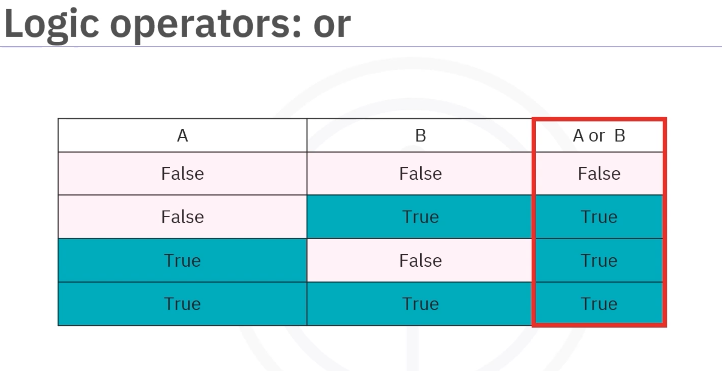

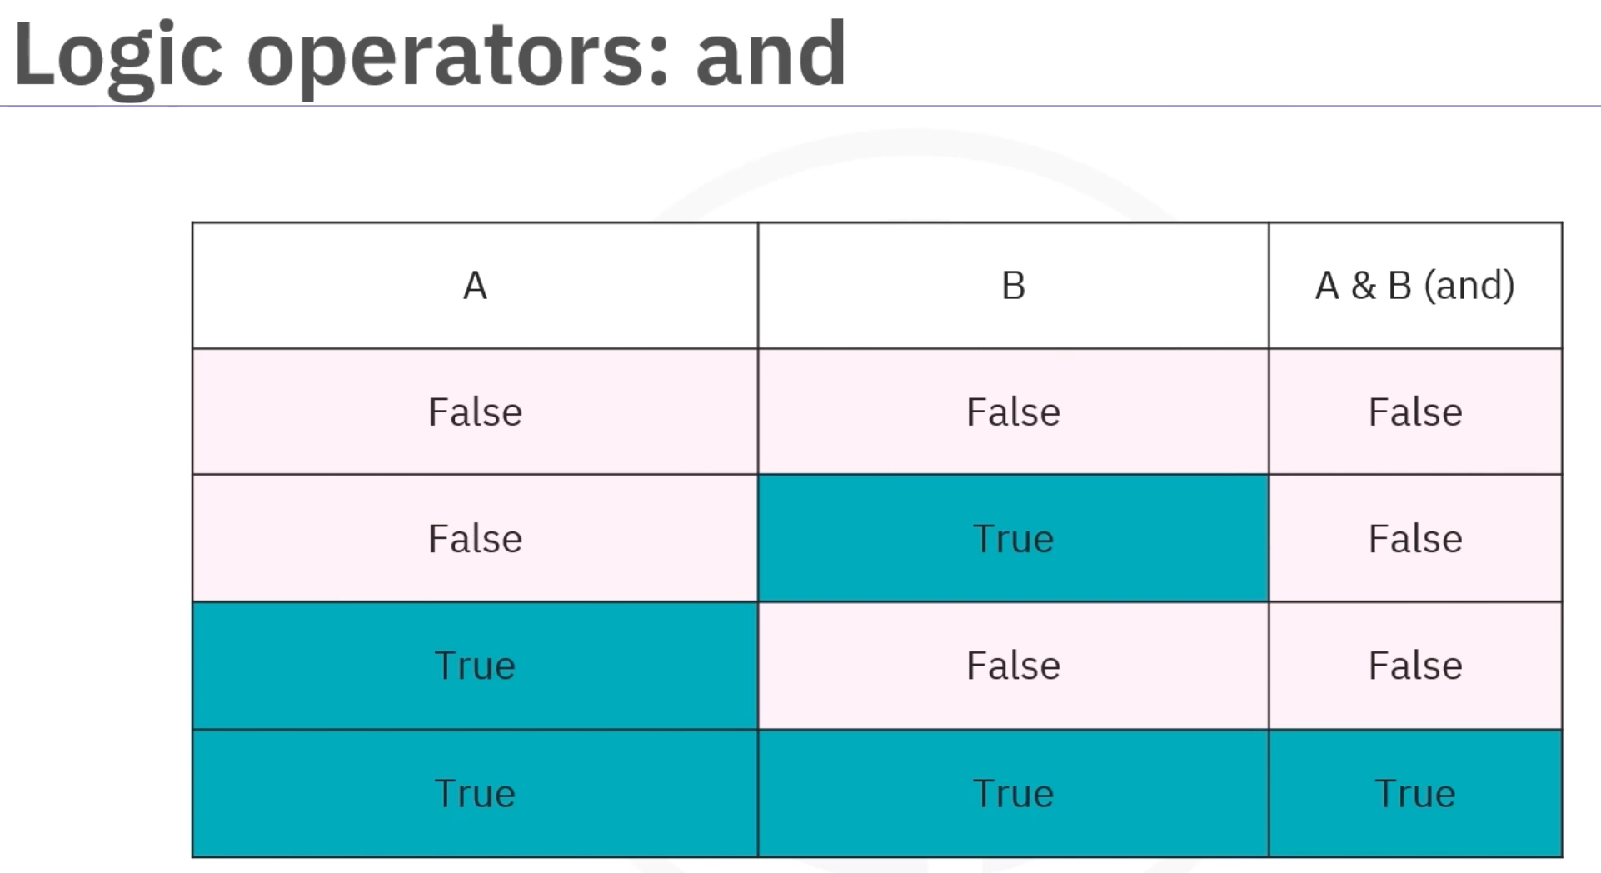

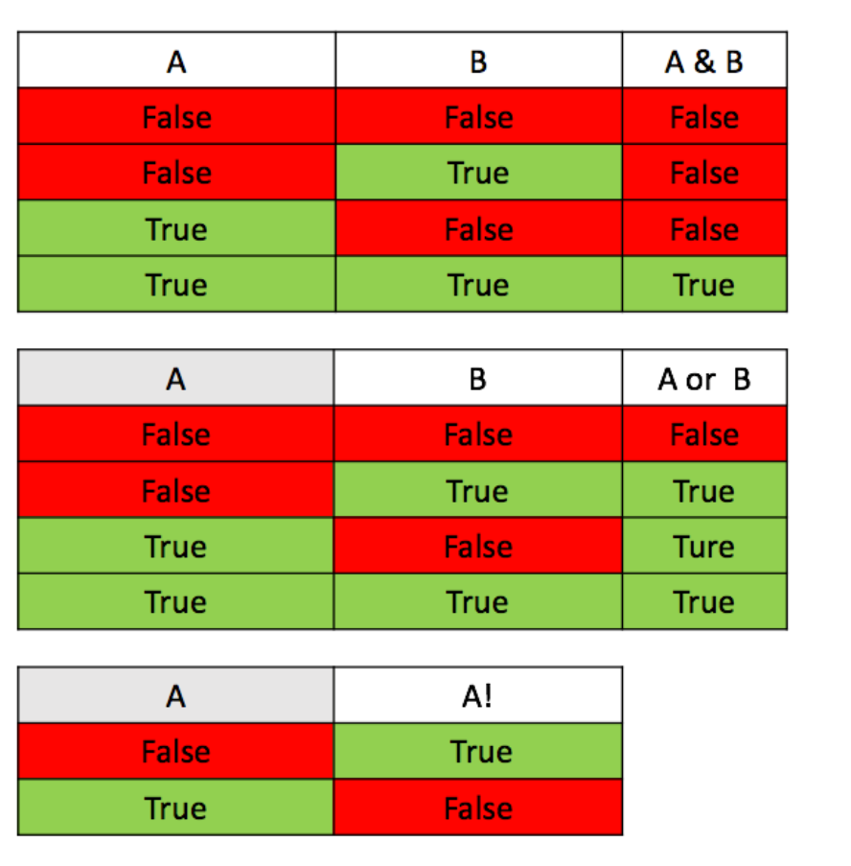

To many argument in Func

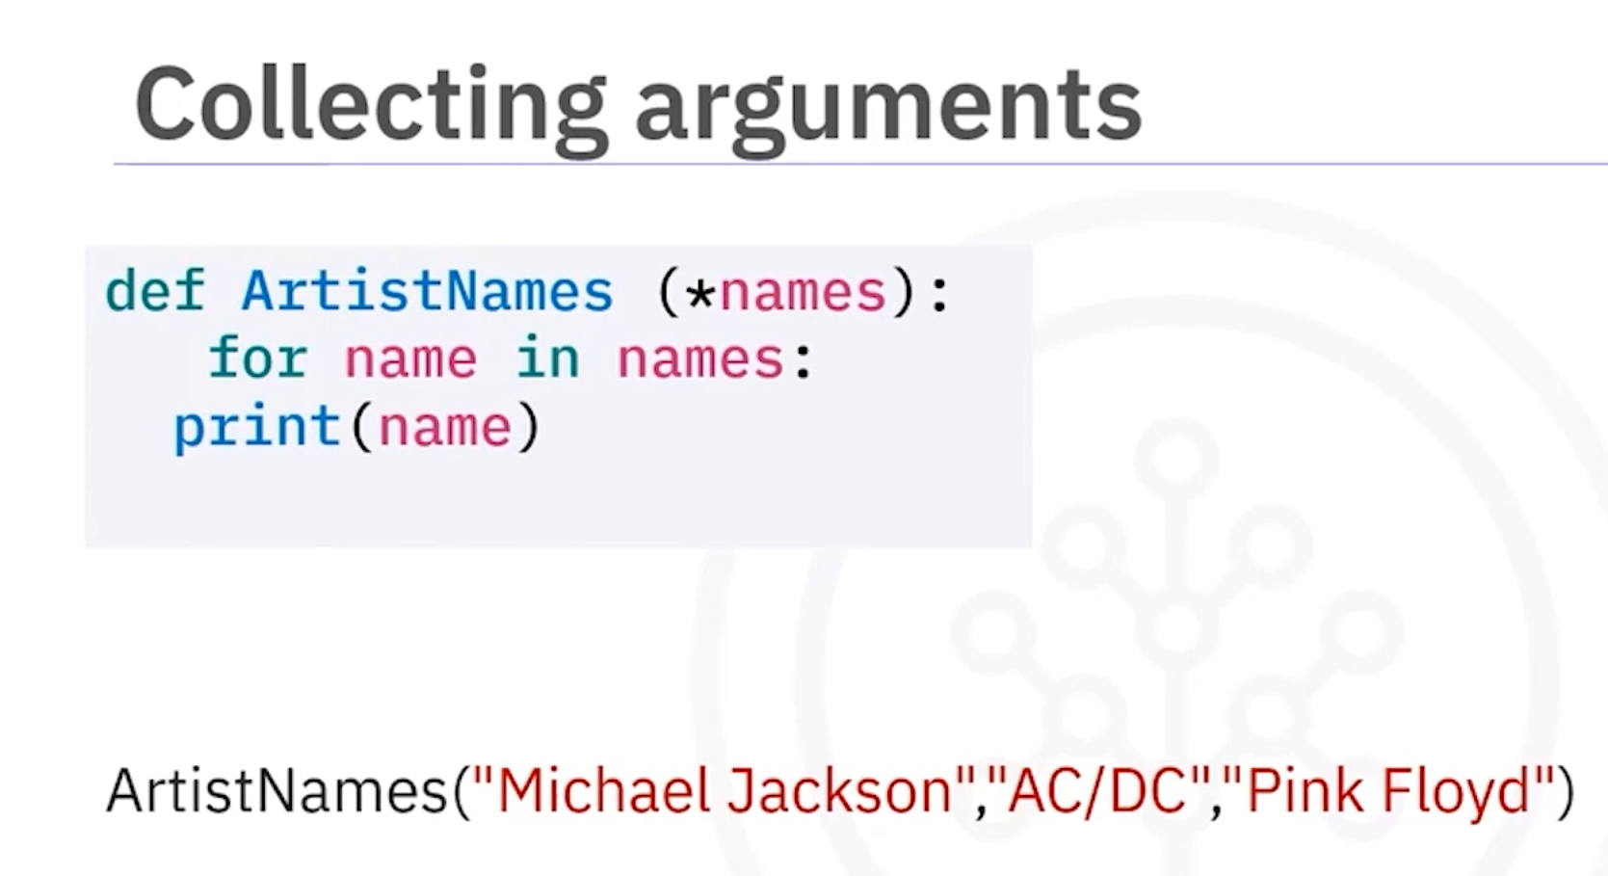

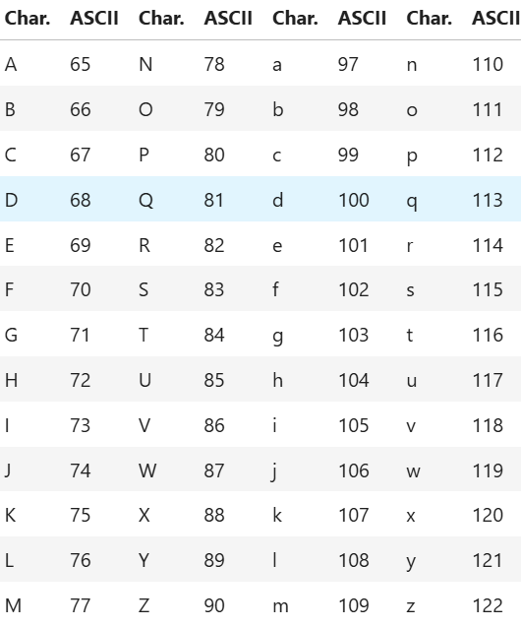

Pandas
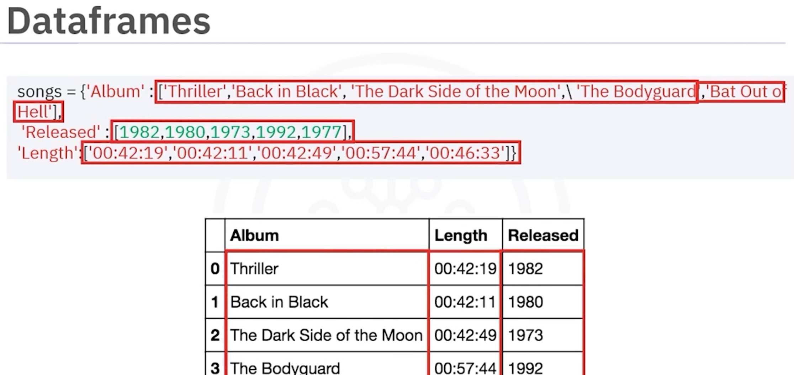

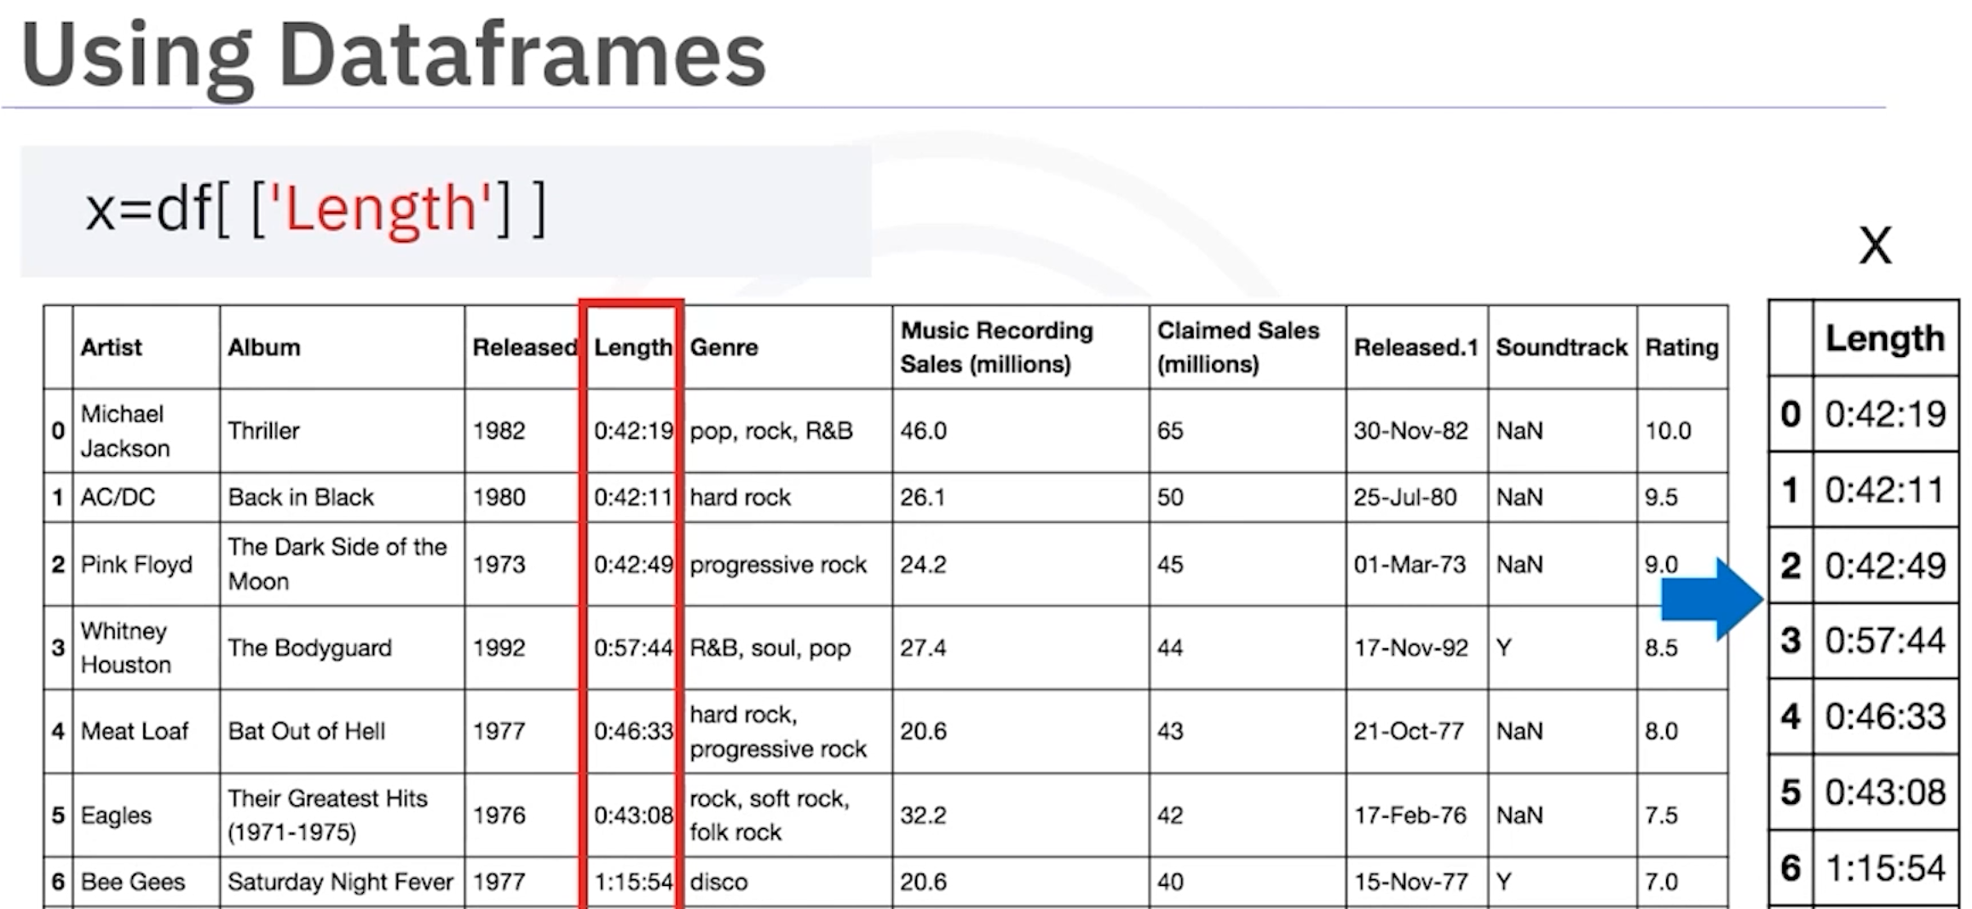––

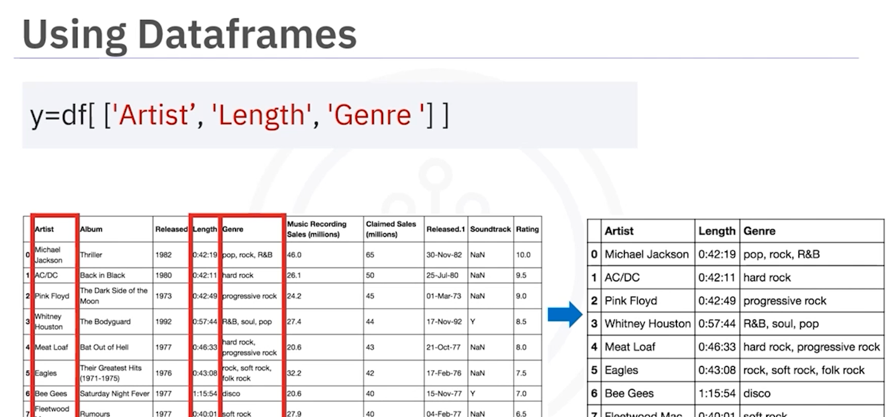

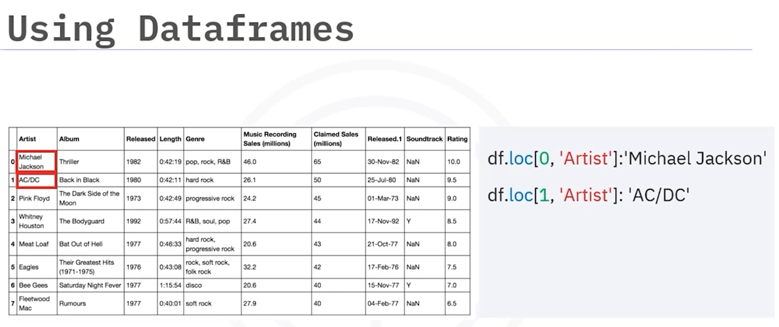.
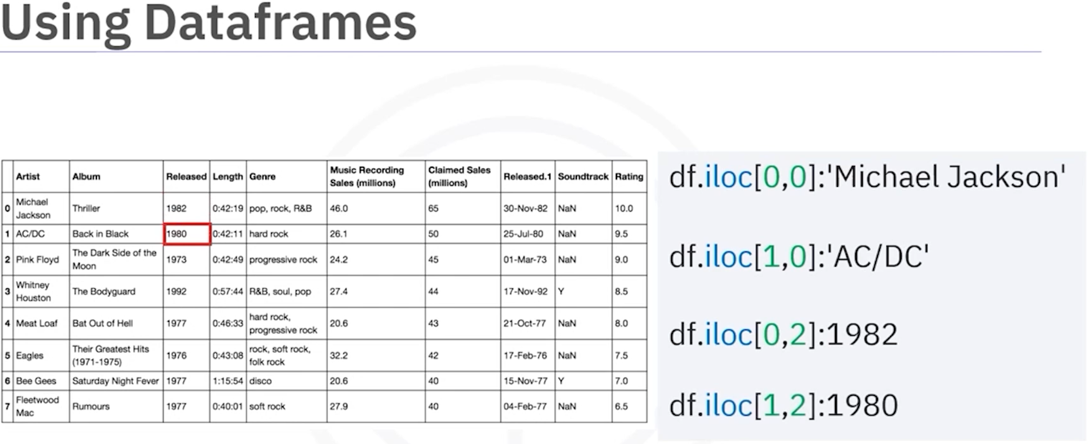
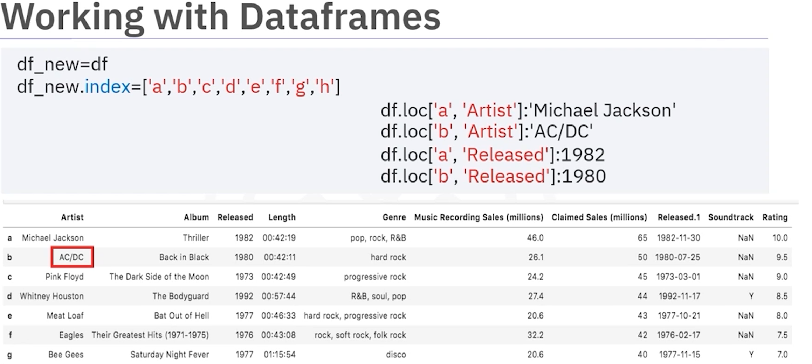
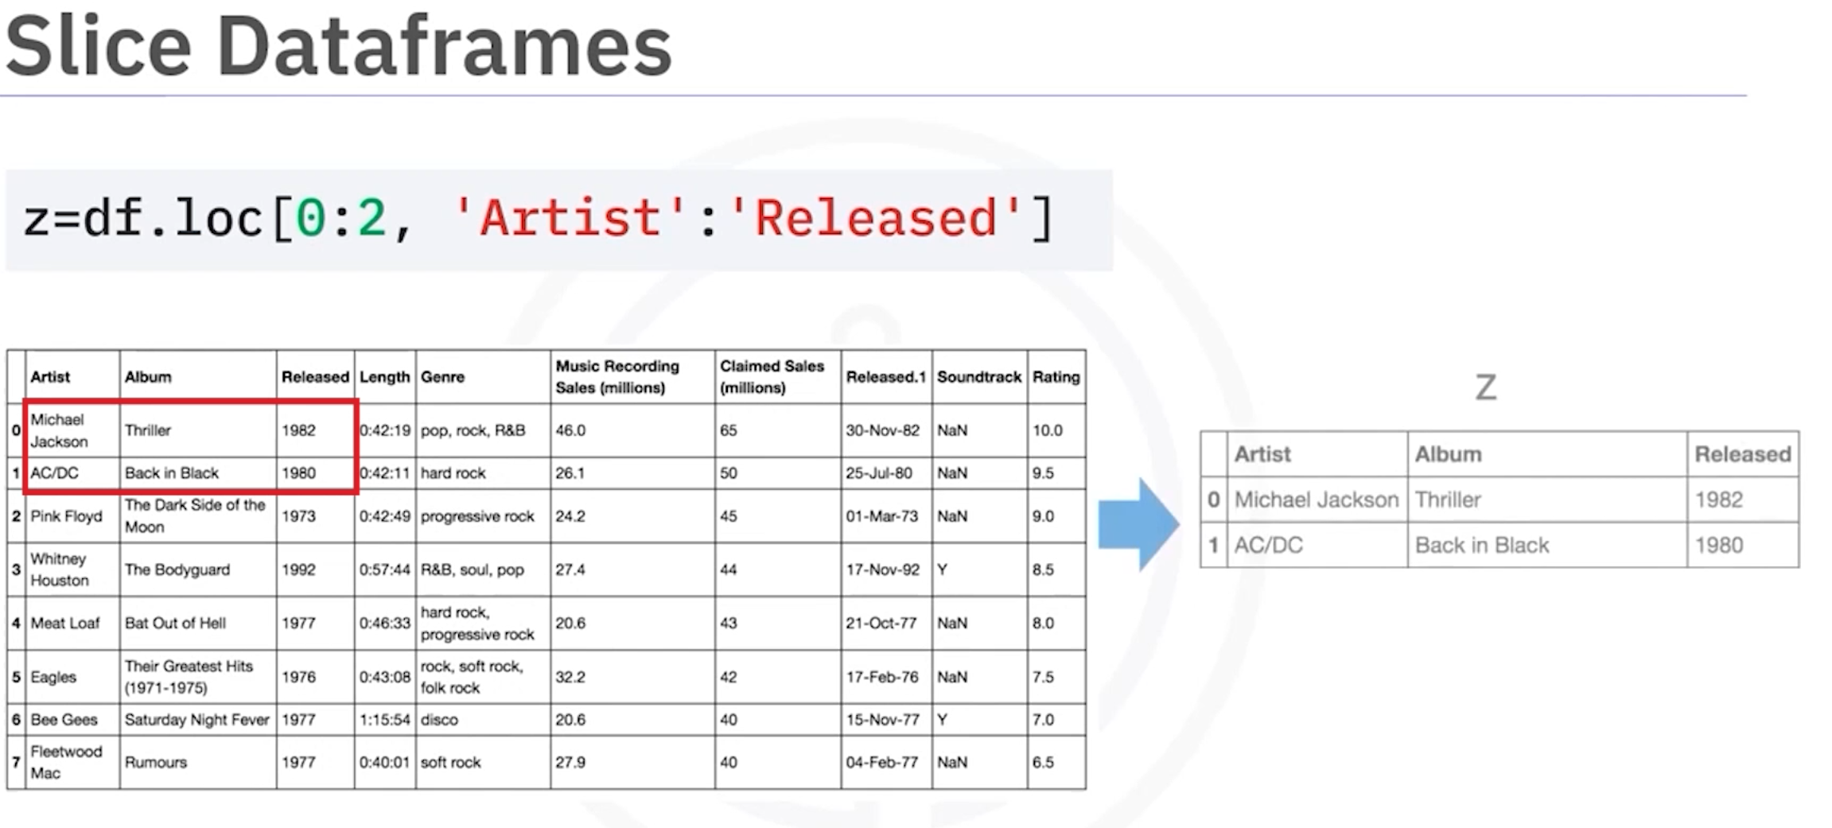
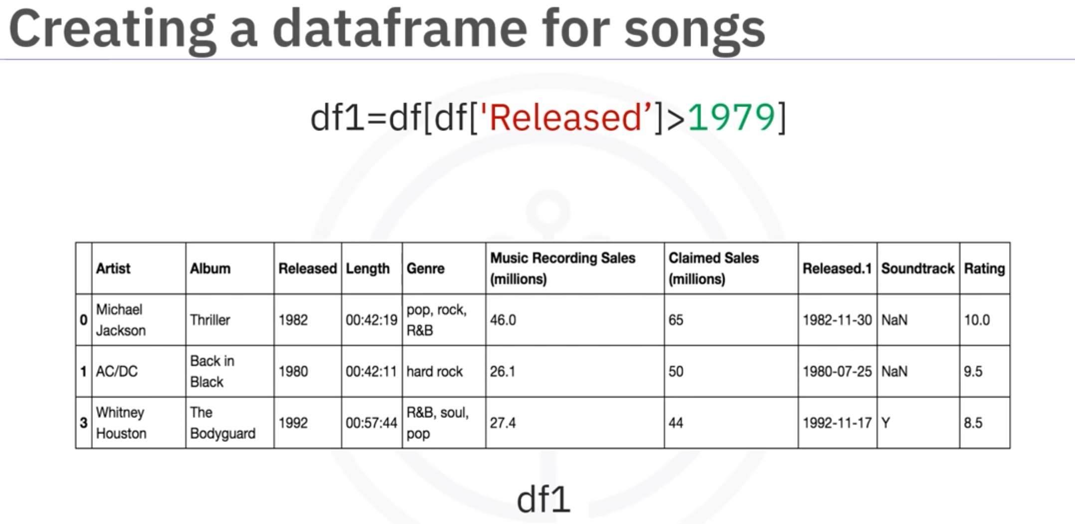

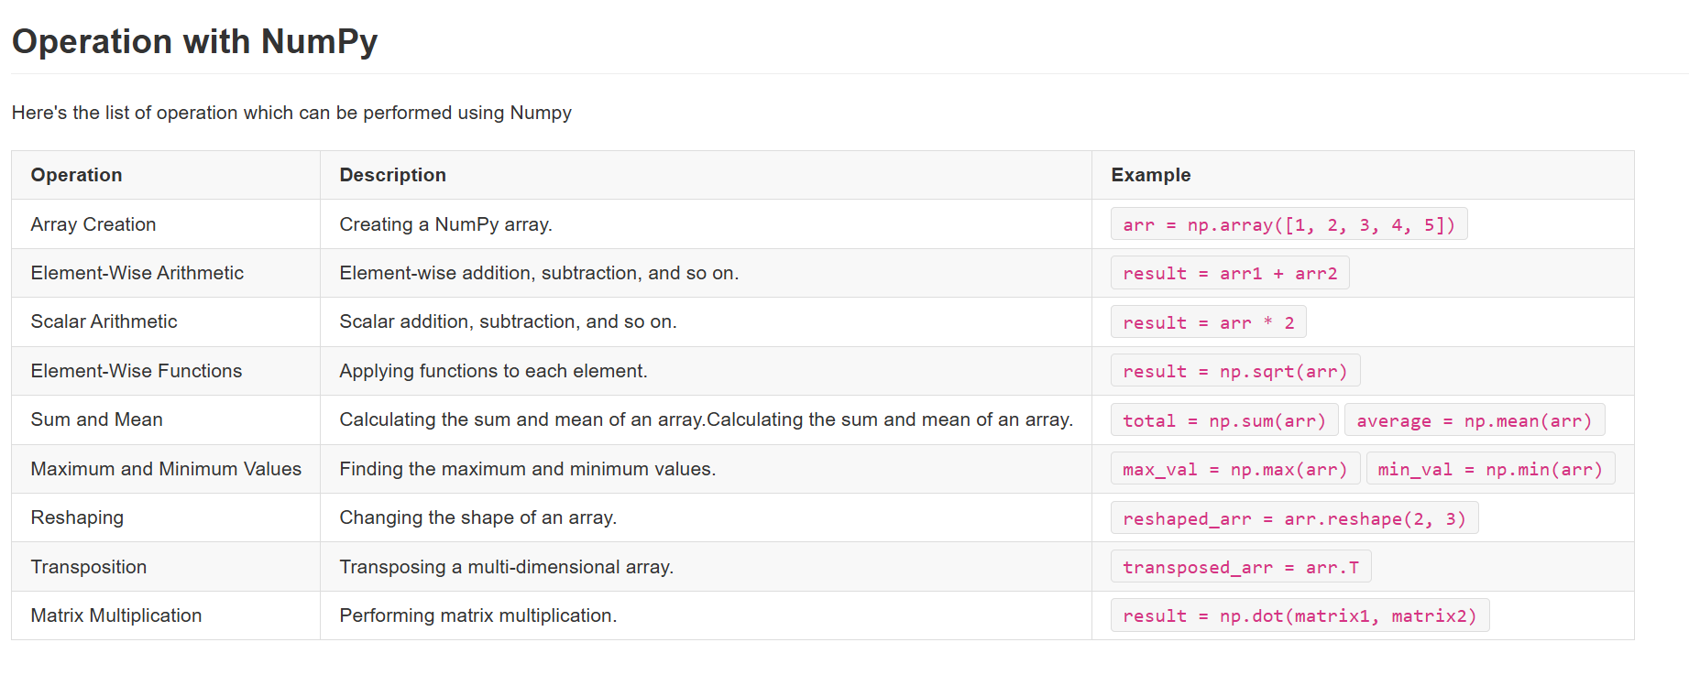

Module 5 http
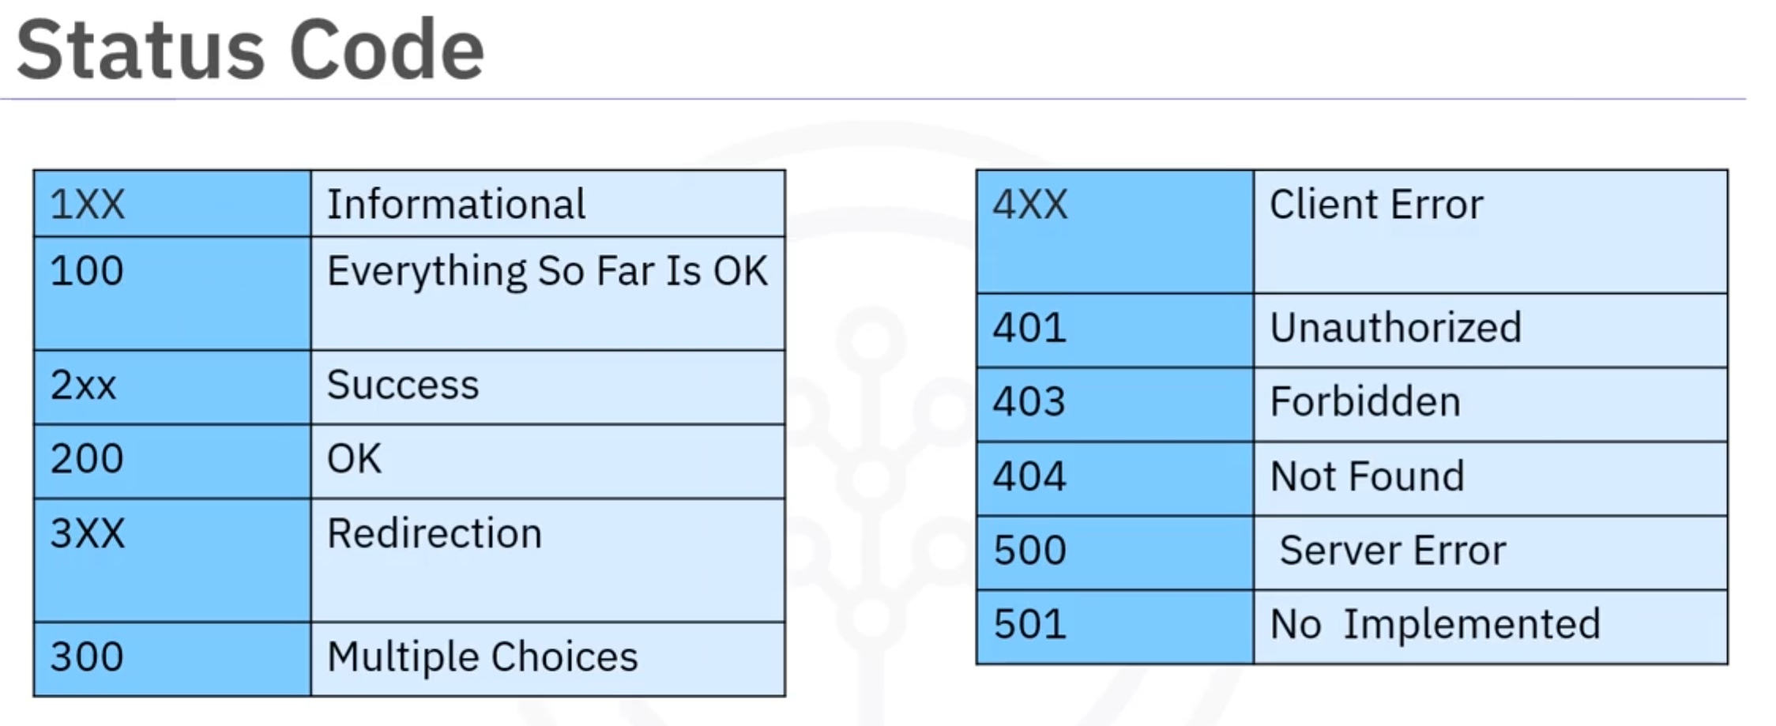

Example 1: RandomUser API
Bellow are Get Methods parameters that we can generate. For more information on the parameters, please visit this documentation page.

Get Methods
- get_cell()
- get_city()
- get_dob()
- get_email()
- get_first_name()
- get_full_name()
- get_gender()
- get_id()
- get_id_number()
- get_id_type()
- get_info()
- get_last_name()
- get_login_md5()
- get_login_salt()
- get_login_sha1()
- get_login_sha256()
- get_nat()
- get_password()
- get_phone()
- get_picture()
- get_postcode()
- get_registered()
- get_state()
- get_street()
- get_username()
- get_zipcode()

