New York University

Database Systems - CSCI-GA.2433-001
Ronojoy Mitra

Database Systems Project Part IV – End-to-End Solution Integration and Data-Driven Database Programming

GitHub Repository: https://github.com/RM-NYU/DatabaseSystemsProject

I - Introduction
- This report covers the fourth and final part of the Database Systems project. This part ties all the previous parts together implementing an end to end program to derive county level chronic disease risk, implement a data driven pipeline that manages the unstructured data layer and re trains the ML model whenever there is a change and a simple workflow web application that implements the quote to policy business process. This closes the loop between the insight generation and the operational use case allowing the pipeline to run with minimal intervention.

II - Business Use Cases
- The business use cases are explored using a use case diagram that documents the workflow of a customer obtaining an insurance quote and policy. In the use case diagram six actors are identified, namely Prospect/Customer, Sales Associate to initiate quotes, Underwriter to review applications, Actuarial to own the product and rate catalogs, Billing System to consume issued policies and to generate invoices, and Analytics Pipeline to refresh the risk model.
The use cases that these actors interact with contain 7 core use cases that represent the different steps in the core quote to policy path while Use Case 8 and Use Case 9 are background processes that inform the core path periodically/when required.

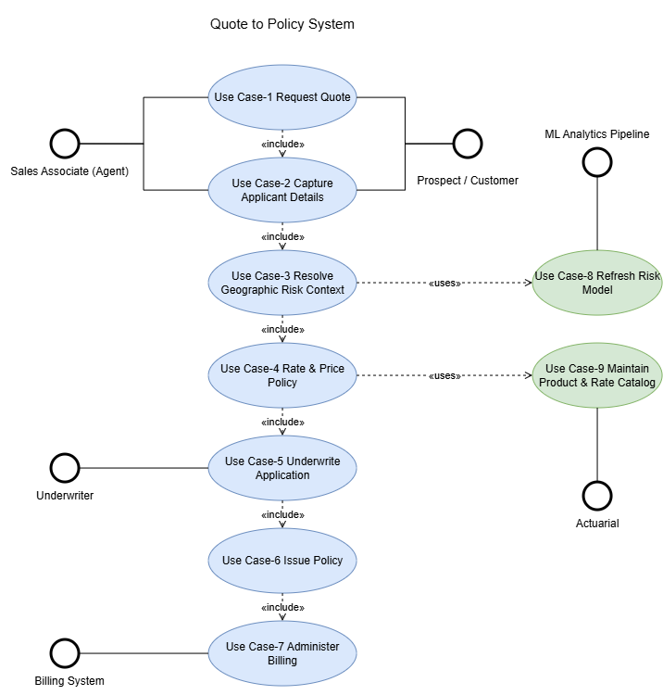
Figure: Use Case Diagram

The activity diagram showcases the sequence of activities and ownership of the business use cases. There are 5 rows representing Customer/Agent, Quote Service, Risk and Rating, Underwriting, and Policy Administration. The underwriting is only involved when auto approval fails and the policy administration does not take place till the customer accepts the policy.

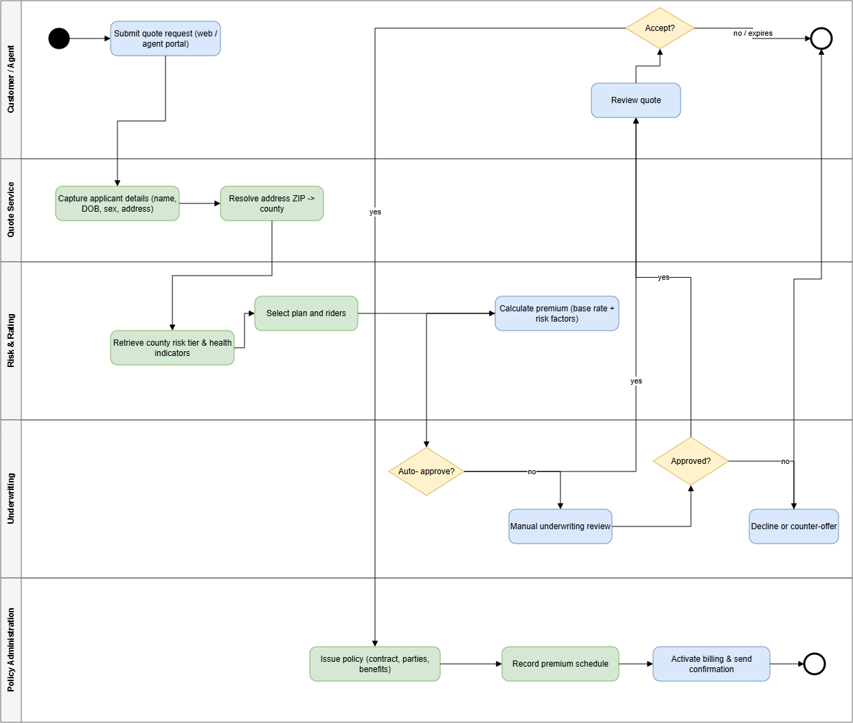
Figure: Activity Diagram

The use cases are as follows
- Use Case 1: Request a Quote
  - Involves Prospect/Customer
  - Prospect/Customer supplies applicant identity and address details, system validates that the fields are present and initiates a quote session
- Use Case 2: Capture Application Details
  - Involves Prospect/Customer, Sales Associate
  - System records name, DoB, sex at birth, contact details and address. System checks for an existing member by matching the natural key and if found the existing record is reused
- Use Case 3: Resolve Geographic Risk Context
  - Involves System
  - The system resolves the applicant’s ZIP code to a county through zip_code.primary_county_id. The system then retrieves the county’s risk tiers and chronic disease indicators and attaches them to the quote session.
- Use Case 4: Rate and Price the Policy
  - Involves System, Actuarial
  - The Actor selects a plan and any optional riders and the system retrieves base rates and benefit definitions from the product catalog. The system then calculates a modal premium from base rate, age band, coverage type and selected riders. The system then produces a quoted premium, deductible and out of pocket maximum.
- Use Case 5: Underwrite the Application
  - Involves Underwriter, System
  - The System applies automated underwriting rules and if all rules pass the application is auto approved. If not the application is routed to an underwriter for manual review
- Use Case 6: Accept Quote and Issue Policy
  - Involves Prospect/Customer, Sales Associate
  - Customer reviews and accepts the quote, the System then creates the contract with an effective date and in force flag. The system then records the customer as the insured party on the contract and selected benefits and the premium schedule. The system then links the contract to the appropriate group account when applicable
- Use Case 7: Administer Billing
  - Involves Billing System
  - Billing receives the contract and premium schedule and the first premium invoice is generated and confirmation documents are issued to the customer
- Use Case 8: Refresh the Risk Model (Independent background process)
  - Involves Analytics Pipeline
  - New source files are ingested into the data lake bronze zone and registered in data_source_catalog, tract level data is aggregated to county grain and loaded into geo_health_indicator. The materialized view county_risk_profile is refreshed and the regression and clustering models are retrained and county_risk_tier is reloaded
- Use Case 9: Maintain Product and Rate Catalog
  - Involves Actuarial/Product
  - Actuarial amends plans and riders and the base rates and benefit definitions are updated. The changes take effect for quotes generated after the effective date while existing contracts are unaffected.

III - Application Design
- The final solution has four components namely Source files, Pipeline module, Database and Web application. The application runs separately from the pipeline since the application runs interactively while the pipeline runs periodically and does a large amount of work. They communicate to each other through the database, the pipeline writes to eda.county_risk_tier and the application reads it. SQLAlchemy is used as the database connectivity framework for both application and pipeline.
The components are as follows
- Source Files
    - Unstructured/Semi structured layer that has CDC, SVI, CDC PLACES and EPA AQI data
    - Tech: CSV, mirrored in MongoDB Atlas
  - Pipeline Module
    - Detects changes, responsible for re staging, aggregation, model re training and reloading risk tier
    - Tech: Python, pandas, scikit-learn, SQLAlchemy
  - Database
    - Has the OLTP/ODS Schema, curated indicators, materialized view and the model output
    - Tech: PostgreSQL 16
  - Application
    - Enables the Quote to Policy workflow for users
    - Tech: Python, Streamlit, SQLAlchemy

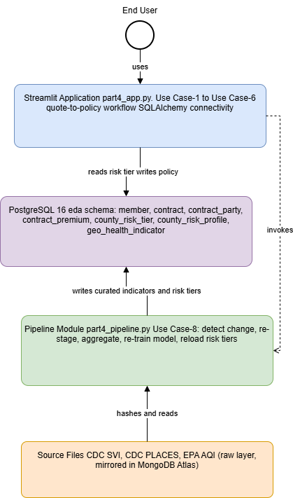
Figure: Component Diagram
IV - Data Driven Program Module
- The Data driven program module leverages the machine learning module from part III, manages the data pipeline for the unstructured data and re trains when the source data is changed.

The module computes a SHA-256 hash and row count for each registered source file and compares them to the values stored from the previous run in eda.source_fingerprint. If no source has changed the module exits without touching the rest of the database which leads to it being more efficient since a no change run completes much faster since it does not re aggregate and re train.

The stages of the pipeline are
- Stage 1: fingerprinting each source and identifying which ones have changed
- Stage 2: reloading only the changed sources into their staging tables
- Stage 3: re aggregate tract level data to county grain into geo_health_indicator and then refresh the county_risk_profile materialized view
- Stage 4: re train the random forest regression and the K means clustering and then reload eda.county_risk_tier

The module re trains the same models from part III, the regression helping predict tract level chronic disease prevalence from ten socioeconomic predictors and grouping counties into four risk tiers. The model excludes potentially discriminatory and protected class proxies as highlighted in the part III report.

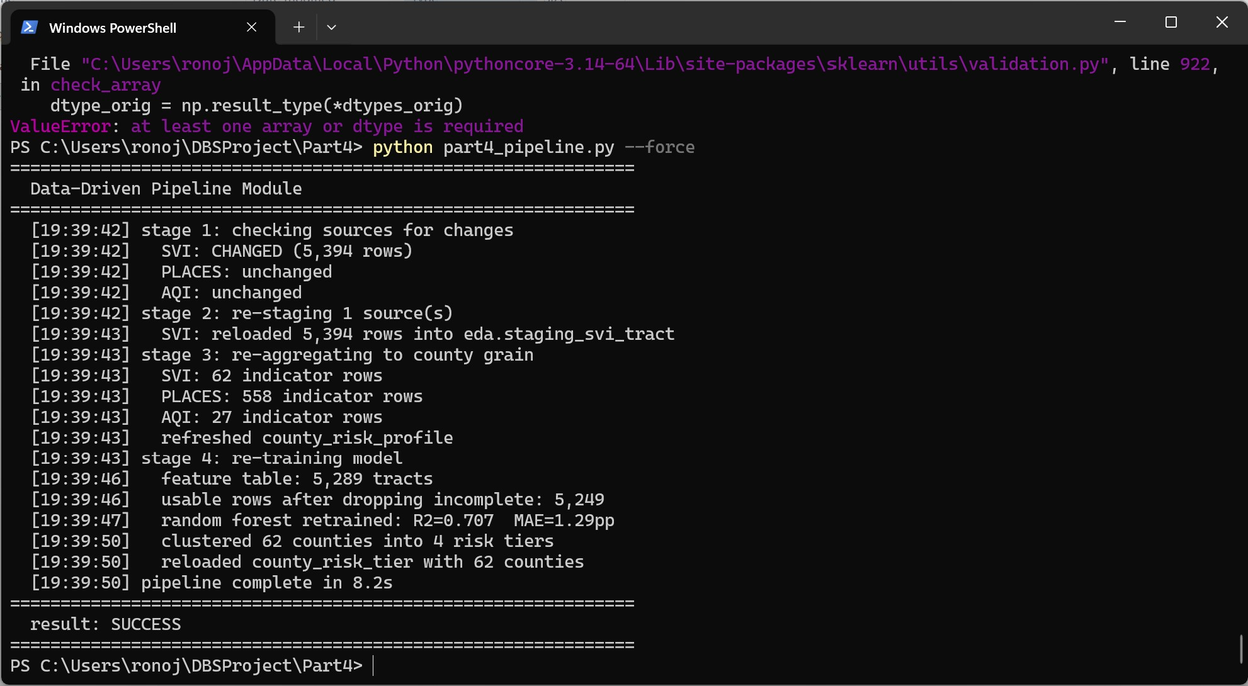
Figure: Terminal - full pipeline run triggered by a changed source

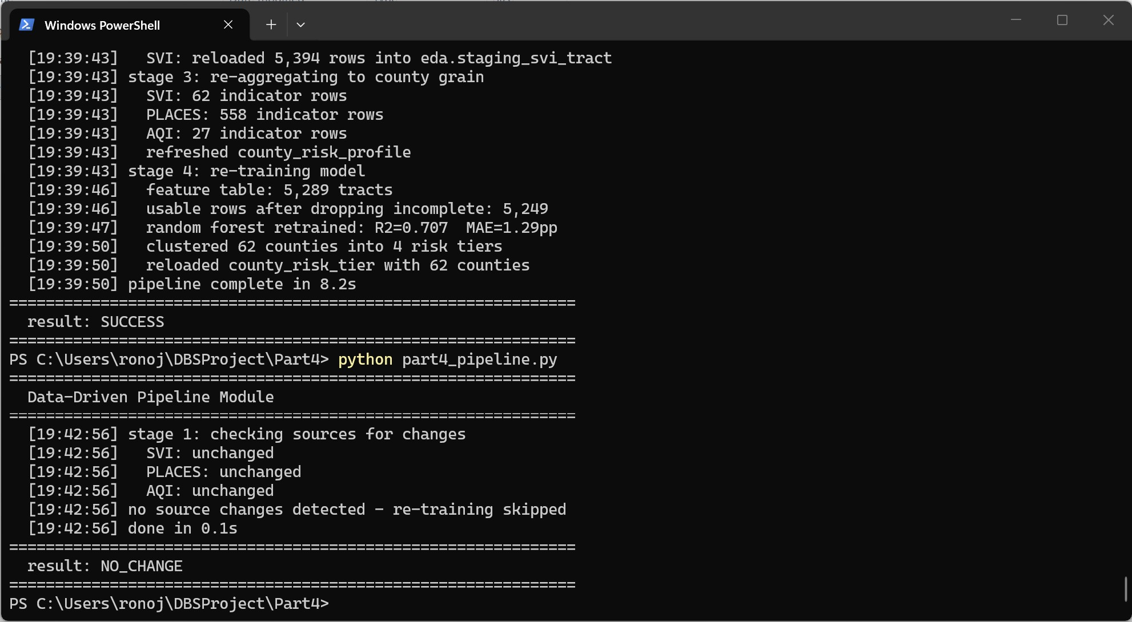
Figure: Terminal - NO_CHANGE run completing in 0.1 seconds

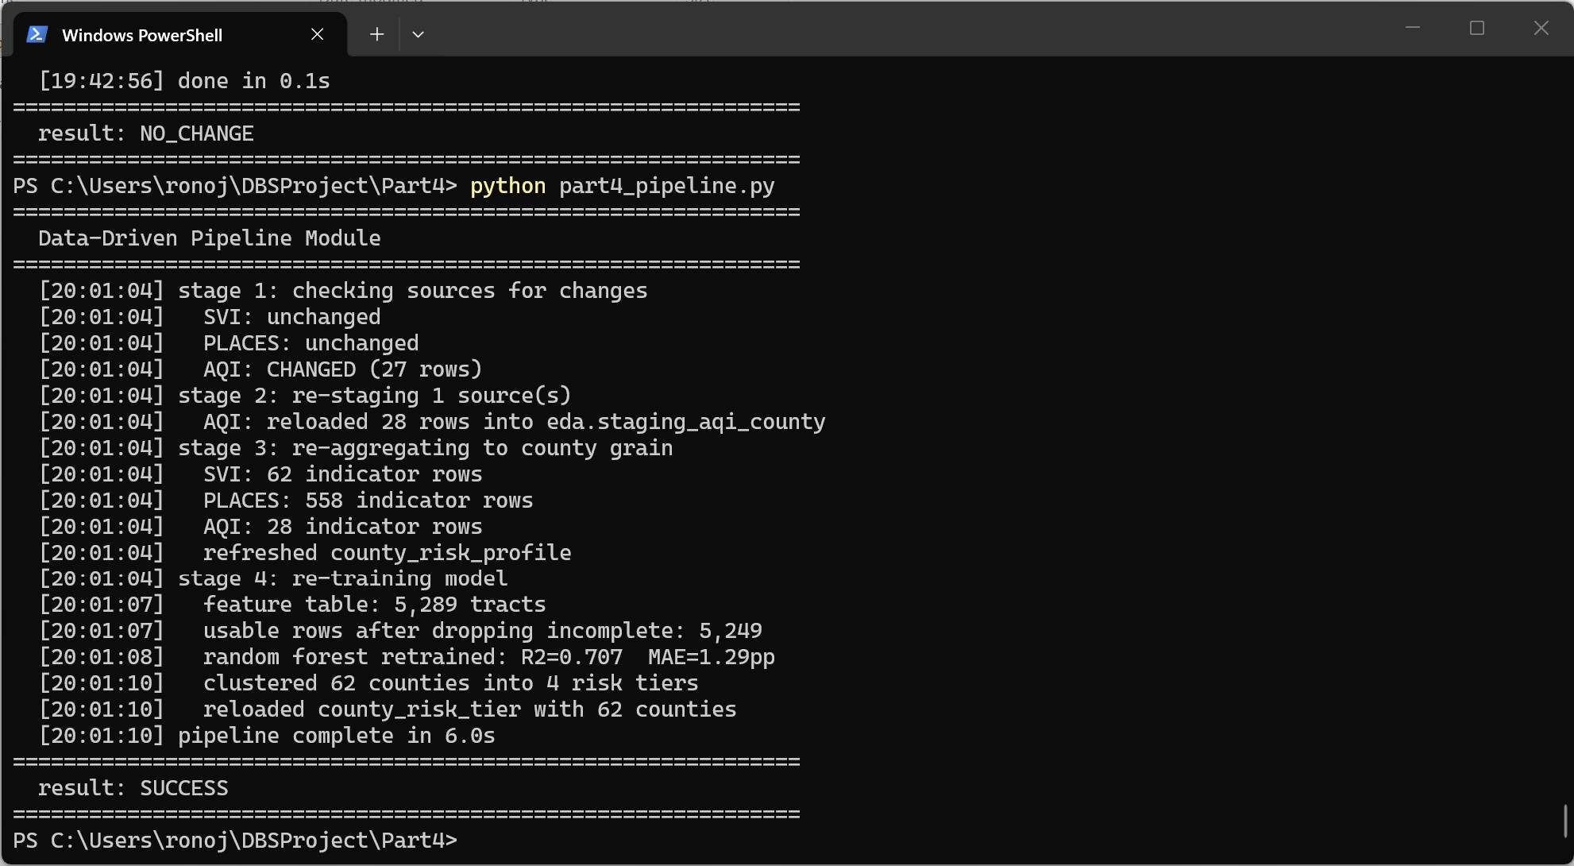
Figure: Terminal - AQI source being changed triggering re training

V - Workflow Application
- The web application implements the use cases 1 through 6 through a web interface for an end user. SQLAlchemy is used for database connectivity and it integrates the data driven module by reading the modules output after use case 3 and can also be invoked directly.

The user enters the applicant's details and their ZIP code and selects a plan.
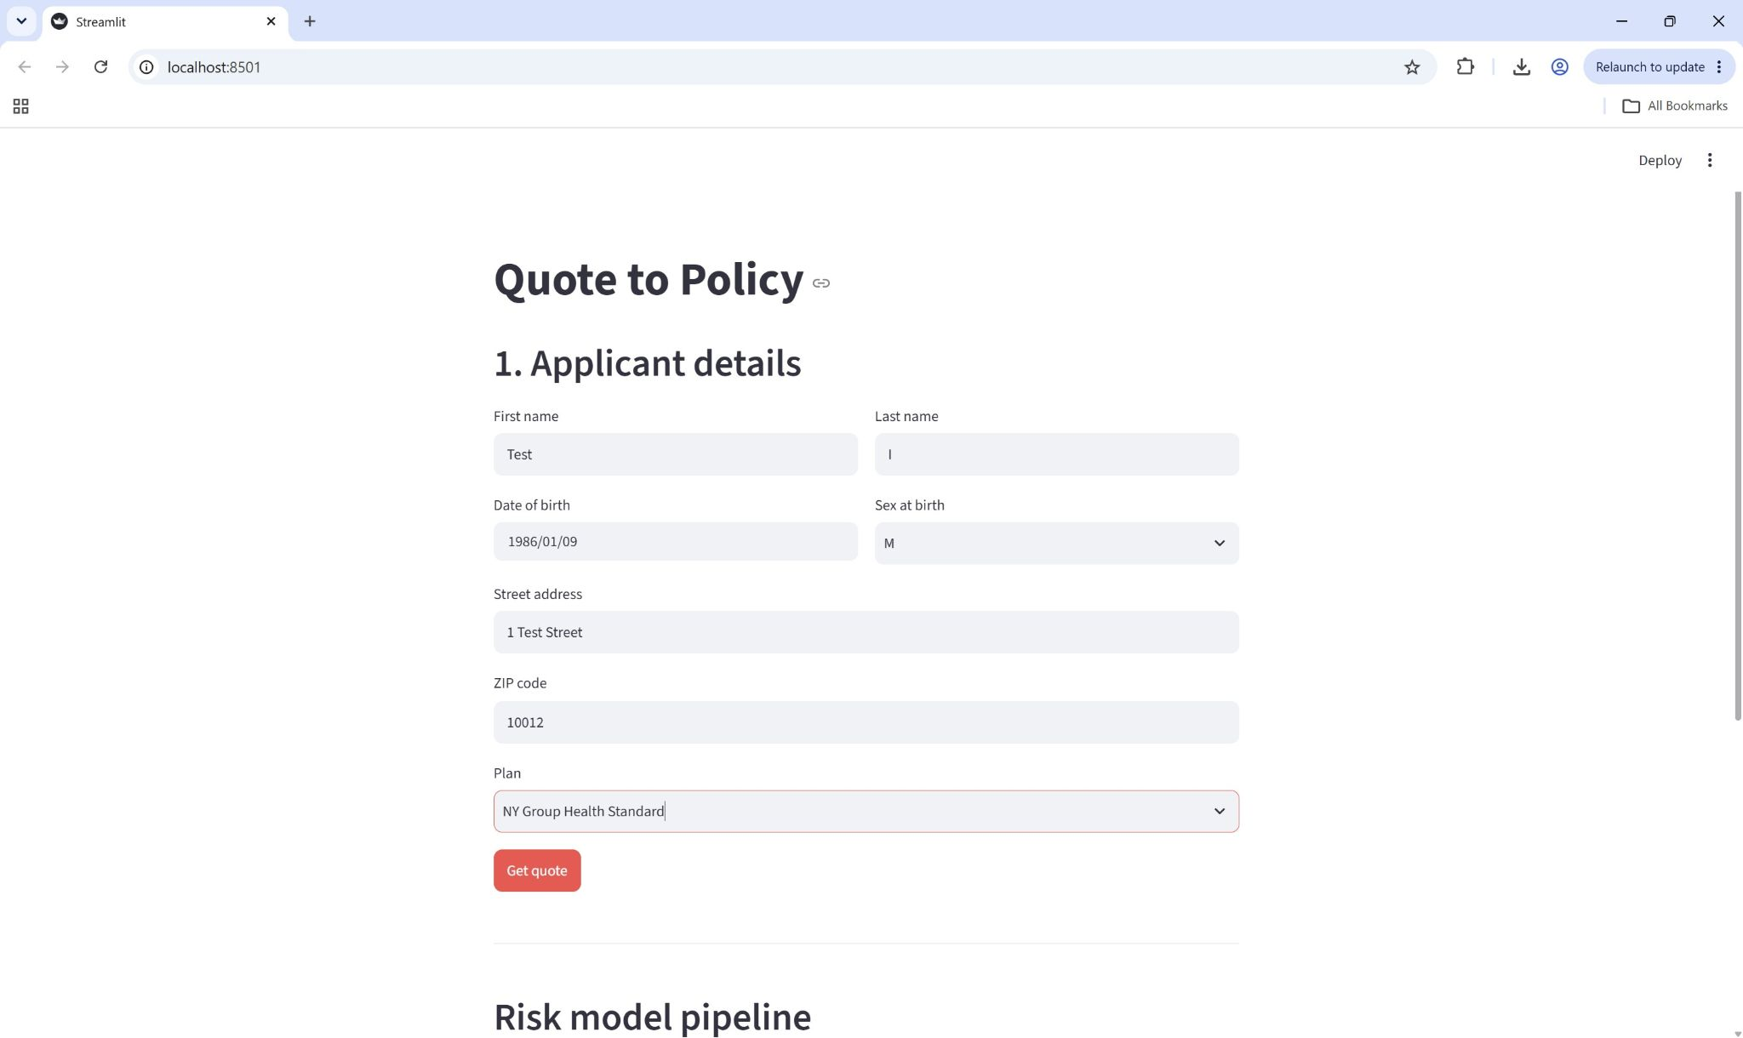
Figure: Web Application - applicant details form

After hitting the Get quote button the application resolves the ZIP to a county and retrieves the county’s ML risk tier and chronic disease indicators, calculates a premium, applies the automated underwriting rules and auto approves if applicable

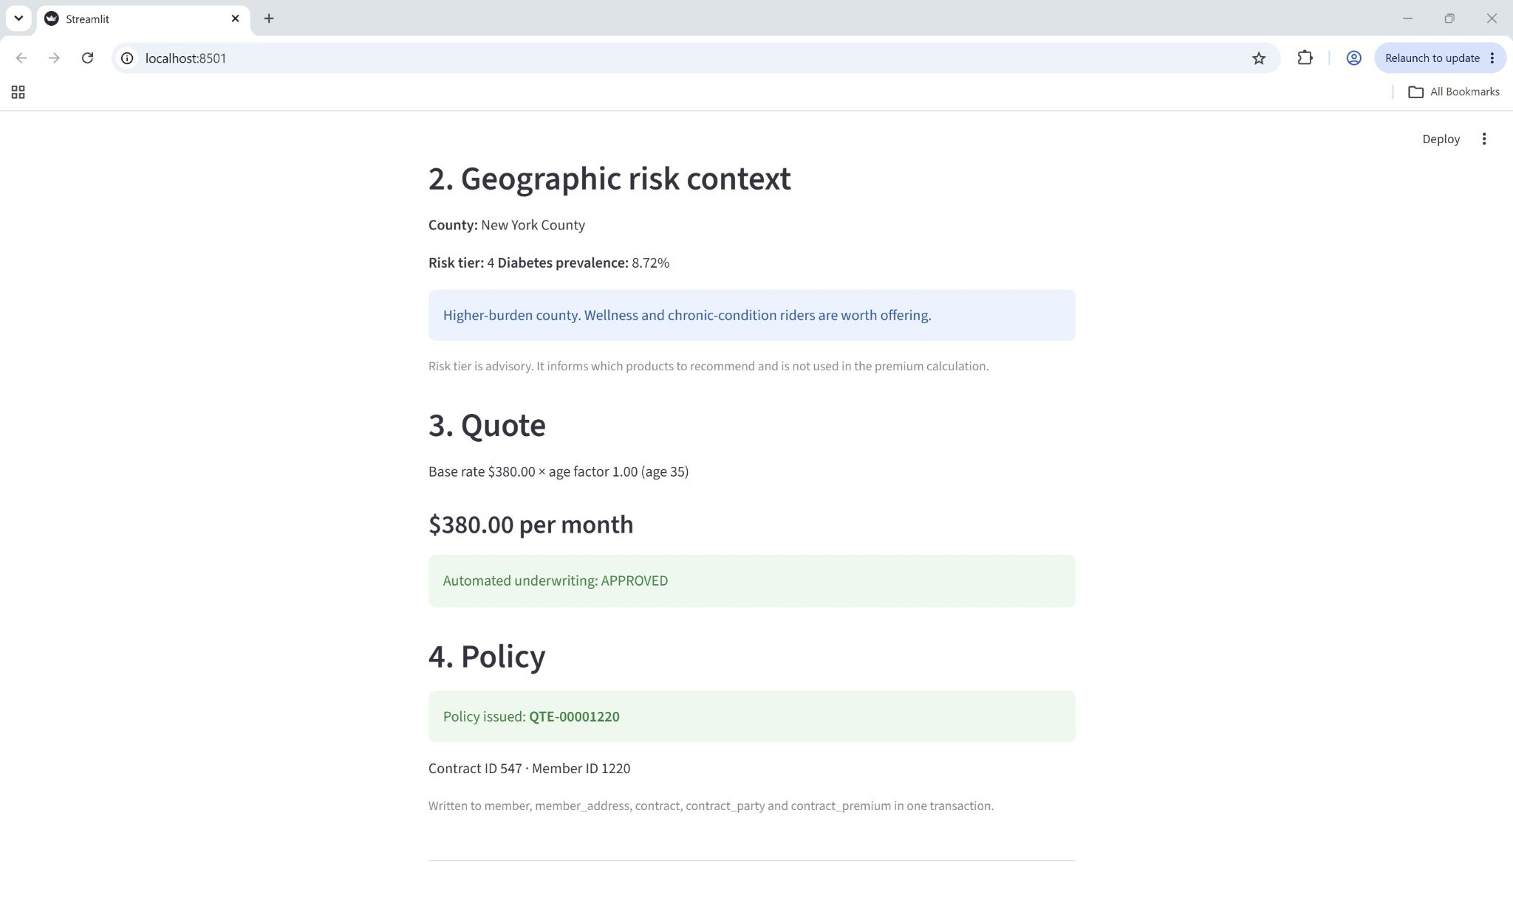
Figure: Web Application - resolved county with risk tier, indicator, calculated quote, underwriting decision and issued policy

If there is an applicant older than 70 it is referred to an underwriter as opposed to being automatically approved and if there is an applicant from a ZIP code that does not resolve to a known county it produces a warning.

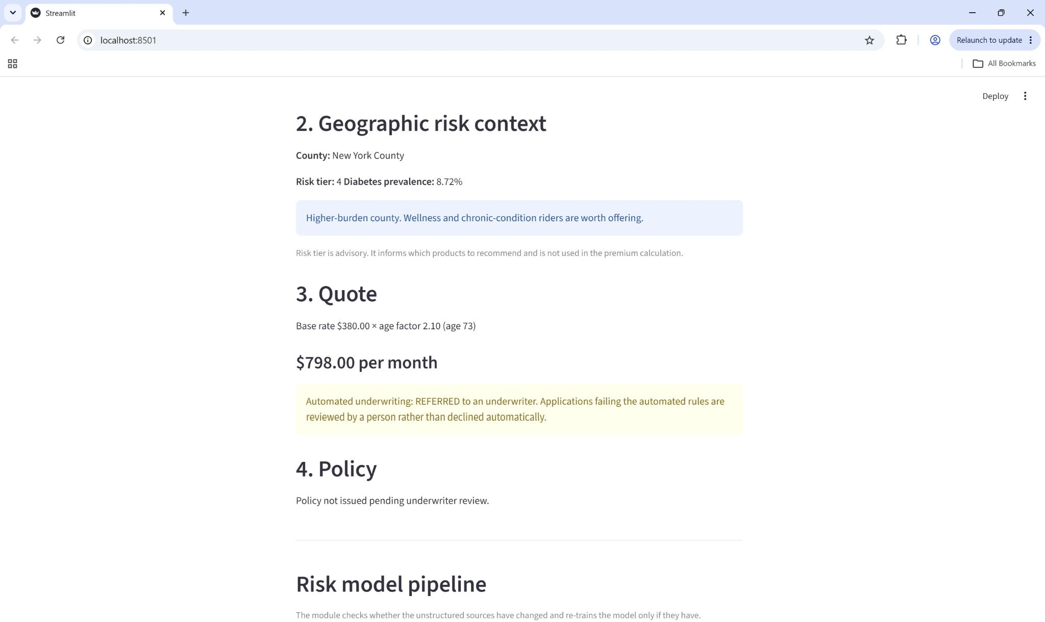
Figure: Web Application - referral for case with applicant aged >70

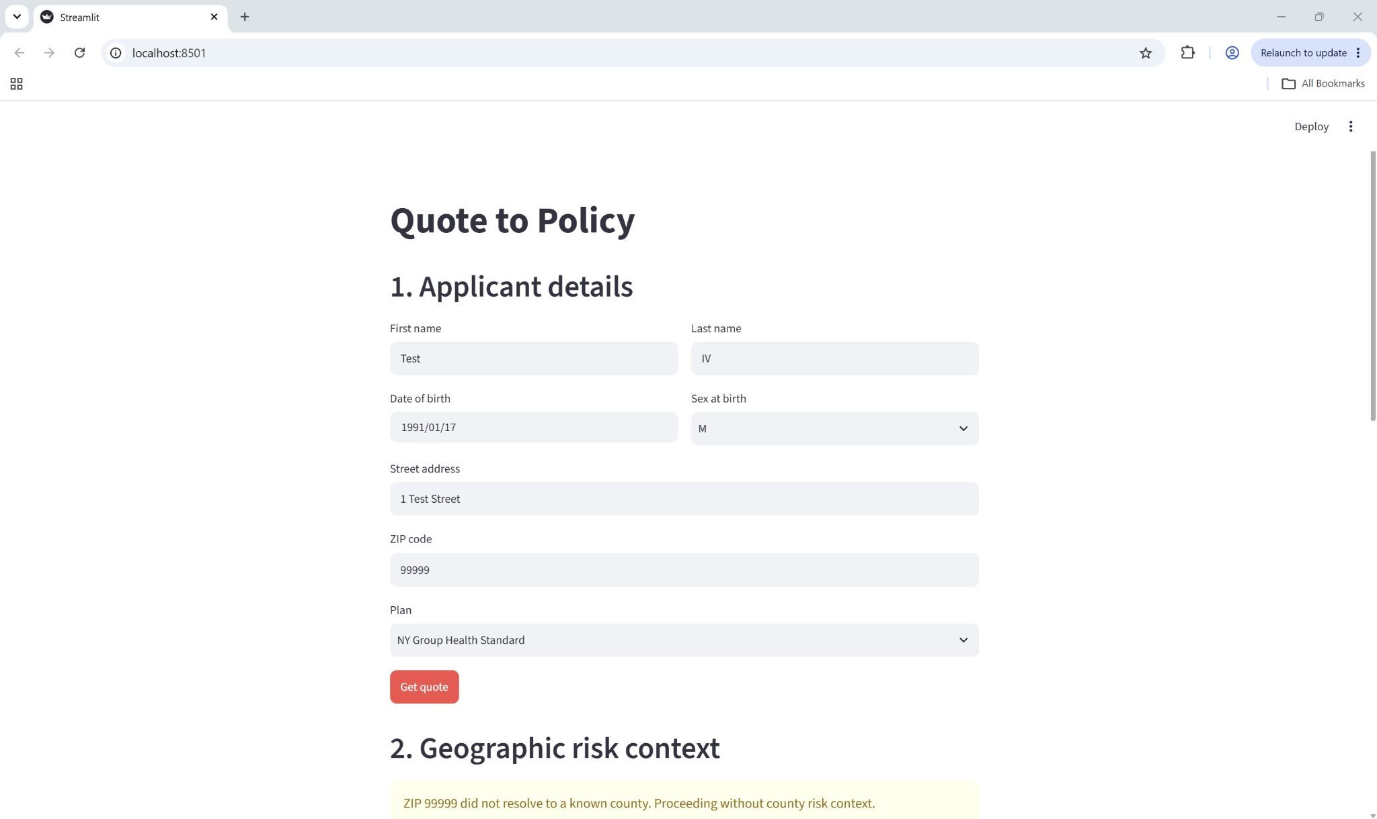
Figure: Web Application - referral case for unresolved ZIP code

The county risk tier is displayed to the user and drives product guidance such as an application in a higher burden county is recommended to add wellness and chronic condition riders. The model learns area level associations and explicitly notes that the risk tier is advisory and not a rating factor.

The application also includes the ability to invoke the pipeline module and display its output. It shows the current risk tier distribution from the database.
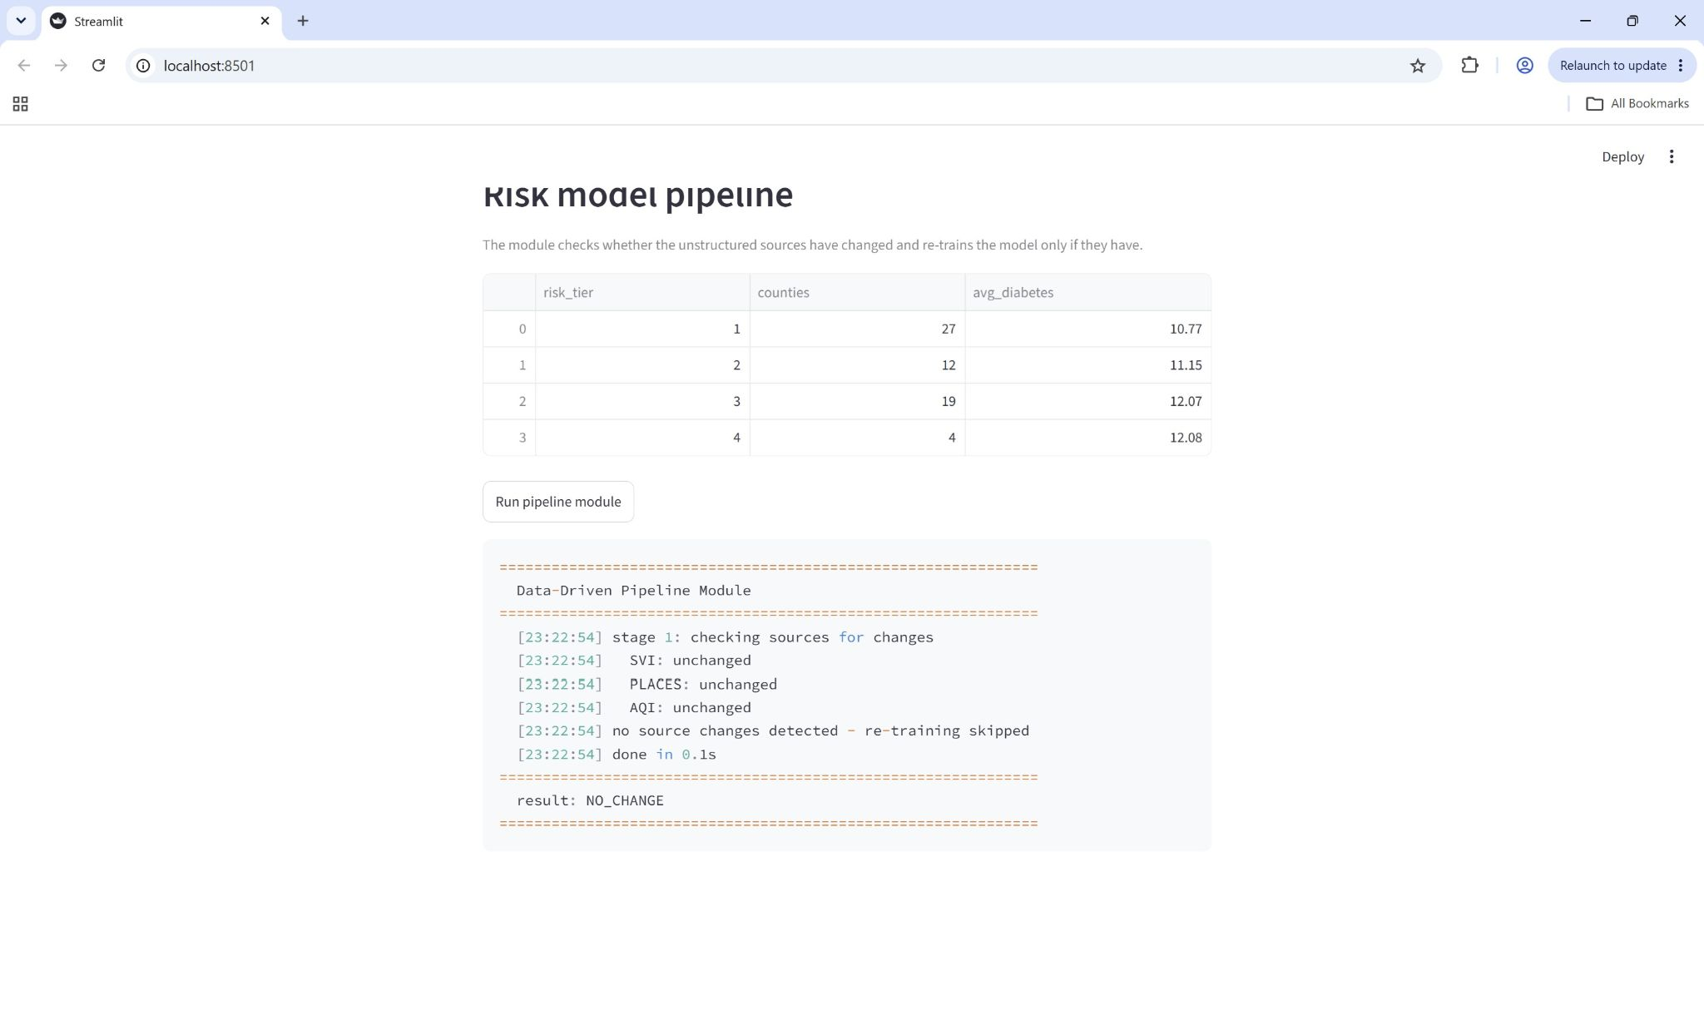
Figure: Web Application - pipeline module invoked from the web application

The policies that are created through the interface are reflected in the operational schema and can be queried in the database.
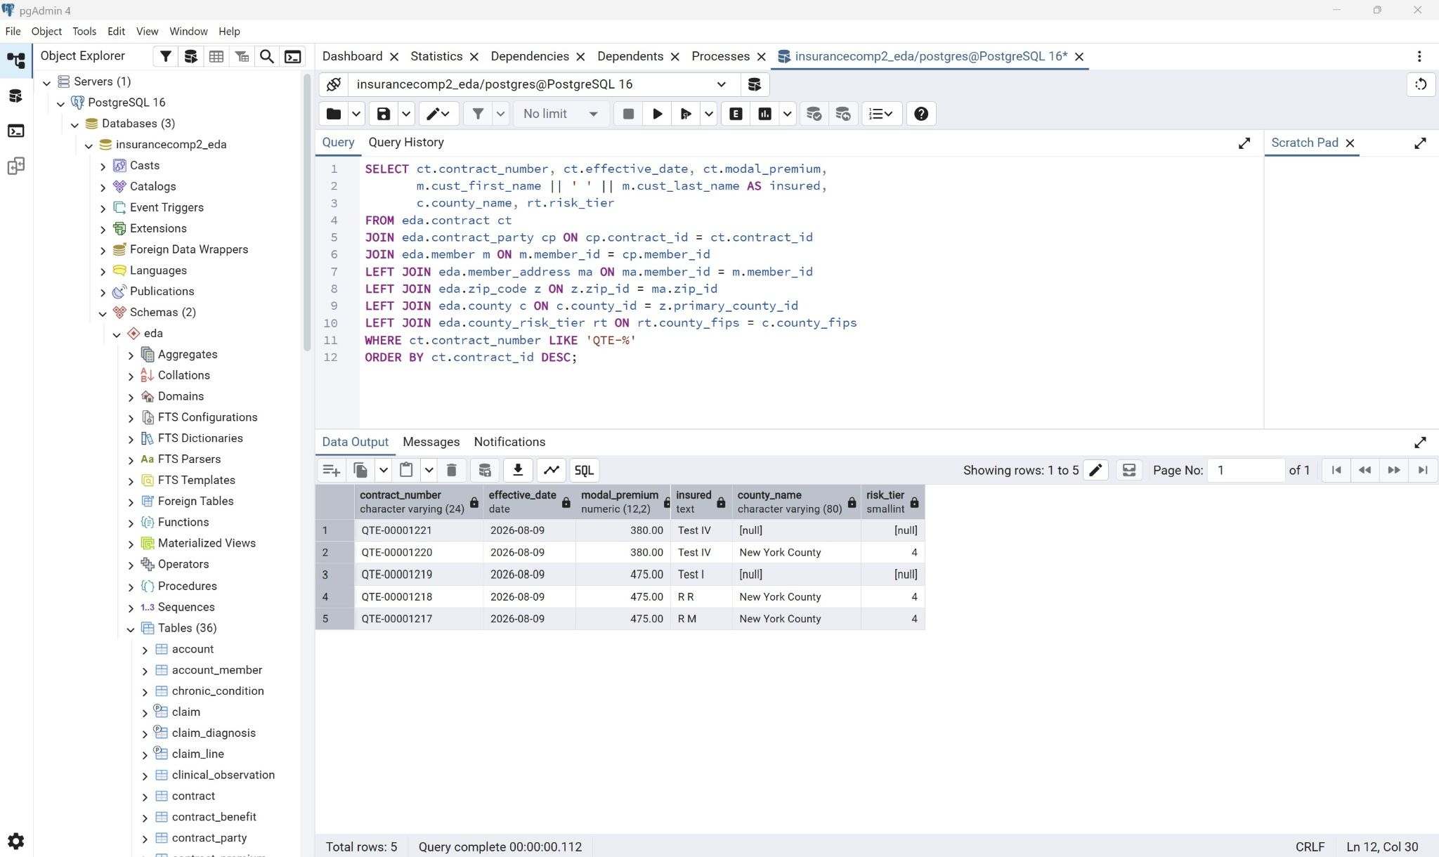
Figure: pgAdmin - contracts created through the application joined to their county risk tier

VI - Query Optimization
- Multiple choices were made in order to optimize the applications queries.
Two deliberate denormalizations sit between the raw indicator data and the application, the county_risk_profile materialized view pivots geo_health_indicator from tall form into wide form. The county_risk_tier table the second denormalization with risk tier being the output of a clustering model that could be recomputed on demand but doing so would mean running K means during a quote request thus storing the model output as a flat table keyed on county FIPS reduces it to an indexed lookup.

Use Case 3’s geographic resolution step joins zip_code to county to county_risk_tier and county_risk_profile in a single query as opposed to a sequence of separate lookups. This join is quick due to the foreign key indexes created in part III.

Policy issuance also writes to member, member_address, contract, contract_party and contract_premium in a single transaction so either all of the rows are written or none are making partial success not possible.

Change detection allows the module to not have to do any database work when there is no change made to the data. When the module does load data it uses bulk inserts rather than one statement per row and clears staging tables with TRUNCATE as opposed to DELETE.

VII - Final Reference Architecture
- The foundational principles guiding the reference architecture are as follows
- Single Source of Truth: Each element is mastered in a single place. For example curated indicators live in geo_health_indicator, model output lives in county_risk_tier and the application reads both instead of recalculating it.
- Separation of raw and curated data: Source data is preserved as ingested and is never edited in place. All transformations produce new curated artifacts preserving the source data and allowing any curated value to be traced back to its source.
- Loose coupling throughout the database: The components communicate through database tables as opposed to direct calls so thus the model can be re trained without the application being changed.
- Automation accountability: The pipeline runs without human intervention but the inputs are fingerprinted and the outputs are inspectable to allow human review after.
- Model outputs recommendations: The model outputs inform recommendations and planning and does not price individuals.

The final layers of the reference architecture would be
- Layer: Sources
Content: 3 datasets (CDC SVI, CDC PLACES, EPA AQI) at native grain and Synthea
synthetic patient data
Where: Downloaded files, Stored in CSVs

- Layer: Data lake - raw
Content: Raw files that are unmodified and catalogued by the grain/license/source/PHI status
Where: MongoDB Atlas, Source files

- Layer: Data lake - Curated
Content: County level population weighted aggregation
Where: Staging tables to geo_health_indicator and the county_health_summary collection in Atlas

- Layer: Physical Schema
Content: Normalized eda schema with indexes, partitions, clustering and materialized views
Where: PostgreSQL 16

- Layer: Machine Learning
Content: Feature extraction, regression, clustering models, fairness constraints
Where: Pipeline module

- Layer: Application
Content: Quote to policy workflow for end users
Where: Streamlit application

- Layer: Governance
Content: wraps all layers and has contains_phi flag, quality_status, source licensing, stewardship, fairness constraints, human in the loop requirements
Where: data_source_catalog, source fingerprint, documented constraints

The business domain is the chronic disease forecasting goal and the quote to policy workflow it informs. The application domain is the physical schema, the pipeline module and the workflow application. The DIKW domain progresses from the raw ingested records, through catalogued indicators to model derived risk tiers to presenting a recommendation to a user. The infrastructure domain is a local PostgreSQL instance in combination with a managed MongoDB Atlas cluster.

Through the course of the project, the planning moved from a conceptual model, to logical schema, to physical design, to application. The delivery lives in a single GitHub repository containing the artifacts and Operation is automated through the pipeline module.

Regarding governance, the sources are registered in data_source_catalog with an explicit quality_status to record the quality so that the data being loaded can be examined for trustworthiness.
The contains_phi flag records the external datasets that do not carry any protected health information, the member population used is generated, synthetic data, policy issuance is transactional so a partial write does not leave orphaned records all contributing to the prevention of data loss and leakage.
Claim data is range partitioned by service year, which helps with retention enforcement. The retention_class column on unstructured_asset records the intended life cycle of each raw artifact and source fingerprints record when each source was last seen and changed aiding in the management of the data lifecycle.
To safeguard against bias and limiting decision power four protected class proxies were excluded from the model in part III at a cost of ~0.118 in R squared. The exclusion is enforced in the pipeline module’s feature list so that it holds for every re training. The output is also advisory and not used as a rating factor and every application that does not get automatically underwritten gets referred to a human. That being said, a current limitation is that excluding protected attributes does not on its own guarantee non discriminatory outcomes.

VIII - Conclusion
- Part IV completes the project making the analysis operational. The pipeline module manages the unstructured data layer and trains the machine learning model when the source data changes. The workflow application implements the quote to policy use cases against the physical schema built in part III and consumes the model’s output at the business decision stage.

Across the four parts the project moved from a conceptual model, to a logical schema that could work with structured and unstructured data, to a physical design that could be deployed and measured and finally to a working application that exposes it to an end user.

