Introduction
You have a problem. For whatever reason you need to recover the code for an application. You only have the .apk file and it's on your device, or perhaps in an email or other download location.
This document describes how to do this on a windows system.

The application is on your device
If the version of the application is on your device then you need to pull that apk from the device.
Connect your device via usb to your PC.
Open a cmd window, use “adb shell pm list packages” to list the available packages on your device.
First use “adb devices” to make sure you can communicate with your device
C:\Users\Mark>adb devices
* daemon not running. starting it now on port 5037 *
* daemon started successfully *
List of devices attached
A00000416AB4FC device

Now get the list of packages:

C:\Users\Mark>adb shell pm list packages
package:android
package:com.android.backupconfirm
package:com.android.bluetooth
package:com.android.browser
package:com.android.calculator2
package:com.android.calendar
package:com.android.camera
package:com.android.certinstaller
package:com.android.chrome
…

Then look for the muse application.
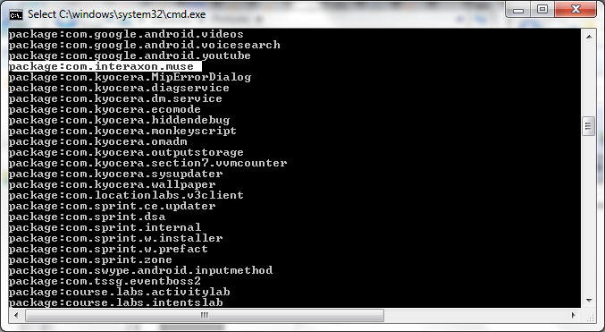
Scroll through the output and find the application you are looking for, or search the output for the application name.
Use the package name (package:com.interaxon.muse) to discover the pathname
Get the pathname:
Use “adb shell pm path com.interaxon.muse”
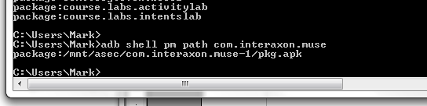
This shows us where the .apk file for the application was installed.
We use this information to pull the .apk from the device by using the “adb pull” command and the pathname just found:

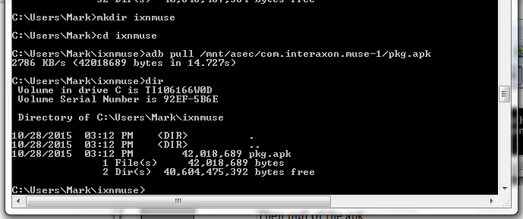

I created a new directory, changed working directory and then pulled the .apk file
The .apk file is just a zip file format, so I used 7-zip to extract its contents into the muse directory under ixnmuse.

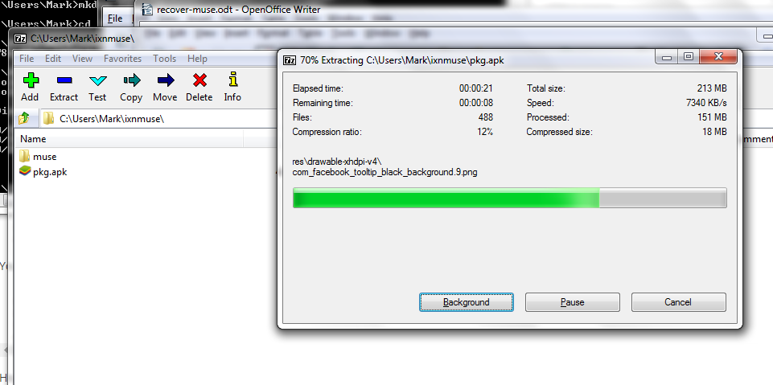
The contents of the muse folder is this:
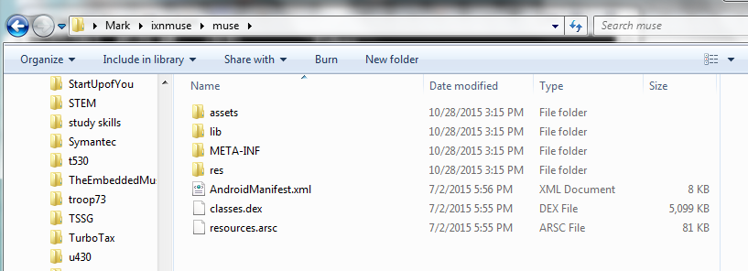

The .apk file is already on a filesystem
The preceeding section just accomplised getting the apk file from the device. If you already have an appropriate version of the .apk file then you can just use that one.
I copied the base.apk file from Konrad's goodle drive share – this apk at the time was the last known working version that we wanted to recover the code from.
I used 7-zip to extract the file and this is what I got:
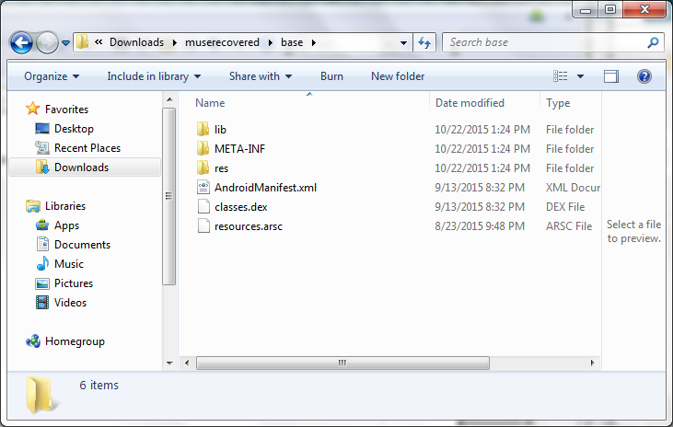

Attempt to recover classes .jar from classes.dex
The classes.dex file is the Davlik executable file for the application.
Download dex2jar from http://sourceforge.net/projects/dex2jar/files/?source=navbar

I downloaded dex2jar-2.0.zip, extracted to folder dex2jar-2.0
Copy classes.dex file into dex2jar-2.0
C:\Users\Mark\Downloads\muserecovered>cd dex2jar-2.0

C:\Users\Mark\Downloads\muserecovered\dex2jar-2.0>cd dex2jar-2.0
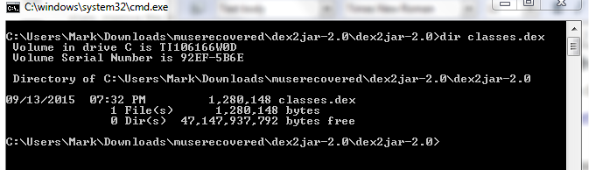
Now use the d2j-dex2jar.bat command on the classes.dex file to produce the jar file.

C:\Users\Mark\Downloads\muserecovered\dex2jar-2.0\dex2jar-2.0>d2j-dex2jar.bat classes.dex
dex2jar classes.dex -> .\classes-dex2jar.jar

C:\Users\Mark\Downloads\muserecovered\dex2jar-2.0\dex2jar-2.0>

Should have a classes-dex2jar.jar file.

C:\Users\Mark\Downloads\muserecovered\dex2jar-2.0\dex2jar-2.0>dir classes*
Volume in drive C is TI106166W0D
Volume Serial Number is 92EF-5B6E

Directory of C:\Users\Mark\Downloads\muserecovered\dex2jar-2.0\dex2jar-2.0

10/22/2015 01:43 PM 792,482 classes-dex2jar.jar
09/13/2015 08:32 PM 1,280,148 classes.dex
2 File(s) 2,072,630 bytes
0 Dir(s) 25,901,846,528 bytes free

C:\Users\Mark\Downloads\muserecovered\dex2jar-2.0\dex2jar-2.0>
In a picture:

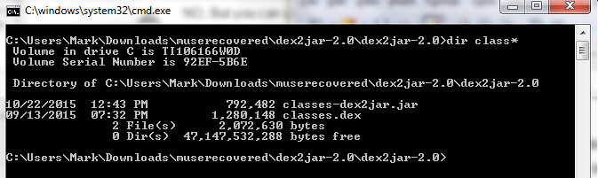
The output file classes-dex2jar.jar is what this step needed to create.

Recover .java files from classes-dex2jar.jar
Now I need a java decompiler to look at the new classes-dex2jar.jar file. Will use JD-GUI from this site:
http://jd.benow.ca/

Download the jd-gui version.
Downloaded jd-gui-windows-1.4.0.zip
Extract into jd-gui-windows-1.4.0 etc
Ran antivirus on the jd-gui.exe. No threats found.
Double click jd-gui.exe
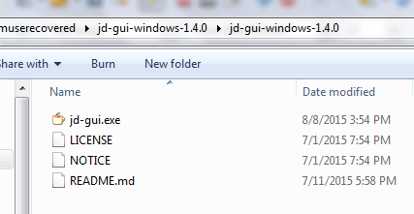
Wait for JD-GUI to open and then use the File menu to open the .jar file.

Click File → Open File and then browse to the dex2jar-2.0 directory with classes-dex2jar.jar in it. Select that file. Open. Now I see this:

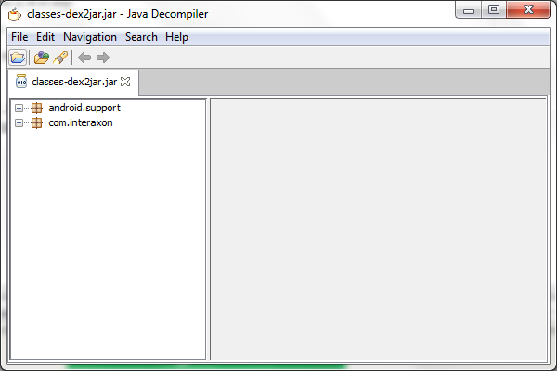

Quick exploration, I find MainActivity.class file and select the class MainActivity
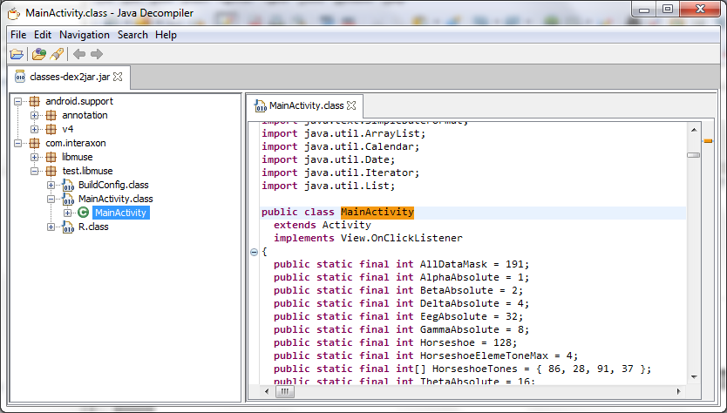

Looks promising.

Selected MainActivity.class, then File → Save All Sources and it created a zip file classes-dex2jar.jar.src.zip which I saved at the top level recoveredmuse

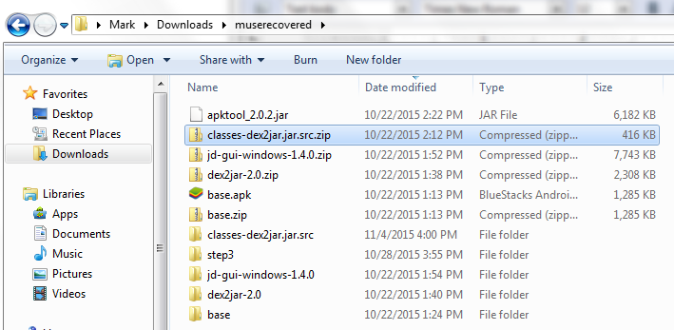
It was this file, the classes-dex2jar.jar.src.zip that I sent to Konrad for him to use to try to recover the code changes he had made.
I had noticed that the java code looked as if it was not complete, names of R.id were not fully recovered, labels used in switch statements were numeric values etc.

What about apktool
I followed these instructions: http://ibotpeaches.github.io/Apktool/install/ Summary: download apktool.bat file, apktool_version_jar file which you rename to apktool.jar.

The former methods may not give you usable resource files. Apktool will provide you with AndroidManifest.xml and resource files.

Step 3 says to recover usable xml files. So I create new directory step3 and copy base.apk into that.
Need apktool. Found this site: https://ibotpeaches.github.io/Apktool/
Under the install tab, it prompts you to check “java -version” responds with 1.7 If so, then install the apktool 2
Follow the install instructions, download, right-click, save as “apktools.bat”
Download apktool-2 from here: https://bitbucket.org/iBotPeaches/apktool/downloads, latest version was apktool_2.0.2,jar
Rename apktool_2.0.2.jar to apktool.jar
Move apktool.jar and apktool.bat into folder step3
cd into step3
Extraxt the /system/framework/framework-res.apk from your device.

C:\Users\Mark\Downloads\muserecovered\step3>adb pull /system/framework/framework-res.apk
2026 KB/s (6730934 bytes in 3.243s)

C:\Users\Mark\Downloads\muserecovered\step3>

C:\Users\Mark\Downloads\muserecovered\step3>apktool if framework-res.apk
I: Framework installed to: C:\Users\Mark\apktool\framework\1.apk

C:\Users\Mark\Downloads\muserecovered\step3>

C:\Users\Mark\Downloads\muserecovered\step3>
C:\Users\Mark\Downloads\muserecovered\step3>apktool d base.apk
I: Using Apktool 2.0.2 on base.apk
I: Loading resource table...
I: Decoding AndroidManifest.xml with resources...
I: Loading resource table from file: C:\Users\Mark\apktool\framework\1.apk
I: Regular manifest package...
I: Decoding file-resources...
I: Decoding values */* XMLs...
I: Baksmaling classes.dex...
I: Copying assets and libs...
I: Copying unknown files...
I: Copying original files...

C:\Users\Mark\Downloads\muserecovered\step3>

