1. How to add product/s

STEP 1: Click the Account Button on the menu bar

STEP 2: Click the Product Settings Button

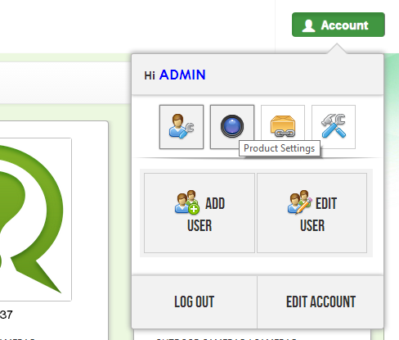

STEP 3: Click the Add Product Button

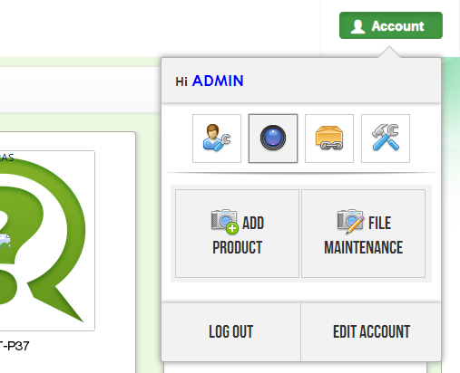

2. How to edit product/s

STEP 1: Click the Account Button on the menu bar

STEP 2: Click the Product Settings Button



STEP 3: Click the File Maintenance Button

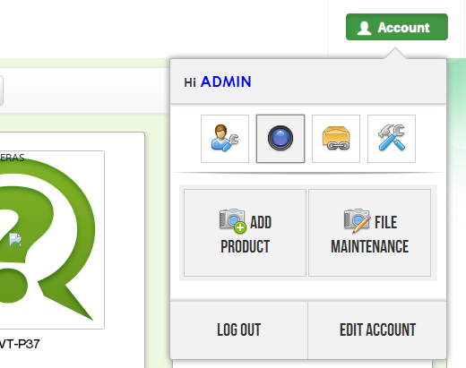

STEP 3: You are you on the File Maintenance Page. In order to edit a product, click the edit button on the selected product

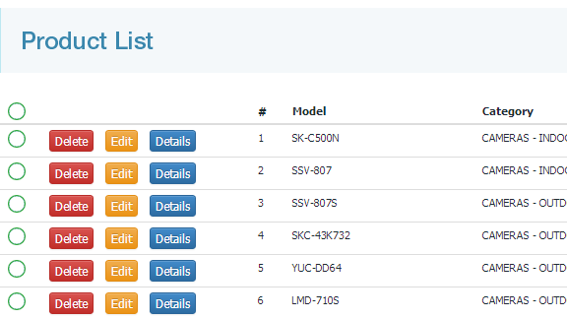

3. How to delete product/s

STEP 1: Click the Account Button on the menu bar

STEP 2: Click the Product Settings Button



STEP 3: Click the File Maintenance Button



STEP 4: You are you on the File Maintenance Page. In order to delete a product, click the delete button on the selected product



You may use the search box to minimize or find specific product(s) that you want to delete. If you want to delete multiple items, click the green circle on the left side of the product that you want to delete. You can also select all products by clicking the circle on the label area or click the button and select “Select All”.

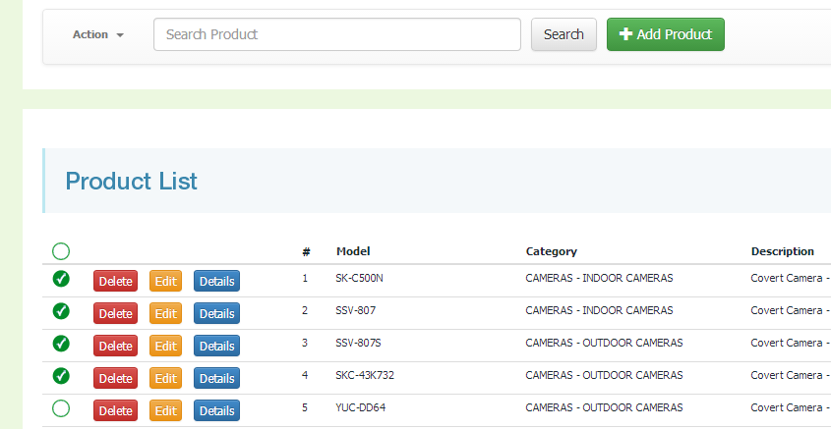

Search Box

Select All

Select All

Select one by one

After selecting the product(s) that you want to delete, click the action button and select “Delete Selected”.

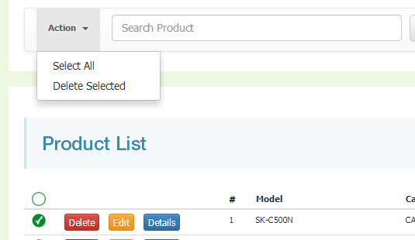

Delete Selected

4. How to add package/s

STEP 1: Click the Account Button on the menu bar

STEP 2: Click the Package Settings Button

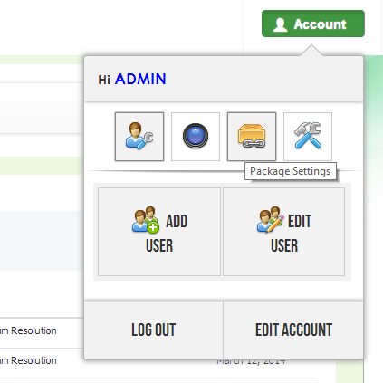

STEP 3: Click the Add Package Button

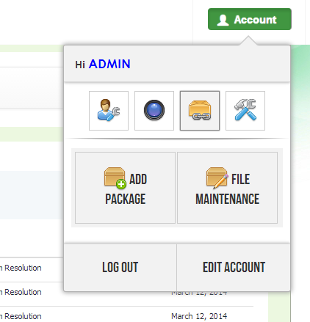

5. How to edit package/s

STEP 1: Click the Account Button on the menu bar

STEP 2: Click the Package Settings Button



STEP 3: Click the File Maintenance Button

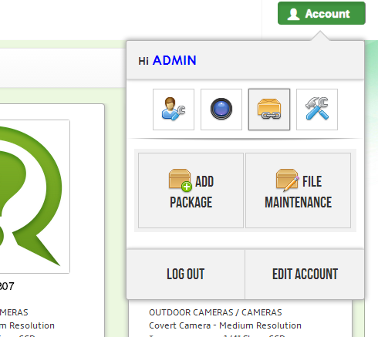

STEP 3: You are you on the File Maintenance Page. In order to edit a package, click the edit button on the selected package

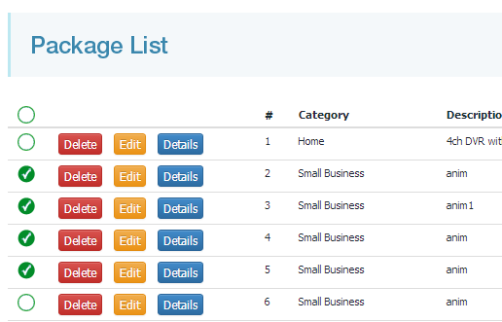

6. How to delete package/s

STEP 1: Click the Account Button on the menu bar

STEP 2: Click the Package Settings Button



STEP 3: Click the File Maintenance Button



STEP 4: You are you on the File Maintenance Page. In order to edit a product, click the delete button on the selected product

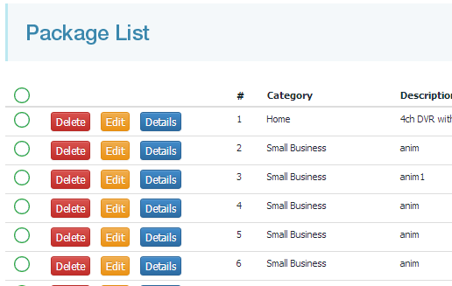

You may use the search box to minimize or find specific package(s) that you want to delete. If you want to delete multiple items, click the green circle on the left side of the package that you want to delete. You can also select all packages by clicking the circle on the label area or click the button and select “Select All”.

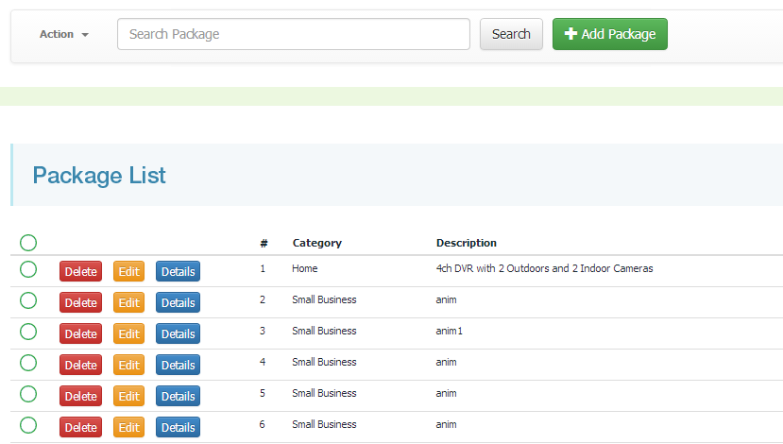

Select All

Search Box

Select All

Select one by one

After selecting the package(s) that you want to delete, click the action button and select “Delete Selected”.

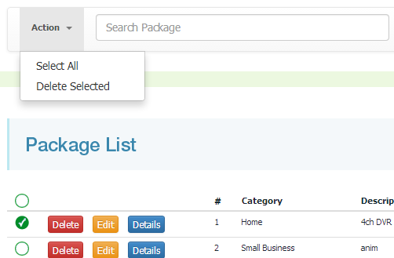

Delete Selected