Module 2 Assignment: Spark SQL and DataFrames

HTTP URL: https://github.com/RMFCONDE/assignment02.git

Top 5 Most Posted Job Titles
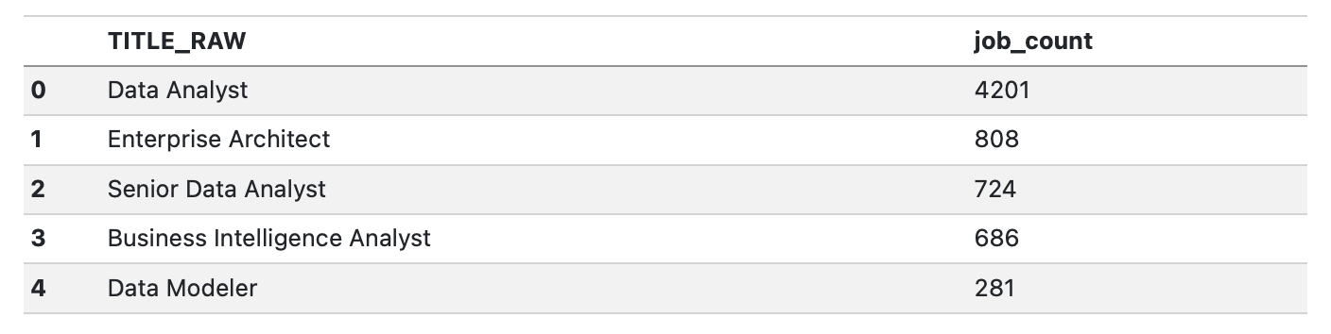
Insight: The Data Analyst role dominates job postings by a large margin, suggesting high demand for data skills, while more specialized roles such as Enterprise Architect appear much less frequently.

Query 1: Industry-Specific Salary Trends Grouped by Job Title
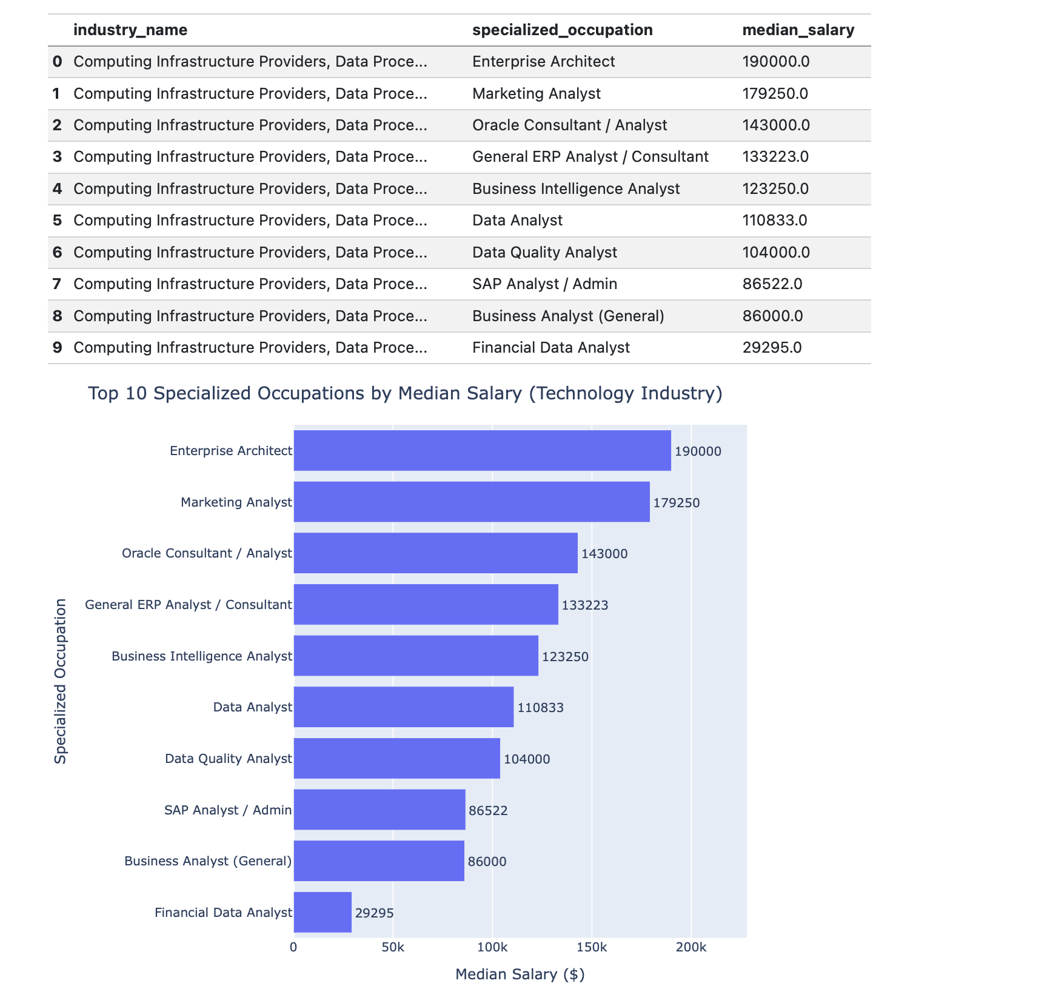

Insight: Higher specialization within the technology industry is clearly associated with higher median salaries, with roles like Enterprise Architect earning significantly more than general positions such as Data Analyst.

Query 2: Top 5 Companies with the Most Remote Jobs in California
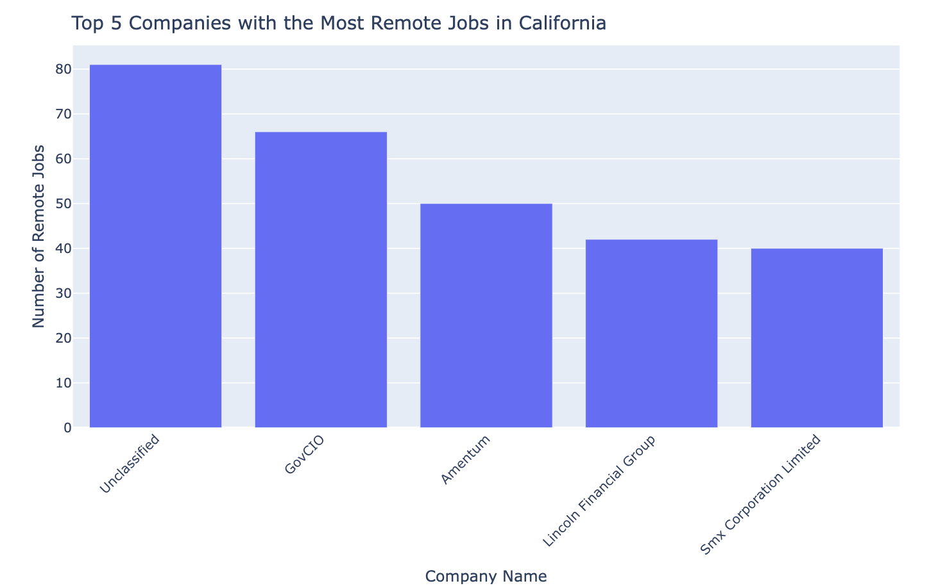

Insight: A small group of companies accounts for the majority of remote job postings in California, suggesting that remote hiring is highly concentrated among specific organizations rather than evenly distributed across the market.

Query 3: Monthly Job Posting Trends in California
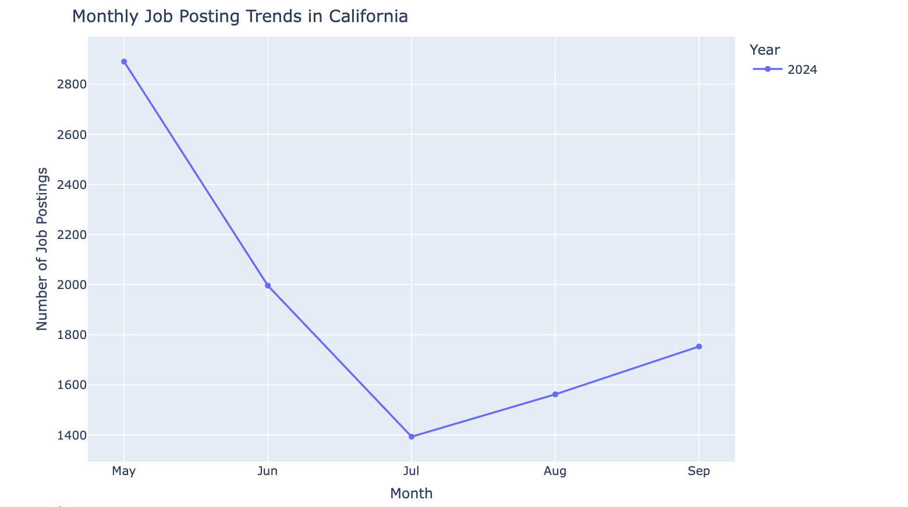
Insight: Job postings in California decline from May to July and then gradually increase through September, indicating a mid-year slowdown followed by a recovery in hiring activity.

Query 4: Salary Comparisons Across Major US Cities
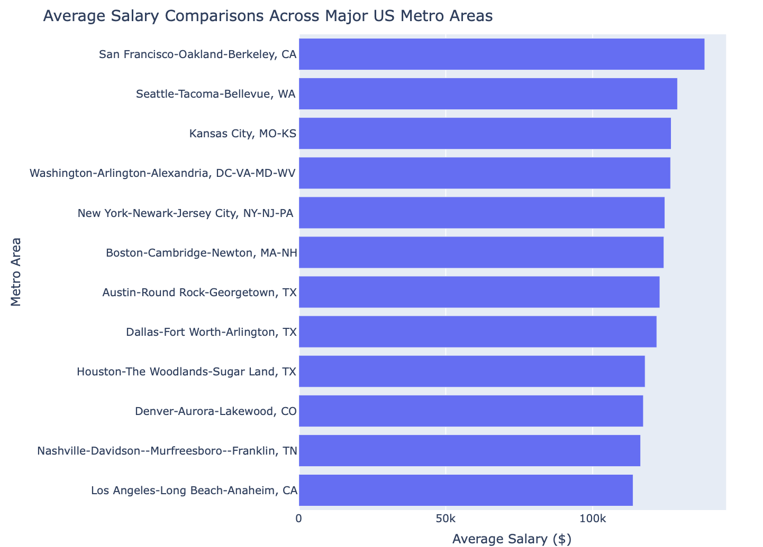

Insight: Average salaries vary across major US metro areas, with cities like San Francisco and Seattle offering the highest compensation, while others such as Los Angeles and Nashville show comparatively lower averages, highlighting regional differences in job market value.

