PROCESSES AND PROCEDURES HANDBOOK

# PART I: PRELIMINARIES

## Introduction

The purpose of this document is two-fold. Firstly it should serve as a guide for the PA running the Marketing Project (Sharif Alam - SA). Secondly it should serve as a focal point for discussion about the design of the project. In that sense it should be considered a living document, in that it will be updated periodically in order to reflect design changes, and thus once completed it will stand as a record of what was done, and decisions that were taken.

## Goals

The primary goal of the Marketing Project is to understand the demand for supervisor training in the RMG sector. A secondary goal is to understand on what basis factories make decisions when deciding whether or not they want to train their supervisors.

Briefly speaking the first goal is to be achieved by offering training to a pre-defined sample of factories. These factories will be randomly sorted into “Price Groups”. Each of these Price Groups will be offered training at a different cost. By monitoring the differential take up of training in the Price Groups a demand curve for training will be calculated.

The second goal will be achieved by recording aspects of the interactions that occur between the marketing team and the factories that are offered training. This will primarily involve recording in a rigorous manner what questions/concerns are raised by the factories during the marketing calls and subsequent interactions.

## Relationship to Supervisor Training Project

The Marketing Project will run alongside the supervisor training project (STP). For each module that is offered as part of the supervisor training project (see brochure for more information on modules) there is a class room capacity size of 20 students. However, only 15 of these “slots” are used by STP participants. This is because five slots have been reserved for Marketing Project participants.

Initially the marketing project was due to be up and running and selling training slots throughout the entire STP training period. However, due to a number of factors this did not happen. The first round of the STP training is now complete, and therefore the Marketing Project must be prepared and fully executed during the second round of training. This training is due to take place in September 13 – Jan 14 (see Timeline, below).

There is therefore an extremely small window in which to determine processes, refine them, and pilot the project.

For the sake of clarity, the STP and the Marketing Project will run in tandem but they are not the same. There is no overlap of factories in the two projects, and at present it is not envisaged that any marketing activities will take place in relation to factories that are already part of the STP sample.

## Personnel

The people involved in the day to day running of this project and their respective responsibilities will be as follows:

|  |  |  |
| --- | --- | --- |
| Name | Position | Responsibilities |
| Rory Creedon | Project Coordinator | * Overall supervision of all aspects of the project but especially:   + Process and procedure design   + Toolkit design (for record keeping) * Monitoring of progress * Troubleshooting |
| [Atonu Rabbani | Principal Investigator | * Not clear at present * Hopefully will be involved in many aspects of the project] |
| Sharif Alam | Project Officer | * Executing ALL aspects of the project. * Primary responsibility for ensuring smooth running of the project, as well as execution that is faithful to the design of the study. * Ensuring that the timetable deadlines are met for all tasks * Assisting the Marketing Individual in the marketing process * Keeping accurate records of interactions with factories using the toolkit designed by RC. * Ensuring the Marketing Person follows procedures * Reporting regularly to RC about progress made * Managing the relationship with CFTM * Piloting the project successfully |
| TBC | CFTM Marketing Individual | * Calling the factories to attempt to generate interest in the training in a manner consistent with the processes and procedures set out herein. |

## Steps to Launch & Timeline

The following steps must be taken in order to get us into a position to launch. Below is a list of the steps, progress made so far, and any comments (20130713). These are the broad steps, there are series of more detailed steps for completion that are described in other parts of this document. The Date for Completion should be considered a hard deadline, i.e. assume that there is zero room for overrun:

|  |  |  |  |  |  |
| --- | --- | --- | --- | --- | --- |
|  | Details | Progress | Comments | Person Responsible | Deadline |
| Step 1 | Creation of the marketing materials (flier, brochure, film, pen, envelope). | * Film is finalized * Pen is finalized * Marketing firm have been engaged to create the flier and brochure. | Getting some push-back from Nizam regarding illegal use of other people’s logos. This is non-negotiable. | SA | July 31 |
| Step 2 | Finalize processes (Handbook, Script, FAQs, codebooks etc.) | * Handbook * Partial FAQs, Script, although drastic rework needed. | Progress on this front should be discussed with RM/AR during the July visit of RM. | RC | July 31 |
| Step 3 | Hiring of dedicated marketing person. | * None | Although the responsibility of CFTM, this process should be overseen by SA. SA is responsible for making sure CFTM are on track | CFTM/SA | August 11 |
| Step 4 | Introduction to the training modules | * None | A three day training session for SA and the marketing person (details below)  Again, CFTM are responsible for providing this, but SA must ensure that steps are taken in the right direction. | SA | August 14 |
| Step 6 | IPA to provide a dedicated work space for the project | * None | For details see below.  SA must ensure that this is being effectively managed by IPA. Ultimate responsibility rests with SA. | SA | August 14 |
| Step 6 | Practice runs, and process checking | * None | For details see below | SA | August 18 |
| Step 7 | Pilot | * None | For details see below | SA | Sept 1 |
| Step 8 | Adjustments to Process | * None | For details see below | SA/RC | Sept 8 |
| LAUNCH SEPT 8 | | | | | |

## Training Timeline

The training timeline is determined by the number of modules that are currently forecast for the STP: 24 modules, 8 * Production Processes, 8 * Quality Control, 8 * Leadership and HR. As previously stated there are five slots reserved for the Marketing Project in each module. Therefore there are 40 slots available in each module over the training period including pilot slots.

A full timeline can be found in the dropbox. For present purposes see the extract below:

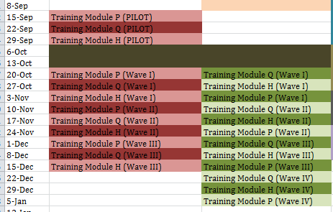

It will be noted that the training modules have been divided into Waves. For a full description of this method please refer to Part II.

If a factory wishes to purchase modules, then we can either try to absorb them into the existing slots (if the numbers are small), or we will have to arrange further modules to be added by CFTM (if the numbers are large). During the pilot phase, if any modules are sold, RC must be contacted immediately.

# part II: the SETUP & marketing process

## The Sample & Pricing

The PIs have created a sample of 600 factories which will potentially be part of the Marketing Project. These factories have all been assigned to receive either a “HIGH” price or a “LOW” price. Additionally each factory has been randomly assigned a “free” module (either P, Q or H).

48 factories have been designated “pilot” factories. The remainder should be randomized into four waves of 100 factories. The marketing will take place sequentially by wave. It is the responsibility of SA to locate contact details for the factories, before the relevant marketing period for that wave begins

[RC: The entire factory sample will be drawn upon in order to create five groups of 100 factories. One of these groups will initially be chosen at the “pilot” group. The remaining four will form the four “Waves” of the study.

Initially the first wave of factories will be offered a “high” price of full price (14,000 taka) per person per module and a low price of 9,250 taka (33% discount). The factories of that are offered the low price will not be informed that a discount has been applied.

The price may be varied between waves.

Each factory is entitled to attend one module for “free”. This module may be attended by anyone of the factories’ choosing. It is anticipated that someone from HR, or production management will attend, although there are no restrictions. Which module they are invited to attend is determined randomly, and absolutely no deviation from the allocation will be permitted, even if that means losing the interest of the factory.

After the nominated individual has attended the free module, the factory will be asked if they would like to proceed with purchasing further training.

## General Format & Recording

The following are the Stages of Marketing Process as currently envisaged. It should be noted that previously the goal of most of the interactions was to set up a meeting with the factory. This strategy has been abandoned somewhat. To the greatest extent possible the project will be conducted by telephone (although SA and the marketing person will make themselves available at CFTM on the first day of each training module). This is for several reasons. Firstly the cost of transportation is large, and budgets are tight. Secondly, each factory visited is a day away from the office. The opportunity cost in terms of calls is therefore very high. If a meeting is to take place, it should be after Stage 5 (The Free Module). Once a person has attended the module, we can consider the interest of the factory to be serious. Until this minor level of commitment has been reached, a physical visit to the factory would be largely pointless.

**Stage 1** Contacting the Relevant Decision Maker: Initially the Marketing Team should try to contact the highest level of management/owner. Once this person has been reached and the purpose of the call has been stated, it should be determined if that individual is the right person to speak with regarding a possible opportunity to train existing supervisors. If someone else is referred by that individual then this person should be contacted. If not, then the process can proceed with the manger/owner as initially contacted.

Recording Stage 1: Up until the point at which a decision maker is reached the only details that will be recorded are the number of attempted calls it takes in order to reach the relevant individual.

**Stage 2**  The Pitch: Once the decision maker has been reached, the pitch will begin. The pitch will not proceed along the lines of a script which cannot be deviated from. This is because the exact nature of each pitch will depend upon how the flow of the conversation proceeds. There will however be a “Points for Inclusion” list, which will be a series of talking points that the Marketing Team must attempt to introduce to the conversation.

The goals of the Pitch are as follows:

* + - * To receive permission to courier a package of marketing materials to the decision maker concerned.
      * To inform them about the “free module”
      * To receive permission for a follow-up call

Recording Stage 2: The talking points that the Marketing Team are able to use in the conversation must be recorded using predefined codes. The questions/comments of the decision maker must be recorded using pre-defined codes. The outcome of the call should be recorded using predefined codes. If any final decision is reached regarding the training then the reasons for this decision should be recorded (to the extent possible), by using a predefined set of codes. Some general notes about the tone of the call, and impressions should be recorded using words. This will all happen in an excel spreadsheet that RC will provide, which will automatically check the inputs and once the format is declared in line with the specifications, then the data will be stored in an invisible database.

For the sake of clarity it should be noted, that only **one** Pitch will be recorded. If the decision maker is reached, and the pitch begins, and the individual then says he does not have time, then this is merely to be treated as an attempt (Stage 1). The Pitch call will be recorded when it actually happens. Recording multiple phone calls will be overly burdensome, and result in unmanageable data. Having to record multiple interactions will also drastically increase the chance of error.

**Stage 3**  The marketing materials are couriered to the factory

Recording Stage 3: Records to be kept of the date of sending.

**Stage 4** Follow-Up Call(s):Once the marketing material have been sent and a couple of days have passedthe Marketing Team will attempt to make a follow-up call. The purpose of the follow-up call is as follows:

* To attempt to enlist the factory to send an individual to the “free module”
* To provide any additional information required

Recording Stage 4: As in stage one and two, attempts to make the follow up call will be recorded, but only in terms of the number of attempts. The follow up call is not to be regarded as having happened, until such time as the follow-up issues have been discussed with the decision maker. Therefore, being asked to call back etc. will only be recorded as an additional attempt.

As in stage two, questions/comments and decisions etc. should be recorded using predefined codes. General impressions should also be recorded. Again, this data will be recorded using an excel sheet provided by RC.

**Stage 5** The appointed factory person receives the “free module”. On the first day of each training module, the Marketing Team must be present in CFTM in order to meet the individual concerned and to answer any questions they may have.

Recording Stage 5: A record of whether the module was attended or not must be kept.

**Stage 6** Post-Training Follow-Up Call: After the individual concerned is due to have received training a second follow-up call should be made. The aim of this call is as follows:

* To assess reactions to the free module (if attended) **or** to find out why they did not attend as planned (if no attendance).
* To determine if they want to purchase training.
* If they request a meeting this can be arranged (for now though, we assume this call to be the last interaction).

Recording Stage 6: Similar to above, but with an increased emphasis on understanding the reasons for the final decision.



## Recording Process

The recording process is yet to be fully created. Roughly speaking it will involve a program written to be used with Excel that will prompt the user for information and then verify the information before storing it in a hidden database that will not be directly modifiable by the user. For security the program will also take a screen shot and save that shot in a folder, in case the data become corrupted or otherwise unusable.

## Expanded Timeline & Call Schedule

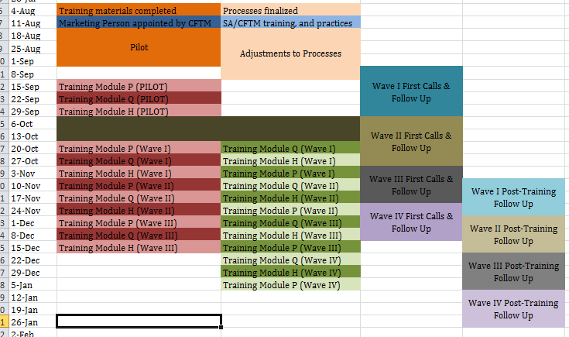

Above is a timetable that includes the call schedule. As will be noticed each of the training modules has been allocated to a particular wave of training. This is not a hard and fast rule, but indicative. In any event the call schedule should be adhered to as though the training by wave schedule was exactly correct.

It is anticipated that there will be 100 factories per wave. It is not yet clear if it is possible to make 100 first calls, follow up calls etc. in the time given, and as such this needs to be determined in the pilot. There may be some readjustment after the pilot phase.

For the first two waves the first and follow up calls needs to be completed in a four week period (although for the second wave this is straddling Eid). In general the Marketing Team must try to make 100 first calls in the first week, 100 follow up calls in the following week, and then consider a “spare” week in which to catch those factories in the wave for which they were not able to complete the call schedule. In general, calls should be made as soon possible within the time frame. In any event we need to budget 3 weeks per wave.

## Piloting the Project

The pilot of the project is going to be hugely important. IPA has very little marketing know-how and the CFTM marketing person may well be a rookie. As such it is important to recognize that the tools and procedures being created are done so behind a veil of serious ignorance. The pilot will an opportunity for learning what works in terms of the procedures, discovering how well our pre-coded version of the universe matches reality, and testing the data input process.

The pilot group is a sample of 50 factories [excluding DIRD], who will be approached by the marketing team in the above manner. As well as recording the interactions in a way that is consistent with the processes as created, there will be a huge amount of extra recording necessary. In particular the following should examined during the pilot process:

* The manner in which we approach factories, and the method for getting through to the relevant decision makers.
* How realistic the Talking Points are, and whether there are additional things that factories need to know
* Whether our FAQ list is as exhaustive as we would like
* Whether meetings will be a necessity
* Whether the data entry mechanisms are intuitive and function in the intended manner.

Please see separate pilot notes and training for more information.