<https://www.behance.net/gallery/99070071/Famskey-Booking-Management-Software?tracking_source=search_projects_recommended%7Cbooking>

Sample theme

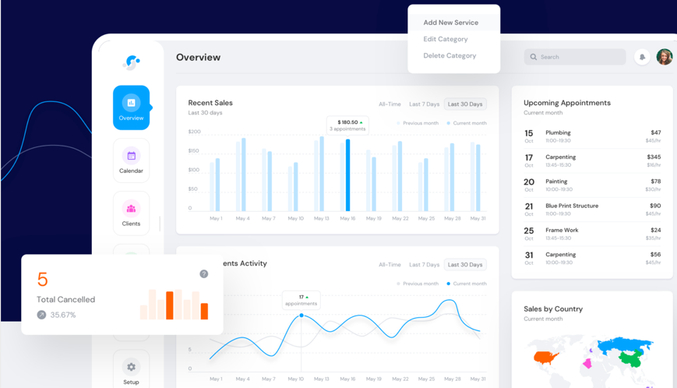

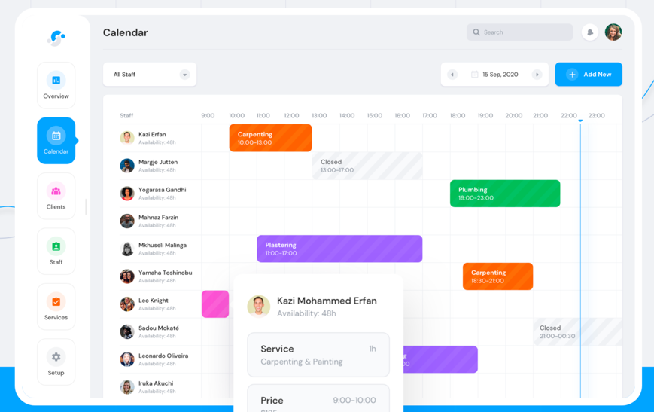Possible worker view (admin)

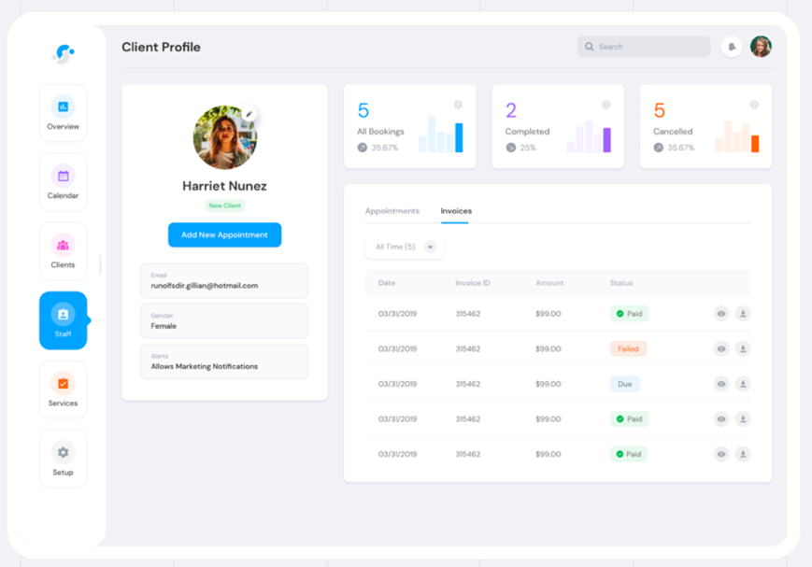Possible customer profile page

<https://www.behance.net/gallery/90714005/Zendenta-Dental-clinic-management-system?tracking_source=search_projects_recommended%7Cbooking>

Possible customer/admin dashboard

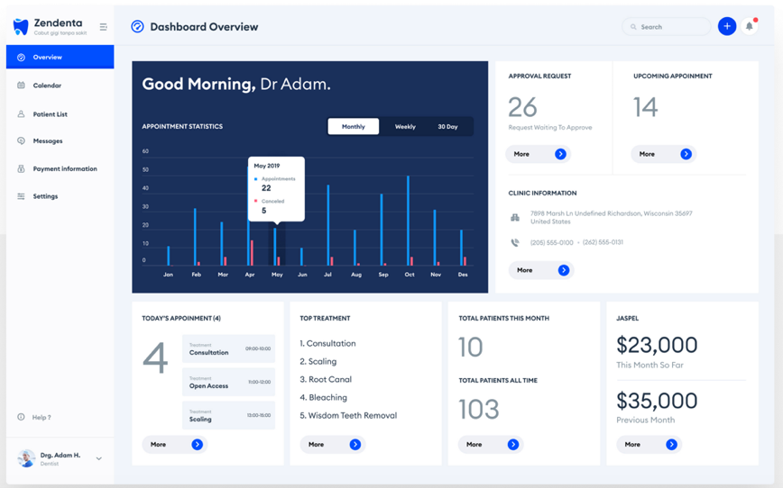

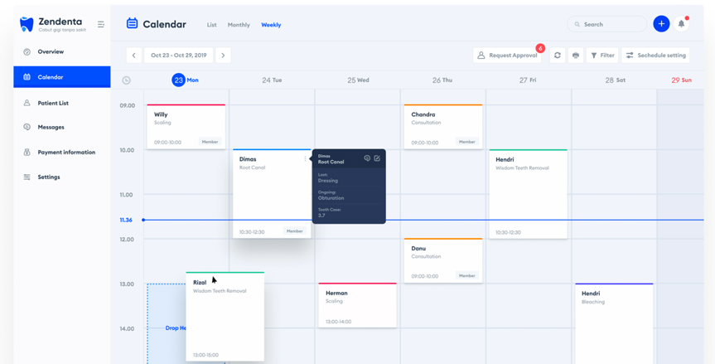Calendar view

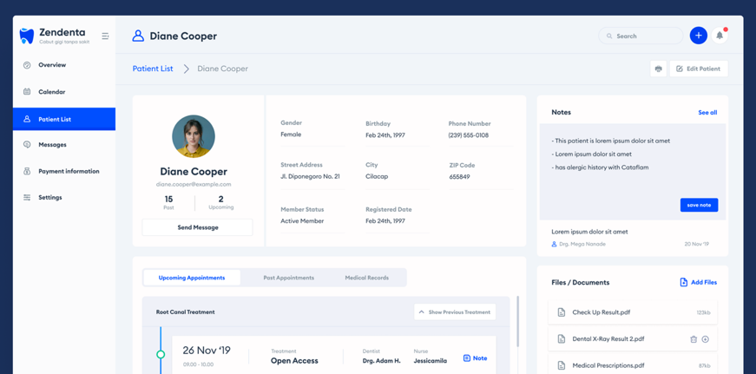Admin views booking/customer details

<https://www.wpbeaverbuilder.com/wordpress-website-header/>

Possible header styling with different colour schemes



<https://milanote.com/guide/create-better-moodboards>

Possible colour scheme for dashboard list of the available services



<https://www.pinterest.com.au/pin/9499849193173810/>

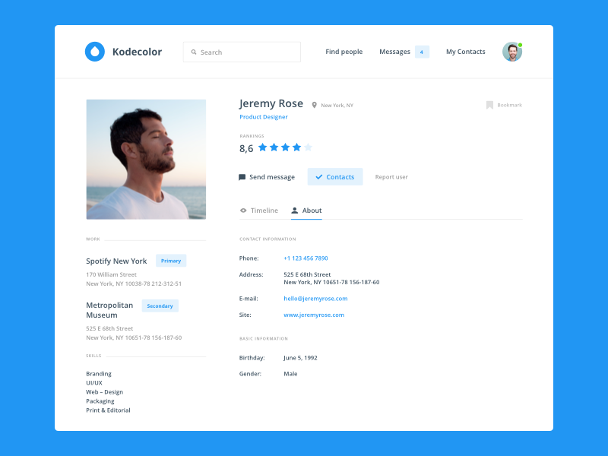Possible Profile page layout of a customer

<https://hashnode.com/post/choosing-how-to-design-a-booking-systemavailability-calendar-cj0kdskpa004m3o53tf9gj8s0>

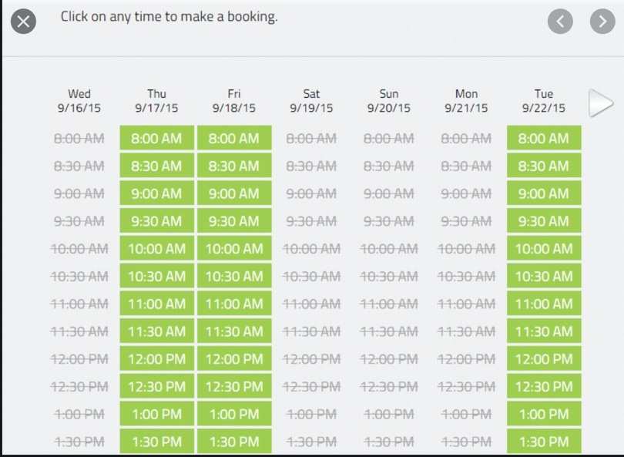Possible layout of available times for a service

<https://www.brafton.com/blog/graphics/12-b2b-about-us-page-examples-to-spark-ideas-for-your-own/>

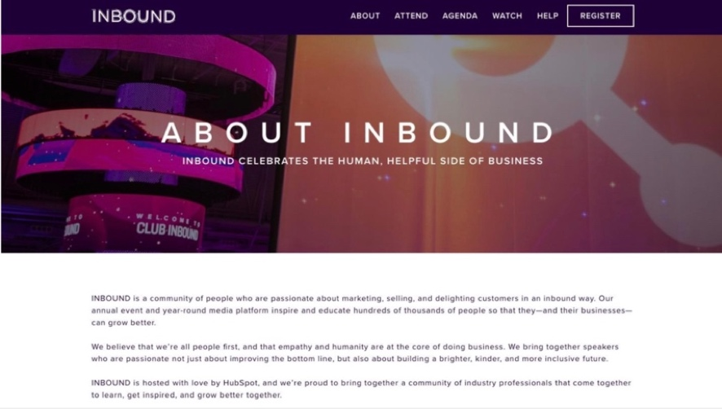Possible About Us Page layout

<https://www.launch27.com/>

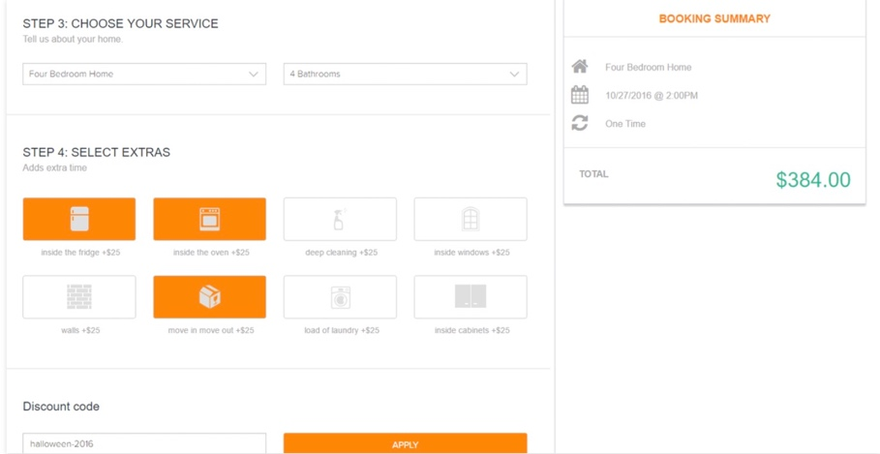Possible booking form layout