As it stands, this is the current status of execution of tests on our front and back end: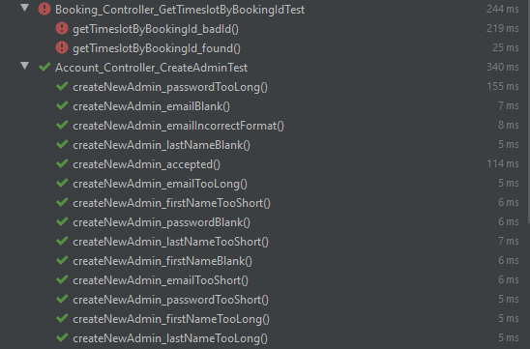

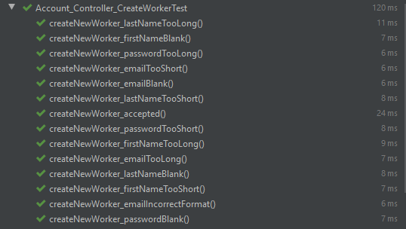

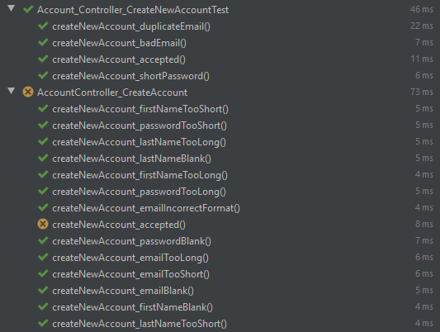

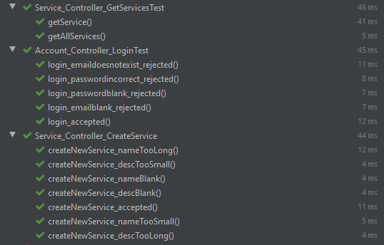

**NOTE: please do not be alarmed by tests that are failing to compile, changes made to the timeslot class that give it a price mean that changes must be made to these tests to ensure they compile correctly. While we do not have time to adjust these before Milestone 3 submission, they will be updated to match the new standard during the subsequent sprint.**

