**Sprint #2 Acceptance Testing**

We ran acceptance tests for all user stories that were completed, front end and back end, in the current sprint. The acceptance tests used were adapted from the acceptance tests originally written during Sprint 0, but adapted to include more detail. These tests were carried out using Firefox (screenshots included) and Chrome.

**User Story #1: Customer registration**

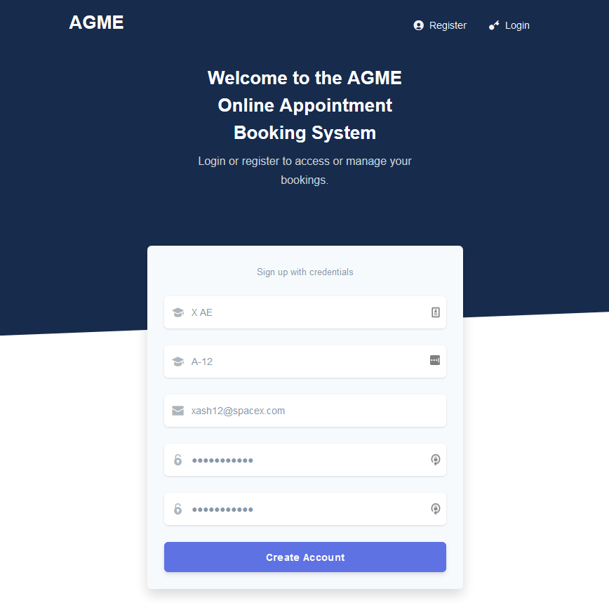

|  |  |
| --- | --- |
| ID | 1.1 |
| Purpose | Test name validation |
| Set up | Customer has clicked “register” and is on the registration page. |
| Steps | 1. Enter invalid input for name (non-name characters) 2. Fill other fields with valid information 3. Click “create account” |
| Expected Result | User should not be registered, and an error message should be presented to the user telling them which input is invalid. |

|  |  |
| --- | --- |
| 1 | 2 |
|  |  |
| 3 | Result: **failed** |
|  |  |

|  |  |
| --- | --- |
| ID | 1.2 |
| Purpose | Test email validation |
| Set up | Customer has clicked “register” and is on the registration page. |
| Steps | 1. Enter invalid input for email 2. Fill other fields with valid information 3. Click create account |
| Expected Result | User should not be registered, and an error message should be presented to the user telling them the email is invalid. |

|  |  |
| --- | --- |
| 1 | 2 |
|  |  |
| 3 | Result: **successful** |
|  |  |

|  |  |
| --- | --- |
| ID | 1.3 |
| Purpose | Test duplicate registration |
| Set up | * Customer clicks “register” and is on the registration page. * There is a user with the email ash@spacex.com already in the database. |
| Steps | 1. Enter “ash@spacex.com” as the email 2. Enter valid input for remaining fields 3. Click Create Account |
| Expected Result | User should not be registered, and an error message should indicate that this email already belongs to a registered user. |

|  |  |
| --- | --- |
| 1 | 2 |
|  |  |
| 3 | Result: **successful** |
|  |  |

|  |  |
| --- | --- |
| ID | 1.4 |
| Purpose | Test valid registration |
| Set up | * Customer clicks “register” and is on the registration page. |
| Steps | 1. Enter valid information for a new user, first name: Ash, surname: Musk, email: amusk@spacex.com and password 2. Click create account |
| Expected Result | User should be registered successfully and alerted as such. |

|  |  |
| --- | --- |
| 1 | 2 |
|  |  |
|  | Result: **successful** |
|  |  |

**User Story #4: Customer Views Services**

|  |  |
| --- | --- |
| ID | 4.1 |
| Purpose | Test the registered customers can view list of services available. |
| Set up | Two services exist in the system, Entertainment 720 and Paunch Burger. |
| Steps | 1. Customer logs in 2. Customer navigates to the services page |
| Expected Result | Customer is shown the list of available services, including both Entertainment 720 and Paunch Burger. |

|  |  |
| --- | --- |
| 1 | 2 |
|  |  |
|  | Result: **successful** |
|  |  |

**User Story #5: Customer Available Time Slots**

|  |  |
| --- | --- |
| ID | 5.1 |
| Purpose | Test that registered customers can view the available time slots for any service they wish to possibly book. |
| Set up | A customer logged in and viewing the list of services. There are two existing timeslots for the service “Entertainment720”. |
| Steps | * 1. Customer clicks on the “book service” button for the Entertainment 720 service |
| Expected Result | Customer is shown a list of available times for the specific service. |

|  |  |
| --- | --- |
| 1 | Result: **successful** |
|  |  |

**User Story #12:  Home page about/contact us section**

|  |  |
| --- | --- |
| ID | 12.1 |
| Purpose | Ensure that all information relevant to the about/contact us page is present. |
| Set up | An individual who is not logged into the service is on the home page of the website |
| Steps | 1. Click “About us” in the bottom corner of the page |
| Expected Result | The individual is able to locate the relevant information on the page |

|  |  |
| --- | --- |
| 1 | Result: **successful** |
|  |  |