Sprint 0 – Planning

27/07/2020 – record by Cathy

Meeting 01

Member presented:

1. Chiraporn Ropkhop (s3781279)
2. Kavin
3. Evan
4. Allan
5. Cindy

Meeting Duration: 2h 12m (ms team)

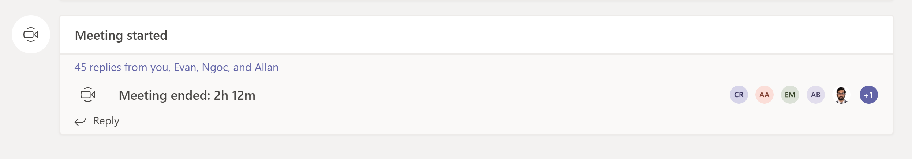

Meeting summary

* Get to know each other
* Set up IntelliJ and task management channel
* Select scrum master and product owner
* Assign Task (Epic)
* Set up GitHub

Individual update

1. Cathy: complete downloaded IntelliJ, set up Trello, set up and join GitHub. Responsible for Back end task (product owner)
2. Kavin
3. Evan
4. Allan
5. Cindy