Consultant Guide
ADP Gross-ups

Commercial in Confidence

Author: | Ian Morris
Date: | 2011-01-25
Review Date: | 2012-01-01
Doc Ref:
Version: | 1.0

PF3100 Document Release Notice
This is a controlled document - for identification of amendments, each page contains its version, release date and page number.
Project ID/  Task no.: |  | Project name/  Task name: | ADP Early corrections
Product name and version

Release date:
Review date:
Amendments in this release:
* Initial version

Description of amendments, including problems resolved
Approved: | Signature | Name | Date (YYYY/MM/DD)

Authorised: | Signature | Name |  | Date (YYYY/MM/DD)
Approved: | Signature | Name | Date (YYYY/MM/DD)
Distribution list (or the location of the distribution list):
Copy number | Version | Release date | Recipient
1 | 0.1 | (2009-02-13)

Table of Contents
Confidentiality 5
Pre-requisites 6
Configuration steps 6

Confidentiality
The information contained in this document is privileged and confidential, and remains the intellectual property of Automatic Data Processing, Inc. and/or its affiliates ("ADP Group"). This document must not be reproduced, stored in a retrieval system, or transmitted in any form by means electronic, mechanical, optical, photocopying, recording or otherwise, without the prior consent of the ADP Group. This document must be kept strictly confidential at all times. It must not be disclosed to any person without the prior written consent of the ADP Group.
ADP is a registered trademark and service mark of ADP of North America, Inc. GLOBALVIEW is a registered trademark and service mark of ADP, Inc.
Copyright 2006 ADP, Inc.

Pre-requisites
A Payroll Gross Up is used when extra or bonus payments are made to staff but the company does not wish the employee to be burdened with the taxes etc on that payment. In this case an extra gross payment is required to cover the taxes. The consequence of this is that the employee will be paid the amount specified but the actual gross payment (and thus expense to the employer) will be higher than specified.

The Gross Up functionality will calculate and generate the associated payment in order to cover the taxes and other deductions. This means if the paymaster allocates a net payment of $250.00, the associated amounts will be automatically calculated when the pay is run to calculate the Gross amount. This is the Gross-up or Net-to-Gross process.

With the net to gross process there are always two wage types : the input (or primary) wage type which is to be paid net to the employee and a secondary (or deductions) wage type which is the amount the ER must pay in addition to cover the deductions to be levied against the primary wage type.

The blueprint is required which cover the details of which net-to-gross elements are required; For each element, which deductions (e.g. tax, social insurance and possibly voluntary deductions) should be levied against both the net payment and the additional gross required cover the deductions; and finally for each net-to-gross payment type it must be understood which deductions must be covered by the company.

It should be noted that different deductions may be accounted for in the net-to-gross process to those which will be levied on the payments. For example one may decide that a net-to-gross element should be subject to deductions of tax, social insurance and voluntary deductions (such as pension) however since pension is a benefit to the employee only the tax and social insurance deductions are covered by the grossing process – in this case the payment to the employee will be LESS than the original input amount as the employee would pay pension deductions on the amount BUT ONLY the pension deductions – the tax and SI liability would be covered by the employer. This situation is uncommon however and the most likely case is that the deductions levied against a net-to-gross payment are those for which the company would gross. Most typically, the net-to-gross payment is not subject to voluntary deductions.

It should be noted that a primary wage type may not be payable – for example if one wanted to use the net-to-gross process to ensure that the employer paid the tax liability a non cash benefit (such as the company giving the employee a computer) then one would configure the input wage type to be taxable and subject to social insurance but not payable and the secondary (deductions) wage type to be payable (as well as probably taxable and subject to social insurance). In this way the payment to the employee (in the secondary wage type) will cover the deductions charged against the input wage type.

Configuration steps
- Program name: ZR_XADP_M99_GROSSUP00
- For each net-to-gross element, two wage types must be configured for infotype 0015 using the standard in country practice. These wage types should be configured to contribute to tax, social insurance and voluntary deductions as is the normal practice for the country. The wage types should be configured to NOT be allowed for entry in retro (V_T591B indicator should be set.)
- The input wage type (The net amount that is to be paid to the employee) is then configured into table ZXADP_M99_GRSPRM: In this case wage type 9920 is entered by the user, the grossing process will generate wage type 9921 for any 9920 wage type.
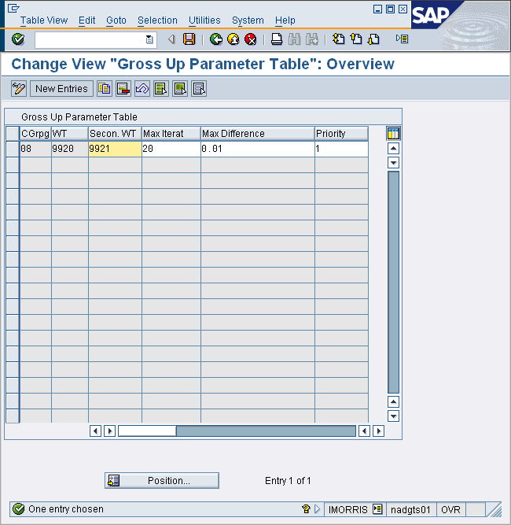
The parameters are as follows:
  - Secondary wage type : this is the wage type that the grossing process will generate in order to cover the deductions liability that arises from the payment of the input wage type.
  - Max Iterat : The calculation method of gross-ups is iterative. In some situations, the iterative refinement approach may not converge. In order that this situation is catered for, the system will stop attempting to converge after this number of iterations. It generally requires of the order of 8-20 iterations to achieve convergence but that exact number will vary with many parameters, not least of which is the details of the deduction calculations. If the process exits without convergence, the amount will not be accurate but the user is informed of this during the gross-up process.
  - Max difference. When the difference in deductions is less than this value, the iterative process will terminate – normally this would be set at the lowest amount of currency that it is possible to pay to the employee.
  - Priority : If multiple net to gross elements are specified in a period, this determines the order in which they are processed.

- The final piece of configuration is to list those deduction wage types for which the additional gross is to be based. In this case, wage type 9921 will contain the value of the additional gross required to cover the additional deductions created in wage type /301 and /501 when wage type 9920 is to be paid:

