SOCKET PROGRAMMING

# Assignment 2a – Networks



Kiara Ramjith

RMJKIA001

Brigitte Sprung

SPRBRI005

Katlego Gaveni

GVNKAT001

## Functionality:

Send Message:

User can send a message to whoever is in the chat at the moment.

Send Picture:

Allows user to send a picture to either 1 or all users by typing “PICTURE”. A file chooser pops up and allows the user to choose the picture they want to send. The user will also have a choice to send to all members or just one. These members have the option to accept or decline the picture.

**note this takes some time to process**

Who is in:

This allows the user to find out who is currently active in the chat room by typing the command “WHOISIN”.

Kick:

This allows the user to kick any active member off the chat room by typing the command “KICK [username].

Unique usernames:

This chatroom will not allow the user to have the same username as someone else. They will have to choose a unique one at the chatrooms prompting.

## Screenshots:

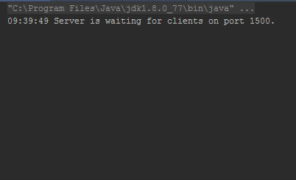

Figure 1: Server Opening

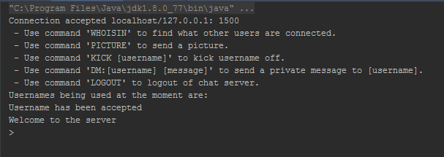

Figure 2: Client Opening (normally)

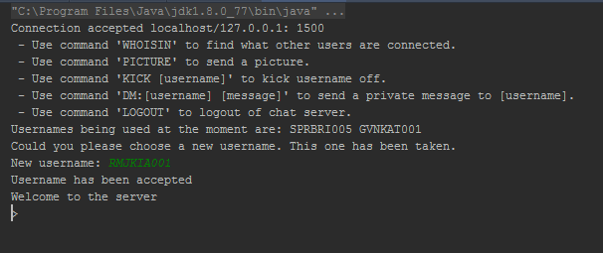

Figure 3: Client Opening (prompted for unique username)

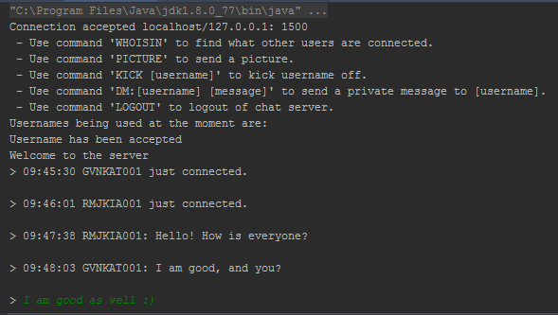

Figure 4: Normal conversation between users

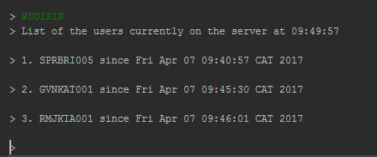

Figure 5: Command “WHOISIN”

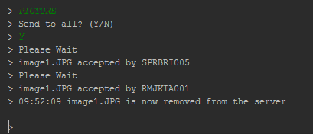

Figure 6.1: Sending a picture

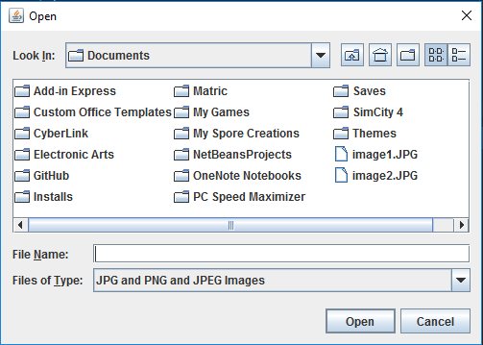

Figure 6.2: File chooser

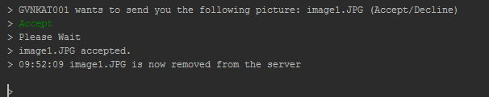

Figure 6.3: Accepting a picture

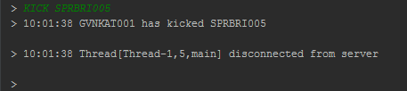



Figure 7: Command “KICK”

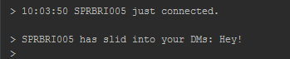

Figure 8: Receiving a direct message

## Do we keep the picture or delete the picture:

We delete the file from the server when it is added because keeping it on the server is a safety issue. In other words if the server is hacked into they could access the pictures. The picture is therefore deleted once it is sent or declined. This also does not clutter the server with innumerable pictures.